Section 1: Overview and Modeling Strategy
Contents
1 Section 1: Overview and Modeling Strategy 1-1
1.1 Introduction 1-1
1.2 Management Context 1-2
1.2.1 Total Maximum Daily Load (TMDL) 1-3
1.2.2 Partnership’s Plan for the post-2025 TMDL 1-4
1.2.3 Governance 1-6
1.2.4 Overall CBP Model Framework 1-7
1.3 Purposes of the CBP Watershed Model 1-8
1.3.1 Estimate Change in Load from Management Actions 1-8
1.3.2 Deliver Loads to Estuarine Models 1-8
1.3.3 Calibration and Validation 1-9
1.3.4 Scientific Study 1-9
1.4 Partnership Direction 1-9
1.4.1 STAC 1-9
1.4.2 WQGIT 1-10
1.4.3 Other GITs 1-11
1.4.4 Regional hydrologic modeling meeting 1-11
1.5 Model Structure 1-12
1.5.1 Overview 1-12
1.5.2 CAST 1-12
1.5.3 CalCAST 1-14
1.5.4 DM-CAST 1-14
1.5.5 Role of Multiple Models 1-15
1.5.6 Comparison of Model Structure to Previous CBWM Phases 1-15
1.6 Documentation 1-16
1.7 Development and Release Schedule 1-18

Introduction
The Chesapeake Bay Program’s (CBP) Phase 7 Watershed Model is a participatory creation of the CBP Partnership. This report provides the CBP partnership with technical documentation of the Phase 7 Model that was developed as a result of the partnership decisions that have been made in the Management Board, the Modeling Workgroup, the Water Quality Goal Implementation Team (WQGIT), and the WQGIT’s workgroups with advice from the Scientific and Technical Advisory Committee (STAC) and other groups within the CBP.
The Phase 7 Watershed Model is a continuation and further development of the general structure of the Phase 6 Watershed Model. There are three components of the Phase 7 model which are more fully developed in Section 1.5.
- The Chesapeake Assessment Scenario Tool (CAST) is the web-available, time-averaged model that is used for official CBP management scenarios. It produces estimates of long-term nutrient and sediment loads given a set of land use acreages, management practices, point sources, and other inputs.
- CalCAST is a statistical model similar in construction to CAST. CalCAST is used to test model structures, data sets, and parameters for use in CAST.
- DM-CAST is a temporal downscaling of CAST and CalCAST through a dynamic watershed model. DM-CAST is used to compare with observed stream data, to supply inputs for the CBP’s estuarine model, and to evaluate lag and other watershed effects.

Management Context
The Phase 7 model will be released at the beginning of 2027 after more than four years of development and review for application to management decisions relevant to the Chesapeake TMDL. Draft documentation will be released as completed. A full draft model will be reviewed by the partnership in 2026.
Phase 7 continues a long history of improvements to the modeling tools used to simulate the Chesapeake Watershed. Major releases of the watershed model are shown in Table 1-1 below. For a more detailed description of the earlier history see Chapter 1 of the Phase 5.3 Watershed Model documentation USEPA 2010a-01 and Linker et al. 2002.
Table 1-1: Watershed model versions
Phase | Year | Purpose
0 | 1983 | Split point source and nonpoint source
1 | 1990 | Refine nonpoint source simulation
2 | 1994 | 40% reduction agreement (of controllable loads)
4.1 | 1997 | Confirmation of 40% goals
4.3 | 2003 | Allocation to avoid a Total Maximum Daily Load
5.3 | 2010 | Total Maximum Daily Load and Phase I Watershed Implementation Plans
5.3.2 | 2011 | Phase II Watershed Implementation Plans
6 | 2017 | Midpoint Assessment and Phase III Watershed Implementation Plans
7 | 2026 | Support post-2025 decisions

Total Maximum Daily Load (TMDL)
The 2010 Chesapeake Bay TMDL sets limits on nitrogen, phosphorus, and sediment pollution necessary to meet water quality standards in the Bay and its tidal rivers. It is the largest and most comprehensive TMDL that the EPA has established to date. The Phase 5.3 Watershed Model was used extensively throughout the TMDL process to estimate loads to the estuarine model and to supply loads and other parameters for the allocation calculations. Initial load allocations by State and major basin were calculated according to a set of rules that was based in large part on Phase 5.3 Watershed Model predictions of effectiveness of delivery of loads and the ability of each region to reduce those loads based on land use and other physical characteristics. Watershed Implementation Plans (WIPs) are plans for how the Bay jurisdictions, in partnership with federal and local governments, will achieve the Chesapeake Bay TMDL allocations and planning targets. Phase I WIPs were developed in 2010 using the Phase 5.3 Watershed Model to inform the TMDL allocations. Phase II WIPs were developed in 2011 using the Phase 5.3.2 Watershed Model which had been updated primarily for developed land use acres and some agricultural inputs.

2017 Midpoint Assessment
The 2017 Midpoint Assessment of the TMDL was an effort of the CBP to evaluate progress at the halfway point between the 2010 setting of the TMDL and the 2025 implementation goal, to make adjustment to models based on updated science and information, and to adjust goals based on these updated models. EPA expected practices in place by 2017 to meet 60 percent of the necessary reductions. The CBP used the Phase 5.3.2 model to evaluate implementation progress through 2017. The CBP developed the Phase 6 Watershed Model to set new nutrient and sediment planning targets and evaluate the effects of climate change. Phase III WIPs were developed by jurisdictions to meet goals based on the new information provided by the Phase 6 Watershed Model, related updates of the Chesapeake Bay Land Change Model and estuarine Water Quality and Sediment Transport Model (WQSTM). Phase III WIPs provided information on actions the Bay jurisdictions intended to implement between 2018 and 2025 to meet the Bay restoration goals.
For more information on the TMDL and the watershed model use in the TMDL, refer to the TMDL documentation (USEPA 2010c), particularly Section 4 for the modeling of the inputs, Section 5 for the modeling of the physical setting, and Section 6 for the specifics on how they were used to set the TMDL.
Phase III WIPs were developed in 2018 and 2019 to meet nitrogen, phosphorus, and sediment planning targets developed by jurisdictions based on the 2017 Midpoint Assessment of progress. The Phase 6 modeling suite was used to set and track pollutant reduction targets.

Principle of relative change
From a modeling standpoint, once a new version of a model is established, ideally there would be no changes to the model until the next version. However, new information on inputs to the watershed and the effectiveness of BMPs continues to become available during the period of application. Therefore, the CBP partnership has established a cycle of updates that are to occur to the modeling tools. Generally, these are two-year updates. For example, the original version of the Phase 6 CAST was CAST-2017, the next version was CAST-2019 and so on.
The integrity of the TMDL calculations require that these updates be implemented with care according to the principle of relative change. The watershed model be best understood to estimate relative change in loads rather than absolute loads relative to a fixed target. The TMDL critical period was established as 1993-1995 (USEPA 2010c) to represent a relatively wet period when standards were more difficult to meet than an average three-year period. The estuarine model is used to estimate the change in loading that would result in water quality standards being met in the three-year period 1993-1995. Therefore, the watershed model is best understood in the context of the TMDL as a tool to estimate changes in load from 1995 due to change in management actions. Substituting new data sets, even if more accurate in an absolute sense, could result in an estimated change in loads that is not consistent with changes actually occurring in the watershed. For example, if a new estimate of the history of atmospheric deposition increases the estimate of deposition in each historical year by 20%, it would not be appropriate to substitute this new data set and thereby increase the estimate of loads to the Bay. Running the 1995 scenario under these circumstances would lead to the impossible conclusion that model input changes had caused water quality during the critical period to degrade relative to what was measured at the time. To be consistent with the TMDL, all versions of the phase 7 CAST must return the same results for the 1995 scenario.
The principle of relative change, as applied to the TMDL, has two components
Accurately measuring change: Only data sets and model strategies that can be consistently applied for 1995 and all future scenarios are valid. New data sources may be applied as a trend in some cases. For example, the phase 6 atmospheric deposition data set estimated deposition from 1985-2012. Changes after 2012 were estimated from the CMAQ model. The changes were applied as change factors from 2012 deposition which was estimated in both models.
Maintaining consistency with 1995: Any model or data alteration must maintain the 1995 loads by land use and land-river segment of the original model. In some cases, changes the partnership desires to make may alter the 1995 data. For example, in Phase 6, jurisdictions updated their BMP history from 1985 through the current year. When these changes occur, additive factors are applied by land use and land-river segment to maintain the 1995 loads.
The full mechanism of adhering to the principle of relative change is covered in section 17.1.4. The partnership has discussed this principle in many settings with different model versions. A presentation to the WQGIT in May of 2021 provided a summary and some specific examples that were current at the time.

Partnership’s Plan for the post-2025 TMDL
As of 2022, there is not yet a comprehensive partnership plan for what is to occur after 2025, however a few relevant decisions have been made.

2035 Climate Change Assessment
On December 17 2020 the Principals’ Staff Committee (PSC) met to discuss the decision made on addressing 2025 climate change conditions. Along with approval of the modeling and the loads for 2025, they agreed that “In 2025, the Partnership will consider results of updated methods, techniques, and studies and revisit existing estimated loads due to climate change to determine if any updates to those 2035 load estimates are needed.” The specific recommendations from the WQGIT were:
- Develop a better understanding of the BMP responses, including new or other emerging BMPs, to climate change conditions.
- Compare the current 2025 climate change assumptions with measured climate conditions through 2024 to include: rainfall volume, intensity, and distribution; air temperature, hydrology, water temperature, sea level rise, and changes in Bay stratification and circulation.
- Consider the efficacy of using projections from measured trends versus downscaled global climate model data for revised 2035 estimates.
- Improve understanding and simulation of climate change impacts to open water designated use in shallow waters.
There are several responses to the above WQGIT recommendation that are underway. Virginia Tech scientists are producing a comprehensive literature survey on the effects of climate change on BMP performance. In addition, a WQGIT-funded project to produce updated intensity-duration-frequency curves for all counties in the watershed will supply necessary estimates of climate effects. Another response is an improved shallow and open water simulation and assessment being addressed through an EPA Request for Applications (RFA) for development of a new estuarine model, and through the development of a new tidal water quality interpolator that will run on finer temporal and spatial scales. Finally, assessment of the measured change in climate and the effectiveness of relying on climate models has been informed by a NOAA-funded project led by VIMS and Penn State scientists leading to an evaluation of future climate inputs that will occur in 2024 and 2025.

Planning Target Recalculation
From the 2010 Bay TMDL executive summary: “The TMDL is designed to ensure that all pollution control measures needed to fully restore the Bay and its tidal rivers are in place by 2025, with at least 60 percent of the actions completed by 2017.” This is repeated in several sections dealing with the timeline for implementation and reasonable assurance that the goals will be achieved. There is no provision in the TMDL documentation for what happens in 2025 or later years other than achieving appropriate implementation levels. Section 1.2 points out that achieving implementation in this timeline was a consensus decision: “At the October 1, 2007, meeting of the PSC the seven watershed jurisdictions and EPA reached consensus that EPA would establish the Bay TMDL on behalf of the seven jurisdictions with a target date of 2025 when all necessary pollution control measures would be in place (CBP PSC 2007).”
During the July 9, 2018 PSC meeting the PSC approved the Phase 6 suite of modeling tools and the planning targets and they further agreed that “The jurisdictions’ Phase III WIP nitrogen and phosphorus planning targets will remain unchanged through 2025, recognizing that the PSC reserves the right to revisit this decision if necessary.” This decision indicates the possibility of planning target changes in 2025, but not the inevitability.
A recalculation of planning targets could be triggered by the approval of a new watershed model, a demonstration that the current planning targets are insufficient to meet water quality standards or excessive in their protection, or a change in the equity rules governing the planning target calculation. For example, a change in planning targets could be handled by a Phase IV WIP process or, as in the case of planning target reductions due to climate change, through the milestones process.

Phase 7 decision time frame
On March 2, 2022, the PSC met and decided to elongate the Phase 7 model development period by 2 years based on input from the partnership. Draft models will be due for partnership review at the beginning of 2026 with decisions on new planning targets to be made in 2027.

Governance
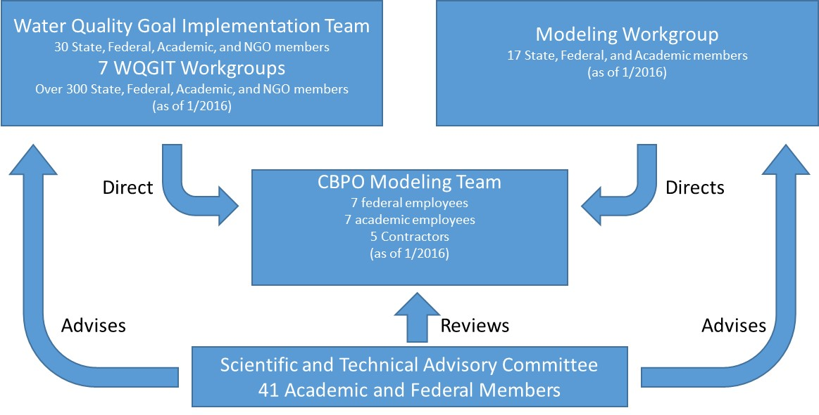
The Phase 7 Watershed Model was developed with extensive partnership input and direction. The figure below illustrates the modeling governance structure within the CBP. These groups are part of the larger CBP organizational chart.
Figure 1-1: CBP modeling governance structure
The Modeling Team is a cross-disciplinary group at the Chesapeake Bay Program Office (CBPO) working on development, analysis, research, calibration, and operation of the CBP modeling suite including the Land Cover Model, Watershed Model, and Estuarine Water Quality and Sediment Transport Model (WQSTM). The team takes direction from decisions of the CBP Partnership, particularly the Modeling Workgroup (MWG), and Water Quality Goal Implementation Team (WQGIT), as well as expert guidance from the Workgroups of the WQGIT. The independent Scientific and Technical Advisory Committee (STAC) advises the partnership through recommendations from workshops and reviews, and through direct communication. The MWG and WQGIT also receive considerable input from stakeholders and other interested parties that participate in regular meetings. The MWG reports to the Scientific and Technical Analysis and Reporting (STAR) group. The WQGIT reports to the Management Board and the Principals’ Staff Committee.
The WQGIT directs the Modeling Team on issues related to how the models are used to inform policy. The WQGIT has seven workgroups that are more closely involved in direction of the Watershed Model efforts, generally in the areas of model inputs, the extent of management practice implementation, and the effectiveness of management practices. Additionally, the WQGIT and its workgroups commission and review panel reports for specific management practices. The Agriculture, Forestry, Urban Stormwater, and Wastewater Treatment Workgroups direct the CBPO Modeling Team on issues related to inputs for their respective areas of interest. Some of these groups have formed subgroups to facilitate discussion. For example, many agricultural simulation decisions are first made in the Agricultural Modeling Team. The Land Use Workgroup oversees the CBPO Modeling Team in developing the land use dataset for modeling and other purposes. The Watershed Technical Workgroup works on cross sector BMP issues and facilitates BMP integration into the Watershed Model.
The MWG directs the Modeling Team on issues related to scientific integrity, modeling of the physical environment, model calibration, and issues that cross sectors such as average sector land use loading rates. The modeling workgroup adopted the following core values on 1/20/16.
- Integration - Integration of most recent science and knowledge in air, watershed, and coastal waters to support ecosystem modeling for restoration decision making
- Innovation - Embracing creativity and encouraging improvement in the development and support of transparent and robust modeling tools.
- Independence – Making modeling decisions based on the best available evidence and using the most appropriate methods to produce, run, and interpret models, independent of policy considerations.
- Inclusiveness - Commitment to an open and transparent process and the engagement of relevant partners, that results in strengthening the Partnership’s decision-making tools.
Table 1-3 near the end of this section shows the relationship between the workgroups, major parts of the watershed model, and the documentation.

Overall CBP Model Framework
The CBP model framework depicted in Figure 1-2 is designed to address questions of how Chesapeake Bay water quality will respond to changes in management actions. The CBP Land Use Change Model predicts changes in land use, sewerage, and septic systems given changes in land use policy. The Airshed Model, a combination of a regression of model of National Atmospheric Deposition Program (NADP) data and a national application of the Community Multiscale Air Quality (CMAQ) Model, predicts changes in deposition of inorganic nitrogen due to changes in emissions. CAST, the Watershed Model, combines the output of these models with other data sources, such as the US Census of Agriculture, and predicts the loads of nitrogen, phosphorus, and sediment that result from the given inputs. The estuarine Water Quality and Sediment Transport Model (WQSTM) predicts changes in Bay water quality due to the changes in input loads provided by the Watershed Model.
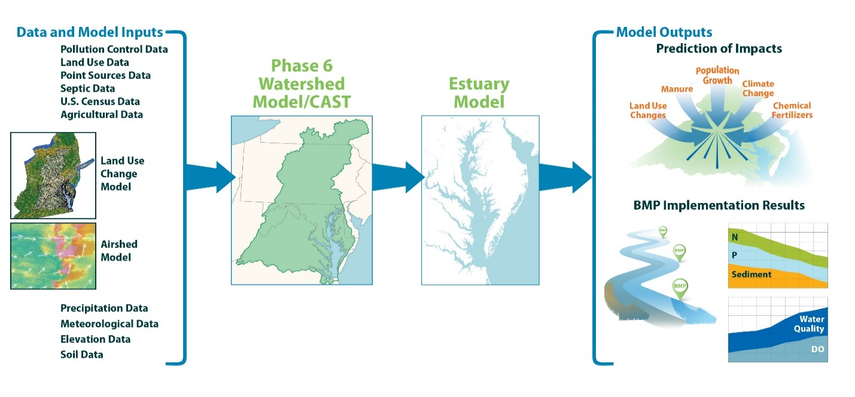
Figure 1-2: Chesapeake Bay Program models

Purposes of the CBP Watershed Model
As discussed above, the CBP community has used the Chesapeake Bay Watershed Model (CBWM) in much the same way throughout its many phases and history and so purposes and uses of the CBWM are well understood.

Estimate Change in Load from Management Actions
The primary water quality management decisions of the CBP are based on long-term flow-averaged estimates of nutrient and sediment load to the estuary. The management questions involve assessing the long-term loads from land uses and other sources indexed to watershed and political boundaries under various management scenarios. The information forms the basis of management decisions about where to implement BMPs and other control measures. The watershed model must be built to most effectively estimate load changes from changes in land use, nutrient inputs, BMP and conservation practice implementation, and wastewater treatment.
In a typical year, hundreds of scenarios are run on the CBWM at different spatial scales and levels of management. These runs are used to develop WIPs, to develop 2-year implementation goals known as Milestones, to assess progress toward WIPs and Milestones, and for special projects. Note that these scenarios are time averaged. The temporal component is not typically considered for this management need.

Deliver Loads to Estuarine Models
A small subset of the scenarios generated for management are also run on the estuarine model (WQSTM). For management purposes, these are typically run during major CBP decision periods such as the 2010 TMDL, the 2017 Midpoint Assessment, and the upcoming 2027 decisions. At other times, scenarios may be run for scientific inquiry. For this purpose, it is necessary to have a watershed model that can load the estuarine model at a daily time step and at fine enough spatial scales appropriate to the scale of the estuarine model. The Phase 7 estuarine May Bay Model has a refined spatial scale relative to the Phase 6 estuarine model, particularly in smaller tributaries. The Phase 7 Multiple Tributary Models have an even finer scale. These models require inputs on a finer spatial scale than previous models. The CBP often participates in collaborative scientific work with state, federal, and academic researchers. The collaborations often involve output of the CBP model to an estuarine model or analysis system.

Calibration and Validation
During the model development, it is essential that the model be judged against observation and other lines of evidence to ensure that it is matching the spatial and temporal patterns of loads as closely as possible. This is accomplished through a weight of evidence approach using multiple data sources. This task is only performed during the initial model development and requires a daily or hourly time step to take advantage of daily flow and instantaneous concentration measurements.

Scientific Study
From time to time, the CBP managers need estimates of the effects of various physical processes on outputs of interest. For the Phase 6 Model in the Midpoint Assessment, these processes include climate change and lag times. Valid scientific inquiry requires a model that incorporates the relevant processes.

Partnership Direction
As described in section 1.2.2.3, the development of the watershed model is governed by decisions made in the Modeling Workgroup (MWG), the Water Quality Goal Implementation Team (WQGIT), and the WQGIT’s subordinate workgroups. Decisions affecting the Watershed Model can also be made at the Management Board and Principals’ Staff Committee if they chose to do so or there is a lack of consensus at the lower level. Other groups within the CBP structure provide advice. Primary among these is the Scientific and Technical Advisory Committee (STAC) which provides independent scientific advice through meetings, workshops, and syntheses. Other Goal Implementations Teams and Advisory Committees within the CBP committee structure provide advice on an ad hoc basis. These discussions here resulted in the formulation of workplans which are available on the Phase 7 page. The modeling workgroup provides ongoing review of the work and contributes to the discussion of modeling priorities. The results of the discussions with the partnership presented to the Modeling Workgroup on January 4, 2022. The modeling workgroup will continue to discuss how the models can be built to address partnership direction.

STAC
The CBP’s Scientific and Technical Advisory Committee (STAC) is composed of independent scientists from academic, non-profit, and government institutions. STAC advises the CBP formally through workshop reports and reviews, and more informally through STAC meetings and STAC members’ participation in CBP meetings. STAC products are influential in the development of all CBP models. Those that pertain directly to the watershed model are described below.

Workshops
A STAC workshop on multiple models in 2014 (Weller et al., 2014) had key recommendations of 'The Chesapeake Bay Program should implement a multiple modeling strategy for each major decision-making model of the Bay (airshed, land use, watershed and estuarine) and analyze the output to quantify skill, advance knowledge and inform adaptive management’ and ‘'The Chesapeake Bay Program should exercise the multiple model system to quantify model uncertainty and confidence in key predictions used in decision-making for the airshed, land use, watershed and estuarine models.’ As described in section 1.5.5, a form of multiple modeling was included in the design of the Phase 6 model. STAC approved of this change in the context of the Phase 6 review (Easton, et al, 2017) and suggested deepening the use of multiple models and using the framework to estimate uncertainty.
A subsequent workshop that discussed “CBP Modeling in 2025 and Beyond” (Hood, et al, 2019) reinforced the approval of the modeling structure of Phase 6: “The CBP should continue to employ and develop the Phase 6 Watershed Model that uses multiple models to determine responses to management actions”. Other major recommendations included:
- The participatory modeling approach taken by the CBP should continue to be advanced, improved, and refined.
- Modular modeling techniques should be adopted in the CBP partnership models wherever possible.
- The CBP partnership should expand its efforts to make its models applicable to smaller “local” scales, appropriate to decision making for smaller-scale jurisdictions and watersheds.
- The CBP should continue its efforts to work toward assessing the uncertainties in its modeling suite, with particular attention to simulated responses to management actions in the context of the TMDL.
- The approaches, processes, and parameterizations used in the CBP models for estimating the impacts of climate change and sea level rise on the TMDL should be reexamined in detail.
A 2019 workshop on reducing the cost of nonpoint source implementation through targeting (Easton, et al., 2020) had direct recommendations for the watershed model to “Improve the spatial prediction capability of the CBP TMDL accounting system by: (a) Develop finer scale modeling capacity to guide and inform targeting; (b) Continue to improve spatial resolution of datasets that drive the CBP models and increase sharing and development of remote sensing and high resolution data that can inform the location of NPS loads and BMP removal effectiveness; and (c) Allow for differential crediting of NPS BMPs.”
Another 2019 workshop focused on the differential estuarine oxygen effect of nutrient loads depending on source, timing, and speciation (Shenk, et al., 2020), Participants urged watershed model developers to include the effects of land use, watershed position, and stream characteristics in determining the speciation and timing of load delivery to the estuarine. The 2018 Climate change modeling 2.0 workshop (Shenk, et al., 2021) contained recommendations to be used for climate scenarios and suggested that model sensitivities to climate variables be emphasized in development.
As of 2022, additional STAC workshops are expected prior to the release of phase 7.

Reviews
Phase 6 review (Easton, et al, 2017)
Scenario Builder Review

WQGIT
The WQGIT began its consideration of the Phase 7 during the review of the Phase 6 model in 2017. In late 2021 and early 2022 a series of meetings and documents formalized the areas of improvement favored by the WQGIT. The process of advice will continue throughout the development of Phase 7.

WQGIT Phase 6 review
During June and July 2017, a final review was conducted based on the Draft Phase 6 (6/1/2017) version of the documentation with the potential for changes to be made during this time. It was referred to as a “fatal flaw” review, reflecting the idea that interactive review had been ongoing for several years and only serious and substantial flaws would be addressed. Section 1 of the Phase 6 documentation has a more complete description.

The 115 comments received during the review remain available. Most were dealt with either through modification of the model or further explanation to the partnership. Issues that were not serious enough to be considered a fatal flaw but unresolved in phase 6 have been noted in the draft Phase 7 documentation in appropriate sections. A particular issue to be dealt with in Phase 7 is the differential handling of phosphorus from agricultural and urban sources.

Determination of WQGIT priorities
Drawing from the STAC workshops and reviews discussed in section 1.4.1 and the WQGIT’s Phase 6 review a an options paper with a transparency addendum were developed for the October 25-26 WQGIT meeting. The options paper discussed potential improvements in scale, physical processes, nutrient application, land use, and climate modeling and the potential addition of co-benefits, uncertainty quantification, and an interface with a user-defined spatial extent. The results of the paper, WQGIT meeting, and individual meetings with each WQGIT member in late 2021 were used to develop a second options paper which was discussed at the January 24, 2022 WQGIT meeting. The January 2022 options paper contained WQGIT reaction to and voting on the issues in the October 2021 options paper. The WQGIT preferred to discuss variable-scale modeling rather than determine a scale for management at this early stage. The WQGIT added categories for general WQGIT operations and future planning target development.

Other GITs
Goal Implementation Teams other than the Water Quality GIT were also engaged in discussions during late 2021 and early 2022. The structure and function of the watershed model was described, and ideas were invited for uses toward tracking of other CBP outcomes. CAST could be used to forward goals other than water quality goals through three strategies. (1) including co-benefits that may influence the choices of water quality managers, (2) including co-benefits so that CAST can be directly used by managers of those benefits, and (3) linking other models, such as living resource models, to the output of CAST. Awareness was increased between modelers and GIT leaders which may lead to future synergies through the inclusion of co-benefits and ecosystem services in CAST. These approaches were discussed at the December, 2021 GIT Chairs and Leadership meeting.

Regional hydrologic modeling meeting
A meeting of regional stakeholders was held on September 18, 2019, to discuss cooperative development of a hydrologic model of the Chesapeake Bay watershed that would be useful for multiple outcomes. The meeting brought together CBP modelers interested in TMDL modeling, state and regional water supply modelers, and USGS scientists working on hydrology-dependent living resource models. The meeting report details the requirements of each user. Common requirements, as shown in table 1 of the linked report are hourly simulation at the NHD100k spatial scale and a long simulation time. Informal cooperation on development between CBPO, USGS, and water supply partners continued through Phase 7 development.

Model Structure
A major version release of the CBP Watershed Model presents an opportunity to examine the structure of the model to ensure that it best meets the needs of the management community while incorporating the sound advice from the scientific community. The needs of the management can be determined through consideration of the purpose.
There is a tension between the simplicity implied in a model that is more understandable to the community and the complexity of a multiple model approach that includes additional important process. There is also a tension between the primary purpose of the watershed model which is a time-averaged assessment of scenarios and the time-variable functions of loading the estuarine model and calibration.
The tradeoffs between complex and simplified models are well documented in the literature. See Hanna (1988) and Beven (1993) for foundational discussions of these issues. Garcia et al. (2016) and Van Liew et al. (2017) are examinations of the ability of complex models to appropriately predict the water quality of streams. Taken together, these studies are unsupportive of complexity beyond the ability to constrain model parameters with data. In this context, data can refer to any information that can help to determine appropriate model parameters including field-scale studies, expert opinion, other process or statistical models, and of course in-stream water quality data.
The intended uses of the watershed model drive CBP decisions about model structure, input data, and methods. The CBP Watershed Model is first and foremost a model used to make management decisions by trading off various scenarios of anthropogenic factors that affect the delivery of nutrients and sediment to the tidal Chesapeake. It can be classified as a model used to create political consensus in the management of a particular ecosystem, following Van Daalen, et al., 2002. It is not a model of prediction, such as a weather forecast model, nor a model that is aiming for the production of new understanding of the system. Rather, the CBP builds the Watershed Model through aggregating understanding generated by research and research-oriented models to create a system that can most effectively evaluate management tradeoffs and climate change effects.
The Phase 6 Model used a simplified structure relative to previous process-based versions with parameters that are well-supported by multiple lines of evidence rather than complex models. This structure was chosen specifically to avoid problems with over-parameterization and over-calibration. The Phase 6 system is similar in structure to other successful management models such as MONERIS (Behrendt et al. 2007), GWLF (Haith and Shoemaker 1987), and other related systems. An important difference was that the parameters in CAST were calibrated to observed data in a dynamic modeling system.

Overview
The Phase 7 model has three components – CAST, CalCAST, and DM-CAST. Phase 7 CAST is similar in structure to Phase 6 in that it returns a time-averaged estimate of loads given a set of anthropogenic inputs. The relatively simple structure and efficient calculation enable the CBP partnership to run scenarios efficiently using the web interface. The dynamic version, DM-CAST is also similar in structure to phase 6 in that it temporally disaggregates CAST output and can include lag effects. CalCAST is similar in structure to CAST, but it is implemented within a statistical software package that allows the empirical estimation of CAST parameters during the calibration and model-building phase.
The three models are briefly described in sections immediately below. The components of CAST are detailed in sections 4 through 11. CalCAST and the Dynamic Model are described in full in sections 12 and 13, respectively.

CAST
CAST is the primary model used for management scenarios. It fulfils the requirement to estimate change in load due to management, as described in section 1.3.1. Figure 1-4 shows the structure of the CAST time-averaged model for nutrients. The processes represented correspond to separable scales and physical domains. The output of the model is the amount of nitrogen or phosphorus delivered to tidal waters from a given land use or loading source in a land-river segment.
Average Loads are loads per acre per year for each land use averaged across the entire Chesapeake Bay watershed. Average loads are not true edge-of-field loads, but average for what would reach a small stream.
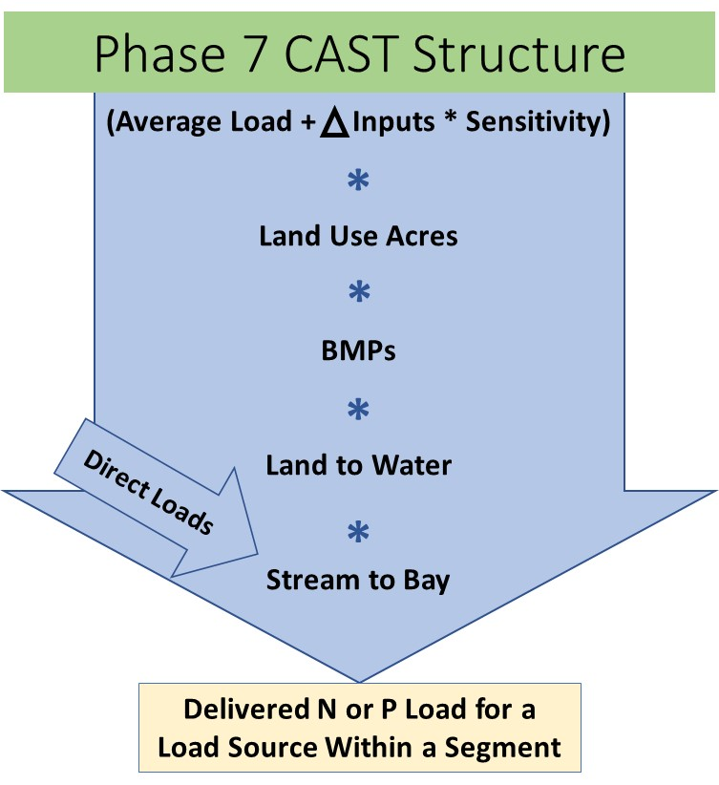
Inputs are the factors that can change through scenarios that affect nutrient export from a land use. These can include applications to the landscape of nutrients from atmospheric deposition, fertilizer, manure, and biosolids. Other examples are stormwater runoff, sediment washoff, and the storage of phosphorus in the soil. Delta inputs are the difference between the inputs to the land use in the local area and the Chesapeake Bay-wide average input.
Sensitivities are the Chesapeake Bay-wide average change in export load to a small stream for each unit change in input load.
The top line in Figure 1-4 (average loads, inputs, and sensitivities) therefore represents the loads exported from a land use to a stream in a land segment considering local applications but not local watershed conditions. For sediment the entire top line is represented by a spatial application of RUSLE, described in section 5. Nutrient and sediment loads are then multiplied by the area of the land use in the segment (Land Use Acres) and the effect of local BMPs.
Figure 1-4: Phase 7 CAST structure
Land to Water factors are then applied to account for spatial differences in loads due to physical watershed characteristics. Land to Water factors for nutrients are centered around do not add to or subtract substantially from the total edge-of-stream loads over the entire Chesapeake Bay watershed, but instead represent the spatial variance of nutrient transport. Land to Water factors for sediment are conceptualized as sediment delivery ratios and are constrained to be between zero and one.
The application of all the above factors (average loads, inputs, sensitivities, land use acres, BMP effects, and land-to-water factors) results in an estimate of loads delivered to a stream or waterbody.
Direct Loads are loads that do not come from the land surface or subsurface. Point sources, stream bank erosion, and direct deposition of livestock manure in streams are examples of loads in this category. Depending upon their location, direct loads may enter the conceptual model either before or after application of Stream to Bay Factors.
Finally, Stream to Bay factors are applied to account for nutrient and sediment processes in streams and rivers. These are attenuation factors that act to decrease nutrient delivery.
Each process depicted in Figure 1-4 is represented by a simple, often spatially variable coefficient which is determined by CBP workgroups using publicly available information. Many are strongly influenced or determined by CalCAST. The factors are available for download on the CAST site (http://cast.chesapeakebay.net). Sections 4 through 12 of this documentation deal with the determination of the coefficients.

Note on the Time-Averaged Structure for Sediment
The time-averaged structure for sediment is similar to that of nutrients with some significant differences. The top line of Figure 1-4 represents edge-of-stream loads for nutrients, but edge-of-field loads for sediment. The top line of Figure 1-4 for sediment does not include inputs and sensitivities, but rather is represented by a spatial application of RUSLE as described in Section 5. Land-to-water factors for nutrients are defined as having a weighted average near one but can be thought of as delivery ratios for sediment, translating edge-of-field to edge-of-stream.
A differentiation between time-averaged modeling and steady-state modeling must also be specified here. A steady-state sediment model might be an attempt to simulate an equilibrium state of a channel or upland sediment process. In contrast, the time-averaged Phase 6 Model is meant to represent the hydrologic average of current or future watershed conditions. For example, in developed areas there is a higher sediment export related to the amount of impervious. This higher export is not considered to be an equilibrium state of the channel, but rather the non-equilibrium load from the stream bed and bank that would be expected over a typical 10-year hydrologic period.

CalCAST
CalCAST, the statistical version of CAST, is used to calibrate parameters for use in CAST. It delivers on the model purposes of calibration and scientific study as outlined in sections 1.3.3 and 1.3.4. The general structure in Figure 1-4 is implemented in a Bayesian framework to calibrate the parameters against water quality observations. The structure of CalCAST is easily altered so that alternatives can be tested within a few hours or days. The CalCAST structure is fully documented in section 12.
Bayesian estimation combines prior knowledge with statistical analysis to arrive at parameters that are informed by both. For example, there is a wealth of prior knowledge in the literature about the relative sensitivities of edge or stream loads to fertilizer and manure applications. A probability distribution can be constructed from this prior knowledge. The Bayesian estimation method incorporates the prior distribution and the knowledge obtained from water quality data to arrive at a robust estimate of a parameter’s likely value, known as a posterior distribution. Information may enter CalCAST either as known values or as parameters to be estimated given prior distributions. Sections 4 through 11 of the documentation contain descriptions of the work to obtain both types of inputs.

DM-CAST
DM-CAST, the dynamic version of CAST, is used to temporally disaggregate the average annual results of CAST and the annual or average annual results of CalCAST into hourly intervals and to investigate watershed processes. DM-CAST fulfills the estuarine loading, calibration, scientific study purposes of the Watershed Model as outlined in sections 1.3.2, 1.3.3, and 1.3.4. DM-CAST landscape hydrology and sediment washoff is built on Hydrologic Simulation Program—Fortran (HSPF, Bicknell, et al., 1997). Nutrient landscape processes are simulated through a procedure known as Unit Nutrient Export Curves (UNEC) developed for the Phase 6 CBP Watershed Model. Riverine processes are simulated through HSPF and simpler formulations. DM-CAST is fully documented in section 13.

Role of Multiple Models
The Phase 7 structure accommodates the scientific community’s recommendations for multiple models and multiple lines of evidence using methods begun in Phase 6 and further developed for Phase 7. Prior parameter distributions are developed for CalCAST using empirical and process-modeling results found in the literature. CAST parameters, such as nutrient inputs, that are not estimated through CalCAST are determined through multiple lines of evidence whenever possible. Table 1-2 shows some of the models that are used in the calculation of the coefficients for Phase 7.
Table 1-2: Models incorporated in the Phase 7 Watershed Model
Model | Use in Phase 7 Model Priors
CBP Phase 5.3.2 Watershed Model | Average loads  Nitrogen sensitivity
USGS SPARROW regression model | Average loads  Nitrogen sensitivity  Land-to-water  Stream delivery
USDA CEAP/APEX Chesapeake model | Average loads  Nitrogen sensitivity
APLE | Phosphorus sensitivity
RUSLE | Sediment edge-of-field loads
rSAS | Lag time
UNEC | Lag time
Modflow | Lag Time

Note that the structure of Phase 7 shown in Figure 1-2 is a set of sequential models, which necessitates more than one model be used. This sequential positioning of models is not what is meant by the term multiple models, but rather the term refers to more than one model being used for a given parameter. Both sequential models and true multiple parallel models are used in the construction of the Phase 7 model.

Comparison of Model Structure to Previous CBWM Phases
In previous phases of the Watershed Model through phase 5, the dynamic model was used as both the accounting model for management scenarios and the loading model for the estuarine model. The CBWM was fed by various databases, most notably the Phase 5 innovation scenario builder, which was used to estimate manure and fertilizer applications and to spatially distribute BMPs, among other functions. CAST and its location-specific versions MAST and VAST, described in Kaufman et al., 2021, were introduced in Phase 5 as an emulator tool that would approximate both Scenario Builder and the average output of the dynamic CBWM.
For Phase 6, the term CAST was applied to a new time-averaged watershed model that encompassed all the functions previously performed in scenario builder plus the coefficient-based simulation of the physical watershed transport. The Phase 6 Dynamic Model supplied some of the coefficients to CAST including storm runoff and River to Bay factors. As in the Phase 7 DM-CAST, the Phase 6 Dynamic Model temporally disaggregated loads from CAST for the estuarine model. Phase 6 had no CalCAST analog. CAST parameters were estimated using the central tendency from multiple lines of evidence. As in Phase 7, the web interface for stakeholders and the public was also known as CAST, available at http://cast.chesapeakebay.net. CBPO staff have a separate interface with more functionality that requires more expertise to run.

Documentation
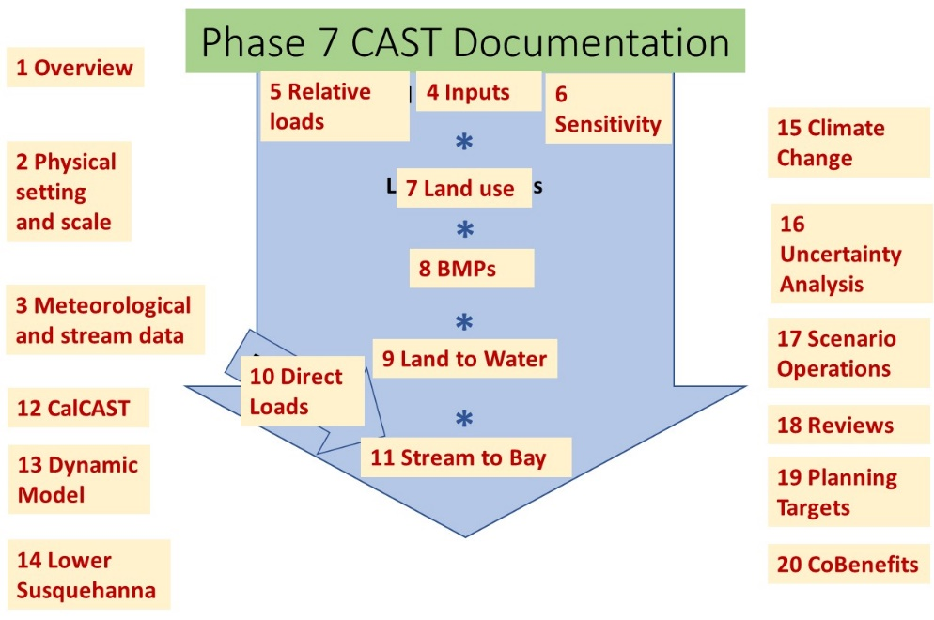
The structure of the documentation is shown in Figure 1-8. The first three sections contain overview and general information about physical data. Sections 4 through 11 follow the structure of the model and document the development of information used as direct input to CAST or as priors for CalCAST. Sections 12 and 13 cover CalCAST and DM-CAST, respectively. Sections 14 through 16 document the special applications of the Lower Susquehanna reservoirs, climate change, and uncertainty analysis. The details of scenarios operations are in section 17. Section 18 contains Phase 7 reviews by the partnership. Section 19 documents the partnership decisions that go into the TMDL planning targets. Co-benefits, which are outputs other than nutrients and sediment, are summarized in Section 20.
Figure 1-8: CAST documentation
The structure of the documentation facilitates finding the work behind each coefficient in the time-averaged model. The documentation also reflects the various responsibilities of groups within the CBP structure. Table 1-3 shows the CBP groups with responsibility for each section of the Phase 6 Model.
Table 1-3: Responsibility for Documentation and Decisions
Documentation Section | Workgroup with Primary Responsibility | Workgroup with Secondary Responsibility
Section 1: Overview | Modeling WG | WQGIT
Section 2: Physical setting | Modeling WG
Section 3: Meteorological and Stream Data | Modeling WG | WQGIT
Section 4: Inputs | Water Quality GIT or Modeling WG, depending on type of input | Agriculture Modeling Team, Agriculture WG, Urban Stormwater WG, Forestry WG, Modeling WG
Section 5: Average Loads | Modeling WG | Agriculture WG, Urban Stormwater WG, Forestry WG
Section 6: Sensitivity | Modeling WG | Agriculture WG
Section 7: Land use | Land Use Workgroup | Agriculture Modeling Team, USWG, AgWG, WQGIT
Section 8: BMPs | Water Quality GIT | Agriculture WG, Urban Stormwater WG, Forestry WG, Modeling WG
Section 9: Land to Water | Modeling WG
Section 10: Direct Loads | Wastewater Treatment WG | Agriculture WG, Modeling WG
Section 11: Stream to Bay | Modeling WG
Section 12: CalCAST | Modeling WG
Section 13: DM-CAST | Modeling WG
Section 14: Lower Susquehanna | Modeling WG
Section 15: Climate Change | Modeling WG
Section 16: Uncertainty Analysis | Modeling WG
Section 17: Scenario Operations | Water Quality GIT
Section 18: Reviews | Water Quality GIT, Modeling WG
Section 19: Planning Targets | Principals’ Staff Committee | Management Board, Water Quality GIT
Section 20: Co-Benefits | All six GITs

Development and Release Schedule
The development of the Phase 7 model follows from the partnership policy schedule. The CBP partnership is expected to make new decisions relevant to the TMDL in 2027 and will need the year of 2026 to review the completed models, making late 2025 the date for model completion.
2022 – The software components of CalCAST and the Dynamic Model will be built in 2022 such that they are running and produce results that are reasonable, although far from fully calibrated. The Dynamic Model will be used to produce output at the NHD scale to load the estuarine models under development. GIS layers will be finalized. Systems for annually updating meteorology, precipitation, and stream flow and water quality data will be completed.
2023-2025 – the draft models will be incrementally advanced through data and structural improvements. The goals for the end of 2025 are for CalCAST and the Dynamic Model to be run and well-calibrated at the NHD scale for flow, sediment, and nutrients. CAST will be running on scale of WQGIT’s choosing. Output quality will be an improvement on the Phase 6 model for the main purposes of spatial apportionment of loads by land use and region, change in loads over time due to management actions and climate change, and accuracy of spatial and temporal loads to the estuary in calibration period. The detailed schedule is kept under the topics CAST, Agricultural Inputs, Watershed Modeling, and High Resolution Land Use on the Phase 7 development web page https://www.chesapeakebay.net/what/programs/modeling/phase-7-model-development

The Phase 3 watershed model was a development-only version to add additional detail to the crop and forest simulation.

