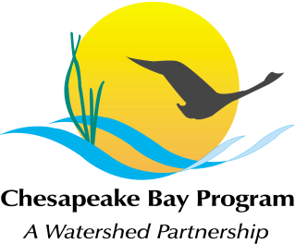
Urban Stormwater Workgroup Meeting

Tuesday, April 18, 2023

Workgroup: 10:00 AM - 11:00 AM

UNM Task Force: 11:00 AM - 12:00 PM

Zoom Link: https://umces-edu.zoom.us/j/81756689495

Meeting ID: 817 5668 9495

Passcode: 12345
Phone: 1 301 715 8592

10:00 Welcome and Review of February Meeting Minutes.
Norm Goulet, Chair. Attach A.

10:05 Announcements and Updates
- BUBBAs Winners and Grand Prize Voting
- Some Stormwater Retreat Highlights
- Highlights from STAC Workshops
- Others

10:15 Coagulant Enhanced Stormwater Pond Performance. Scott Smith (Hampton, VA). Attach B & C.

Coagulant treatment involves adding a common flocculent to stormwater/surface water which forms precipitates which trap total phosphorus (TP), total nitrogen (TN), bacteria, total suspended solids (TSS), and other pollutants. Scott will present findings from past research on these systems and share a proposal for a BMP interpretation request.

The USWG will have time to review the presentation and white paper. A decision on whether to consider the request will be made at the next workgroup meeting.

11:00 The full USWG will adjourn.

11:05 UNM Task Force Meeting

Members of the UNM Task Force will convene to hear updates from CBPO staff on the status of efforts to develop a method to smooth non-farm fertilizer data and to incorporate new, state datasets.

12:00 Adjourn

