Narrative Analysis

[insert outcome name and date of quarterly progress meeting]

ABSTRACT: [Provide a concise paragraph summary, beginning with the outcome status (e.g., on track, off track, ahead of schedule), your key findings, successes and challenges that are described in more detail below.]

otes
Note: The narrative analysis summarizes the findings of the logic and action plan and serves as the bridge between the pre-quarterly logic and action plan and the quarterly progress meeting presentation. After the quarterly progress meeting, your responses to these questions will guide your updates to your logic and action plan. Additional guidance can be found on ChesapeakeDecisions.

Are we, as a partnership, making progress at a rate that is necessary to achieve this outcome? Would you define our outlook as on course, off course, uncertain, or completed? Upon what basis are you forecasting this outlook?
How would you summarize your recent progress toward achieving your outcome (since your last QPM)? If you don’t have an indicator, would you characterize this progress as an increase, decrease, no change, or completed? If you have an indicator and it was updated since your last QPM, use your answer to question 16 from your Analysis and Methods document.

Explain any gap(s) between our actual progress and our outcome.

Use a graph or chart to illustrate where feasible (replace example provided with your own illustration).

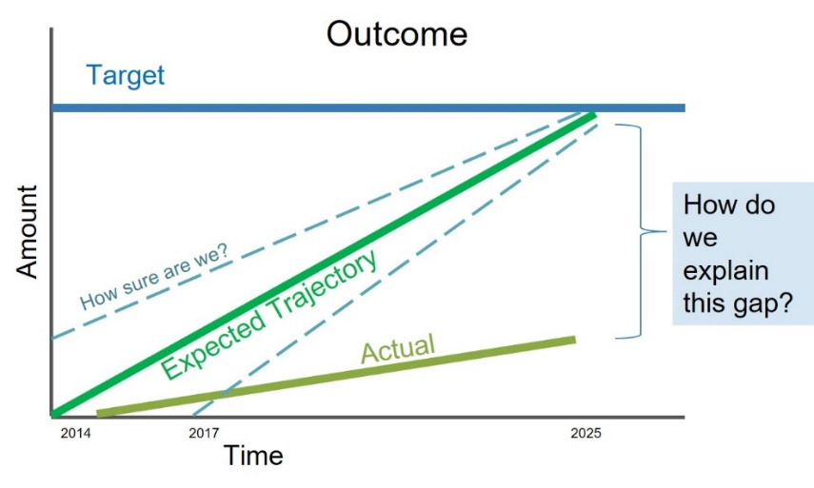

NOTE: Your responses related to outlook and recent progress will be used to update your outcome page on ChesapeakeProgress and the outcome status page.

- Looking back over the last two or more years, describe any scientific (including the impacts of climate change), fiscal, and policy-related developments that impacted your progress or may influence your work over the next two years. Have these resulted in revised needs (e.g., less, more) to achieve the outcome?

To the extent feasible, describe your needs using the SPURR thought model, i.e., Specific and actionable, Programmatic partner, Urgency of the needed action, Risk of not acting, Resources required.

Based on the red/yellow/green analysis of the actions described in your logic and action plan, summarize what you have learned over the past two years of implementation.

Summarize overall (not per action) what you have learned about what worked and what didn’t work. For example, have you identified additional factors to consider or filled an information gap?

Based on what you have learned through this process and any new developments or considerations described in response to question #2, how will your work change over the next two years? If we need to accelerate progress towards achieving our outcome, what steps are needed and, in particular, what specific actions or needs are beyond the ability of your group to meet and, therefore, you need the assistance of the Management Board to achieve?

Describe any adaptations that may be necessary to achieve your outcome more efficiently and explain how these changes might lead you to adjust your Management Strategy (if significant) or the actions described in column four of your Logic & Action Plan. What new science, fiscal, and policy-related information, could be recommended or pursued over the next two years to maintain or, if needed, accelerate progress? Use the SPURR model described in question #2, to provide detail to the needed steps and actions.

What steps are you taking, or do you recommend, to ensure your actions and work will be equitably distributed and focused in geographic areas and communities that have been underserved in the past?

