Summary of step trend results for all Core Trend Stations

Mon Aug 04 10:21:36 2014

Lab Change occurred 07/01/2005

dependents analyzed are:

TSS TN NH4 NO23 NO2 TP PO4

Stations analyzed are:

ANA0082 ANT0044 ANT0203 ANT0366 BDK0000 BPC0035 CAC0031 CAC0148 CAS0479 CCR0001 CHO0626 CJB0005 CON0005 CON0180 DER0015 GEO0009 GUN0125 GUN0258 GUN0476 GWN0115 JON0184 LYO0004 MON0020 MON0155 MON0269 MON0528 NBP0023 NBP0103 NBP0326 NBP0461 NBP0534 NBP0689 NPA0165 PAT0176 PAT0285 POT1184 POT1471 POT1472 POT1595 POT1596 POT1830 POT2386 POT2766 PXT0809 PXT0972 RCM0111 SAV0000 SEN0008 SUS0109 TOW0030 WIL0013 YOU0925 YOU1139

This analysis implements an intervention model for each dependent variable at each station. In addition to the intervention term, terms for season effect, linear trend and non-linear trend are included in the model. In the figure, the open circles represent the observed data, the red line are predictions from the full model, the blue line represents the nonlinear trend holding season constant, and the green line represents linear trend holding season and non-linear trend constant

The verticle blue line shows the date of the lab change. Following each figure are an ANOVA table and table of fixed coefficients that report the significance and direction of the step and linear trends.

station = ANA0082 dependent = lnTSS

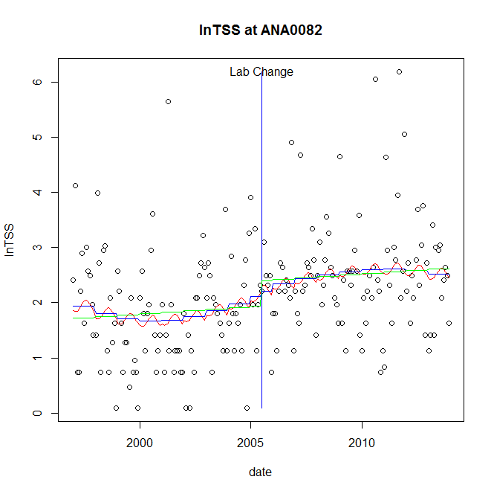

GAM analysis for station ANA0082 dependent variable lnTSS

|  |  |  |  |  |
| --- | --- | --- | --- | --- |
| **Type** | **Source** | **edf** | **F-stat** | **p-value** |
| parametric terms | Step | 1 | 0.0746 | 0.7850 |
|  | Year | 1 | 115.8792 | <0.0001 |
| smoothed terms | s(year) | 3.33 | 0.9815 | 0.4191 |
|  | s(doy) | 1.17 | 0.2792 | 0.1323 |

GAM analysis for station ANA0082 dependent variable lnTSS

|  |  |  |  |  |
| --- | --- | --- | --- | --- |
| **Parameter** | **estimate** | **Std. Err.** | **t value** | **p-value** |
| (Intercept) | 0.001245 | 0.001051 | 1.1848 | 0.2375 |
| Step | 0.099826 | 0.365421 | 0.2732 | 0.7850 |
| Year | 0.001048 | 9.7e-05 | 10.7647 | <0.0001 |

root mean-square error = 0.9864

adjusted r-square = 0.1252

station = ANA0082 dependent = lnTN

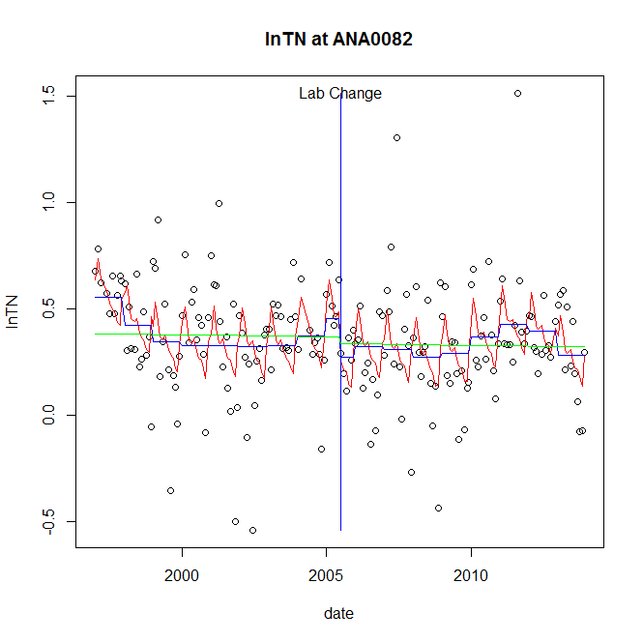

GAM analysis for station ANA0082 dependent variable lnTN

|  |  |  |  |  |
| --- | --- | --- | --- | --- |
| **Type** | **Source** | **edf** | **F-stat** | **p-value** |
| parametric terms | Step | 1 | 2.1598 | 0.1434 |
|  | Year | 1 | 46.3352 | <0.0001 |
| smoothed terms | s(year) | 6.21 | 2.0427 | 0.0540 |
|  | s(doy) | 5.6 | 3.7891 | <0.0001 |

GAM analysis for station ANA0082 dependent variable lnTN

|  |  |  |  |  |
| --- | --- | --- | --- | --- |
| **Parameter** | **estimate** | **Std. Err.** | **t value** | **p-value** |
| (Intercept) | 0.001599 | 0.000544 | 2.9367 | 0.0037 |
| step | -0.180498 | 0.122819 | -1.4696 | 0.1434 |
| year | 0.000221 | 3.3e-05 | 6.807 | <0.0001 |

root mean-square error = 0.2416

adjusted r-square = 0.1841

station = ANA0082 dependent = lnNH4

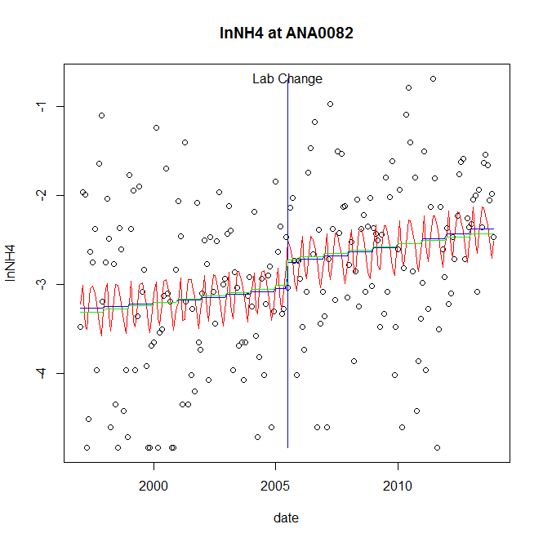

GAM analysis for station ANA0082 dependent variable lnNH4

|  |  |  |  |  |
| --- | --- | --- | --- | --- |
| **Type** | **Source** | **edf** | **F-stat** | **p-value** |
| parametric terms | step | 1 | 1.3267 | 0.2508 |
|  | year | 1 | 464.8466 | <0.0001 |
| smoothed terms | s(year) | 1.39 | 1.1734 | 0.2912 |
|  | s(doy) | 5.53 | 1.5876 | 0.0293 |

GAM analysis for station ANA0082 dependent variable lnNH4

|  |  |  |  |  |
| --- | --- | --- | --- | --- |
| **parameter** | **estimate** | **Std. Err.** | **t value** | **p-value** |
| (Intercept) | -0.000469 | 0.000345 | -1.3616 | 0.1749 |
| step | 0.28792 | 0.249965 | 1.1518 | 0.2508 |
| year | -0.001506 | 7e-05 | -21.5603 | <0.0001 |

root mean-square error = 0.8745

adjusted r-square = 0.1473

station = ANA0082 dependent = lnNO23

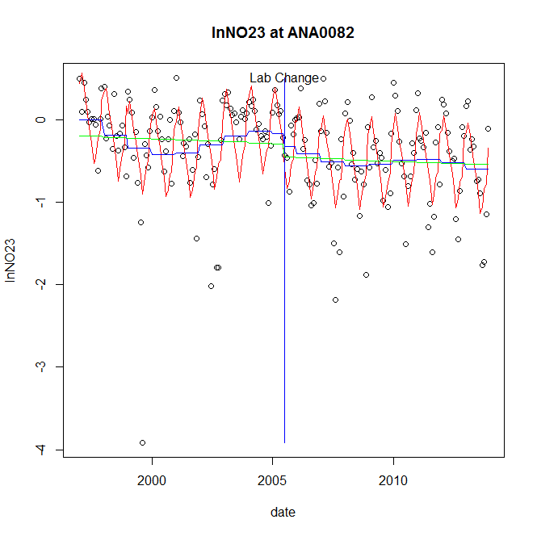

GAM analysis for station ANA0082 dependent variable lnNO23

|  |  |  |  |  |
| --- | --- | --- | --- | --- |
| **Type** | **Source** | **edf** | **F-stat** | **p-value** |
| parametric terms | step | 1 | 0.5151 | 0.4738 |
|  | year | 1 | 6.7626 | 0.0100 |
| smoothed terms | s(year) | 5.22 | 2.3122 | 0.0344 |
|  | s(doy) | 6.56 | 15.2478 | <0.0001 |

GAM analysis for station ANA0082 dependent variable lnNO23

|  |  |  |  |  |
| --- | --- | --- | --- | --- |
| **parameter** | **estimate** | **Std. Err.** | **t value** | **p-value** |
| (Intercept) | 0.001692 | 0.000811 | 2.0861 | 0.0383 |
| step | -0.148579 | 0.207027 | -0.7177 | 0.4738 |
| year | -0.00014 | 5.4e-05 | -2.6005 | 0.0100 |

root mean-square error = 0.4491

adjusted r-square = 0.427

station = ANA0082 dependent = lnNO2

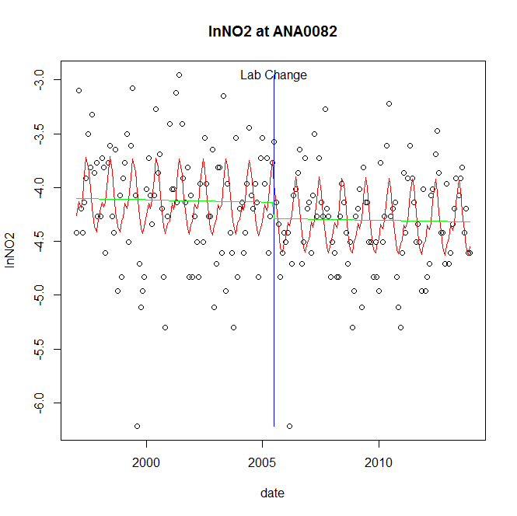

GAM analysis for station ANA0082 dependent variable lnNO2

|  |  |  |  |  |
| --- | --- | --- | --- | --- |
| **Type** | **Source** | **edf** | **F-stat** | **p-value** |
| parametric terms | step | 1 | 1.2823 | 0.2589 |
|  | year | 1 | 3173.2462 | <0.0001 |
| smoothed terms | s(year) | 1 | 0.0226 | 0.8807 |
|  | s(doy) | 4.93 | 5.6275 | <0.0001 |

GAM analysis for station ANA0082 dependent variable lnNO2

|  |  |  |  |  |
| --- | --- | --- | --- | --- |
| **parameter** | **estimate** | **Std. Err.** | **t value** | **p-value** |
| (Intercept) | 2.3e-05 | 0.00016 | 0.1438 | 0.8858 |
| step | -0.149183 | 0.131743 | -1.1324 | 0.2589 |
| year | -0.002072 | 3.7e-05 | -56.3316 | <0.0001 |

root mean-square error = 0.4701

adjusted r-square = 0.1976

station = ANA0082 dependent = lnTP

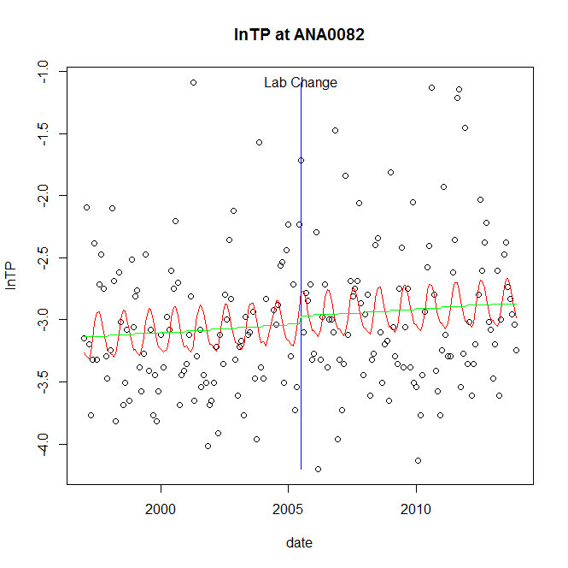

GAM analysis for station ANA0082 dependent variable lnTP

|  |  |  |  |  |
| --- | --- | --- | --- | --- |
| **Type** | **Source** | **edf** | **F-stat** | **p-value** |
| parametric terms | step | 1 | 0.1474 | 0.7015 |
|  | year | 1 | 1115.6397 | <0.0001 |
| smoothed terms | s(year) | 1 | 0.7783 | 0.3788 |
|  | s(doy) | 2.6 | 1.7551 | 0.0007 |

GAM analysis for station ANA0082 dependent variable lnTP

|  |  |  |  |  |
| --- | --- | --- | --- | --- |
| **parameter** | **estimate** | **Std. Err.** | **t value** | **p-value** |
| (Intercept) | -0.000174 | 0.000197 | -0.8861 | 0.3767 |
| step | 0.061523 | 0.16025 | 0.3839 | 0.7015 |
| year | -0.001516 | 4.5e-05 | -33.4012 | <0.0001 |

root mean-square error = 0.562

adjusted r-square = 0.0796

station = ANA0082 dependent = lnPO4

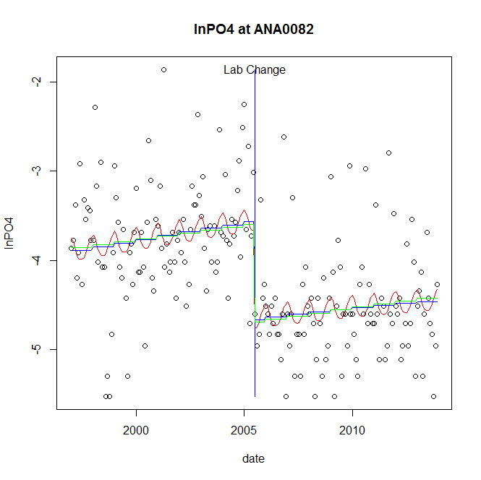

GAM analysis for station ANA0082 dependent variable lnPO4

|  |  |  |  |  |
| --- | --- | --- | --- | --- |
| **Type** | **Source** | **edf** | **F-stat** | **p-value** |
| parametric terms | step | 1 | 38.889 | <0.0001 |
|  | year | 1 | 1330.2882 | <0.0001 |
| smoothed terms | s(year) | 1.42 | 3.0411 | 0.0578 |
|  | s(doy) | 1.91 | 0.7583 | 0.0256 |

GAM analysis for station ANA0082 dependent variable lnPO4

|  |  |  |  |  |
| --- | --- | --- | --- | --- |
| **parameter** | **estimate** | **Std. Err.** | **t value** | **p-value** |
| (Intercept) | -0.000387 | 0.000246 | -1.5727 | 0.1174 |
| step | -1.097872 | 0.176051 | -6.2361 | <0.0001 |
| year | -0.001787 | 4.9e-05 | -36.4731 | <0.0001 |

root mean-square error = 0.6174

adjusted r-square = 0.3229

step significant

No title given

|  |  |  |  |
| --- | --- | --- | --- |
| **station** | **dep** | **step.est** | **step.pv** |
| ANA0082 | lnTSS | 0.099826 | 0.7850 |
| ANA0082 | lnTN | -0.180498 | 0.1434 |
| ANA0082 | lnNH4 | 0.28792 | 0.2508 |
| ANA0082 | lnNO23 | -0.148579 | 0.4738 |
| ANA0082 | lnNO2 | -0.149183 | 0.2589 |
| ANA0082 | lnTP | 0.061523 | 0.7015 |
| ANA0082 | lnPO4 | -1.097872 | <0.0001 |

station = ANT0044 dependent = lnTSS

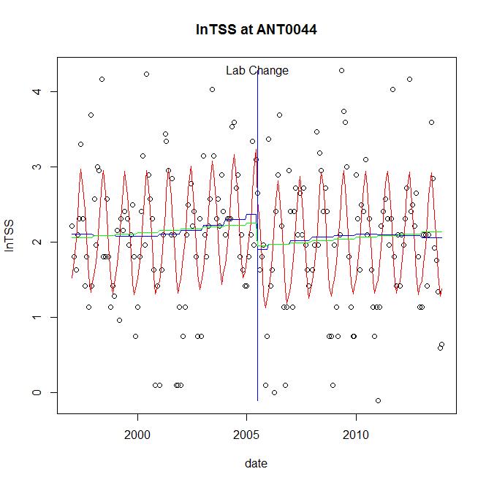

GAM analysis for station ANT0044 dependent variable lnTSS

|  |  |  |  |  |
| --- | --- | --- | --- | --- |
| **Type** | **Source** | **edf** | **F-stat** | **p-value** |
| parametric terms | step | 1 | 3.529 | 0.0618 |
|  | year | 1 | 296.4668 | <0.0001 |
| smoothed terms | s(year) | 2.75 | 0.8348 | 0.4842 |
|  | s(doy) | 4.59 | 14.7119 | <0.0001 |

GAM analysis for station ANT0044 dependent variable lnTSS

|  |  |  |  |  |
| --- | --- | --- | --- | --- |
| **parameter** | **estimate** | **Std. Err.** | **t value** | **p-value** |
| (Intercept) | 0.000253 | 0.000607 | 0.4175 | 0.6768 |
| step | -0.46099 | 0.245393 | -1.8786 | 0.0618 |
| year | 0.001139 | 6.6e-05 | 17.2182 | <0.0001 |

root mean-square error = 0.7159

adjusted r-square = 0.376

station = ANT0044 dependent = lnTN

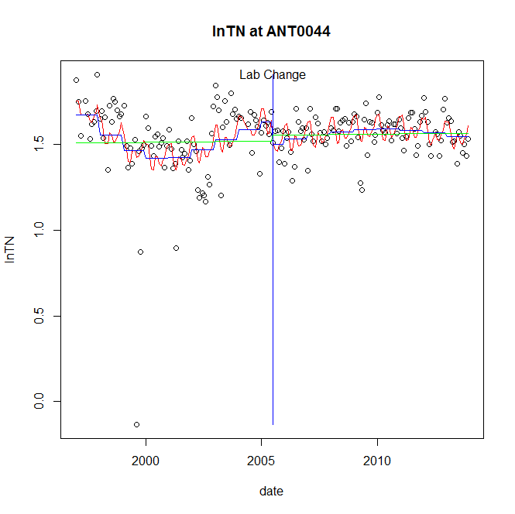

GAM analysis for station ANT0044 dependent variable lnTN

|  |  |  |  |  |
| --- | --- | --- | --- | --- |
| **Type** | **Source** | **edf** | **F-stat** | **p-value** |
| parametric terms | step | 1 | 2.7824 | 0.0970 |
|  | year | 1 | 1515.4921 | <0.0001 |
| smoothed terms | s(year) | 4.77 | 5.0098 | 0.0001 |
|  | s(doy) | 5.08 | 2.415 | 0.0011 |

GAM analysis for station ANT0044 dependent variable lnTN

|  |  |  |  |  |
| --- | --- | --- | --- | --- |
| **parameter** | **estimate** | **Std. Err.** | **t value** | **p-value** |
| (Intercept) | 0.000848 | 0.000287 | 2.9511 | 0.0036 |
| step | -0.12873 | 0.077174 | -1.668 | 0.0970 |
| year | 0.000805 | 2.1e-05 | 38.9293 | <0.0001 |

root mean-square error = 0.1722

adjusted r-square = 0.2078

station = ANT0044 dependent = lnNH4

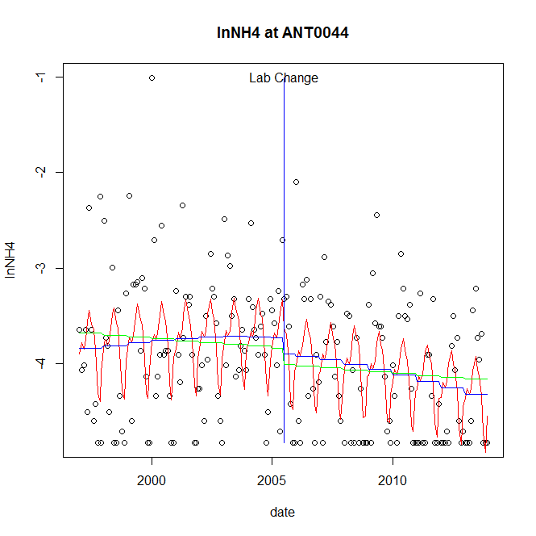

GAM analysis for station ANT0044 dependent variable lnNH4

|  |  |  |  |  |
| --- | --- | --- | --- | --- |
| **Type** | **Source** | **edf** | **F-stat** | **p-value** |
| parametric terms | step | 1 | 0.701 | 0.4035 |
|  | year | 1 | 1259.0246 | <0.0001 |
| smoothed terms | s(year) | 1.98 | 2.3674 | 0.0848 |
|  | s(doy) | 5.64 | 5.3091 | <0.0001 |

GAM analysis for station ANT0044 dependent variable lnNH4

|  |  |  |  |  |
| --- | --- | --- | --- | --- |
| **parameter** | **estimate** | **Std. Err.** | **t value** | **p-value** |
| (Intercept) | 0.000194 | 0.000356 | 0.544 | 0.5871 |
| step | -0.165014 | 0.19709 | -0.8373 | 0.4035 |
| year | -0.001925 | 5.4e-05 | -35.4827 | <0.0001 |

root mean-square error = 0.6504

adjusted r-square = 0.2276

station = ANT0044 dependent = lnNO23

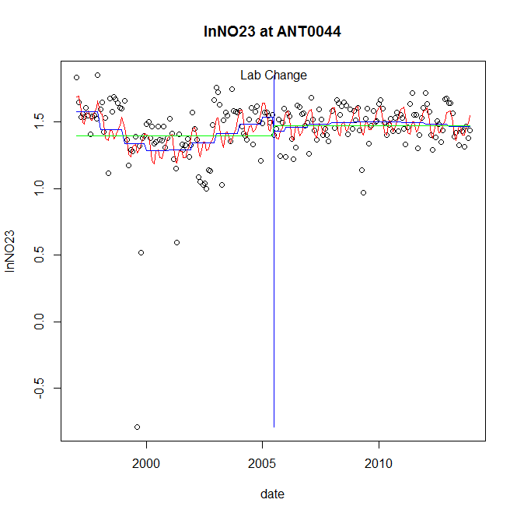

GAM analysis for station ANT0044 dependent variable lnNO23

|  |  |  |  |  |
| --- | --- | --- | --- | --- |
| **Type** | **Source** | **edf** | **F-stat** | **p-value** |
| parametric terms | step | 1 | 1.2027 | 0.2742 |
|  | year | 1 | 915.4595 | <0.0001 |
| smoothed terms | s(year) | 4.72 | 4.6287 | 0.0003 |
|  | s(doy) | 5.35 | 2.9425 | 0.0002 |

GAM analysis for station ANT0044 dependent variable lnNO23

|  |  |  |  |  |
| --- | --- | --- | --- | --- |
| **parameter** | **estimate** | **Std. Err.** | **t value** | **p-value** |
| (Intercept) | 0.000962 | 0.000348 | 2.7642 | 0.0063 |
| step | -0.103626 | 0.094492 | -1.0967 | 0.2742 |
| year | 0.000749 | 2.5e-05 | 30.2566 | <0.0001 |

root mean-square error = 0.2153

adjusted r-square = 0.2095

station = ANT0044 dependent = lnNO2

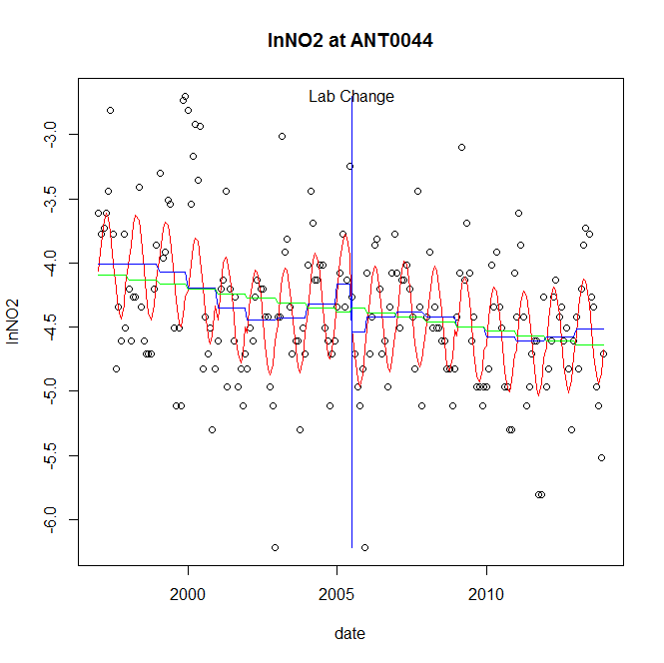

GAM analysis for station ANT0044 dependent variable lnNO2

|  |  |  |  |  |
| --- | --- | --- | --- | --- |
| **Type** | **Source** | **edf** | **F-stat** | **p-value** |
| parametric terms | step | 1 | 2.8068 | 0.0955 |
|  | year | 1 | 1333.7068 | <0.0001 |
| smoothed terms | s(year) | 5.27 | 2.712 | 0.0143 |
|  | s(doy) | 2.95 | 9.9162 | <0.0001 |

GAM analysis for station ANT0044 dependent variable lnNO2

|  |  |  |  |  |
| --- | --- | --- | --- | --- |
| **parameter** | **estimate** | **Std. Err.** | **t value** | **p-value** |
| (Intercept) | -0.000473 | 0.000874 | -0.5413 | 0.5889 |
| step | -0.367788 | 0.219528 | -1.6754 | 0.0955 |
| year | -0.002089 | 5.7e-05 | -36.52 | <0.0001 |

root mean-square error = 0.4751

adjusted r-square = 0.3788

station = ANT0044 dependent = lnTP

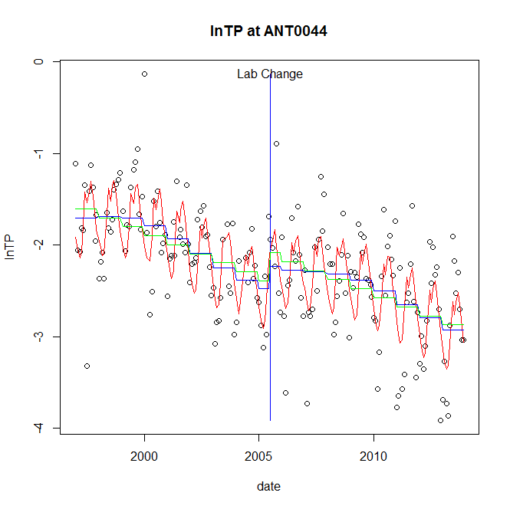

GAM analysis for station ANT0044 dependent variable lnTP

|  |  |  |  |  |
| --- | --- | --- | --- | --- |
| **Type** | **Source** | **edf** | **F-stat** | **p-value** |
| parametric terms | step | 1 | 1.6754 | 0.1972 |
|  | year | 1 | 541.864 | <0.0001 |
| smoothed terms | s(year) | 4.51 | 12.4428 | <0.0001 |
|  | s(doy) | 6.51 | 10.4833 | <0.0001 |

GAM analysis for station ANT0044 dependent variable lnTP

|  |  |  |  |  |
| --- | --- | --- | --- | --- |
| **parameter** | **estimate** | **Std. Err.** | **t value** | **p-value** |
| (Intercept) | 0.000611 | 0.000682 | 0.8959 | 0.3715 |
| step | 0.245493 | 0.189662 | 1.2944 | 0.1972 |
| year | -0.001184 | 5.1e-05 | -23.278 | <0.0001 |

root mean-square error = 0.4342

adjusted r-square = 0.5361

station = ANT0044 dependent = lnPO4

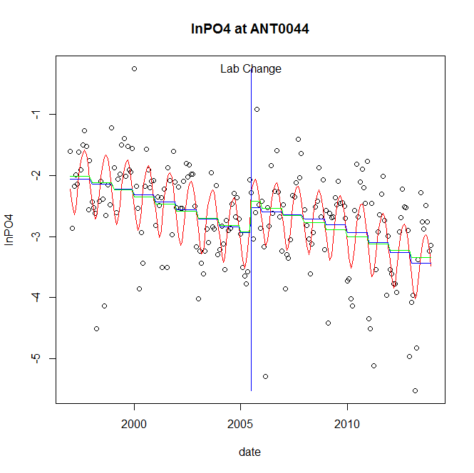

GAM analysis for station ANT0044 dependent variable lnPO4

|  |  |  |  |  |
| --- | --- | --- | --- | --- |
| **Type** | **Source** | **edf** | **F-stat** | **p-value** |
| parametric terms | step | 1 | 3.0036 | 0.0847 |
|  | year | 1 | 533.1297 | <0.0001 |
| smoothed terms | s(year) | 3.43 | 10.2322 | <0.0001 |
|  | s(doy) | 3.41 | 9.3152 | <0.0001 |

GAM analysis for station ANT0044 dependent variable lnPO4

|  |  |  |  |  |
| --- | --- | --- | --- | --- |
| **parameter** | **estimate** | **Std. Err.** | **t value** | **p-value** |
| (Intercept) | 0.001492 | 0.00069 | 2.1637 | 0.0317 |
| step | 0.406575 | 0.234597 | 1.7331 | 0.0847 |
| year | -0.001441 | 6.2e-05 | -23.0896 | <0.0001 |

root mean-square error = 0.6199

adjusted r-square = 0.431

No title given

|  |  |  |  |
| --- | --- | --- | --- |
| **station** | **dep** | **step.est** | **step.pv** |
| ANT0044 | lnTSS | -0.46099 | 0.0618 |
| ANT0044 | lnTN | -0.12873 | 0.0970 |
| ANT0044 | lnNH4 | -0.165014 | 0.4035 |
| ANT0044 | lnNO23 | -0.103626 | 0.2742 |
| ANT0044 | lnNO2 | -0.367788 | 0.0955 |
| ANT0044 | lnTP | 0.245493 | 0.1972 |
| ANT0044 | lnPO4 | 0.406575 | 0.0847 |

station = ANT0203 dependent = lnTSS

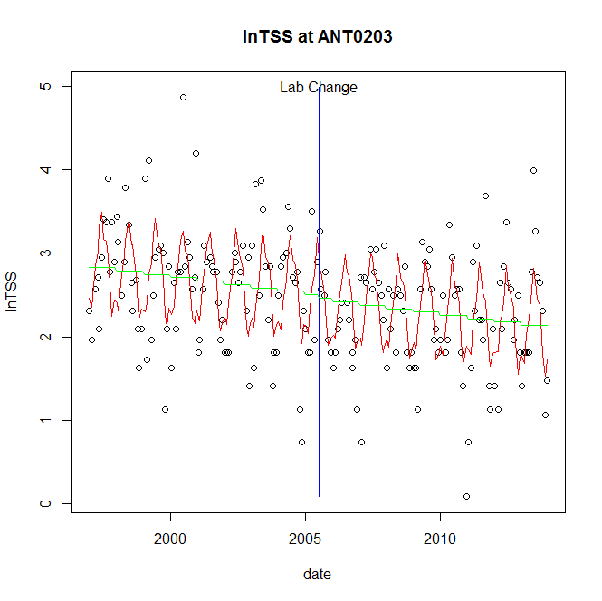

GAM analysis for station ANT0203 dependent variable lnTSS

|  |  |  |  |  |
| --- | --- | --- | --- | --- |
| **Type** | **Source** | **edf** | **F-stat** | **p-value** |
| parametric terms | step | 1 | 0.0752 | 0.7842 |
|  | year | 1 | 701.0024 | <0.0001 |
| smoothed terms | s(year) | 1 | 5.9996 | 0.0152 |
|  | s(doy) | 6.91 | 11.7201 | <0.0001 |

GAM analysis for station ANT0203 dependent variable lnTSS

|  |  |  |  |  |
| --- | --- | --- | --- | --- |
| **parameter** | **estimate** | **Std. Err.** | **t value** | **p-value** |
| (Intercept) | 0.000499 | 0.000203 | 2.4526 | 0.0151 |
| step | -0.045836 | 0.167146 | -0.2742 | 0.7842 |
| year | 0.001234 | 4.7e-05 | 26.4764 | <0.0001 |

root mean-square error = 0.5923

adjusted r-square = 0.36

station = ANT0203 dependent = lnTN

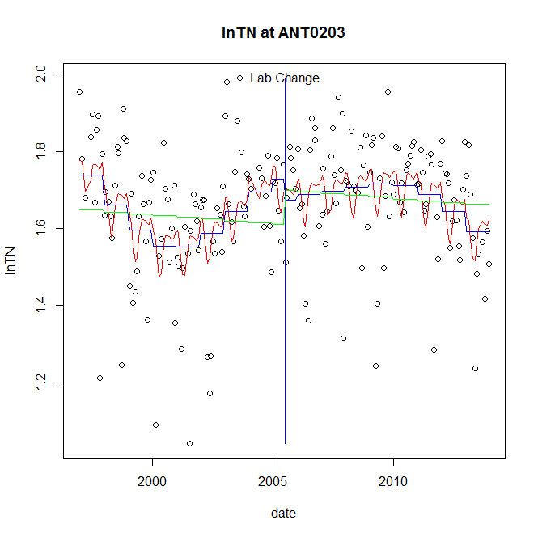

GAM analysis for station ANT0203 dependent variable lnTN

|  |  |  |  |  |
| --- | --- | --- | --- | --- |
| **Type** | **Source** | **edf** | **F-stat** | **p-value** |
| parametric terms | step | 1 | 0.6115 | 0.4352 |
|  | year | 1 | 2101.0376 | <0.0001 |
| smoothed terms | s(year) | 4.87 | 4.5858 | 0.0003 |
|  | s(doy) | 4.15 | 1.8902 | 0.0029 |

GAM analysis for station ANT0203 dependent variable lnTN

|  |  |  |  |  |
| --- | --- | --- | --- | --- |
| **parameter** | **estimate** | **Std. Err.** | **t value** | **p-value** |
| (Intercept) | 0.000804 | 0.00026 | 3.0883 | 0.0023 |
| step | -0.053894 | 0.068921 | -0.782 | 0.4352 |
| year | 0.000841 | 1.8e-05 | 45.8371 | <0.0001 |

root mean-square error = 0.1515

adjusted r-square = 0.1913

station = ANT0203 dependent = lnNH4

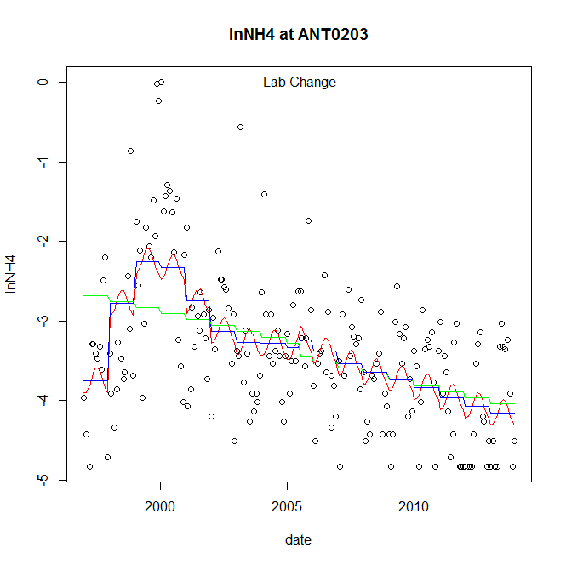

GAM analysis for station ANT0203 dependent variable lnNH4

|  |  |  |  |  |
| --- | --- | --- | --- | --- |
| **Type** | **Source** | **edf** | **F-stat** | **p-value** |
| parametric terms | step | 1 | 0.0697 | 0.7920 |
|  | year | 1 | 286.7075 | <0.0001 |
| smoothed terms | s(year) | 6.31 | 8.118 | <0.0001 |
|  | s(doy) | 1.71 | 0.8482 | 0.0107 |

GAM analysis for station ANT0203 dependent variable lnNH4

|  |  |  |  |  |
| --- | --- | --- | --- | --- |
| **parameter** | **estimate** | **Std. Err.** | **t value** | **p-value** |
| (Intercept) | -0.005869 | 0.001733 | -3.3859 | 0.0009 |
| step | 0.102769 | 0.389149 | 0.2641 | 0.7920 |
| year | -0.001704 | 0.000101 | -16.9324 | <0.0001 |

root mean-square error = 0.7696

adjusted r-square = 0.3557

station = ANT0203 dependent = lnNO23

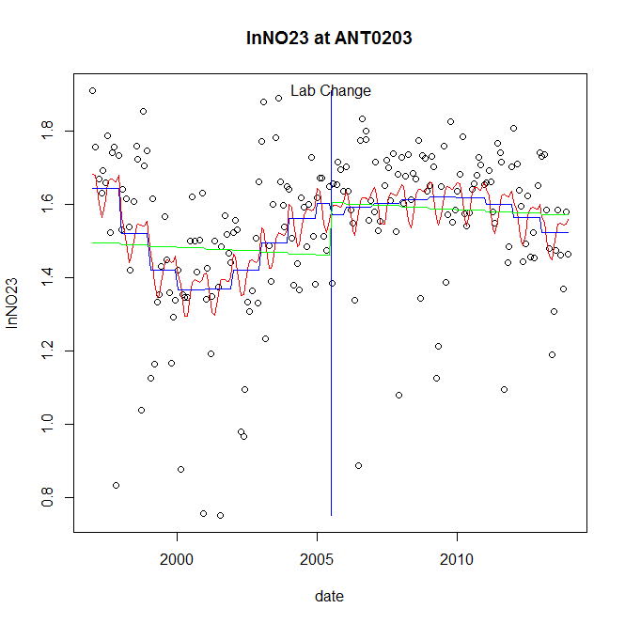

GAM analysis for station ANT0203 dependent variable lnNO23

|  |  |  |  |  |
| --- | --- | --- | --- | --- |
| **Type** | **Source** | **edf** | **F-stat** | **p-value** |
| parametric terms | step | 1 | 0.1273 | 0.7216 |
|  | year | 1 | 1236.9262 | <0.0001 |
| smoothed terms | s(year) | 4.91 | 5.5716 | <0.0001 |
|  | s(doy) | 3.52 | 1.3725 | 0.0113 |

GAM analysis for station ANT0203 dependent variable lnNO23

|  |  |  |  |  |
| --- | --- | --- | --- | --- |
| **parameter** | **estimate** | **Std. Err.** | **t value** | **p-value** |
| (Intercept) | 0.001029 | 0.000317 | 3.2433 | 0.0014 |
| step | -0.030074 | 0.084279 | -0.3568 | 0.7216 |
| year | 0.000774 | 2.2e-05 | 35.17 | <0.0001 |

root mean-square error = 0.1884

adjusted r-square = 0.2222

station = ANT0203 dependent = lnNO2

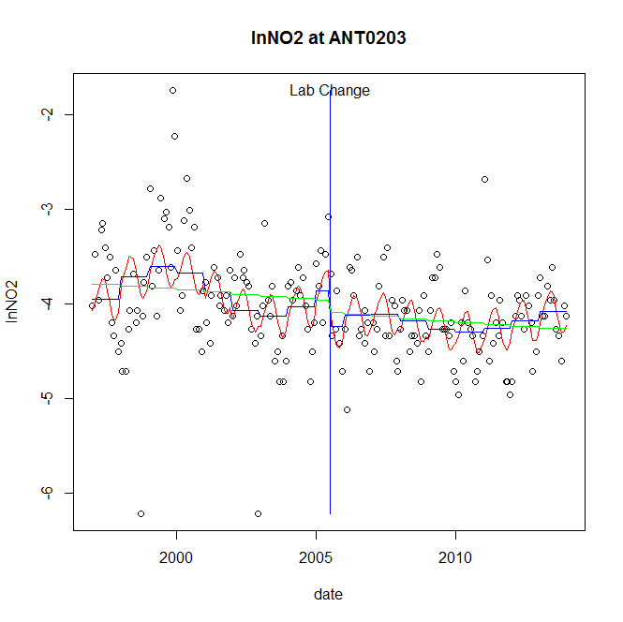

GAM analysis for station ANT0203 dependent variable lnNO2

|  |  |  |  |  |
| --- | --- | --- | --- | --- |
| **Type** | **Source** | **edf** | **F-stat** | **p-value** |
| parametric terms | step | 1 | 2.5554 | 0.1115 |
|  | year | 1 | 995.4191 | <0.0001 |
| smoothed terms | s(year) | 5.9 | 2.956 | 0.0069 |
|  | s(doy) | 2.56 | 3.0195 | <0.0001 |

GAM analysis for station ANT0203 dependent variable lnNO2

|  |  |  |  |  |
| --- | --- | --- | --- | --- |
| **parameter** | **estimate** | **Std. Err.** | **t value** | **p-value** |
| (Intercept) | -0.002164 | 0.000999 | -2.1655 | 0.0316 |
| step | -0.375736 | 0.235045 | -1.5986 | 0.1115 |
| year | -0.001923 | 6.1e-05 | -31.5503 | <0.0001 |

root mean-square error = 0.4803

adjusted r-square = 0.2404

station = ANT0203 dependent = lnTP

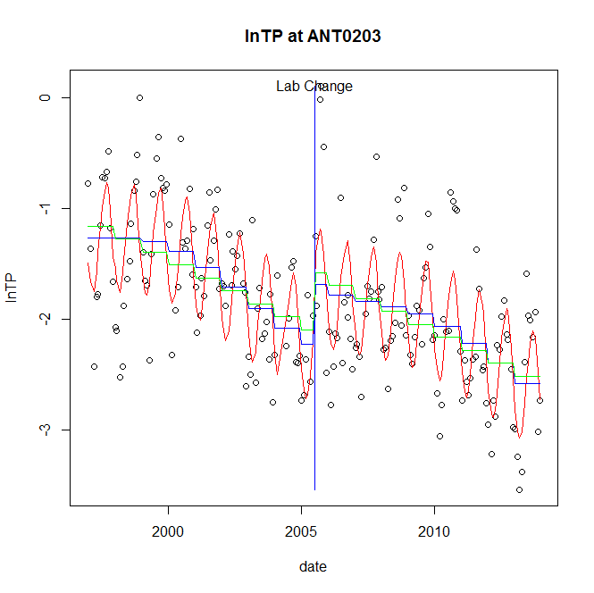

GAM analysis for station ANT0203 dependent variable lnTP

|  |  |  |  |  |
| --- | --- | --- | --- | --- |
| **Type** | **Source** | **edf** | **F-stat** | **p-value** |
| parametric terms | step | 1 | 7.9114 | 0.0054 |
|  | year | 1 | 414.1952 | <0.0001 |
| smoothed terms | s(year) | 4.28 | 16.6739 | <0.0001 |
|  | s(doy) | 3.94 | 14.2648 | <0.0001 |

GAM analysis for station ANT0203 dependent variable lnTP

|  |  |  |  |  |
| --- | --- | --- | --- | --- |
| **parameter** | **estimate** | **Std. Err.** | **t value** | **p-value** |
| (Intercept) | 0.001067 | 0.000664 | 1.6086 | 0.1094 |
| step | 0.54367 | 0.19329 | 2.8127 | 0.0054 |
| year | -0.001052 | 5.2e-05 | -20.3518 | <0.0001 |

root mean-square error = 0.4535

adjusted r-square = 0.5817

step significant

station = ANT0203 dependent = lnPO4

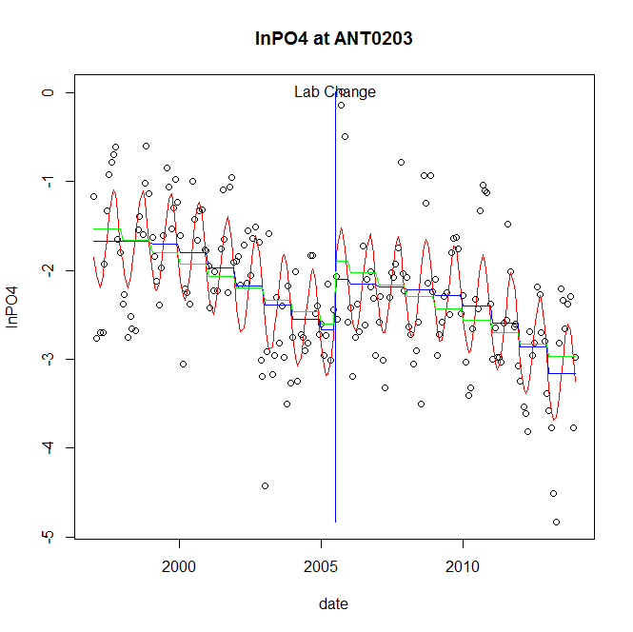

GAM analysis for station ANT0203 dependent variable lnPO4

|  |  |  |  |  |
| --- | --- | --- | --- | --- |
| **Type** | **Source** | **edf** | **F-stat** | **p-value** |
| parametric terms | step | 1 | 6.0022 | 0.0152 |
|  | year | 1 | 432.1847 | <0.0001 |
| smoothed terms | s(year) | 4.45 | 15.5071 | <0.0001 |
|  | s(doy) | 3.35 | 12.9046 | <0.0001 |

GAM analysis for station ANT0203 dependent variable lnPO4

|  |  |  |  |  |
| --- | --- | --- | --- | --- |
| **parameter** | **estimate** | **Std. Err.** | **t value** | **p-value** |
| (Intercept) | 0.001815 | 0.000813 | 2.2315 | 0.0268 |
| step | 0.566601 | 0.231272 | 2.4499 | 0.0152 |
| year | -0.001262 | 6.1e-05 | -20.7891 | <0.0001 |

root mean-square error = 0.5421

adjusted r-square = 0.5411

step significant

No title given

|  |  |  |  |
| --- | --- | --- | --- |
| **station** | **dep** | **step.est** | **step.pv** |
| ANT0203 | lnTSS | -0.045836 | 0.7842 |
| ANT0203 | lnTN | -0.053894 | 0.4352 |
| ANT0203 | lnNH4 | 0.102769 | 0.7920 |
| ANT0203 | lnNO23 | -0.030074 | 0.7216 |
| ANT0203 | lnNO2 | -0.375736 | 0.1115 |
| ANT0203 | lnTP | 0.54367 | 0.0054 |
| ANT0203 | lnPO4 | 0.566601 | 0.0152 |

station = ANT0366 dependent = lnTSS

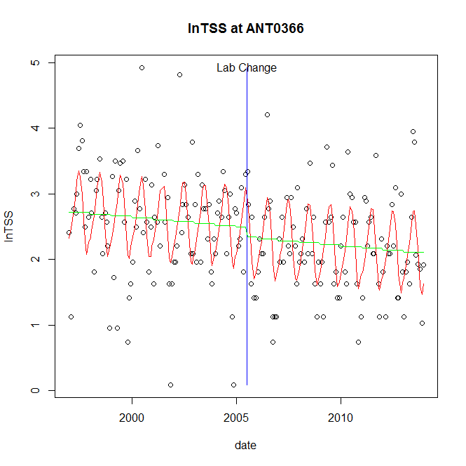

GAM analysis for station ANT0366 dependent variable lnTSS

|  |  |  |  |  |
| --- | --- | --- | --- | --- |
| **Type** | **Source** | **edf** | **F-stat** | **p-value** |
| parametric terms | step | 1 | 0.6463 | 0.4224 |
|  | year | 1 | 564.2787 | <0.0001 |
| smoothed terms | s(year) | 1 | 2.5561 | 0.1115 |
|  | s(doy) | 4.24 | 11.0649 | <0.0001 |

GAM analysis for station ANT0366 dependent variable lnTSS

|  |  |  |  |  |
| --- | --- | --- | --- | --- |
| **parameter** | **estimate** | **Std. Err.** | **t value** | **p-value** |
| (Intercept) | 0.00036 | 0.000225 | 1.6016 | 0.1108 |
| step | -0.148222 | 0.184365 | -0.804 | 0.4224 |
| year | 0.001227 | 5.2e-05 | 23.7546 | <0.0001 |

root mean-square error = 0.6553

adjusted r-square = 0.3452

station = ANT0366 dependent = lnTN

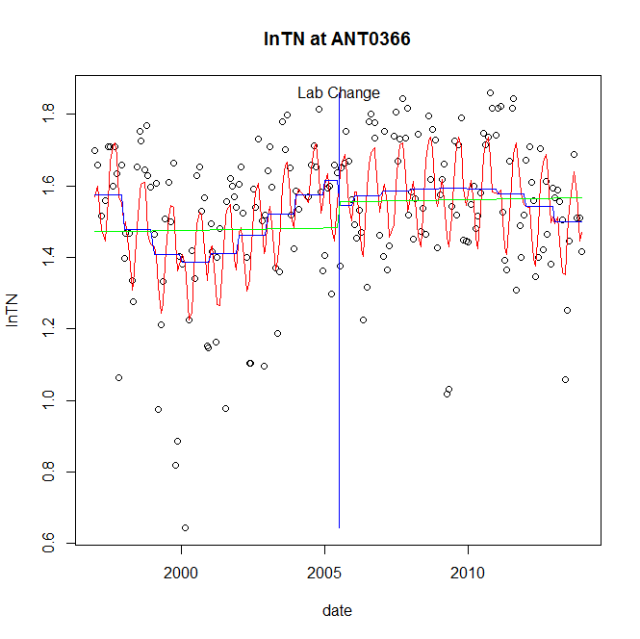

GAM analysis for station ANT0366 dependent variable lnTN

|  |  |  |  |  |
| --- | --- | --- | --- | --- |
| **Type** | **Source** | **edf** | **F-stat** | **p-value** |
| parametric terms | step | 1 | 0.7744 | 0.3800 |
|  | year | 1 | 1392.7638 | <0.0001 |
| smoothed terms | s(year) | 4.85 | 4.1106 | 0.0008 |
|  | s(doy) | 5.79 | 7.299 | <0.0001 |

GAM analysis for station ANT0366 dependent variable lnTN

|  |  |  |  |  |
| --- | --- | --- | --- | --- |
| **parameter** | **estimate** | **Std. Err.** | **t value** | **p-value** |
| (Intercept) | 0.000911 | 0.000295 | 3.0895 | 0.0023 |
| step | -0.069038 | 0.078455 | -0.88 | 0.3800 |
| year | 0.000779 | 2.1e-05 | 37.3198 | <0.0001 |

root mean-square error = 0.1725

adjusted r-square = 0.3224

station = ANT0366 dependent = lnNH4

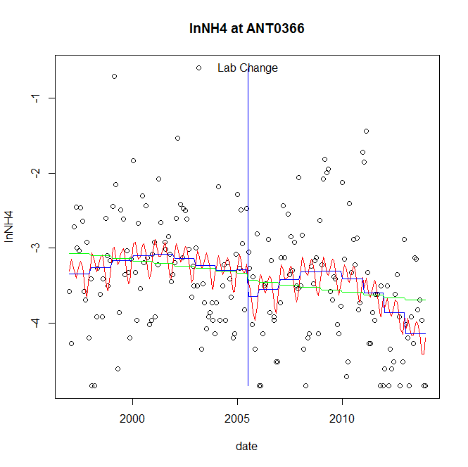

GAM analysis for station ANT0366 dependent variable lnNH4

|  |  |  |  |  |
| --- | --- | --- | --- | --- |
| **Type** | **Source** | **edf** | **F-stat** | **p-value** |
| parametric terms | step | 1 | 1.307 | 0.2544 |
|  | year | 1 | 379.0219 | <0.0001 |
| smoothed terms | s(year) | 4.39 | 3.1406 | 0.0083 |
|  | s(doy) | 4.12 | 1.5276 | 0.0112 |

GAM analysis for station ANT0366 dependent variable lnNH4

|  |  |  |  |  |
| --- | --- | --- | --- | --- |
| **parameter** | **estimate** | **Std. Err.** | **t value** | **p-value** |
| (Intercept) | 0.001203 | 0.001092 | 1.1019 | 0.2719 |
| step | -0.357734 | 0.31291 | -1.1432 | 0.2544 |
| year | -0.001607 | 8.3e-05 | -19.4685 | <0.0001 |

root mean-square error = 0.7372

adjusted r-square = 0.1601

station = ANT0366 dependent = lnNO23

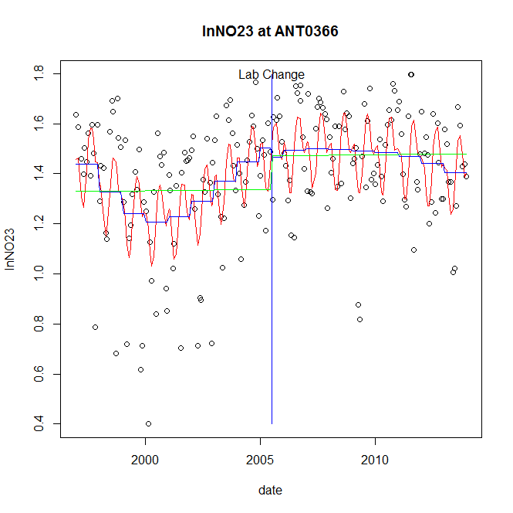

GAM analysis for station ANT0366 dependent variable lnNO23

|  |  |  |  |  |
| --- | --- | --- | --- | --- |
| **Type** | **Source** | **edf** | **F-stat** | **p-value** |
| parametric terms | step | 1 | 0.1516 | 0.6974 |
|  | year | 1 | 837.6684 | <0.0001 |
| smoothed terms | s(year) | 4.73 | 4.7632 | 0.0002 |
|  | s(doy) | 4.95 | 5.833 | <0.0001 |

GAM analysis for station ANT0366 dependent variable lnNO23

|  |  |  |  |  |
| --- | --- | --- | --- | --- |
| **parameter** | **estimate** | **Std. Err.** | **t value** | **p-value** |
| (Intercept) | 0.000949 | 0.000342 | 2.7777 | 0.0060 |
| step | -0.036234 | 0.093061 | -0.3894 | 0.6974 |
| year | 0.000708 | 2.4e-05 | 28.9425 | <0.0001 |

root mean-square error = 0.2113

adjusted r-square = 0.3214

station = ANT0366 dependent = lnNO2

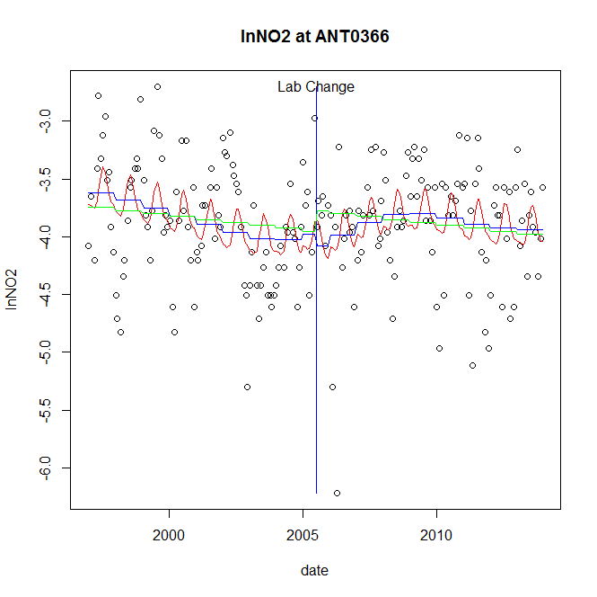

GAM analysis for station ANT0366 dependent variable lnNO2

|  |  |  |  |  |
| --- | --- | --- | --- | --- |
| **Type** | **Source** | **edf** | **F-stat** | **p-value** |
| parametric terms | step | 1 | 0.2564 | 0.6132 |
|  | year | 1 | 1233.457 | <0.0001 |
| smoothed terms | s(year) | 4.37 | 2.4014 | 0.0357 |
|  | s(doy) | 3.19 | 1.9215 | 0.0008 |

GAM analysis for station ANT0366 dependent variable lnNO2

|  |  |  |  |  |
| --- | --- | --- | --- | --- |
| **parameter** | **estimate** | **Std. Err.** | **t value** | **p-value** |
| (Intercept) | 0.00042 | 0.000718 | 0.5856 | 0.5588 |
| step | -0.104343 | 0.206067 | -0.5064 | 0.6132 |
| year | -0.001909 | 5.4e-05 | -35.1206 | <0.0001 |

root mean-square error = 0.4868

adjusted r-square = 0.1096

station = ANT0366 dependent = lnTP

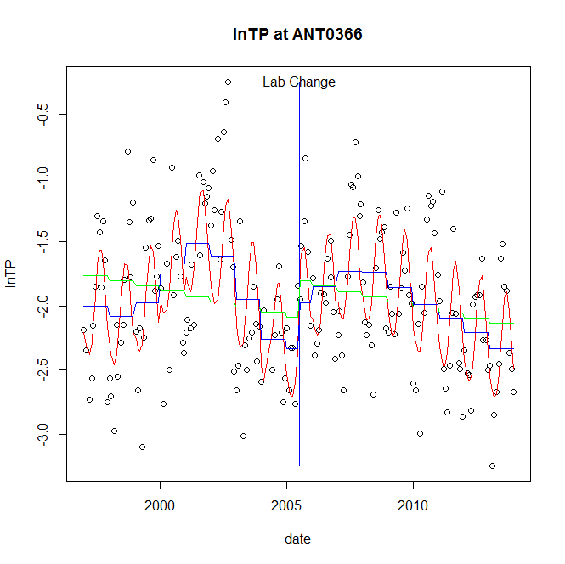

GAM analysis for station ANT0366 dependent variable lnTP

|  |  |  |  |  |
| --- | --- | --- | --- | --- |
| **Type** | **Source** | **edf** | **F-stat** | **p-value** |
| parametric terms | step | 1 | 2.6061 | 0.1081 |
|  | year | 1 | 318.8878 | <0.0001 |
| smoothed terms | s(year) | 6.61 | 8.6612 | <0.0001 |
|  | s(doy) | 3.48 | 11.8417 | <0.0001 |

GAM analysis for station ANT0366 dependent variable lnTP

|  |  |  |  |  |
| --- | --- | --- | --- | --- |
| **parameter** | **estimate** | **Std. Err.** | **t value** | **p-value** |
| (Intercept) | 0.001501 | 0.00104 | 1.4432 | 0.1506 |
| step | 0.363398 | 0.225108 | 1.6143 | 0.1081 |
| year | -0.001062 | 5.9e-05 | -17.8574 | <0.0001 |

root mean-square error = 0.4289

adjusted r-square = 0.4452

station = ANT0366 dependent = lnPO4

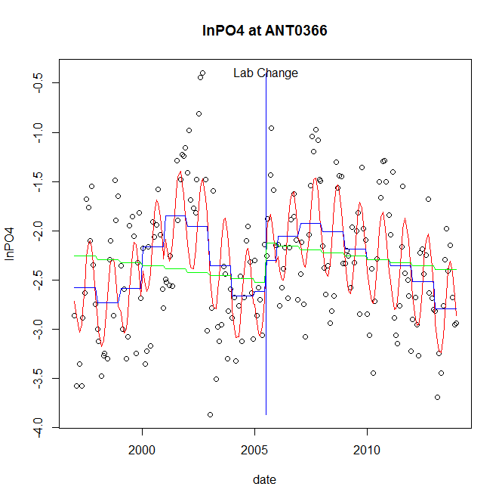

GAM analysis for station ANT0366 dependent variable lnPO4

|  |  |  |  |  |
| --- | --- | --- | --- | --- |
| **Type** | **Source** | **edf** | **F-stat** | **p-value** |
| parametric terms | step | 1 | 1.3471 | 0.2472 |
|  | year | 1 | 319.7307 | <0.0001 |
| smoothed terms | s(year) | 6.79 | 9.0416 | <0.0001 |
|  | s(doy) | 3.1 | 11.0049 | <0.0001 |

GAM analysis for station ANT0366 dependent variable lnPO4

|  |  |  |  |  |
| --- | --- | --- | --- | --- |
| **parameter** | **estimate** | **Std. Err.** | **t value** | **p-value** |
| (Intercept) | 0.003109 | 0.001243 | 2.5013 | 0.0132 |
| step | 0.30939 | 0.266566 | 1.1607 | 0.2472 |
| year | -0.00124 | 6.9e-05 | -17.881 | <0.0001 |

root mean-square error = 0.5033

adjusted r-square = 0.4485

No title given

|  |  |  |  |
| --- | --- | --- | --- |
| **station** | **dep** | **step.est** | **step.pv** |
| ANT0366 | lnTSS | -0.148222 | 0.4224 |
| ANT0366 | lnTN | -0.069038 | 0.3800 |
| ANT0366 | lnNH4 | -0.357734 | 0.2544 |
| ANT0366 | lnNO23 | -0.036234 | 0.6974 |
| ANT0366 | lnNO2 | -0.104343 | 0.6132 |
| ANT0366 | lnTP | 0.363398 | 0.1081 |
| ANT0366 | lnPO4 | 0.30939 | 0.2472 |

station = BDK0000 dependent = lnTSS

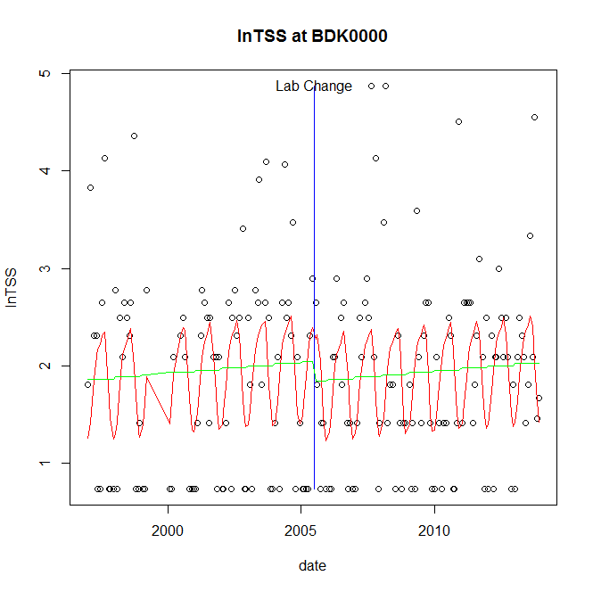

GAM analysis for station BDK0000 dependent variable lnTSS

|  |  |  |  |  |
| --- | --- | --- | --- | --- |
| **Type** | **Source** | **edf** | **F-stat** | **p-value** |
| parametric terms | step | 1 | 0.6756 | 0.4122 |
|  | year | 1 | 181.6771 | <0.0001 |
| smoothed terms | s(year) | 1 | 0.7012 | 0.4035 |
|  | s(doy) | 3.67 | 4.8724 | <0.0001 |

GAM analysis for station BDK0000 dependent variable lnTSS

|  |  |  |  |  |
| --- | --- | --- | --- | --- |
| **parameter** | **estimate** | **Std. Err.** | **t value** | **p-value** |
| (Intercept) | -0.000253 | 0.000302 | -0.8358 | 0.4044 |
| step | -0.208544 | 0.253714 | -0.822 | 0.4122 |
| year | 0.001009 | 7.5e-05 | 13.4788 | <0.0001 |

root mean-square error = 0.8995

adjusted r-square = 0.1663

station = BDK0000 dependent = lnTN

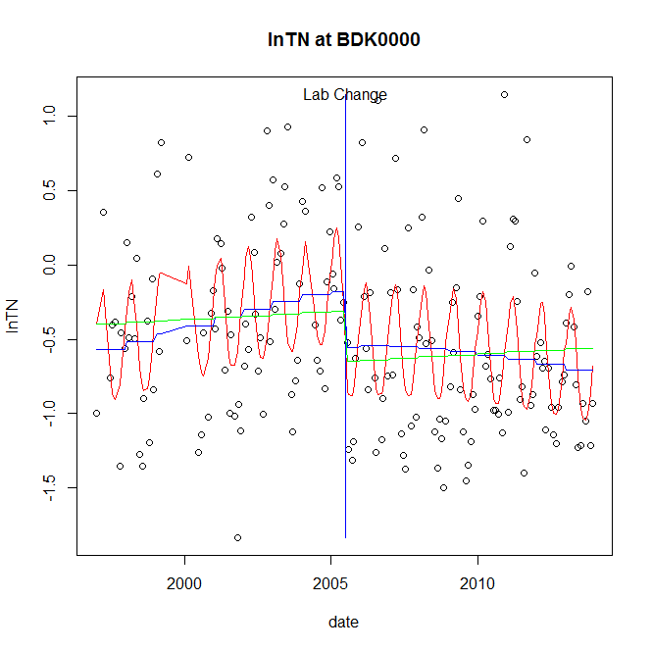

GAM analysis for station BDK0000 dependent variable lnTN

|  |  |  |  |  |
| --- | --- | --- | --- | --- |
| **Type** | **Source** | **edf** | **F-stat** | **p-value** |
| parametric terms | step | 1 | 4.9703 | 0.0270 |
|  | year | 1 | 7.5954 | 0.0065 |
| smoothed terms | s(year) | 2.24 | 2.5159 | 0.0653 |
|  | s(doy) | 3.04 | 6.7928 | <0.0001 |

GAM analysis for station BDK0000 dependent variable lnTN

|  |  |  |  |  |
| --- | --- | --- | --- | --- |
| **parameter** | **estimate** | **Std. Err.** | **t value** | **p-value** |
| (Intercept) | -8.6e-05 | 0.000333 | -0.2584 | 0.7964 |
| step | -0.376344 | 0.168809 | -2.2294 | 0.0270 |
| year | -0.000139 | 5e-05 | -2.756 | 0.0065 |

root mean-square error = 0.52

adjusted r-square = 0.2914

step significant

station = BDK0000 dependent = lnNH4

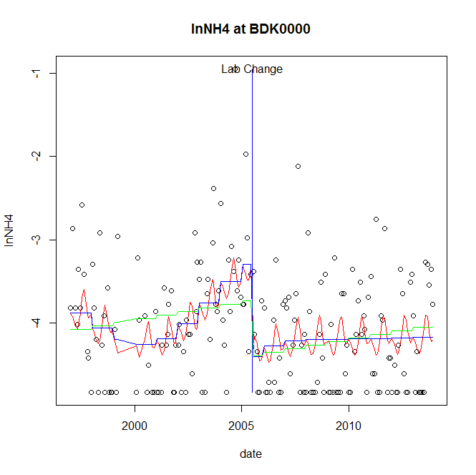

GAM analysis for station BDK0000 dependent variable lnNH4

|  |  |  |  |  |
| --- | --- | --- | --- | --- |
| **Type** | **Source** | **edf** | **F-stat** | **p-value** |
| parametric terms | step | 1 | 16.365 | <0.0001 |
|  | year | 1 | 513.1352 | <0.0001 |
| smoothed terms | s(year) | 4.32 | 4.1504 | 0.0012 |
|  | s(doy) | 3.99 | 1.3484 | 0.0196 |

GAM analysis for station BDK0000 dependent variable lnNH4

|  |  |  |  |  |
| --- | --- | --- | --- | --- |
| **parameter** | **estimate** | **Std. Err.** | **t value** | **p-value** |
| (Intercept) | 0.001002 | 0.000948 | 1.0568 | 0.2920 |
| step | -1.109749 | 0.274326 | -4.0454 | <0.0001 |
| year | -0.001736 | 7.7e-05 | -22.6525 | <0.0001 |

root mean-square error = 0.6436

adjusted r-square = 0.1614

step significant

station = BDK0000 dependent = lnNO23

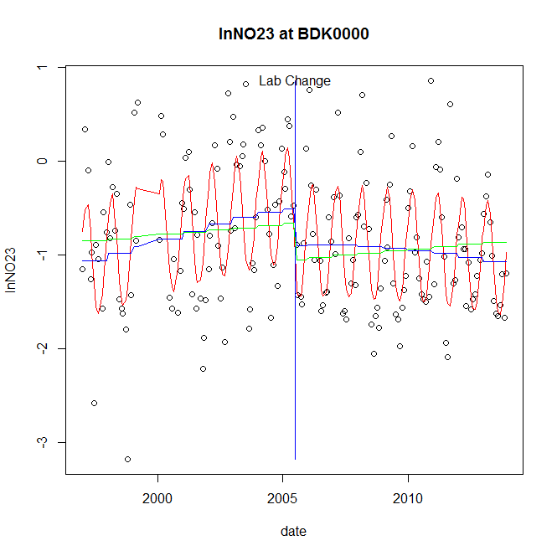

GAM analysis for station BDK0000 dependent variable lnNO23

|  |  |  |  |  |
| --- | --- | --- | --- | --- |
| **Type** | **Source** | **edf** | **F-stat** | **p-value** |
| parametric terms | step | 1 | 4.7638 | 0.0303 |
|  | year | 1 | 36.5058 | <0.0001 |
| smoothed terms | s(year) | 2.38 | 4.0986 | 0.0083 |
|  | s(doy) | 3.25 | 15.3174 | <0.0001 |

GAM analysis for station BDK0000 dependent variable lnNO23

|  |  |  |  |  |
| --- | --- | --- | --- | --- |
| **parameter** | **estimate** | **Std. Err.** | **t value** | **p-value** |
| (Intercept) | -0.000196 | 0.00038 | -0.5146 | 0.6075 |
| step | -0.391803 | 0.17951 | -2.1826 | 0.0303 |
| year | -0.000313 | 5.2e-05 | -6.042 | <0.0001 |

root mean-square error = 0.5534

adjusted r-square = 0.4435

step significant

station = BDK0000 dependent = lnNO2

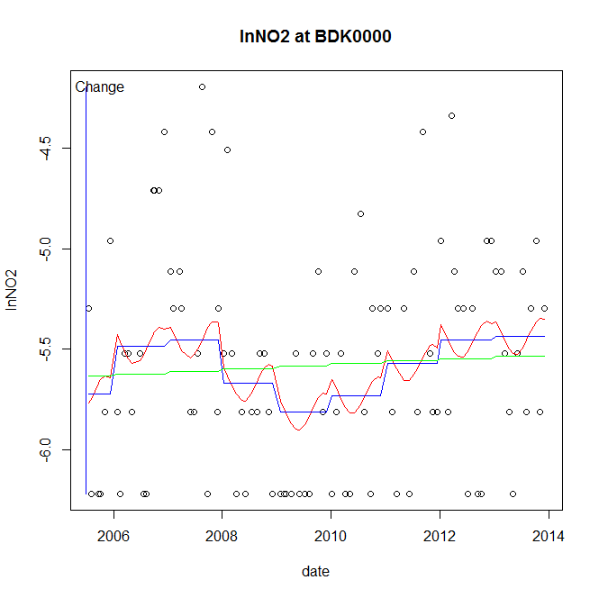

GAM analysis for station BDK0000 dependent variable lnNO2

|  |  |  |  |  |
| --- | --- | --- | --- | --- |
| **Type** | **Source** | **edf** | **F-stat** | **p-value** |
| parametric terms | step | 1 | 0.9202 | 0.3399 |
|  | year | 1 | 12243.9938 | <0.0001 |
| smoothed terms | s(year) | 4.22 | 1.8894 | 0.1015 |
|  | s(doy) | 1.25 | 0.3658 | 0.0821 |

GAM analysis for station BDK0000 dependent variable lnNO2

|  |  |  |  |  |
| --- | --- | --- | --- | --- |
| **parameter** | **estimate** | **Std. Err.** | **t value** | **p-value** |
| (Intercept) | -0.000414 | 0.000432 | -0.9593 | 0.3399 |
| step | -0.000414 | 0.000432 | -0.9593 | 0.3399 |
| year | -0.002775 | 2.5e-05 | -110.6526 | <0.0001 |

root mean-square error = 0.5063

adjusted r-square = 0.0956

station = BDK0000 dependent = lnTP

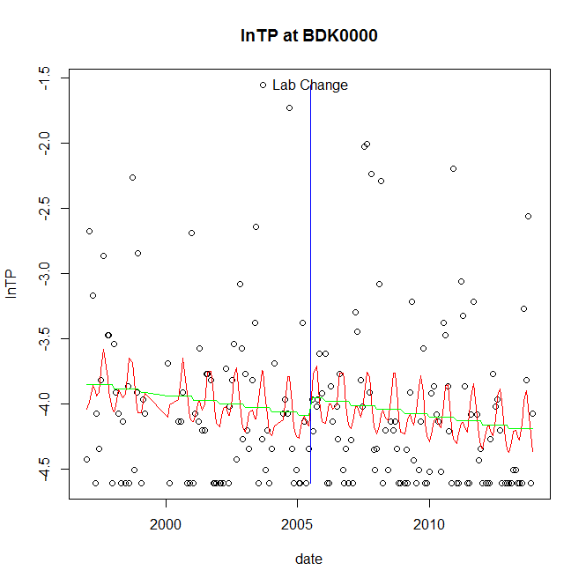

GAM analysis for station BDK0000 dependent variable lnTP

|  |  |  |  |  |
| --- | --- | --- | --- | --- |
| **Type** | **Source** | **edf** | **F-stat** | **p-value** |
| parametric terms | step | 1 | 0.5703 | 0.4511 |
|  | year | 1 | 1461.1207 | <0.0001 |
| smoothed terms | s(year) | 1 | 2.2387 | 0.1363 |
|  | s(doy) | 3.85 | 1.5266 | 0.0088 |

GAM analysis for station BDK0000 dependent variable lnTP

|  |  |  |  |  |
| --- | --- | --- | --- | --- |
| **parameter** | **estimate** | **Std. Err.** | **t value** | **p-value** |
| (Intercept) | 0.000318 | 0.000213 | 1.4916 | 0.1376 |
| step | 0.134659 | 0.178309 | 0.7552 | 0.4511 |
| year | -0.00205 | 5.4e-05 | -38.2246 | <0.0001 |

root mean-square error = 0.6223

adjusted r-square = 0.0656

station = BDK0000 dependent = lnPO4

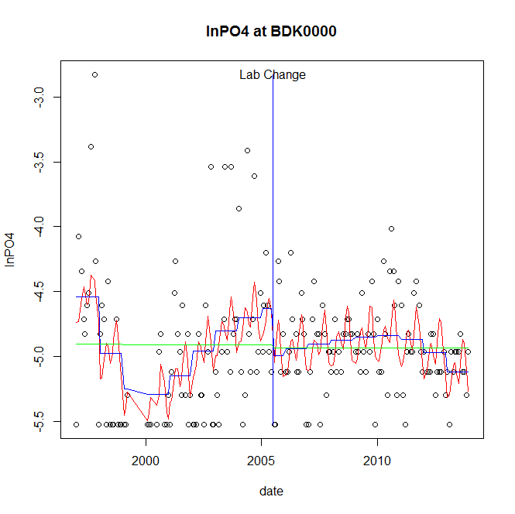

GAM analysis for station BDK0000 dependent variable lnPO4

|  |  |  |  |  |
| --- | --- | --- | --- | --- |
| **Type** | **Source** | **edf** | **F-stat** | **p-value** |
| parametric terms | step | 1 | 3.0878 | 0.0806 |
|  | year | 1 | 1722.4469 | <0.0001 |
| smoothed terms | s(year) | 5.85 | 5.5927 | <0.0001 |
|  | s(doy) | 4.89 | 3.0731 | <0.0001 |

GAM analysis for station BDK0000 dependent variable lnPO4

|  |  |  |  |  |
| --- | --- | --- | --- | --- |
| **parameter** | **estimate** | **Std. Err.** | **t value** | **p-value** |
| (Intercept) | 0.003526 | 0.000899 | 3.9207 | 0.0001 |
| step | -0.362317 | 0.206188 | -1.7572 | 0.0806 |
| year | -0.002362 | 5.7e-05 | -41.5024 | <0.0001 |

root mean-square error = 0.4177

adjusted r-square = 0.2347

No title given

|  |  |  |  |
| --- | --- | --- | --- |
| **station** | **dep** | **step.est** | **step.pv** |
| BDK0000 | lnTSS | -0.208544 | 0.4122 |
| BDK0000 | lnTN | -0.376344 | 0.0270 |
| BDK0000 | lnNH4 | -1.109749 | <0.0001 |
| BDK0000 | lnNO23 | -0.391803 | 0.0303 |
| BDK0000 | lnNO2 | -0.000414 | 0.3399 |
| BDK0000 | lnTP | 0.134659 | 0.4511 |
| BDK0000 | lnPO4 | -0.362317 | 0.0806 |

station = BPC0035 dependent = lnTSS

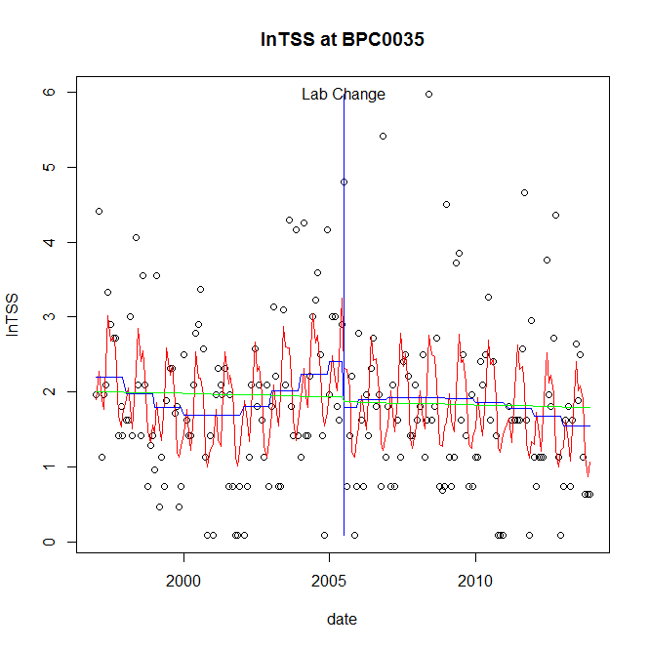

GAM analysis for station BPC0035 dependent variable lnTSS

|  |  |  |  |  |
| --- | --- | --- | --- | --- |
| **Type** | **Source** | **edf** | **F-stat** | **p-value** |
| parametric terms | step | 1 | 2.4178 | 0.1216 |
|  | year | 1 | 109.6421 | <0.0001 |
| smoothed terms | s(year) | 3.9 | 2.1619 | 0.0629 |
|  | s(doy) | 6.72 | 6.2753 | <0.0001 |

GAM analysis for station BPC0035 dependent variable lnTSS

|  |  |  |  |  |
| --- | --- | --- | --- | --- |
| **parameter** | **estimate** | **Std. Err.** | **t value** | **p-value** |
| (Intercept) | 0.002118 | 0.001254 | 1.6886 | 0.0929 |
| step | -0.606 | 0.389732 | -1.5549 | 0.1216 |
| year | 0.001073 | 0.000103 | 10.471 | <0.0001 |

root mean-square error = 0.9696

adjusted r-square = 0.2175

station = BPC0035 dependent = lnTN

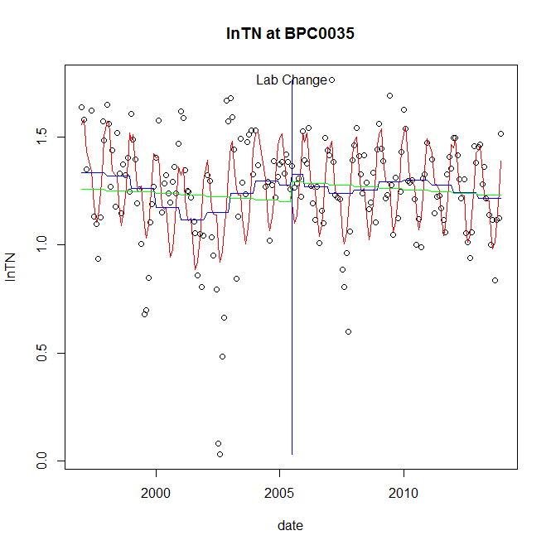

GAM analysis for station BPC0035 dependent variable lnTN

|  |  |  |  |  |
| --- | --- | --- | --- | --- |
| **Type** | **Source** | **edf** | **F-stat** | **p-value** |
| parametric terms | step | 1 | 0.234 | 0.6291 |
|  | year | 1 | 550.8853 | <0.0001 |
| smoothed terms | s(year) | 6.3 | 2.925 | 0.0069 |
|  | s(doy) | 5.71 | 15.2369 | <0.0001 |

GAM analysis for station BPC0035 dependent variable lnTN

|  |  |  |  |  |
| --- | --- | --- | --- | --- |
| **parameter** | **estimate** | **Std. Err.** | **t value** | **p-value** |
| (Intercept) | 0.000185 | 0.000449 | 0.4126 | 0.6804 |
| step | 0.047856 | 0.098924 | 0.4838 | 0.6291 |
| year | 0.000615 | 2.6e-05 | 23.4709 | <0.0001 |

root mean-square error = 0.1932

adjusted r-square = 0.4172

station = BPC0035 dependent = lnNH4

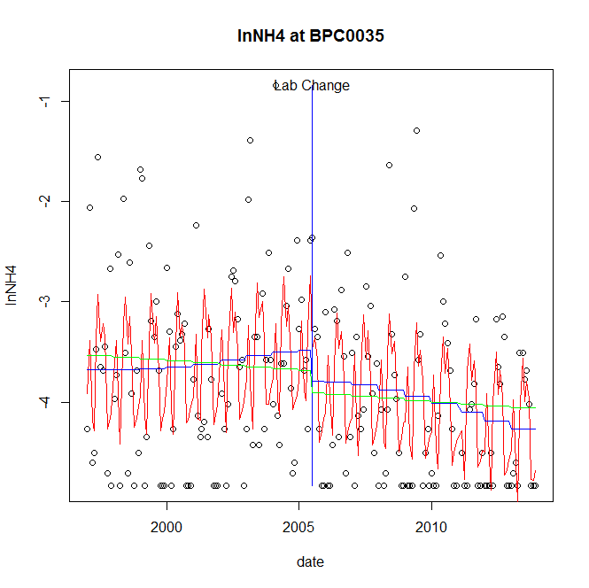

GAM analysis for station BPC0035 dependent variable lnNH4

|  |  |  |  |  |
| --- | --- | --- | --- | --- |
| **Type** | **Source** | **edf** | **F-stat** | **p-value** |
| parametric terms | step | 1 | 1.5213 | 0.2190 |
|  | year | 1 | 756.0597 | <0.0001 |
| smoothed terms | s(year) | 2.53 | 1.9814 | 0.1154 |
|  | s(doy) | 7.43 | 9.4327 | <0.0001 |

GAM analysis for station BPC0035 dependent variable lnNH4

|  |  |  |  |  |
| --- | --- | --- | --- | --- |
| **parameter** | **estimate** | **Std. Err.** | **t value** | **p-value** |
| (Intercept) | 0.000463 | 0.000567 | 0.8166 | 0.4152 |
| step | -0.305678 | 0.24783 | -1.2334 | 0.2190 |
| year | -0.001841 | 6.7e-05 | -27.4965 | <0.0001 |

root mean-square error = 0.7507

adjusted r-square = 0.309

station = BPC0035 dependent = lnNO23

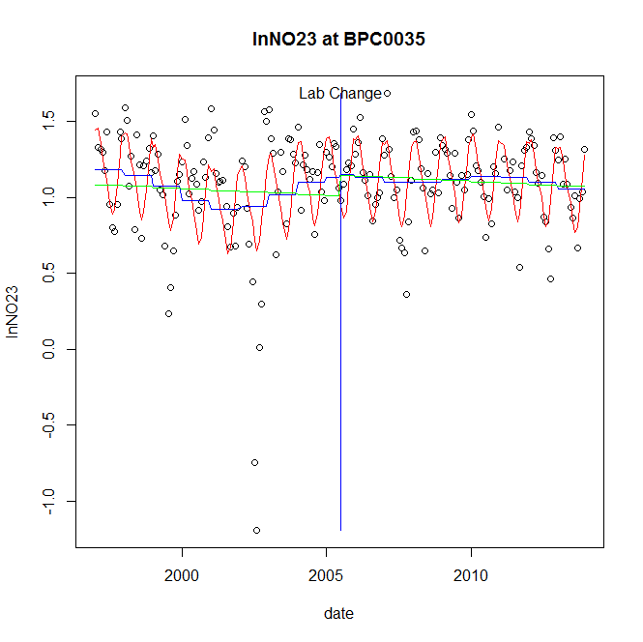

GAM analysis for station BPC0035 dependent variable lnNO23

|  |  |  |  |  |
| --- | --- | --- | --- | --- |
| **Type** | **Source** | **edf** | **F-stat** | **p-value** |
| parametric terms | step | 1 | 0.0196 | 0.8889 |
|  | year | 1 | 254.243 | <0.0001 |
| smoothed terms | s(year) | 5.54 | 1.8809 | 0.0816 |
|  | s(doy) | 4.1 | 12.4895 | <0.0001 |

GAM analysis for station BPC0035 dependent variable lnNO23

|  |  |  |  |  |
| --- | --- | --- | --- | --- |
| **parameter** | **estimate** | **Std. Err.** | **t value** | **p-value** |
| (Intercept) | 0.000455 | 0.00054 | 0.8437 | 0.3999 |
| step | 0.018352 | 0.131205 | 0.1399 | 0.8889 |
| year | 0.000542 | 3.4e-05 | 15.945 | <0.0001 |

root mean-square error = 0.2763

adjusted r-square = 0.3637

station = BPC0035 dependent = lnNO2

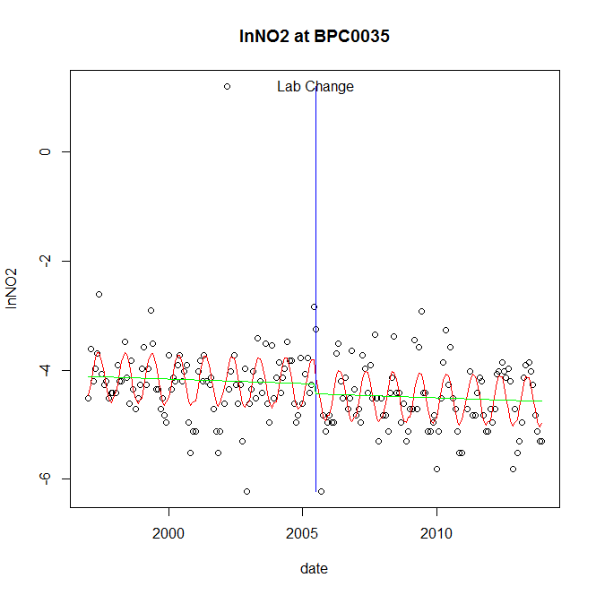

GAM analysis for station BPC0035 dependent variable lnNO2

|  |  |  |  |  |
| --- | --- | --- | --- | --- |
| **Type** | **Source** | **edf** | **F-stat** | **p-value** |
| parametric terms | step | 1 | 1.2113 | 0.2724 |
|  | year | 1 | 2021.6846 | <0.0001 |
| smoothed terms | s(year) | 1 | 0.6193 | 0.4323 |
|  | s(doy) | 2.77 | 8.5518 | <0.0001 |

GAM analysis for station BPC0035 dependent variable lnNO2

|  |  |  |  |  |
| --- | --- | --- | --- | --- |
| **parameter** | **estimate** | **Std. Err.** | **t value** | **p-value** |
| (Intercept) | 0.000163 | 0.000208 | 0.7819 | 0.4352 |
| step | -0.18817 | 0.170972 | -1.1006 | 0.2724 |
| year | -0.002129 | 4.7e-05 | -44.9631 | <0.0001 |

root mean-square error = 0.6037

adjusted r-square = 0.3058

station = BPC0035 dependent = lnTP

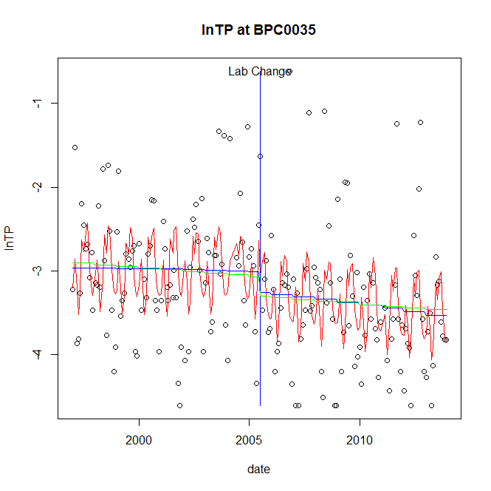

GAM analysis for station BPC0035 dependent variable lnTP

|  |  |  |  |  |
| --- | --- | --- | --- | --- |
| **Type** | **Source** | **edf** | **F-stat** | **p-value** |
| parametric terms | step | 1 | 1.4188 | 0.2351 |
|  | year | 1 | 701.2346 | <0.0001 |
| smoothed terms | s(year) | 1.6 | 0.7722 | 0.4577 |
|  | s(doy) | 7 | 5.7827 | <0.0001 |

GAM analysis for station BPC0035 dependent variable lnTP

|  |  |  |  |  |
| --- | --- | --- | --- | --- |
| **parameter** | **estimate** | **Std. Err.** | **t value** | **p-value** |
| (Intercept) | 0.000257 | 0.000312 | 0.8225 | 0.4119 |
| step | -0.246373 | 0.206837 | -1.1911 | 0.2351 |
| year | -0.001537 | 5.8e-05 | -26.4808 | <0.0001 |

root mean-square error = 0.6998

adjusted r-square = 0.2321

station = BPC0035 dependent = lnPO4

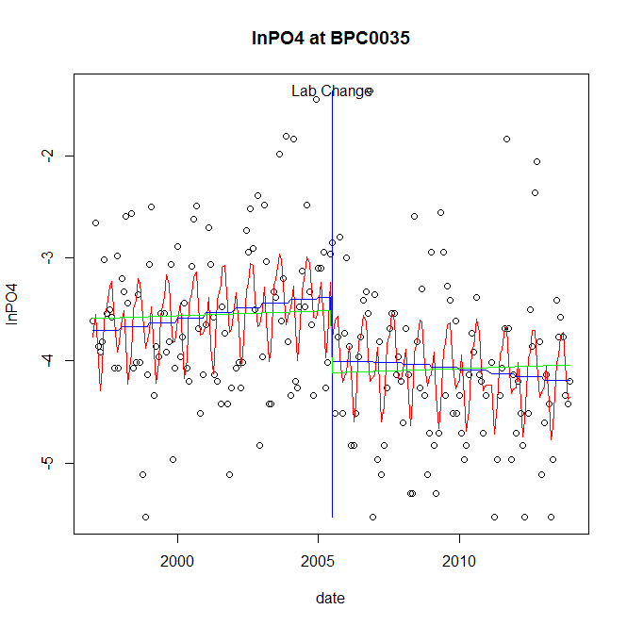

GAM analysis for station BPC0035 dependent variable lnPO4

|  |  |  |  |  |
| --- | --- | --- | --- | --- |
| **Type** | **Source** | **edf** | **F-stat** | **p-value** |
| parametric terms | step | 1 | 8.0263 | 0.0051 |
|  | year | 1 | 838.9817 | <0.0001 |
| smoothed terms | s(year) | 2.14 | 1.5019 | 0.2149 |
|  | s(doy) | 6.07 | 5.088 | <0.0001 |

GAM analysis for station BPC0035 dependent variable lnPO4

|  |  |  |  |  |
| --- | --- | --- | --- | --- |
| **parameter** | **estimate** | **Std. Err.** | **t value** | **p-value** |
| (Intercept) | -3.6e-05 | 0.000432 | -0.0829 | 0.9340 |
| step | -0.627282 | 0.221414 | -2.8331 | 0.0051 |
| year | -0.001751 | 6e-05 | -28.9652 | <0.0001 |

root mean-square error = 0.7146

adjusted r-square = 0.2488

step significant

No title given

|  |  |  |  |
| --- | --- | --- | --- |
| **station** | **dep** | **step.est** | **step.pv** |
| BPC0035 | lnTSS | -0.606 | 0.1216 |
| BPC0035 | lnTN | 0.047856 | 0.6291 |
| BPC0035 | lnNH4 | -0.305678 | 0.2190 |
| BPC0035 | lnNO23 | 0.018352 | 0.8889 |
| BPC0035 | lnNO2 | -0.18817 | 0.2724 |
| BPC0035 | lnTP | -0.246373 | 0.2351 |
| BPC0035 | lnPO4 | -0.627282 | 0.0051 |

station = CAC0031 dependent = lnTSS

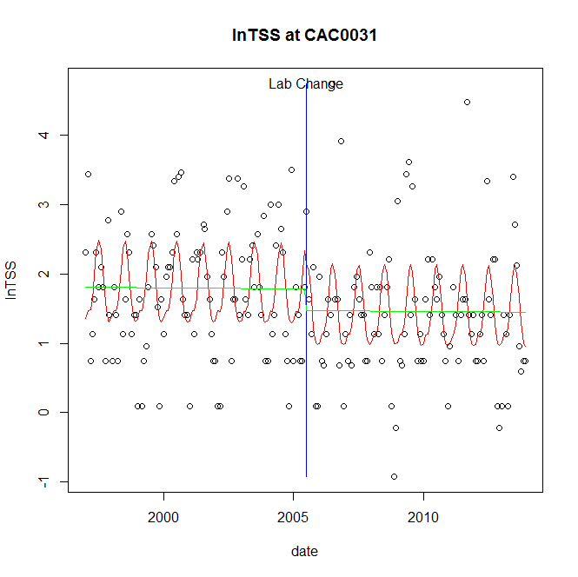

GAM analysis for station CAC0031 dependent variable lnTSS

|  |  |  |  |  |
| --- | --- | --- | --- | --- |
| **Type** | **Source** | **edf** | **F-stat** | **p-value** |
| parametric terms | step | 1 | 1.7955 | 0.1818 |
|  | year | 1 | 180.0557 | <0.0001 |
| smoothed terms | s(year) | 1 | 0.0236 | 0.8780 |
|  | s(doy) | 4.08 | 6.5978 | <0.0001 |

GAM analysis for station CAC0031 dependent variable lnTSS

|  |  |  |  |  |
| --- | --- | --- | --- | --- |
| **parameter** | **estimate** | **Std. Err.** | **t value** | **p-value** |
| (Intercept) | 4.4e-05 | 0.000284 | 0.1552 | 0.8768 |
| step | -0.312851 | 0.23348 | -1.3399 | 0.1818 |
| year | 0.000872 | 6.5e-05 | 13.4185 | <0.0001 |

root mean-square error = 0.8335

adjusted r-square = 0.2235

station = CAC0031 dependent = lnTN

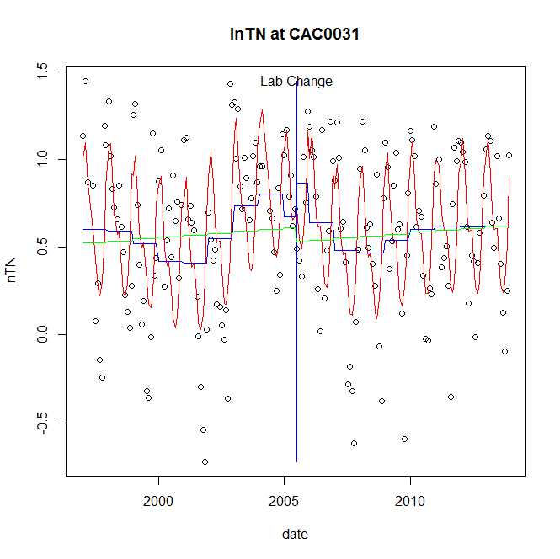

GAM analysis for station CAC0031 dependent variable lnTN

|  |  |  |  |  |
| --- | --- | --- | --- | --- |
| **Type** | **Source** | **edf** | **F-stat** | **p-value** |
| parametric terms | step | 1 | 1.1382 | 0.2874 |
|  | year | 1 | 27.7605 | <0.0001 |
| smoothed terms | s(year) | 6.45 | 3.2936 | 0.0027 |
|  | s(doy) | 5.56 | 16.5311 | <0.0001 |

GAM analysis for station CAC0031 dependent variable lnTN

|  |  |  |  |  |
| --- | --- | --- | --- | --- |
| **parameter** | **estimate** | **Std. Err.** | **t value** | **p-value** |
| (Intercept) | -6.6e-05 | 0.000822 | -0.0805 | 0.9360 |
| step | 0.19234 | 0.180285 | 1.0669 | 0.2874 |
| year | 0.00025 | 4.7e-05 | 5.2688 | <0.0001 |

root mean-square error = 0.348

adjusted r-square = 0.4326

station = CAC0031 dependent = lnNH4

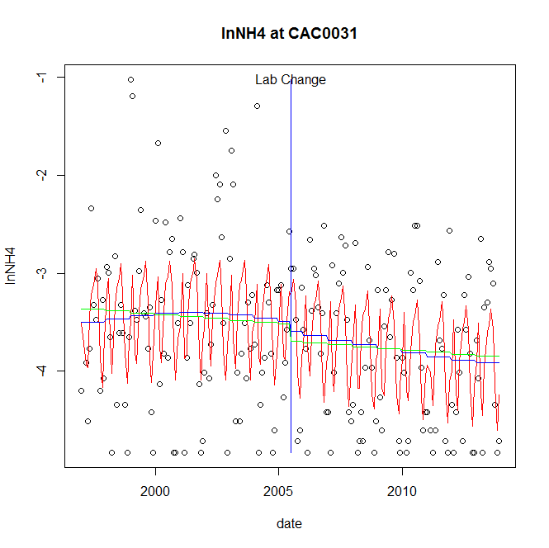

GAM analysis for station CAC0031 dependent variable lnNH4

|  |  |  |  |  |
| --- | --- | --- | --- | --- |
| **Type** | **Source** | **edf** | **F-stat** | **p-value** |
| parametric terms | step | 1 | 0.2077 | 0.6491 |
|  | year | 1 | 827.6909 | <0.0001 |
| smoothed terms | s(year) | 2.21 | 1.1016 | 0.3396 |
|  | s(doy) | 6.83 | 7.8493 | <0.0001 |

GAM analysis for station CAC0031 dependent variable lnNH4

|  |  |  |  |  |
| --- | --- | --- | --- | --- |
| **parameter** | **estimate** | **Std. Err.** | **t value** | **p-value** |
| (Intercept) | -6.4e-05 | 0.000456 | -0.1397 | 0.8890 |
| step | -0.103489 | 0.227059 | -0.4558 | 0.6491 |
| year | -0.001787 | 6.2e-05 | -28.7696 | <0.0001 |

root mean-square error = 0.7246

adjusted r-square = 0.2629

station = CAC0031 dependent = lnNO23

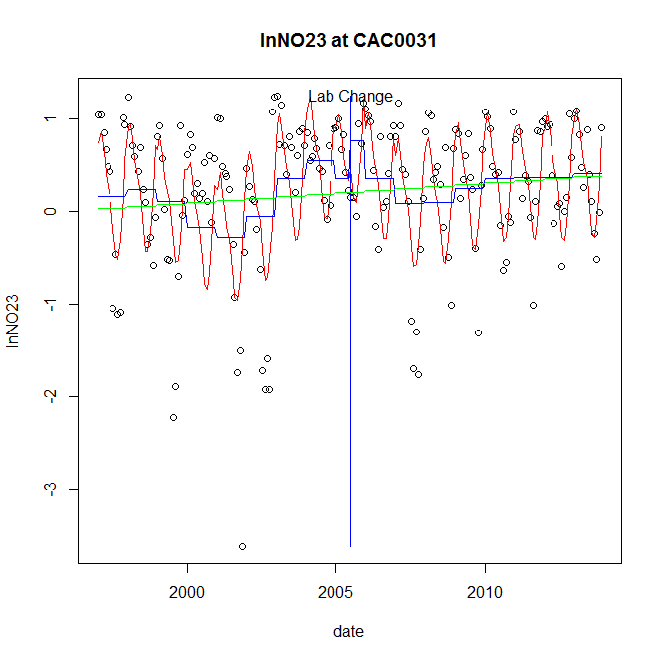

GAM analysis for station CAC0031 dependent variable lnNO23

|  |  |  |  |  |
| --- | --- | --- | --- | --- |
| **Type** | **Source** | **edf** | **F-stat** | **p-value** |
| parametric terms | step | 1 | 1.8302 | 0.1777 |
|  | year | 1 | 0.0559 | 0.8133 |
| smoothed terms | s(year) | 6.65 | 4.4274 | 0.0001 |
|  | s(doy) | 4.91 | 15.5694 | <0.0001 |

GAM analysis for station CAC0031 dependent variable lnNO23

|  |  |  |  |  |
| --- | --- | --- | --- | --- |
| **parameter** | **estimate** | **Std. Err.** | **t value** | **p-value** |
| (Intercept) | -0.000965 | 0.001415 | -0.6821 | 0.4960 |
| step | 0.416478 | 0.307855 | 1.3528 | 0.1777 |
| year | 1.9e-05 | 7.9e-05 | 0.2365 | 0.8133 |

root mean-square error = 0.5888

adjusted r-square = 0.4301

station = CAC0031 dependent = lnNO2

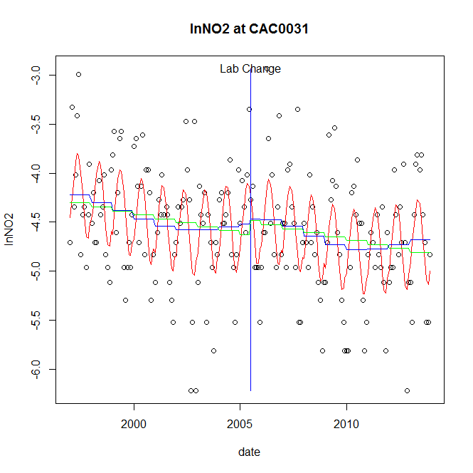

GAM analysis for station CAC0031 dependent variable lnNO2

|  |  |  |  |  |
| --- | --- | --- | --- | --- |
| **Type** | **Source** | **edf** | **F-stat** | **p-value** |
| parametric terms | step | 1 | 0.0514 | 0.8209 |
|  | year | 1 | 1718.2712 | <0.0001 |
| smoothed terms | s(year) | 4.27 | 2.376 | 0.0384 |
|  | s(doy) | 3.26 | 9.7403 | <0.0001 |

GAM analysis for station CAC0031 dependent variable lnNO2

|  |  |  |  |  |
| --- | --- | --- | --- | --- |
| **parameter** | **estimate** | **Std. Err.** | **t value** | **p-value** |
| (Intercept) | 0.000108 | 0.000724 | 0.149 | 0.8817 |
| step | 0.047925 | 0.211416 | 0.2267 | 0.8209 |
| year | -0.002295 | 5.5e-05 | -41.452 | <0.0001 |

root mean-square error = 0.5058

adjusted r-square = 0.3296

station = CAC0031 dependent = lnTP

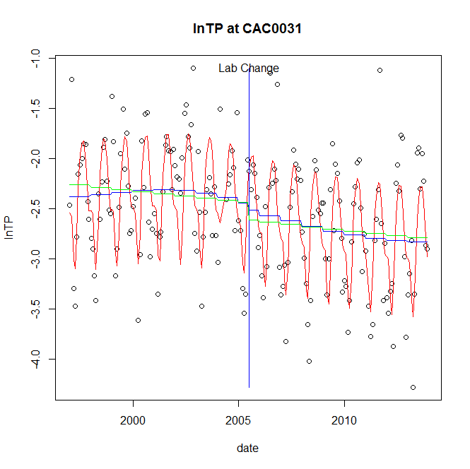

GAM analysis for station CAC0031 dependent variable lnTP

|  |  |  |  |  |
| --- | --- | --- | --- | --- |
| **Type** | **Source** | **edf** | **F-stat** | **p-value** |
| parametric terms | step | 1 | 0.2259 | 0.6351 |
|  | year | 1 | 923.4056 | <0.0001 |
| smoothed terms | s(year) | 2.84 | 1.9256 | 0.1154 |
|  | s(doy) | 6.08 | 23.6685 | <0.0001 |

GAM analysis for station CAC0031 dependent variable lnTP

|  |  |  |  |  |
| --- | --- | --- | --- | --- |
| **parameter** | **estimate** | **Std. Err.** | **t value** | **p-value** |
| (Intercept) | -3.2e-05 | 0.000383 | -0.0831 | 0.9339 |
| step | -0.071705 | 0.150871 | -0.4753 | 0.6351 |
| year | -0.001248 | 4.1e-05 | -30.3876 | <0.0001 |

root mean-square error = 0.4261

adjusted r-square = 0.538

station = CAC0031 dependent = lnPO4

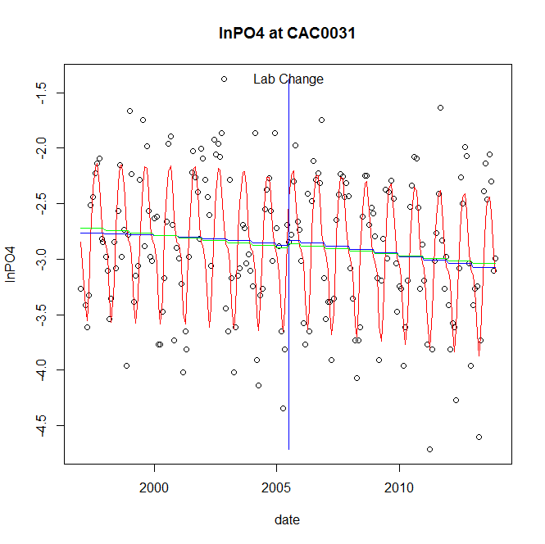

GAM analysis for station CAC0031 dependent variable lnPO4

|  |  |  |  |  |
| --- | --- | --- | --- | --- |
| **Type** | **Source** | **edf** | **F-stat** | **p-value** |
| parametric terms | step | 1 | 0.151 | 0.6981 |
|  | year | 1 | 1642.7405 | <0.0001 |
| smoothed terms | s(year) | 1.65 | 1.8668 | 0.1570 |
|  | s(doy) | 5.64 | 27.2265 | <0.0001 |

GAM analysis for station CAC0031 dependent variable lnPO4

|  |  |  |  |  |
| --- | --- | --- | --- | --- |
| **parameter** | **estimate** | **Std. Err.** | **t value** | **p-value** |
| (Intercept) | 0.000205 | 0.000198 | 1.0376 | 0.3008 |
| step | 0.050183 | 0.129162 | 0.3885 | 0.6981 |
| year | -0.001452 | 3.6e-05 | -40.5307 | <0.0001 |

root mean-square error = 0.4436

adjusted r-square = 0.5311

No title given

|  |  |  |  |
| --- | --- | --- | --- |
| **station** | **dep** | **step.est** | **step.pv** |
| CAC0031 | lnTSS | -0.312851 | 0.1818 |
| CAC0031 | lnTN | 0.19234 | 0.2874 |
| CAC0031 | lnNH4 | -0.103489 | 0.6491 |
| CAC0031 | lnNO23 | 0.416478 | 0.1777 |
| CAC0031 | lnNO2 | 0.047925 | 0.8209 |
| CAC0031 | lnTP | -0.071705 | 0.6351 |
| CAC0031 | lnPO4 | 0.050183 | 0.6981 |

station = CAC0148 dependent = lnTSS

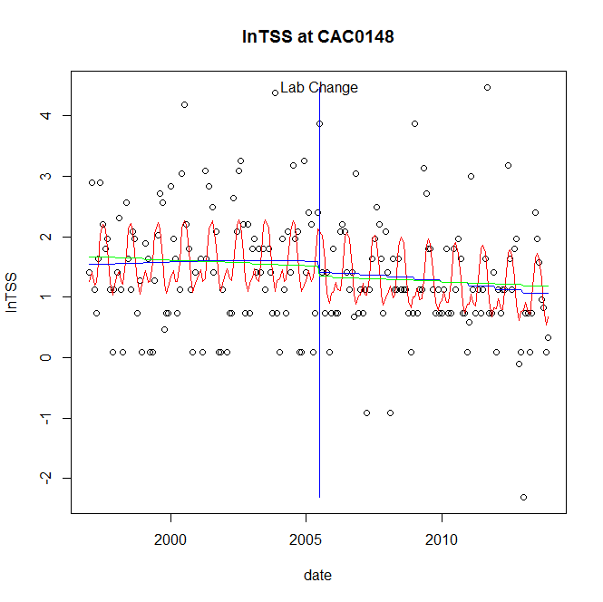

GAM analysis for station CAC0148 dependent variable lnTSS

|  |  |  |  |  |
| --- | --- | --- | --- | --- |
| **Type** | **Source** | **edf** | **F-stat** | **p-value** |
| parametric terms | step | 1 | 0.4567 | 0.5000 |
|  | year | 1 | 106.814 | <0.0001 |
| smoothed terms | s(year) | 1.77 | 1.0698 | 0.3447 |
|  | s(doy) | 4.87 | 5.7801 | <0.0001 |

GAM analysis for station CAC0148 dependent variable lnTSS

|  |  |  |  |  |
| --- | --- | --- | --- | --- |
| **parameter** | **estimate** | **Std. Err.** | **t value** | **p-value** |
| (Intercept) | 0.000306 | 0.000418 | 0.7307 | 0.4658 |
| step | -0.173063 | 0.2561 | -0.6758 | 0.5000 |
| year | 0.000741 | 7.2e-05 | 10.3351 | <0.0001 |

root mean-square error = 0.8684

adjusted r-square = 0.2097

station = CAC0148 dependent = lnTN

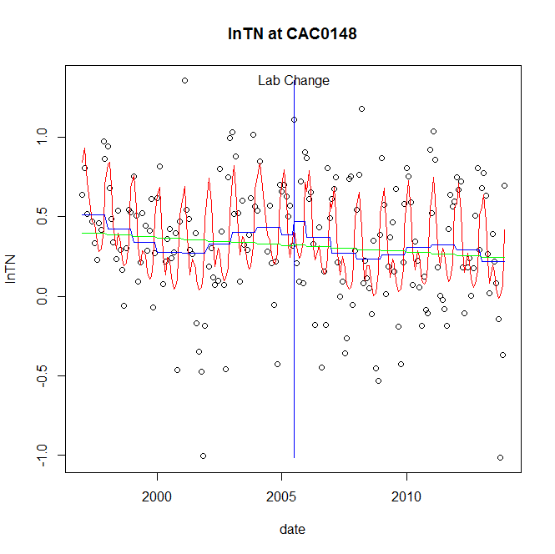

GAM analysis for station CAC0148 dependent variable lnTN

|  |  |  |  |  |
| --- | --- | --- | --- | --- |
| **Type** | **Source** | **edf** | **F-stat** | **p-value** |
| parametric terms | step | 1 | 0.3084 | 0.5793 |
|  | year | 1 | 12.979 | 0.0004 |
| smoothed terms | s(year) | 5.45 | 1.8292 | 0.0919 |
|  | s(doy) | 6.05 | 11.4815 | <0.0001 |

GAM analysis for station CAC0148 dependent variable lnTN

|  |  |  |  |  |
| --- | --- | --- | --- | --- |
| **parameter** | **estimate** | **Std. Err.** | **t value** | **p-value** |
| (Intercept) | 0.001004 | 0.000628 | 1.5986 | 0.1117 |
| step | 0.084831 | 0.152746 | 0.5554 | 0.5793 |
| year | 0.000149 | 4.1e-05 | 3.6026 | 0.0004 |

root mean-square error = 0.3185

adjusted r-square = 0.3491

station = CAC0148 dependent = lnNH4

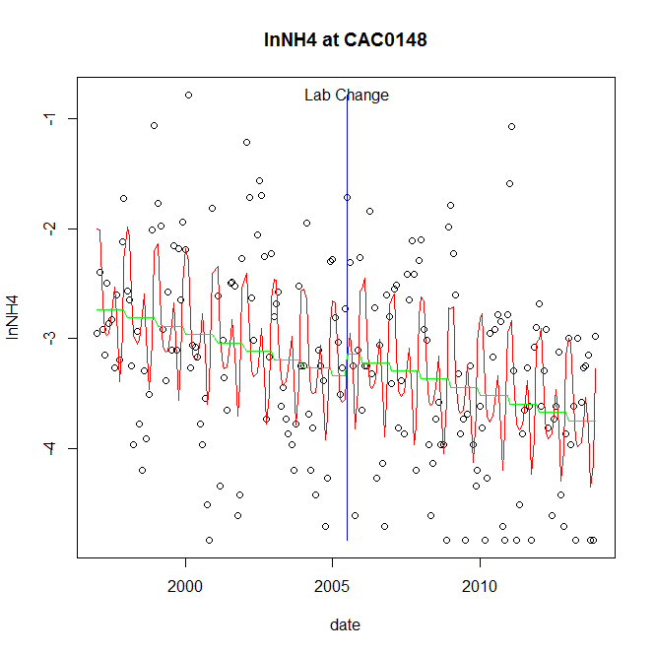

GAM analysis for station CAC0148 dependent variable lnNH4

|  |  |  |  |  |
| --- | --- | --- | --- | --- |
| **Type** | **Source** | **edf** | **F-stat** | **p-value** |
| parametric terms | step | 1 | 0.9864 | 0.3219 |
|  | year | 1 | 840.0005 | <0.0001 |
| smoothed terms | s(year) | 1 | 13.0765 | 0.0004 |
|  | s(doy) | 6.19 | 8.8163 | <0.0001 |

GAM analysis for station CAC0148 dependent variable lnNH4

|  |  |  |  |  |
| --- | --- | --- | --- | --- |
| **parameter** | **estimate** | **Std. Err.** | **t value** | **p-value** |
| (Intercept) | 0.000889 | 0.000246 | 3.6131 | 0.0004 |
| step | 0.200616 | 0.201998 | 0.9932 | 0.3219 |
| year | -0.001656 | 5.7e-05 | -28.9828 | <0.0001 |

root mean-square error = 0.7184

adjusted r-square = 0.3328

station = CAC0148 dependent = lnNO23

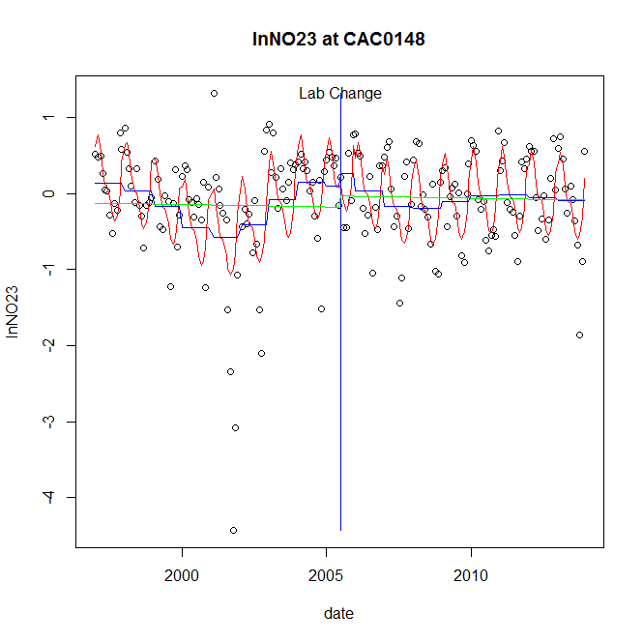

GAM analysis for station CAC0148 dependent variable lnNO23

|  |  |  |  |  |
| --- | --- | --- | --- | --- |
| **Type** | **Source** | **edf** | **F-stat** | **p-value** |
| parametric terms | step | 1 | 0.3293 | 0.5668 |
|  | year | 1 | 1.2921 | 0.2571 |
| smoothed terms | s(year) | 6.39 | 4.4551 | 0.0001 |
|  | s(doy) | 5.43 | 11.8206 | <0.0001 |

GAM analysis for station CAC0148 dependent variable lnNO23

|  |  |  |  |  |
| --- | --- | --- | --- | --- |
| **parameter** | **estimate** | **Std. Err.** | **t value** | **p-value** |
| (Intercept) | 0.000672 | 0.001249 | 0.5383 | 0.5910 |
| step | 0.158948 | 0.276986 | 0.5738 | 0.5668 |
| year | -8.3e-05 | 7.3e-05 | -1.1367 | 0.2571 |

root mean-square error = 0.541

adjusted r-square = 0.381

station = CAC0148 dependent = lnNO2

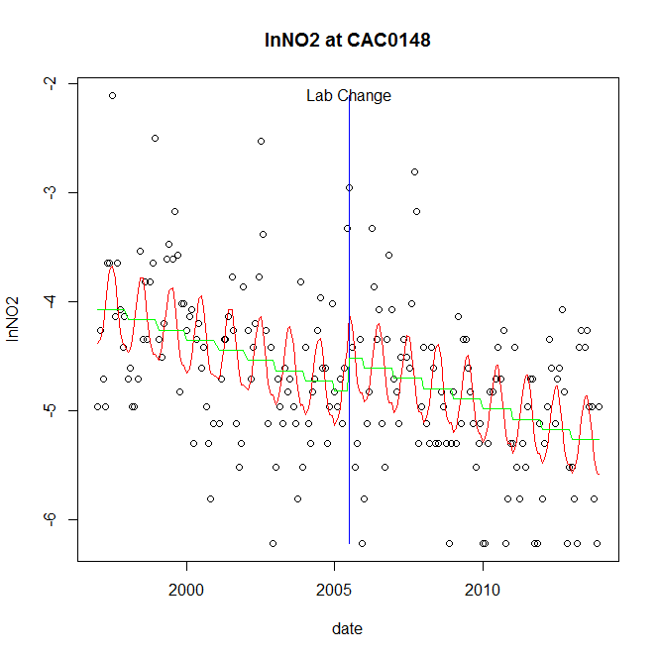

GAM analysis for station CAC0148 dependent variable lnNO2

|  |  |  |  |  |
| --- | --- | --- | --- | --- |
| **Type** | **Source** | **edf** | **F-stat** | **p-value** |
| parametric terms | step | 1 | 3.0844 | 0.0806 |
|  | year | 1 | 2432.0977 | <0.0001 |
| smoothed terms | s(year) | 1 | 26.7898 | <0.0001 |
|  | s(doy) | 3.07 | 5.1403 | <0.0001 |

GAM analysis for station CAC0148 dependent variable lnNO2

|  |  |  |  |  |
| --- | --- | --- | --- | --- |
| **parameter** | **estimate** | **Std. Err.** | **t value** | **p-value** |
| (Intercept) | 0.001092 | 0.000211 | 5.1706 | <0.0001 |
| step | 0.304522 | 0.173393 | 1.7563 | 0.0806 |
| year | -0.002419 | 4.9e-05 | -49.3163 | <0.0001 |

root mean-square error = 0.6172

adjusted r-square = 0.3357

station = CAC0148 dependent = lnTP

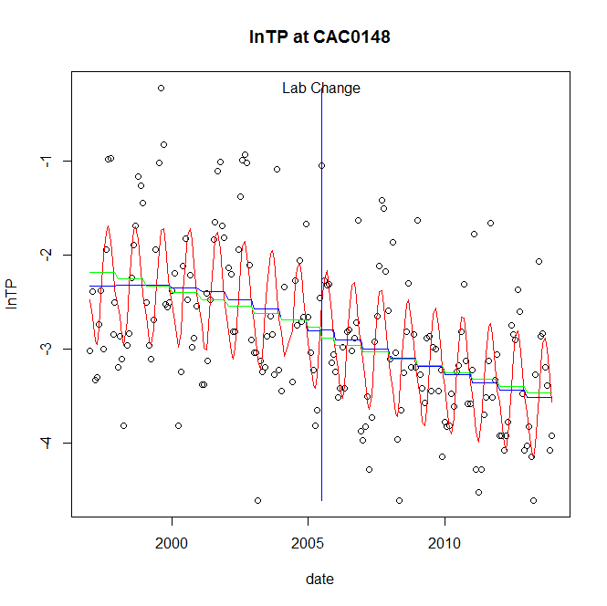

GAM analysis for station CAC0148 dependent variable lnTP

|  |  |  |  |  |
| --- | --- | --- | --- | --- |
| **Type** | **Source** | **edf** | **F-stat** | **p-value** |
| parametric terms | step | 1 | 0 | 0.9955 |
|  | year | 1 | 557.4059 | <0.0001 |
| smoothed terms | s(year) | 2.89 | 5.3615 | 0.0008 |
|  | s(doy) | 3.65 | 12.8062 | <0.0001 |

GAM analysis for station CAC0148 dependent variable lnTP

|  |  |  |  |  |
| --- | --- | --- | --- | --- |
| **parameter** | **estimate** | **Std. Err.** | **t value** | **p-value** |
| (Intercept) | 0.000435 | 0.000559 | 0.7785 | 0.4372 |
| step | 0.00123 | 0.215741 | 0.0057 | 0.9955 |
| year | -0.00141 | 6e-05 | -23.6094 | <0.0001 |

root mean-square error = 0.6046

adjusted r-square = 0.506

station = CAC0148 dependent = lnPO4

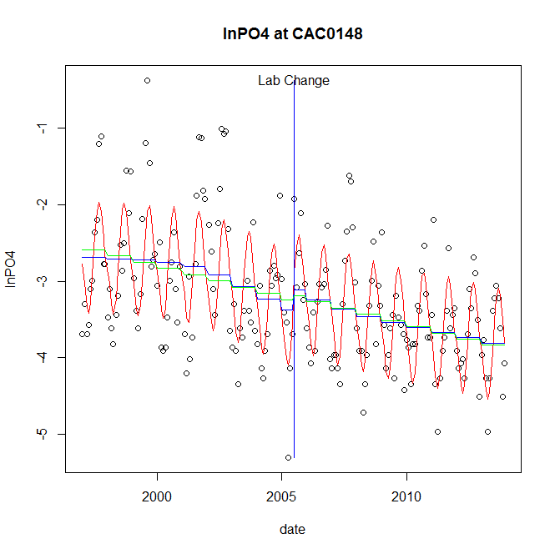

GAM analysis for station CAC0148 dependent variable lnPO4

|  |  |  |  |  |
| --- | --- | --- | --- | --- |
| **Type** | **Source** | **edf** | **F-stat** | **p-value** |
| parametric terms | step | 1 | 1.4643 | 0.2277 |
|  | year | 1 | 825.5013 | <0.0001 |
| smoothed terms | s(year) | 3.4 | 6.0799 | <0.0001 |
|  | s(doy) | 3.72 | 19.0523 | <0.0001 |

GAM analysis for station CAC0148 dependent variable lnPO4

|  |  |  |  |  |
| --- | --- | --- | --- | --- |
| **parameter** | **estimate** | **Std. Err.** | **t value** | **p-value** |
| (Intercept) | 0.000561 | 0.000631 | 0.8888 | 0.3752 |
| step | 0.260907 | 0.21561 | 1.2101 | 0.2277 |
| year | -0.001671 | 5.8e-05 | -28.7315 | <0.0001 |

root mean-square error = 0.5723

adjusted r-square = 0.555

No title given

|  |  |  |  |
| --- | --- | --- | --- |
| **station** | **dep** | **step.est** | **step.pv** |
| CAC0148 | lnTSS | -0.173063 | 0.5000 |
| CAC0148 | lnTN | 0.084831 | 0.5793 |
| CAC0148 | lnNH4 | 0.200616 | 0.3219 |
| CAC0148 | lnNO23 | 0.158948 | 0.5668 |
| CAC0148 | lnNO2 | 0.304522 | 0.0806 |
| CAC0148 | lnTP | 0.00123 | 0.9955 |
| CAC0148 | lnPO4 | 0.260907 | 0.2277 |

station = CAS0479 dependent = lnTSS

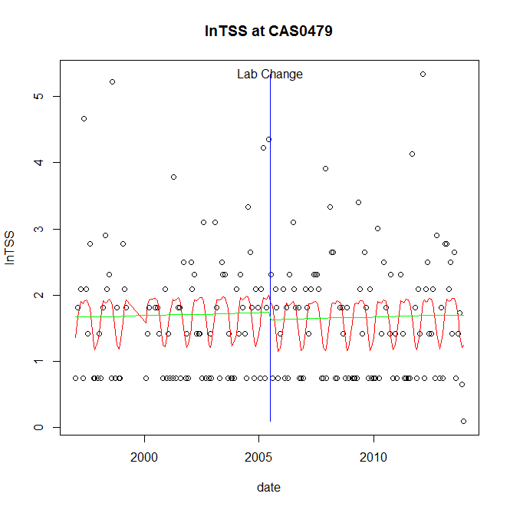

GAM analysis for station CAS0479 dependent variable lnTSS

|  |  |  |  |  |
| --- | --- | --- | --- | --- |
| **Type** | **Source** | **edf** | **F-stat** | **p-value** |
| parametric terms | step | 1 | 0.1652 | 0.6849 |
|  | year | 1 | 126.8321 | <0.0001 |
| smoothed terms | s(year) | 1 | 0.0834 | 0.7731 |
|  | s(doy) | 3.64 | 2.5337 | 0.0001 |

GAM analysis for station CAS0479 dependent variable lnTSS

|  |  |  |  |  |
| --- | --- | --- | --- | --- |
| **parameter** | **estimate** | **Std. Err.** | **t value** | **p-value** |
| (Intercept) | -8.9e-05 | 0.000308 | -0.2874 | 0.7741 |
| step | -0.105021 | 0.258411 | -0.4064 | 0.6849 |
| year | 0.000856 | 7.6e-05 | 11.262 | <0.0001 |

root mean-square error = 0.9126

adjusted r-square = 0.0872

station = CAS0479 dependent = lnTN

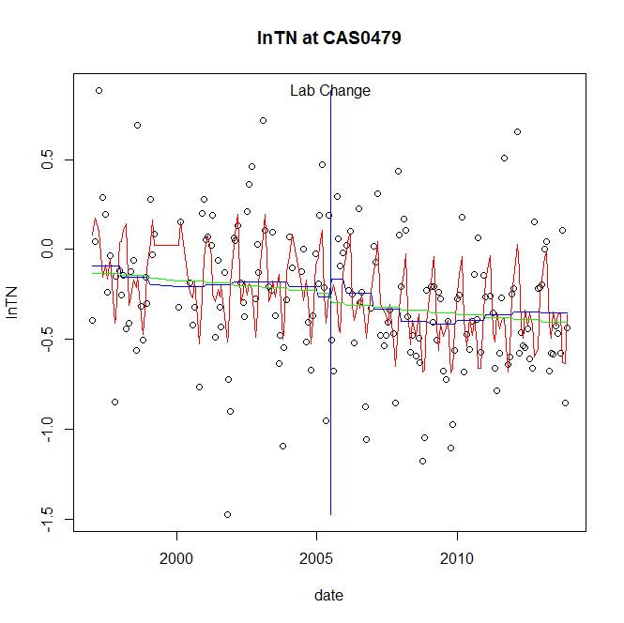

GAM analysis for station CAS0479 dependent variable lnTN

|  |  |  |  |  |
| --- | --- | --- | --- | --- |
| **Type** | **Source** | **edf** | **F-stat** | **p-value** |
| parametric terms | step | 1 | 0.468 | 0.4949 |
|  | year | 1 | 15.4 | 0.0001 |
| smoothed terms | s(year) | 4.55 | 1.1856 | 0.3152 |
|  | s(doy) | 7.21 | 8.175 | <0.0001 |

GAM analysis for station CAS0479 dependent variable lnTN

|  |  |  |  |  |
| --- | --- | --- | --- | --- |
| **parameter** | **estimate** | **Std. Err.** | **t value** | **p-value** |
| (Intercept) | 0.00045 | 0.000519 | 0.866 | 0.3877 |
| step | 0.098026 | 0.143295 | 0.6841 | 0.4949 |
| year | -0.00016 | 4.1e-05 | -3.9243 | 0.0001 |

root mean-square error = 0.3194

adjusted r-square = 0.2984

station = CAS0479 dependent = lnNH4

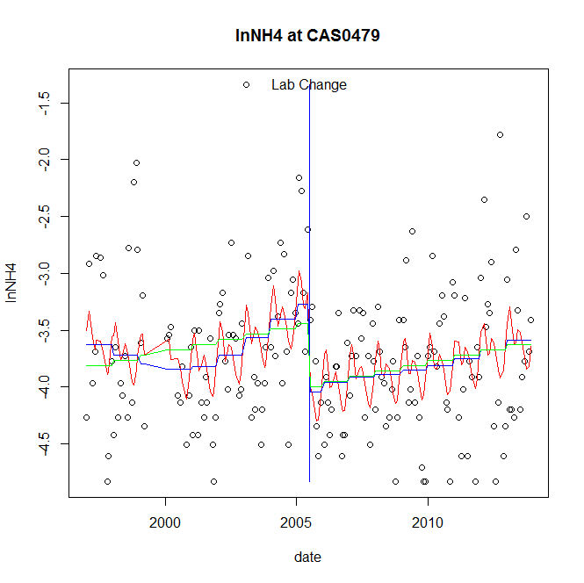

GAM analysis for station CAS0479 dependent variable lnNH4

|  |  |  |  |  |
| --- | --- | --- | --- | --- |
| **Type** | **Source** | **edf** | **F-stat** | **p-value** |
| parametric terms | step | 1 | 10.1844 | 0.0017 |
|  | year | 1 | 590.7239 | <0.0001 |
| smoothed terms | s(year) | 3.94 | 2.6984 | 0.0241 |
|  | s(doy) | 4.61 | 2.0942 | 0.0022 |

GAM analysis for station CAS0479 dependent variable lnNH4

|  |  |  |  |  |
| --- | --- | --- | --- | --- |
| **parameter** | **estimate** | **Std. Err.** | **t value** | **p-value** |
| (Intercept) | 1.8e-05 | 0.000777 | 0.0228 | 0.9819 |
| step | -0.770448 | 0.241421 | -3.1913 | 0.0017 |
| year | -0.001655 | 6.8e-05 | -24.3048 | <0.0001 |

root mean-square error = 0.5892

adjusted r-square = 0.1546

step significant

station = CAS0479 dependent = lnNO23

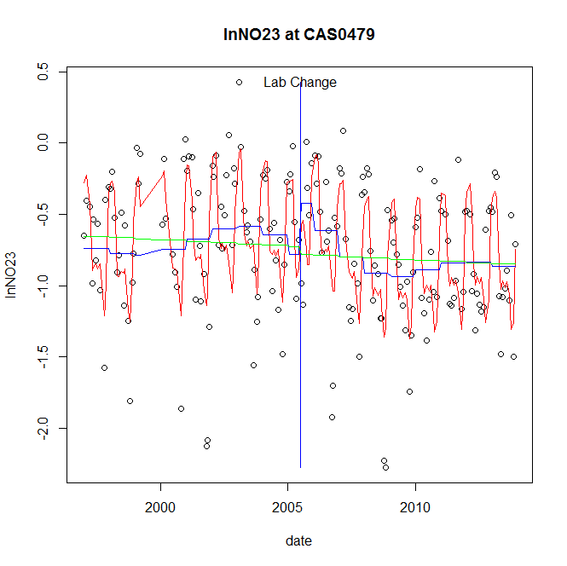

GAM analysis for station CAS0479 dependent variable lnNO23

|  |  |  |  |  |
| --- | --- | --- | --- | --- |
| **Type** | **Source** | **edf** | **F-stat** | **p-value** |
| parametric terms | step | 1 | 4.5898 | 0.0336 |
|  | year | 1 | 99.804 | <0.0001 |
| smoothed terms | s(year) | 5.35 | 3.1265 | 0.0057 |
|  | s(doy) | 7.2 | 20.0404 | <0.0001 |

GAM analysis for station CAS0479 dependent variable lnNO23

|  |  |  |  |  |
| --- | --- | --- | --- | --- |
| **parameter** | **estimate** | **Std. Err.** | **t value** | **p-value** |
| (Intercept) | 0.000479 | 0.000684 | 0.7004 | 0.4846 |
| step | 0.357816 | 0.167019 | 2.1424 | 0.0336 |
| year | -0.000462 | 4.6e-05 | -9.9902 | <0.0001 |

root mean-square error = 0.3516

adjusted r-square = 0.4838

step significant

station = CAS0479 dependent = lnNO2

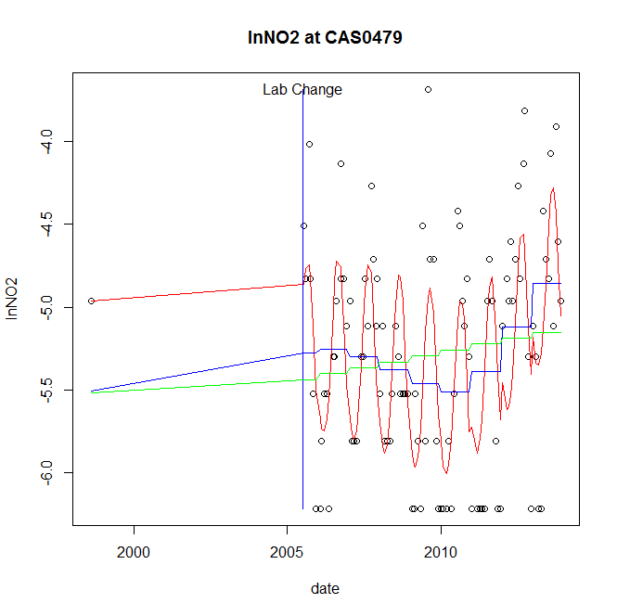

GAM analysis for station CAS0479 dependent variable lnNO2

|  |  |  |  |  |
| --- | --- | --- | --- | --- |
| **Type** | **Source** | **edf** | **F-stat** | **p-value** |
| parametric terms | step | 1 | 0.0044 | 0.9475 |
|  | year | 1 | 4.6959 | 0.0328 |
| smoothed terms | s(year) | 3.34 | 4.255 | 0.0031 |
|  | s(doy) | 3.04 | 8.326 | <0.0001 |

GAM analysis for station CAS0479 dependent variable lnNO2

|  |  |  |  |  |
| --- | --- | --- | --- | --- |
| **parameter** | **estimate** | **Std. Err.** | **t value** | **p-value** |
| (Intercept) | -0.000466 | 0.000882 | -0.5287 | 0.5983 |
| step | 0.167447 | 2.536087 | 0.066 | 0.9475 |
| year | -0.00271 | 0.001251 | -2.167 | 0.0328 |

root mean-square error = 0.4948

adjusted r-square = 0.4613

station = CAS0479 dependent = lnTP

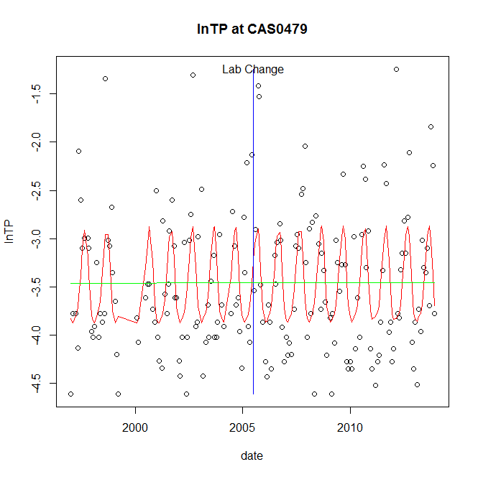

GAM analysis for station CAS0479 dependent variable lnTP

|  |  |  |  |  |
| --- | --- | --- | --- | --- |
| **Type** | **Source** | **edf** | **F-stat** | **p-value** |
| parametric terms | step | 1 | 3e-04 | 0.9852 |
|  | year | 1 | 1016.4275 | <0.0001 |
| smoothed terms | s(year) | 1 | 0.0109 | 0.9169 |
|  | s(doy) | 3.84 | 7.613 | <0.0001 |

GAM analysis for station CAS0479 dependent variable lnTP

|  |  |  |  |  |
| --- | --- | --- | --- | --- |
| **parameter** | **estimate** | **Std. Err.** | **t value** | **p-value** |
| (Intercept) | -2.3e-05 | 0.000216 | -0.1085 | 0.9137 |
| step | 0.003356 | 0.18041 | 0.0186 | 0.9852 |
| year | -0.001732 | 5.4e-05 | -31.8815 | <0.0001 |

root mean-square error = 0.627

adjusted r-square = 0.2459

station = CAS0479 dependent = lnPO4

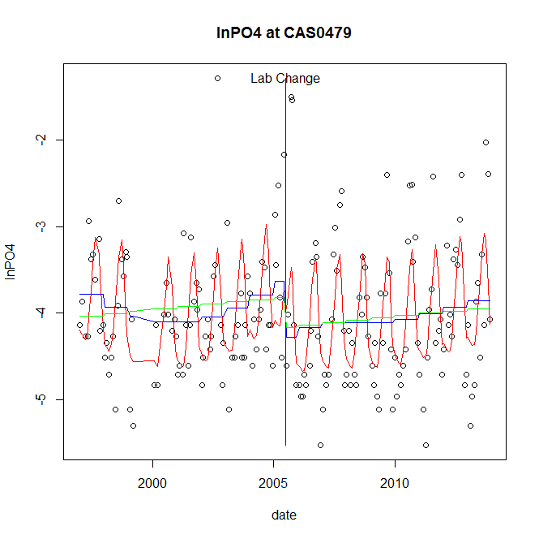

GAM analysis for station CAS0479 dependent variable lnPO4

|  |  |  |  |  |
| --- | --- | --- | --- | --- |
| **Type** | **Source** | **edf** | **F-stat** | **p-value** |
| parametric terms | step | 1 | 6.0334 | 0.0150 |
|  | year | 1 | 621.1994 | <0.0001 |
| smoothed terms | s(year) | 4.15 | 1.9508 | 0.0875 |
|  | s(doy) | 4.81 | 12.7227 | <0.0001 |

GAM analysis for station CAS0479 dependent variable lnPO4

|  |  |  |  |  |
| --- | --- | --- | --- | --- |
| **parameter** | **estimate** | **Std. Err.** | **t value** | **p-value** |
| (Intercept) | 0.000458 | 0.000884 | 0.5183 | 0.6049 |
| step | -0.646465 | 0.263188 | -2.4563 | 0.0150 |
| year | -0.001837 | 7.4e-05 | -24.9239 | <0.0001 |

root mean-square error = 0.6277

adjusted r-square = 0.3578

step significant

No title given

|  |  |  |  |
| --- | --- | --- | --- |
| **station** | **dep** | **step.est** | **step.pv** |
| CAS0479 | lnTSS | -0.105021 | 0.6849 |
| CAS0479 | lnTN | 0.098026 | 0.4949 |
| CAS0479 | lnNH4 | -0.770448 | 0.0017 |
| CAS0479 | lnNO23 | 0.357816 | 0.0336 |
| CAS0479 | lnNO2 | 0.167447 | 0.9475 |
| CAS0479 | lnTP | 0.003356 | 0.9852 |
| CAS0479 | lnPO4 | -0.646465 | 0.0150 |

station = CCR0001 dependent = lnTSS

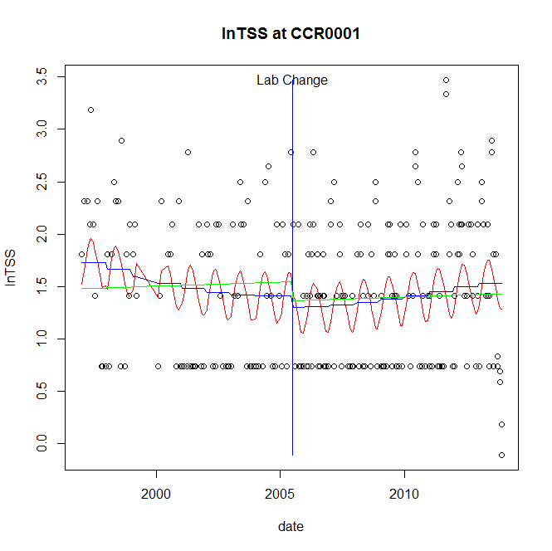

GAM analysis for station CCR0001 dependent variable lnTSS

|  |  |  |  |  |
| --- | --- | --- | --- | --- |
| **Type** | **Source** | **edf** | **F-stat** | **p-value** |
| parametric terms | step | 1 | 0.3835 | 0.5362 |
|  | year | 1 | 138.5007 | <0.0001 |
| smoothed terms | s(year) | 2.27 | 2.1172 | 0.1023 |
|  | s(doy) | 2.58 | 2.8018 | <0.0001 |

GAM analysis for station CCR0001 dependent variable lnTSS

|  |  |  |  |  |
| --- | --- | --- | --- | --- |
| **parameter** | **estimate** | **Std. Err.** | **t value** | **p-value** |
| (Intercept) | 0.000177 | 0.000317 | 0.5571 | 0.5779 |
| step | -0.109352 | 0.17657 | -0.6193 | 0.5362 |
| year | 0.000748 | 6.4e-05 | 11.7686 | <0.0001 |

root mean-square error = 0.6472

adjusted r-square = 0.0991

station = CCR0001 dependent = lnTN

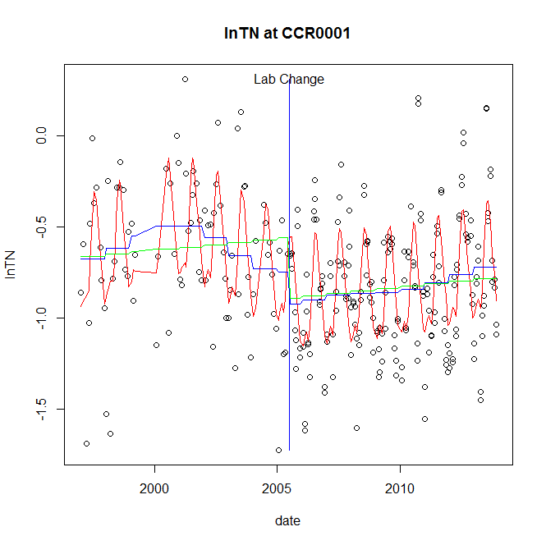

GAM analysis for station CCR0001 dependent variable lnTN

|  |  |  |  |  |
| --- | --- | --- | --- | --- |
| **Type** | **Source** | **edf** | **F-stat** | **p-value** |
| parametric terms | step | 1 | 2.2501 | 0.1348 |
|  | year | 1 | 58.889 | <0.0001 |
| smoothed terms | s(year) | 5.26 | 2.8034 | 0.0111 |
|  | s(doy) | 5.92 | 20.7166 | <0.0001 |

GAM analysis for station CCR0001 dependent variable lnTN

|  |  |  |  |  |
| --- | --- | --- | --- | --- |
| **parameter** | **estimate** | **Std. Err.** | **t value** | **p-value** |
| (Intercept) | -0.000526 | 0.000423 | -1.2437 | 0.2147 |
| step | -0.176878 | 0.117916 | -1.5 | 0.1348 |
| year | -0.000323 | 4.2e-05 | -7.6739 | <0.0001 |

root mean-square error = 0.2911

adjusted r-square = 0.4193

station = CCR0001 dependent = lnNH4

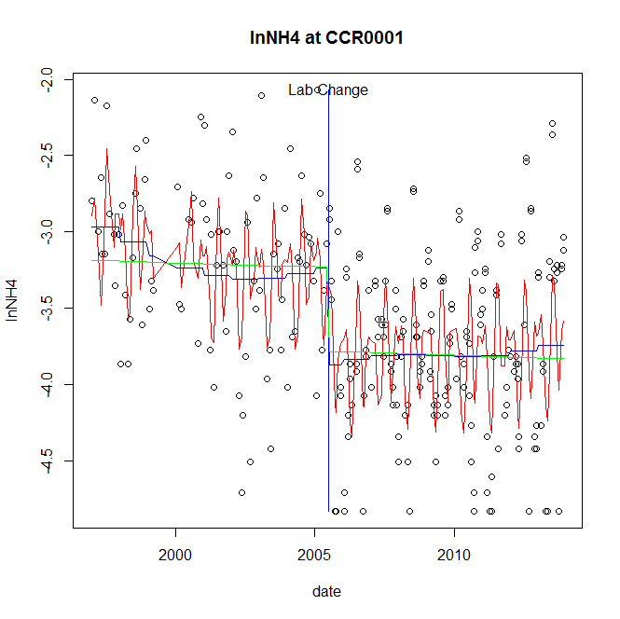

GAM analysis for station CCR0001 dependent variable lnNH4

|  |  |  |  |  |
| --- | --- | --- | --- | --- |
| **Type** | **Source** | **edf** | **F-stat** | **p-value** |
| parametric terms | step | 1 | 14.37 | 0.0002 |
|  | year | 1 | 692.852 | <0.0001 |
| smoothed terms | s(year) | 3.56 | 1.5281 | 0.1875 |
|  | s(doy) | 6.96 | 11.939 | <0.0001 |

GAM analysis for station CCR0001 dependent variable lnNH4

|  |  |  |  |  |
| --- | --- | --- | --- | --- |
| **parameter** | **estimate** | **Std. Err.** | **t value** | **p-value** |
| (Intercept) | 0.000282 | 0.000443 | 0.6373 | 0.5245 |
| step | -0.638152 | 0.168344 | -3.7908 | 0.0002 |
| year | -0.001577 | 6e-05 | -26.3221 | <0.0001 |

root mean-square error = 0.5067

adjusted r-square = 0.3909

step significant

station = CCR0001 dependent = lnNO23

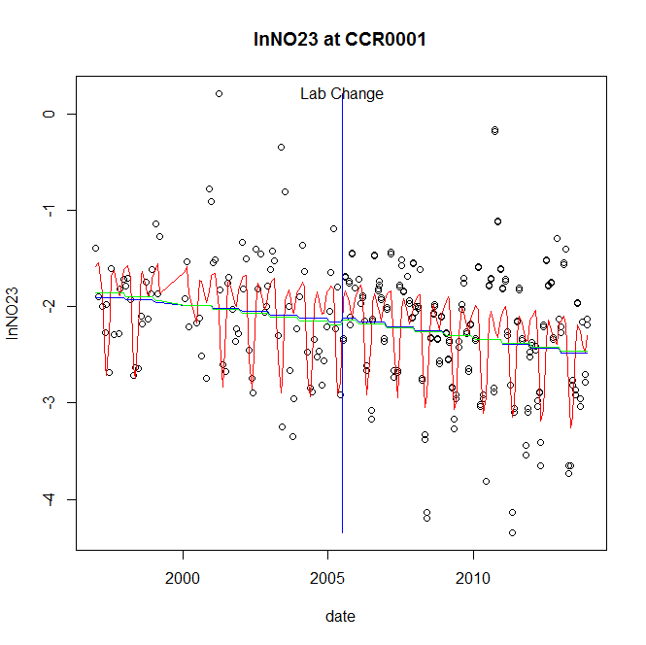

GAM analysis for station CCR0001 dependent variable lnNO23

|  |  |  |  |  |
| --- | --- | --- | --- | --- |
| **Type** | **Source** | **edf** | **F-stat** | **p-value** |
| parametric terms | step | 1 | 0.1096 | 0.7409 |
|  | year | 1 | 542.1833 | <0.0001 |
| smoothed terms | s(year) | 1.51 | 4.5461 | 0.0143 |
|  | s(doy) | 6.62 | 17.1797 | <0.0001 |

GAM analysis for station CCR0001 dependent variable lnNO23

|  |  |  |  |  |
| --- | --- | --- | --- | --- |
| **parameter** | **estimate** | **Std. Err.** | **t value** | **p-value** |
| (Intercept) | 0.000366 | 0.000164 | 2.2395 | 0.0259 |
| step | 0.043141 | 0.130332 | 0.331 | 0.7409 |
| year | -0.001108 | 4.8e-05 | -23.2848 | <0.0001 |

root mean-square error = 0.5304

adjusted r-square = 0.3708

station = CCR0001 dependent = lnNO2

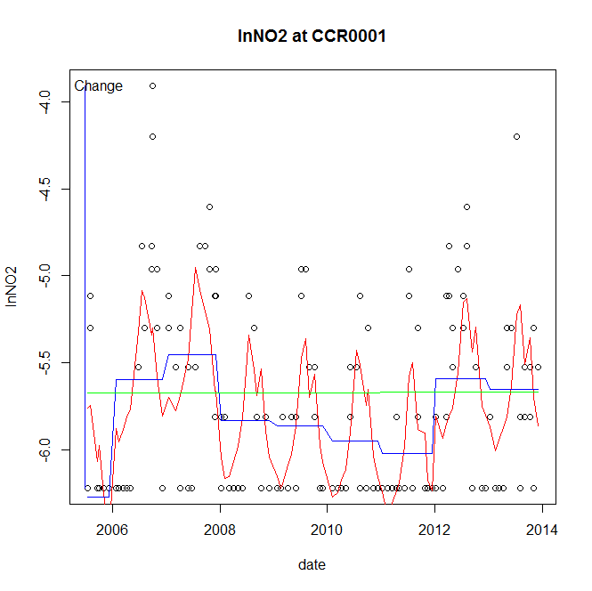

GAM analysis for station CCR0001 dependent variable lnNO2

|  |  |  |  |  |
| --- | --- | --- | --- | --- |
| **Type** | **Source** | **edf** | **F-stat** | **p-value** |
| parametric terms | step | 1 | 4.4762 | 0.0357 |
|  | year | 1 | 37517.6782 | <0.0001 |
| smoothed terms | s(year) | 6.52 | 7.7119 | <0.0001 |
|  | s(doy) | 7.26 | 11.0433 | <0.0001 |

GAM analysis for station CCR0001 dependent variable lnNO2

|  |  |  |  |  |
| --- | --- | --- | --- | --- |
| **parameter** | **estimate** | **Std. Err.** | **t value** | **p-value** |
| (Intercept) | -0.000844 | 0.000399 | -2.1157 | 0.0357 |
| step | -0.000844 | 0.000399 | -2.1157 | 0.0357 |
| year | -0.002869 | 1.5e-05 | -193.6948 | <0.0001 |

root mean-square error = 0.4208

adjusted r-square = 0.3956

step significant

station = CCR0001 dependent = lnTP

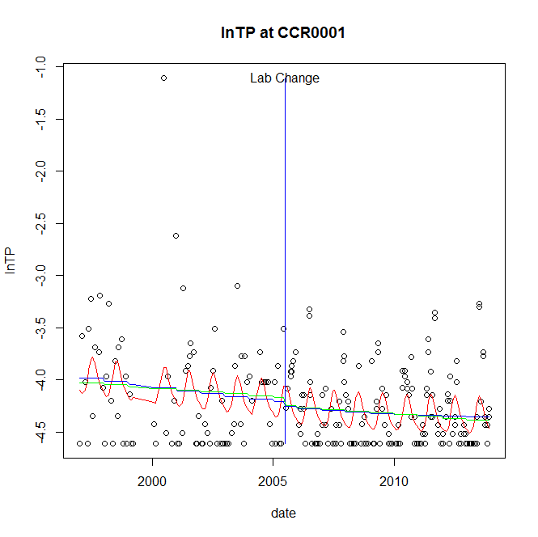

GAM analysis for station CCR0001 dependent variable lnTP

|  |  |  |  |  |
| --- | --- | --- | --- | --- |
| **Type** | **Source** | **edf** | **F-stat** | **p-value** |
| parametric terms | step | 1 | 0.2579 | 0.6120 |
|  | year | 1 | 3264.2556 | <0.0001 |
| smoothed terms | s(year) | 1.68 | 1.8304 | 0.1604 |
|  | s(doy) | 3.22 | 3.8147 | <0.0001 |

GAM analysis for station CCR0001 dependent variable lnTP

|  |  |  |  |  |
| --- | --- | --- | --- | --- |
| **parameter** | **estimate** | **Std. Err.** | **t value** | **p-value** |
| (Intercept) | 0.00018 | 0.000135 | 1.3341 | 0.1833 |
| step | -0.050795 | 0.100022 | -0.5078 | 0.6120 |
| year | -0.002105 | 3.7e-05 | -57.1337 | <0.0001 |

root mean-square error = 0.3928

adjusted r-square = 0.1544

station = CCR0001 dependent = lnPO4

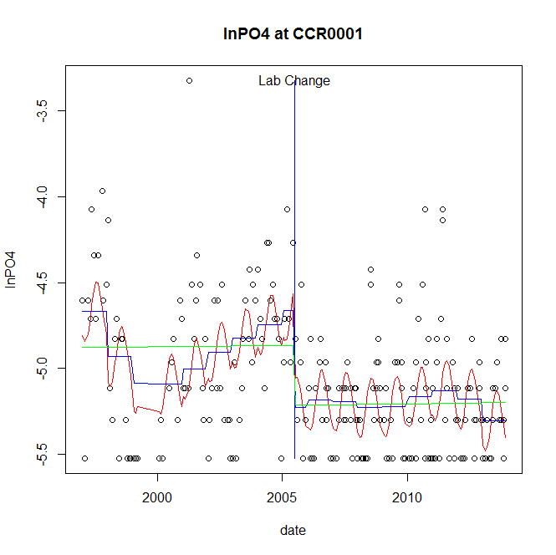

GAM analysis for station CCR0001 dependent variable lnPO4

|  |  |  |  |  |
| --- | --- | --- | --- | --- |
| **Type** | **Source** | **edf** | **F-stat** | **p-value** |
| parametric terms | step | 1 | 17.2846 | <0.0001 |
|  | year | 1 | 2402.3082 | <0.0001 |
| smoothed terms | s(year) | 6.19 | 3.5063 | 0.0015 |
|  | s(doy) | 2.61 | 6.2289 | <0.0001 |

GAM analysis for station CCR0001 dependent variable lnPO4

|  |  |  |  |  |
| --- | --- | --- | --- | --- |
| **parameter** | **estimate** | **Std. Err.** | **t value** | **p-value** |
| (Intercept) | 0.002162 | 0.000568 | 3.8043 | 0.0002 |
| step | -0.567139 | 0.136414 | -4.1575 | <0.0001 |
| year | -0.00235 | 4.8e-05 | -49.0133 | <0.0001 |

root mean-square error = 0.3188

adjusted r-square = 0.3193

step significant

No title given

|  |  |  |  |
| --- | --- | --- | --- |
| **station** | **dep** | **step.est** | **step.pv** |
| CCR0001 | lnTSS | -0.109352 | 0.5362 |
| CCR0001 | lnTN | -0.176878 | 0.1348 |
| CCR0001 | lnNH4 | -0.638152 | 0.0002 |
| CCR0001 | lnNO23 | 0.043141 | 0.7409 |
| CCR0001 | lnNO2 | -0.000844 | 0.0357 |
| CCR0001 | lnTP | -0.050795 | 0.6120 |
| CCR0001 | lnPO4 | -0.567139 | <0.0001 |

station = CHO0626 dependent = lnTSS

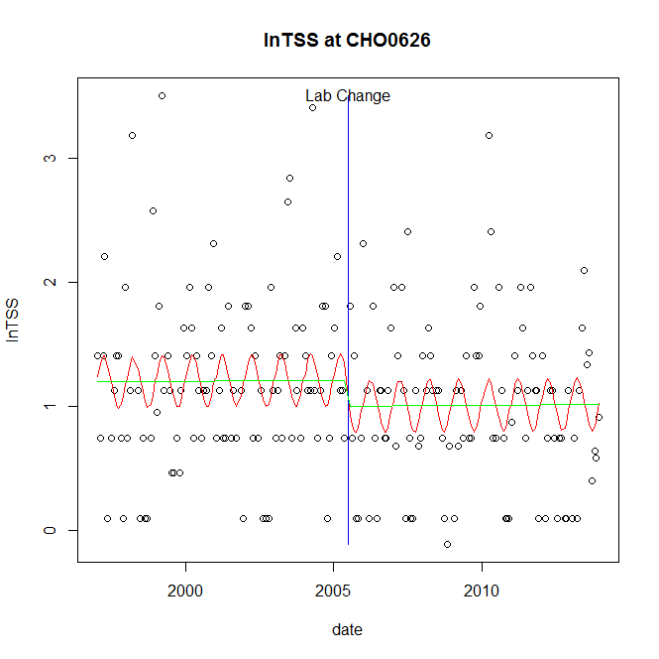

GAM analysis for station CHO0626 dependent variable lnTSS

|  |  |  |  |  |
| --- | --- | --- | --- | --- |
| **Type** | **Source** | **edf** | **F-stat** | **p-value** |
| parametric terms | step | 1 | 1.2712 | 0.2609 |
|  | year | 1 | 131.5373 | <0.0001 |
| smoothed terms | s(year) | 1 | 0.0048 | 0.9448 |
|  | s(doy) | 2.13 | 1.5158 | 0.0009 |

GAM analysis for station CHO0626 dependent variable lnTSS

|  |  |  |  |  |
| --- | --- | --- | --- | --- |
| **parameter** | **estimate** | **Std. Err.** | **t value** | **p-value** |
| (Intercept) | -1.5e-05 | 0.000228 | -0.068 | 0.9459 |
| step | -0.21136 | 0.187461 | -1.1275 | 0.2609 |
| year | 0.000603 | 5.3e-05 | 11.469 | <0.0001 |

root mean-square error = 0.6617

adjusted r-square = 0.076

station = CHO0626 dependent = lnTN

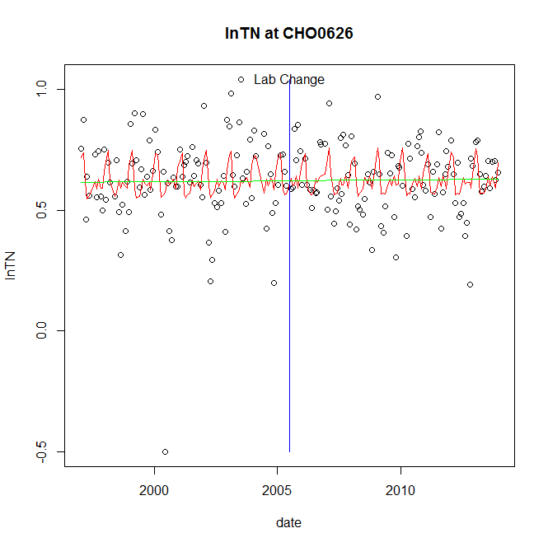

GAM analysis for station CHO0626 dependent variable lnTN

|  |  |  |  |  |
| --- | --- | --- | --- | --- |
| **Type** | **Source** | **edf** | **F-stat** | **p-value** |
| parametric terms | step | 1 | 0.001 | 0.9750 |
|  | year | 1 | 551.6456 | <0.0001 |
| smoothed terms | s(year) | 1 | 0.0043 | 0.9478 |
|  | s(doy) | 6.79 | 3.2494 | 0.0004 |

GAM analysis for station CHO0626 dependent variable lnTN

|  |  |  |  |  |
| --- | --- | --- | --- | --- |
| **parameter** | **estimate** | **Std. Err.** | **t value** | **p-value** |
| (Intercept) | -4e-06 | 5.7e-05 | -0.0629 | 0.9499 |
| step | 0.00146 | 0.04662 | 0.0313 | 0.9750 |
| year | 0.000311 | 1.3e-05 | 23.4871 | <0.0001 |

root mean-square error = 0.1602

adjusted r-square = 0.0946

station = CHO0626 dependent = lnNH4

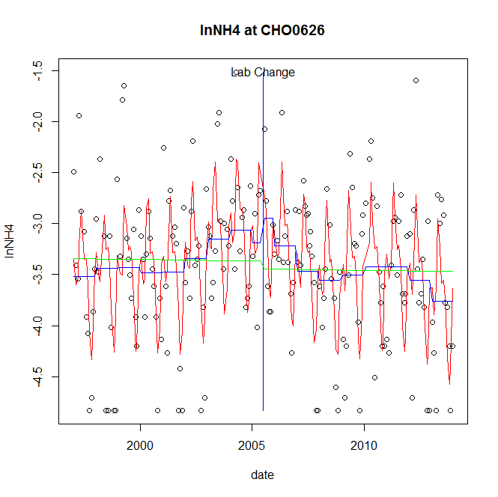

GAM analysis for station CHO0626 dependent variable lnNH4

|  |  |  |  |  |
| --- | --- | --- | --- | --- |
| **Type** | **Source** | **edf** | **F-stat** | **p-value** |
| parametric terms | step | 1 | 0.678 | 0.4113 |
|  | year | 1 | 520.0459 | <0.0001 |
| smoothed terms | s(year) | 5.98 | 3.1503 | 0.0043 |
|  | s(doy) | 7.08 | 14.2385 | <0.0001 |

GAM analysis for station CHO0626 dependent variable lnNH4

|  |  |  |  |  |
| --- | --- | --- | --- | --- |
| **parameter** | **estimate** | **Std. Err.** | **t value** | **p-value** |
| (Intercept) | 0.000724 | 0.001234 | 0.587 | 0.5579 |
| step | 0.244402 | 0.296819 | 0.8234 | 0.4113 |
| year | -0.001766 | 7.7e-05 | -22.8045 | <0.0001 |

root mean-square error = 0.5796

adjusted r-square = 0.393

station = CHO0626 dependent = lnNO23

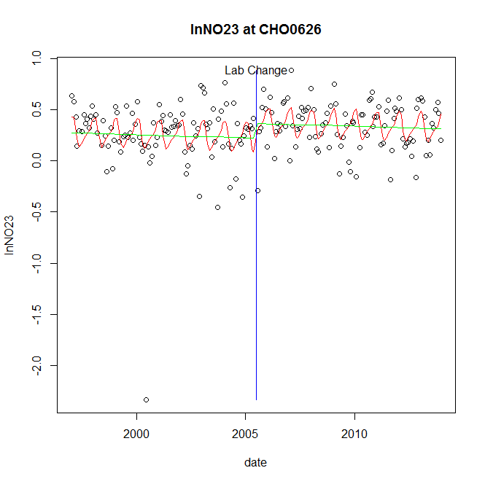

GAM analysis for station CHO0626 dependent variable lnNO23

|  |  |  |  |  |
| --- | --- | --- | --- | --- |
| **Type** | **Source** | **edf** | **F-stat** | **p-value** |
| parametric terms | step | 1 | 3.4193 | 0.0660 |
|  | year | 1 | 26.7233 | <0.0001 |
| smoothed terms | s(year) | 1 | 0.5918 | 0.4427 |
|  | s(doy) | 4.19 | 3.2221 | <0.0001 |

GAM analysis for station CHO0626 dependent variable lnNO23

|  |  |  |  |  |
| --- | --- | --- | --- | --- |
| **parameter** | **estimate** | **Std. Err.** | **t value** | **p-value** |
| (Intercept) | 7.3e-05 | 9.5e-05 | 0.7699 | 0.4423 |
| step | 0.144671 | 0.078237 | 1.8491 | 0.0660 |
| year | 0.000113 | 2.2e-05 | 5.1695 | <0.0001 |

root mean-square error = 0.2761

adjusted r-square = 0.1239

station = CHO0626 dependent = lnNO2

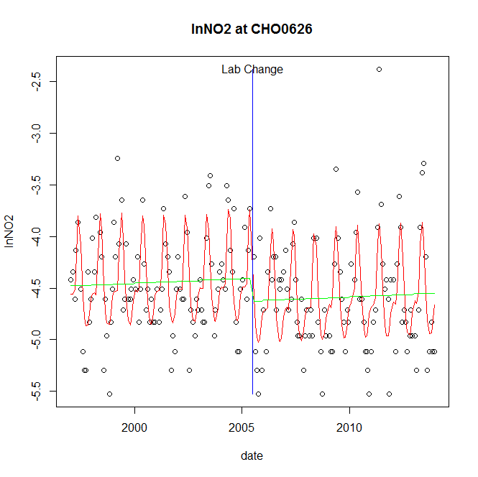

GAM analysis for station CHO0626 dependent variable lnNO2

|  |  |  |  |  |
| --- | --- | --- | --- | --- |
| **Type** | **Source** | **edf** | **F-stat** | **p-value** |
| parametric terms | step | 1 | 4.1631 | 0.0427 |
|  | year | 1 | 5229.5195 | <0.0001 |
| smoothed terms | s(year) | 1 | 1.0391 | 0.3093 |
|  | s(doy) | 5.95 | 19.8005 | <0.0001 |

GAM analysis for station CHO0626 dependent variable lnNO2

|  |  |  |  |  |
| --- | --- | --- | --- | --- |
| **parameter** | **estimate** | **Std. Err.** | **t value** | **p-value** |
| (Intercept) | -0.000136 | 0.000132 | -1.0277 | 0.3054 |
| step | -0.221777 | 0.108695 | -2.0404 | 0.0427 |
| year | -0.002202 | 3e-05 | -72.3154 | <0.0001 |

root mean-square error = 0.3835

adjusted r-square = 0.455

step significant

station = CHO0626 dependent = lnTP

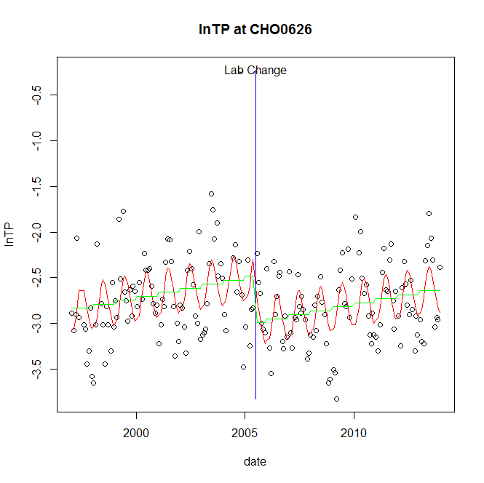

GAM analysis for station CHO0626 dependent variable lnTP

|  |  |  |  |  |
| --- | --- | --- | --- | --- |
| **Type** | **Source** | **edf** | **F-stat** | **p-value** |
| parametric terms | step | 1 | 18.9697 | <0.0001 |
|  | year | 1 | 1406.7908 | <0.0001 |
| smoothed terms | s(year) | 1 | 14.4477 | 0.0002 |
|  | s(doy) | 2.85 | 5.4899 | <0.0001 |

GAM analysis for station CHO0626 dependent variable lnTP

|  |  |  |  |  |
| --- | --- | --- | --- | --- |
| **parameter** | **estimate** | **Std. Err.** | **t value** | **p-value** |
| (Intercept) | -0.000541 | 0.000142 | -3.8057 | 0.0002 |
| step | -0.507463 | 0.116513 | -4.3554 | <0.0001 |
| year | -0.001243 | 3.3e-05 | -37.5072 | <0.0001 |

root mean-square error = 0.4031

adjusted r-square = 0.2401

step significant

station = CHO0626 dependent = lnPO4

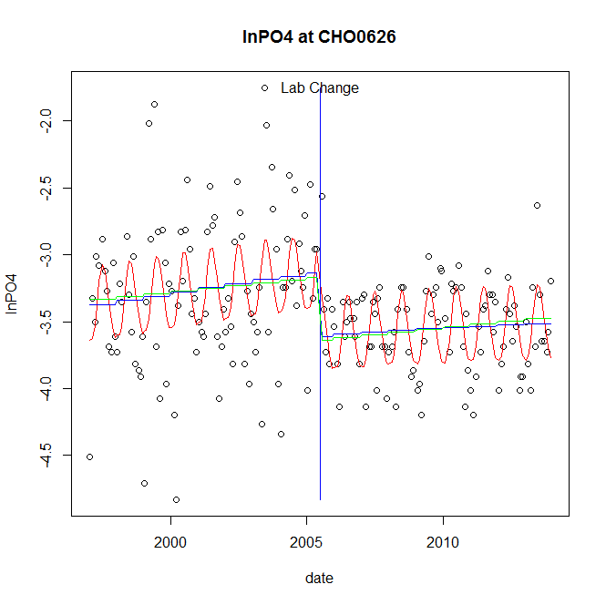

GAM analysis for station CHO0626 dependent variable lnPO4

|  |  |  |  |  |
| --- | --- | --- | --- | --- |
| **Type** | **Source** | **edf** | **F-stat** | **p-value** |
| parametric terms | step | 1 | 15.4132 | 0.0001 |
|  | year | 1 | 2229.2957 | <0.0001 |
| smoothed terms | s(year) | 1.63 | 2.4831 | 0.0863 |
|  | s(doy) | 2.95 | 6.6047 | <0.0001 |

GAM analysis for station CHO0626 dependent variable lnPO4

|  |  |  |  |  |
| --- | --- | --- | --- | --- |
| **parameter** | **estimate** | **Std. Err.** | **t value** | **p-value** |
| (Intercept) | -0.00026 | 0.000183 | -1.4182 | 0.1577 |
| step | -0.474076 | 0.120754 | -3.926 | 0.0001 |
| year | -0.001586 | 3.4e-05 | -47.2154 | <0.0001 |

root mean-square error = 0.4115

adjusted r-square = 0.2862

step significant

No title given

|  |  |  |  |
| --- | --- | --- | --- |
| **station** | **dep** | **step.est** | **step.pv** |
| CHO0626 | lnTSS | -0.21136 | 0.2609 |
| CHO0626 | lnTN | 0.00146 | 0.9750 |
| CHO0626 | lnNH4 | 0.244402 | 0.4113 |
| CHO0626 | lnNO23 | 0.144671 | 0.0660 |
| CHO0626 | lnNO2 | -0.221777 | 0.0427 |
| CHO0626 | lnTP | -0.507463 | <0.0001 |
| CHO0626 | lnPO4 | -0.474076 | 0.0001 |

station = CJB0005 dependent = lnTSS

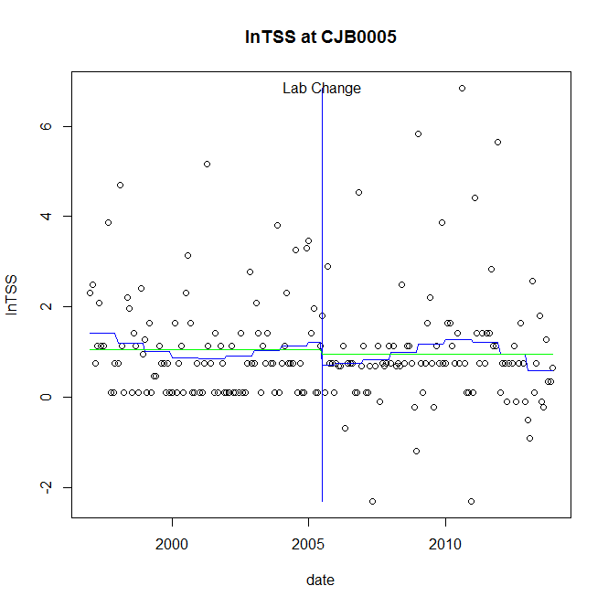

GAM analysis for station CJB0005 dependent variable lnTSS

|  |  |  |  |  |
| --- | --- | --- | --- | --- |
| **Type** | **Source** | **edf** | **F-stat** | **p-value** |
| parametric terms | step | 1 | 0.9595 | 0.3285 |
|  | year | 1 | 21.2852 | <0.0001 |
| smoothed terms | s(year) | 4.45 | 1.2324 | 0.2920 |
|  | s(doy) | 0 | 0 | 0.8854 |

GAM analysis for station CJB0005 dependent variable lnTSS

|  |  |  |  |  |
| --- | --- | --- | --- | --- |
| **parameter** | **estimate** | **Std. Err.** | **t value** | **p-value** |
| (Intercept) | 0.003718 | 0.00183 | 2.0322 | 0.0435 |
| step | -0.502248 | 0.512747 | -0.9795 | 0.3285 |
| year | 0.000624 | 0.000135 | 4.6136 | <0.0001 |

root mean-square error = 1.2178

adjusted r-square = 0.0242

station = CJB0005 dependent = lnTN

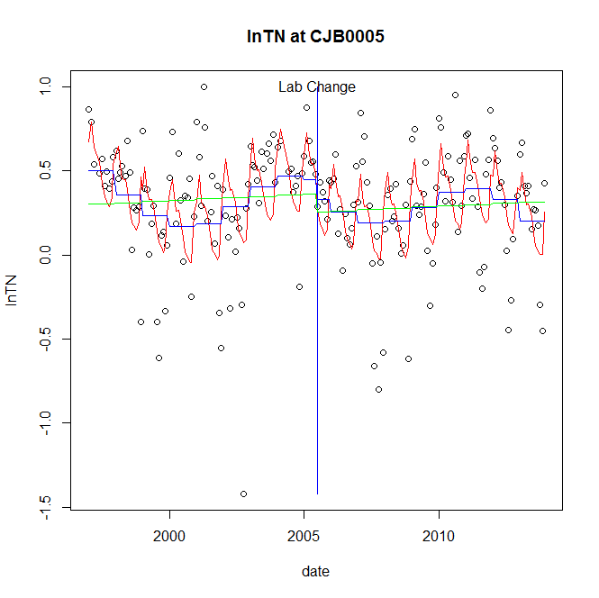

GAM analysis for station CJB0005 dependent variable lnTN

|  |  |  |  |  |
| --- | --- | --- | --- | --- |
| **Type** | **Source** | **edf** | **F-stat** | **p-value** |
| parametric terms | step | 1 | 0.5981 | 0.4403 |
|  | year | 1 | 21.6292 | <0.0001 |
| smoothed terms | s(year) | 5.85 | 3.6346 | 0.0014 |
|  | s(doy) | 5.82 | 7.2496 | <0.0001 |

GAM analysis for station CJB0005 dependent variable lnTN

|  |  |  |  |  |
| --- | --- | --- | --- | --- |
| **parameter** | **estimate** | **Std. Err.** | **t value** | **p-value** |
| (Intercept) | 0.001687 | 0.000629 | 2.6806 | 0.0080 |
| step | -0.114327 | 0.147833 | -0.7734 | 0.4403 |
| year | 0.000183 | 3.9e-05 | 4.6507 | <0.0001 |

root mean-square error = 0.2996

adjusted r-square = 0.2895

station = CJB0005 dependent = lnNH4

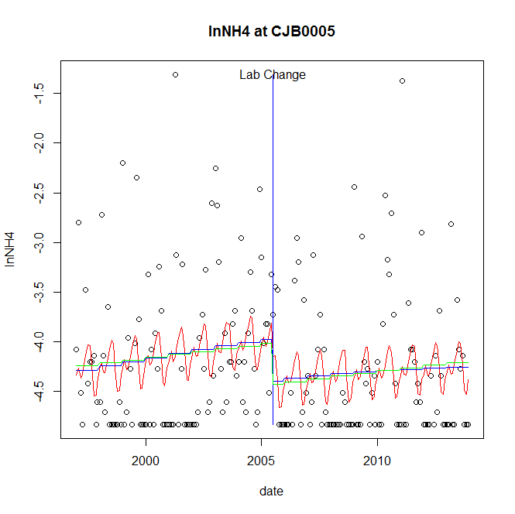

GAM analysis for station CJB0005 dependent variable lnNH4

|  |  |  |  |  |
| --- | --- | --- | --- | --- |
| **Type** | **Source** | **edf** | **F-stat** | **p-value** |
| parametric terms | step | 1 | 4.1251 | 0.0436 |
|  | year | 1 | 1207.2609 | <0.0001 |
| smoothed terms | s(year) | 1.52 | 1.8592 | 0.1582 |
|  | s(doy) | 4.28 | 1.6093 | 0.0095 |

GAM analysis for station CJB0005 dependent variable lnNH4

|  |  |  |  |  |
| --- | --- | --- | --- | --- |
| **parameter** | **estimate** | **Std. Err.** | **t value** | **p-value** |
| (Intercept) | -0.000319 | 0.000299 | -1.0662 | 0.2877 |
| step | -0.419865 | 0.206724 | -2.031 | 0.0436 |
| year | -0.002003 | 5.8e-05 | -34.7457 | <0.0001 |

root mean-square error = 0.7174

adjusted r-square = 0.0697

step significant

station = CJB0005 dependent = lnNO23

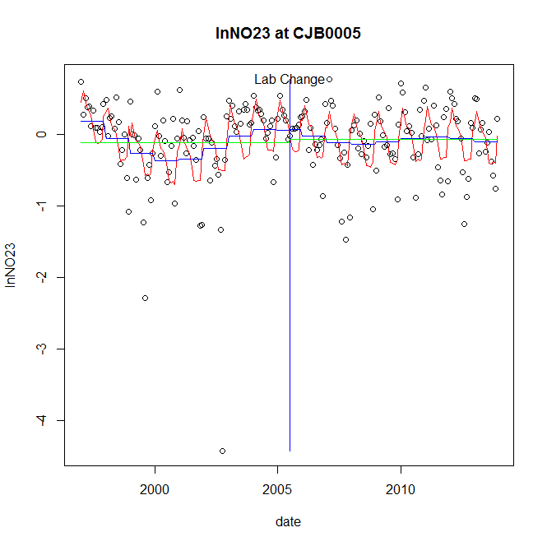

GAM analysis for station CJB0005 dependent variable lnNO23

|  |  |  |  |  |
| --- | --- | --- | --- | --- |
| **Type** | **Source** | **edf** | **F-stat** | **p-value** |
| parametric terms | step | 1 | 5e-04 | 0.9823 |
|  | year | 1 | 0.5046 | 0.4783 |
| smoothed terms | s(year) | 5.34 | 3.0744 | 0.0062 |
|  | s(doy) | 5.89 | 7.032 | <0.0001 |

GAM analysis for station CJB0005 dependent variable lnNO23

|  |  |  |  |  |
| --- | --- | --- | --- | --- |
| **parameter** | **estimate** | **Std. Err.** | **t value** | **p-value** |
| (Intercept) | 0.001795 | 0.000903 | 1.9867 | 0.0484 |
| step | 0.005044 | 0.227134 | 0.0222 | 0.9823 |
| year | -4.2e-05 | 5.9e-05 | -0.7104 | 0.4783 |

root mean-square error = 0.4874

adjusted r-square = 0.2622

station = CJB0005 dependent = lnNO2

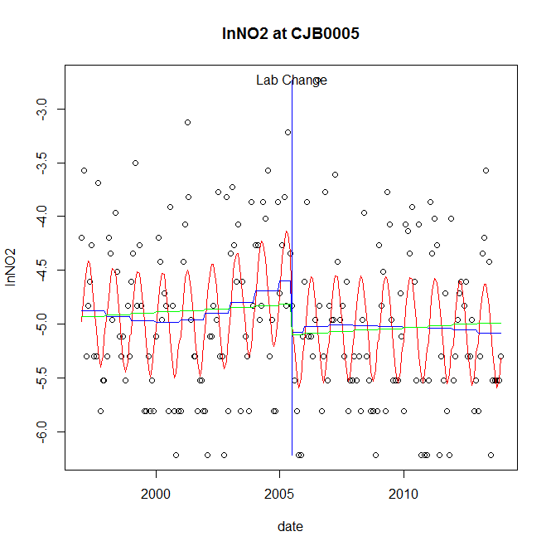

GAM analysis for station CJB0005 dependent variable lnNO2

|  |  |  |  |  |
| --- | --- | --- | --- | --- |
| **Type** | **Source** | **edf** | **F-stat** | **p-value** |
| parametric terms | step | 1 | 3.8487 | 0.0512 |
|  | year | 1 | 1356.2471 | <0.0001 |
| smoothed terms | s(year) | 3.46 | 1.2417 | 0.2916 |
|  | s(doy) | 3.16 | 7.7712 | <0.0001 |

GAM analysis for station CJB0005 dependent variable lnNO2

|  |  |  |  |  |
| --- | --- | --- | --- | --- |
| **parameter** | **estimate** | **Std. Err.** | **t value** | **p-value** |
| (Intercept) | 0.000471 | 0.00071 | 0.6639 | 0.5075 |
| step | -0.472894 | 0.241051 | -1.9618 | 0.0512 |
| year | -0.002359 | 6.4e-05 | -36.8273 | <0.0001 |

root mean-square error = 0.6363

adjusted r-square = 0.2704

station = CJB0005 dependent = lnTP

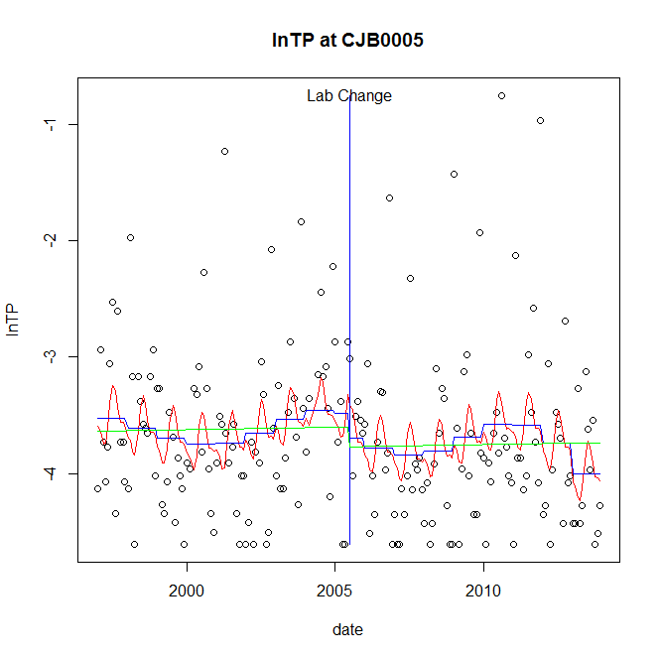

GAM analysis for station CJB0005 dependent variable lnTP

|  |  |  |  |  |
| --- | --- | --- | --- | --- |
| **Type** | **Source** | **edf** | **F-stat** | **p-value** |
| parametric terms | step | 1 | 0.4401 | 0.5079 |
|  | year | 1 | 427.0297 | <0.0001 |
| smoothed terms | s(year) | 5.19 | 1.2816 | 0.2667 |
|  | s(doy) | 3.59 | 1.4907 | 0.0076 |

GAM analysis for station CJB0005 dependent variable lnTP

|  |  |  |  |  |
| --- | --- | --- | --- | --- |
| **parameter** | **estimate** | **Std. Err.** | **t value** | **p-value** |
| (Intercept) | 0.00219 | 0.00128 | 1.7106 | 0.0888 |
| step | -0.215905 | 0.325466 | -0.6634 | 0.5079 |
| year | -0.001785 | 8.6e-05 | -20.6647 | <0.0001 |

root mean-square error = 0.7013

adjusted r-square = 0.0758

station = CJB0005 dependent = lnPO4

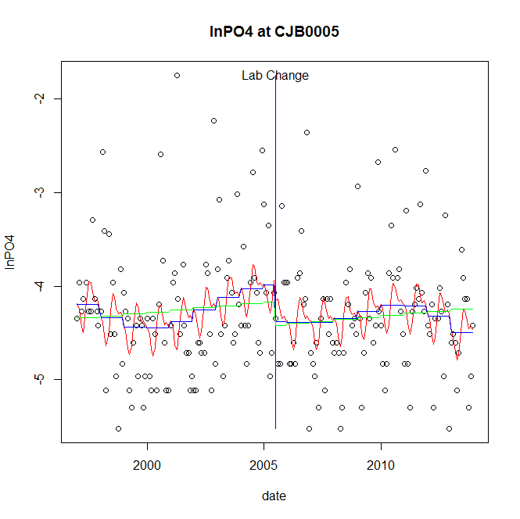

GAM analysis for station CJB0005 dependent variable lnPO4

|  |  |  |  |  |
| --- | --- | --- | --- | --- |
| **Type** | **Source** | **edf** | **F-stat** | **p-value** |
| parametric terms | step | 1 | 1.9363 | 0.1657 |
|  | year | 1 | 758.8566 | <0.0001 |
| smoothed terms | s(year) | 4.71 | 1.6264 | 0.1457 |
|  | s(doy) | 4.01 | 1.9192 | 0.0022 |

GAM analysis for station CJB0005 dependent variable lnPO4

|  |  |  |  |  |
| --- | --- | --- | --- | --- |
| **parameter** | **estimate** | **Std. Err.** | **t value** | **p-value** |
| (Intercept) | 0.001954 | 0.001034 | 1.8888 | 0.0604 |
| step | -0.392786 | 0.282272 | -1.3915 | 0.1657 |
| year | -0.002045 | 7.4e-05 | -27.5474 | <0.0001 |

root mean-square error = 0.6443

adjusted r-square = 0.09

No title given

|  |  |  |  |
| --- | --- | --- | --- |
| **station** | **dep** | **step.est** | **step.pv** |
| CJB0005 | lnTSS | -0.502248 | 0.3285 |
| CJB0005 | lnTN | -0.114327 | 0.4403 |
| CJB0005 | lnNH4 | -0.419865 | 0.0436 |
| CJB0005 | lnNO23 | 0.005044 | 0.9823 |
| CJB0005 | lnNO2 | -0.472894 | 0.0512 |
| CJB0005 | lnTP | -0.215905 | 0.5079 |
| CJB0005 | lnPO4 | -0.392786 | 0.1657 |

station = CON0005 dependent = lnTSS

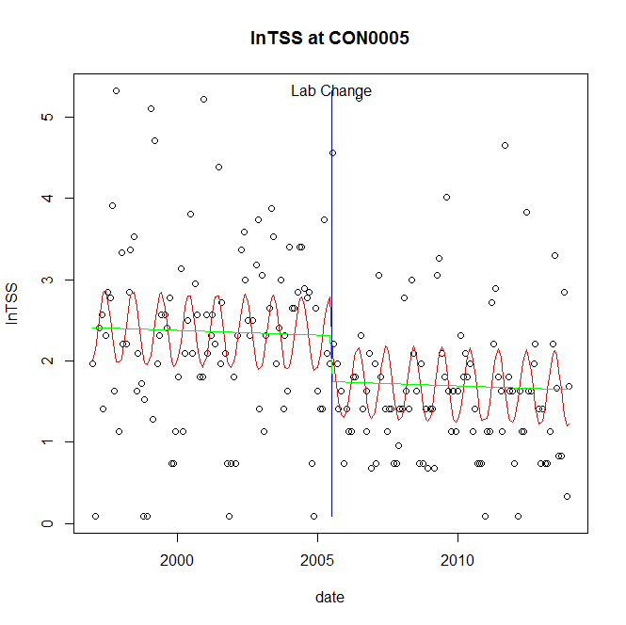

GAM analysis for station CON0005 dependent variable lnTSS

|  |  |  |  |  |
| --- | --- | --- | --- | --- |
| **Type** | **Source** | **edf** | **F-stat** | **p-value** |
| parametric terms | step | 1 | 4.6607 | 0.0321 |
|  | year | 1 | 239.3547 | <0.0001 |
| smoothed terms | s(year) | 1 | 0.2044 | 0.6517 |
|  | s(doy) | 2.38 | 3.5471 | <0.0001 |

GAM analysis for station CON0005 dependent variable lnTSS

|  |  |  |  |  |
| --- | --- | --- | --- | --- |
| **parameter** | **estimate** | **Std. Err.** | **t value** | **p-value** |
| (Intercept) | 0.000146 | 0.000323 | 0.4539 | 0.6504 |
| step | -0.571688 | 0.26481 | -2.1589 | 0.0321 |
| year | 0.001144 | 7.4e-05 | 15.4711 | <0.0001 |

root mean-square error = 0.944

adjusted r-square = 0.2111

step significant

station = CON0005 dependent = lnTN

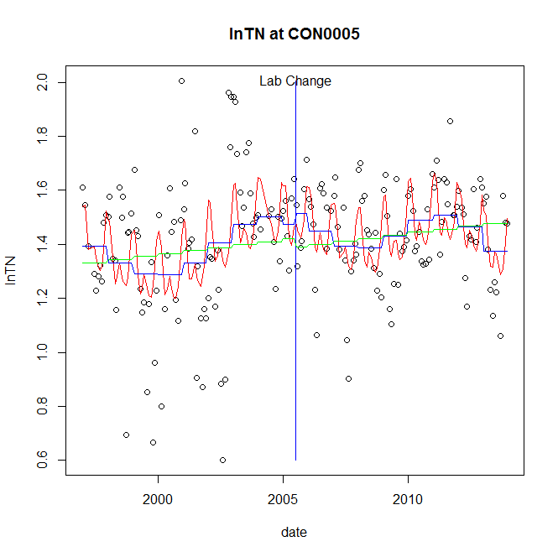

GAM analysis for station CON0005 dependent variable lnTN

|  |  |  |  |  |
| --- | --- | --- | --- | --- |
| **Type** | **Source** | **edf** | **F-stat** | **p-value** |
| parametric terms | step | 1 | 0.1554 | 0.6939 |
|  | year | 1 | 680.5452 | <0.0001 |
| smoothed terms | s(year) | 5.81 | 3.2875 | 0.0033 |
|  | s(doy) | 4.92 | 4.5639 | <0.0001 |

GAM analysis for station CON0005 dependent variable lnTN

|  |  |  |  |  |
| --- | --- | --- | --- | --- |
| **parameter** | **estimate** | **Std. Err.** | **t value** | **p-value** |
| (Intercept) | 0.00097 | 0.000431 | 2.2513 | 0.0256 |
| step | 0.039801 | 0.100979 | 0.3941 | 0.6939 |
| year | 0.000696 | 2.7e-05 | 26.0873 | <0.0001 |

root mean-square error = 0.2043

adjusted r-square = 0.2316

station = CON0005 dependent = lnNH4

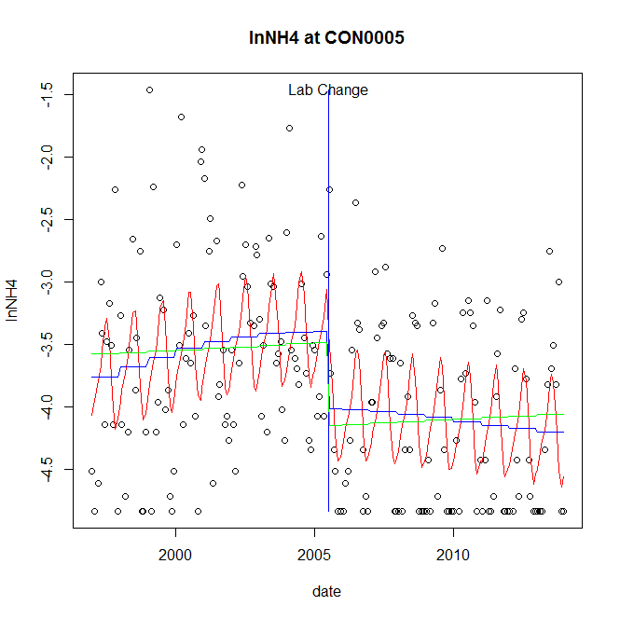

GAM analysis for station CON0005 dependent variable lnNH4

|  |  |  |  |  |
| --- | --- | --- | --- | --- |
| **Type** | **Source** | **edf** | **F-stat** | **p-value** |
| parametric terms | step | 1 | 8.5131 | 0.0039 |
|  | year | 1 | 921.3591 | <0.0001 |
| smoothed terms | s(year) | 2.21 | 2.4552 | 0.0706 |
|  | s(doy) | 3.77 | 5.358 | <0.0001 |

GAM analysis for station CON0005 dependent variable lnNH4

|  |  |  |  |  |
| --- | --- | --- | --- | --- |
| **parameter** | **estimate** | **Std. Err.** | **t value** | **p-value** |
| (Intercept) | -0.000344 | 0.000425 | -0.8098 | 0.4190 |
| step | -0.617791 | 0.211737 | -2.9177 | 0.0039 |
| year | -0.001757 | 5.8e-05 | -30.3539 | <0.0001 |

root mean-square error = 0.6761

adjusted r-square = 0.2879

step significant

station = CON0005 dependent = lnNO23

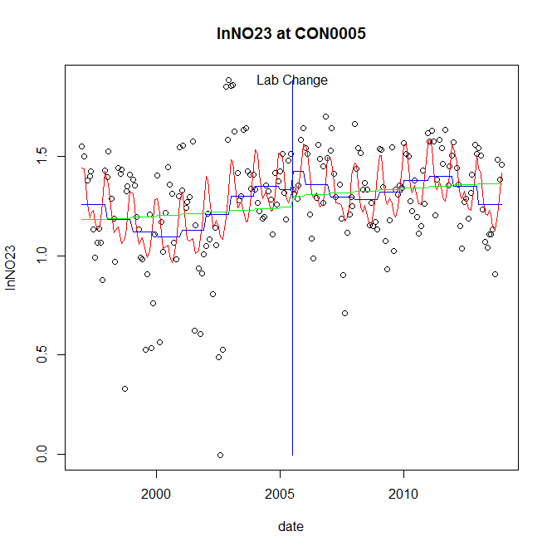

GAM analysis for station CON0005 dependent variable lnNO23

|  |  |  |  |  |
| --- | --- | --- | --- | --- |
| **Type** | **Source** | **edf** | **F-stat** | **p-value** |
| parametric terms | step | 1 | 0.6667 | 0.4152 |
|  | year | 1 | 421.7215 | <0.0001 |
| smoothed terms | s(year) | 5.79 | 3.3146 | 0.0031 |
|  | s(doy) | 4.54 | 5.3937 | <0.0001 |

GAM analysis for station CON0005 dependent variable lnNO23

|  |  |  |  |  |
| --- | --- | --- | --- | --- |
| **parameter** | **estimate** | **Std. Err.** | **t value** | **p-value** |
| (Intercept) | 0.001086 | 0.000483 | 2.2459 | 0.0259 |
| step | 0.094227 | 0.115404 | 0.8165 | 0.4152 |
| year | 0.000615 | 3e-05 | 20.5359 | <0.0001 |

root mean-square error = 0.2373

adjusted r-square = 0.2679

station = CON0005 dependent = lnNO2

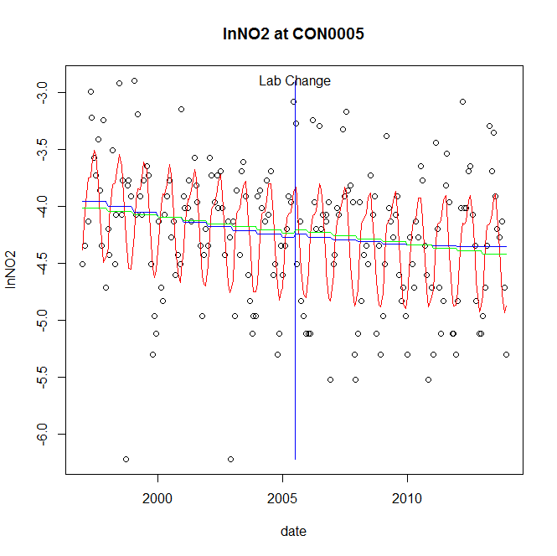

GAM analysis for station CON0005 dependent variable lnNO2

|  |  |  |  |  |
| --- | --- | --- | --- | --- |
| **Type** | **Source** | **edf** | **F-stat** | **p-value** |
| parametric terms | step | 1 | 0.0373 | 0.8470 |
|  | year | 1 | 2923.8853 | <0.0001 |
| smoothed terms | s(year) | 1.82 | 2.3008 | 0.0962 |
|  | s(doy) | 4.94 | 14.2317 | <0.0001 |

GAM analysis for station CON0005 dependent variable lnNO2

|  |  |  |  |  |
| --- | --- | --- | --- | --- |
| **parameter** | **estimate** | **Std. Err.** | **t value** | **p-value** |
| (Intercept) | 0.00028 | 0.000237 | 1.1805 | 0.2393 |
| step | 0.027497 | 0.142359 | 0.1932 | 0.8470 |
| year | -0.002125 | 3.9e-05 | -54.073 | <0.0001 |

root mean-square error = 0.4795

adjusted r-square = 0.3827

station = CON0005 dependent = lnTP

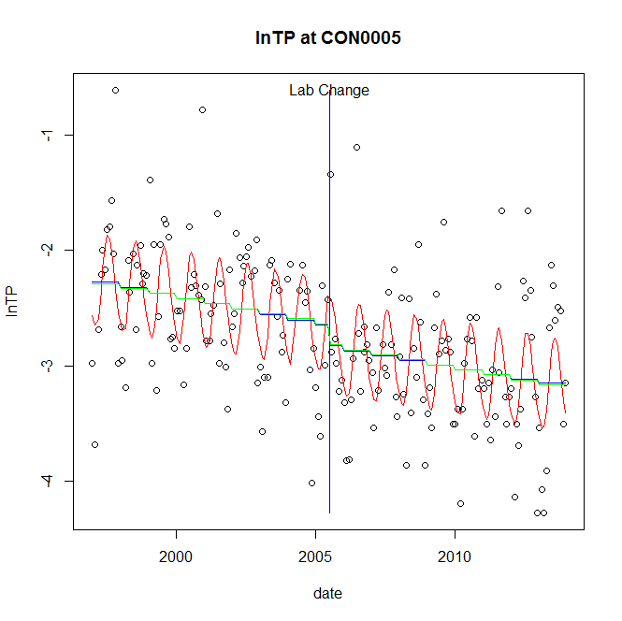

GAM analysis for station CON0005 dependent variable lnTP

|  |  |  |  |  |
| --- | --- | --- | --- | --- |
| **Type** | **Source** | **edf** | **F-stat** | **p-value** |
| parametric terms | step | 1 | 1.6066 | 0.2065 |
|  | year | 1 | 1076.7721 | <0.0001 |
| smoothed terms | s(year) | 1.24 | 6.9356 | 0.0045 |
|  | s(doy) | 3.28 | 8.8334 | <0.0001 |

GAM analysis for station CON0005 dependent variable lnTP

|  |  |  |  |  |
| --- | --- | --- | --- | --- |
| **parameter** | **estimate** | **Std. Err.** | **t value** | **p-value** |
| (Intercept) | 0.00051 | 0.000188 | 2.7168 | 0.0072 |
| step | -0.180669 | 0.142537 | -1.2675 | 0.2065 |
| year | -0.001322 | 4e-05 | -32.8142 | <0.0001 |

root mean-square error = 0.4938

adjusted r-square = 0.4236

station = CON0005 dependent = lnPO4

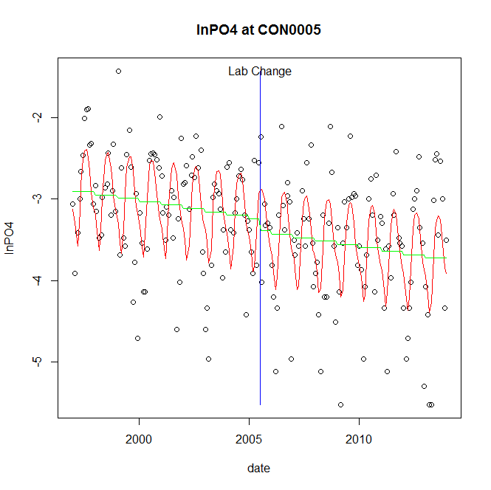

GAM analysis for station CON0005 dependent variable lnPO4

|  |  |  |  |  |
| --- | --- | --- | --- | --- |
| **Type** | **Source** | **edf** | **F-stat** | **p-value** |
| parametric terms | step | 1 | 0.7602 | 0.3843 |
|  | year | 1 | 1148.982 | <0.0001 |
| smoothed terms | s(year) | 1 | 5.3035 | 0.0223 |
|  | s(doy) | 5.07 | 10.855 | <0.0001 |

GAM analysis for station CON0005 dependent variable lnPO4

|  |  |  |  |  |
| --- | --- | --- | --- | --- |
| **parameter** | **estimate** | **Std. Err.** | **t value** | **p-value** |
| (Intercept) | 0.00048 | 0.000209 | 2.2993 | 0.0225 |
| step | -0.149467 | 0.171423 | -0.8719 | 0.3843 |
| year | -0.001621 | 4.8e-05 | -33.8966 | <0.0001 |

root mean-square error = 0.6092

adjusted r-square = 0.3831

No title given

|  |  |  |  |
| --- | --- | --- | --- |
| **station** | **dep** | **step.est** | **step.pv** |
| CON0005 | lnTSS | -0.571688 | 0.0321 |
| CON0005 | lnTN | 0.039801 | 0.6939 |
| CON0005 | lnNH4 | -0.617791 | 0.0039 |
| CON0005 | lnNO23 | 0.094227 | 0.4152 |
| CON0005 | lnNO2 | 0.027497 | 0.8470 |
| CON0005 | lnTP | -0.180669 | 0.2065 |
| CON0005 | lnPO4 | -0.149467 | 0.3843 |

station = CON0180 dependent = lnTSS

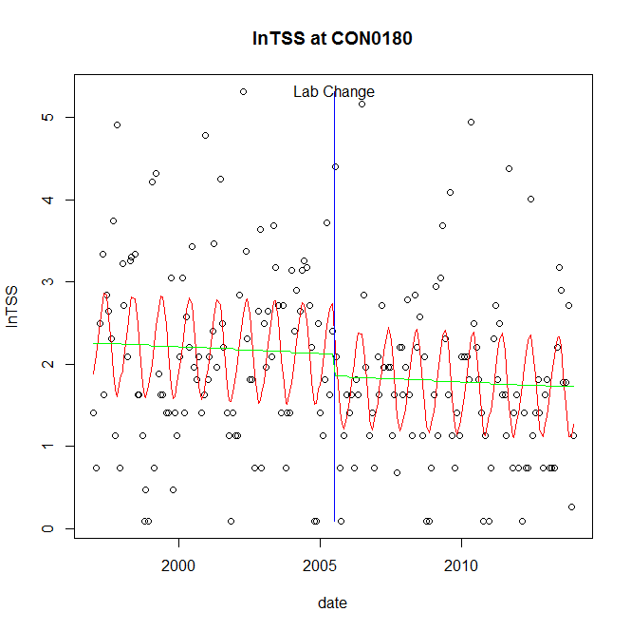

GAM analysis for station CON0180 dependent variable lnTSS

|  |  |  |  |  |
| --- | --- | --- | --- | --- |
| **Type** | **Source** | **edf** | **F-stat** | **p-value** |
| parametric terms | step | 1 | 0.9592 | 0.3286 |
|  | year | 1 | 189.4354 | <0.0001 |
| smoothed terms | s(year) | 1 | 0.398 | 0.5289 |
|  | s(doy) | 2.9 | 5.6976 | <0.0001 |

GAM analysis for station CON0180 dependent variable lnTSS

|  |  |  |  |  |
| --- | --- | --- | --- | --- |
| **parameter** | **estimate** | **Std. Err.** | **t value** | **p-value** |
| (Intercept) | 0.000209 | 0.000331 | 0.6325 | 0.5278 |
| step | -0.266304 | 0.271908 | -0.9794 | 0.3286 |
| year | 0.001045 | 7.6e-05 | 13.7636 | <0.0001 |

root mean-square error = 0.9686

adjusted r-square = 0.214

station = CON0180 dependent = lnTN

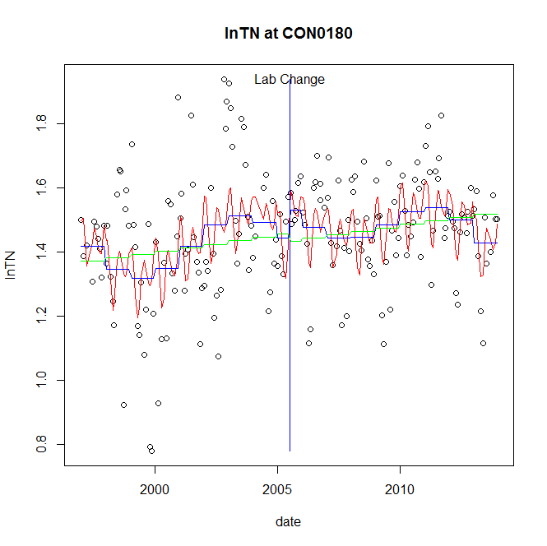

GAM analysis for station CON0180 dependent variable lnTN

|  |  |  |  |  |
| --- | --- | --- | --- | --- |
| **Type** | **Source** | **edf** | **F-stat** | **p-value** |
| parametric terms | step | 1 | 1.0971 | 0.2963 |
|  | year | 1 | 996.6641 | <0.0001 |
| smoothed terms | s(year) | 5.84 | 3.4778 | 0.0021 |
|  | s(doy) | 5.08 | 3.7635 | <0.0001 |

GAM analysis for station CON0180 dependent variable lnTN

|  |  |  |  |  |
| --- | --- | --- | --- | --- |
| **parameter** | **estimate** | **Std. Err.** | **t value** | **p-value** |
| (Intercept) | 0.000928 | 0.000361 | 2.5723 | 0.0109 |
| step | 0.088315 | 0.084318 | 1.0474 | 0.2963 |
| year | 0.000704 | 2.2e-05 | 31.57 | <0.0001 |

root mean-square error = 0.1702

adjusted r-square = 0.2303

station = CON0180 dependent = lnNH4

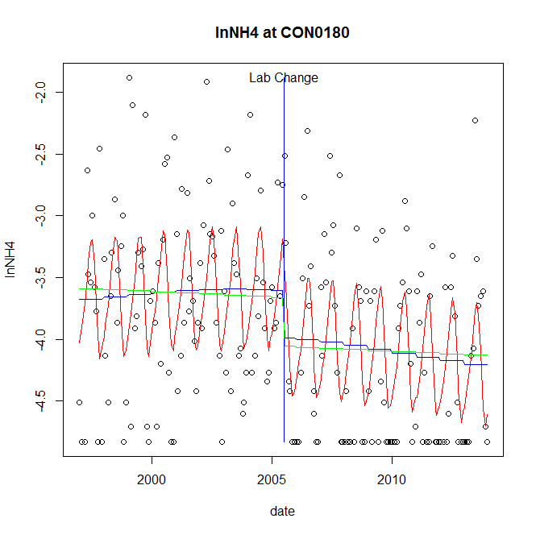

GAM analysis for station CON0180 dependent variable lnNH4

|  |  |  |  |  |
| --- | --- | --- | --- | --- |
| **Type** | **Source** | **edf** | **F-stat** | **p-value** |
| parametric terms | step | 1 | 3.9806 | 0.0474 |
|  | year | 1 | 1185.9121 | <0.0001 |
| smoothed terms | s(year) | 1.76 | 0.9993 | 0.3705 |
|  | s(doy) | 3.79 | 7.1036 | <0.0001 |

GAM analysis for station CON0180 dependent variable lnNH4

|  |  |  |  |  |
| --- | --- | --- | --- | --- |
| **parameter** | **estimate** | **Std. Err.** | **t value** | **p-value** |
| (Intercept) | 2.4e-05 | 0.000313 | 0.0755 | 0.9399 |
| step | -0.38548 | 0.193208 | -1.9952 | 0.0474 |
| year | -0.001839 | 5.3e-05 | -34.4371 | <0.0001 |

root mean-square error = 0.6558

adjusted r-square = 0.2913

step significant

station = CON0180 dependent = lnNO23

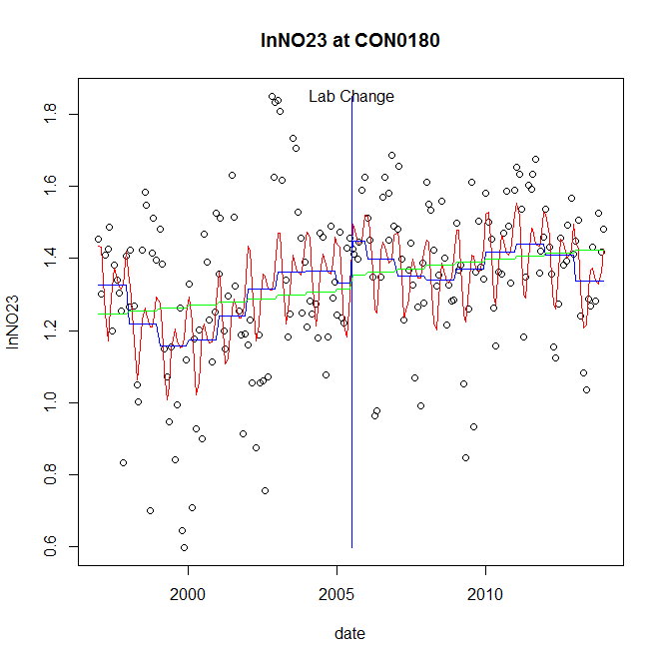

GAM analysis for station CON0180 dependent variable lnNO23

|  |  |  |  |  |
| --- | --- | --- | --- | --- |
| **Type** | **Source** | **edf** | **F-stat** | **p-value** |
| parametric terms | step | 1 | 1.4963 | 0.2227 |
|  | year | 1 | 667.5498 | <0.0001 |
| smoothed terms | s(year) | 5.82 | 3.3979 | 0.0025 |
|  | s(doy) | 5.02 | 4.4161 | <0.0001 |

GAM analysis for station CON0180 dependent variable lnNO23

|  |  |  |  |  |
| --- | --- | --- | --- | --- |
| **parameter** | **estimate** | **Std. Err.** | **t value** | **p-value** |
| (Intercept) | 0.001178 | 0.000399 | 2.9545 | 0.0035 |
| step | 0.116094 | 0.094907 | 1.2232 | 0.2227 |
| year | 0.000636 | 2.5e-05 | 25.837 | <0.0001 |

root mean-square error = 0.1945

adjusted r-square = 0.2651

station = CON0180 dependent = lnNO2

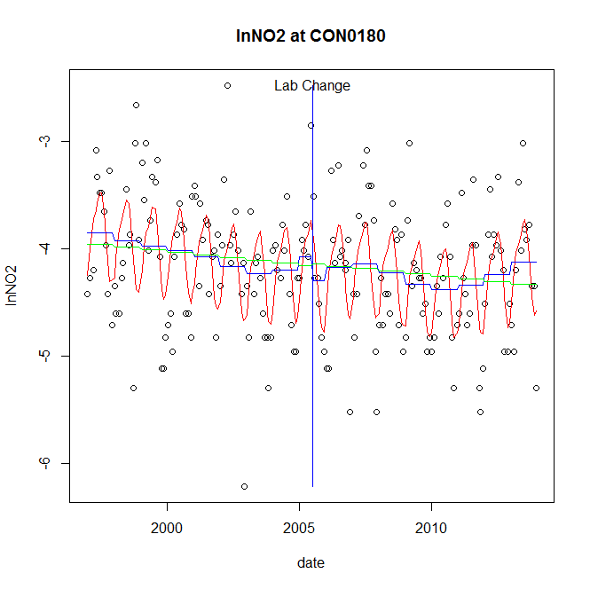

GAM analysis for station CON0180 dependent variable lnNO2

|  |  |  |  |  |
| --- | --- | --- | --- | --- |
| **Type** | **Source** | **edf** | **F-stat** | **p-value** |
| parametric terms | step | 1 | 0.8483 | 0.3582 |
|  | year | 1 | 1047.9385 | <0.0001 |
| smoothed terms | s(year) | 5.47 | 1.6127 | 0.1413 |
|  | s(doy) | 4.04 | 9.7491 | <0.0001 |

GAM analysis for station CON0180 dependent variable lnNO2

|  |  |  |  |  |
| --- | --- | --- | --- | --- |
| **parameter** | **estimate** | **Std. Err.** | **t value** | **p-value** |
| (Intercept) | -0.000266 | 0.000973 | -0.2736 | 0.7847 |
| step | -0.221613 | 0.24062 | -0.921 | 0.3582 |
| year | -0.002025 | 6.3e-05 | -32.3719 | <0.0001 |

root mean-square error = 0.5095

adjusted r-square = 0.3146

station = CON0180 dependent = lnTP

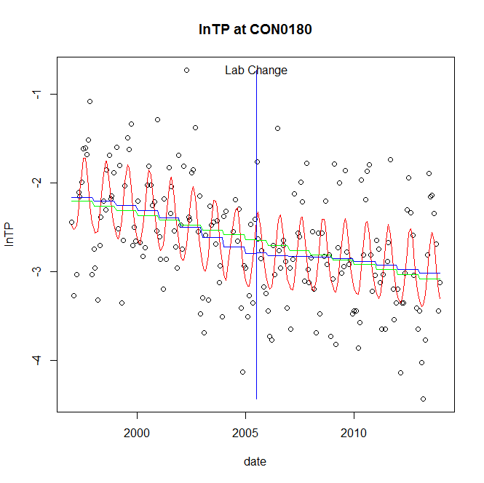

GAM analysis for station CON0180 dependent variable lnTP

|  |  |  |  |  |
| --- | --- | --- | --- | --- |
| **Type** | **Source** | **edf** | **F-stat** | **p-value** |
| parametric terms | step | 1 | 0.0011 | 0.9731 |
|  | year | 1 | 627.6028 | <0.0001 |
| smoothed terms | s(year) | 3.47 | 3.8299 | 0.0043 |
|  | s(doy) | 3.35 | 9.0443 | <0.0001 |

GAM analysis for station CON0180 dependent variable lnTP

|  |  |  |  |  |
| --- | --- | --- | --- | --- |
| **parameter** | **estimate** | **Std. Err.** | **t value** | **p-value** |
| (Intercept) | 0.000515 | 0.000581 | 0.887 | 0.3762 |
| step | 0.006659 | 0.196875 | 0.0338 | 0.9731 |
| year | -0.001332 | 5.3e-05 | -25.052 | <0.0001 |

root mean-square error = 0.5084

adjusted r-square = 0.4082

station = CON0180 dependent = lnPO4

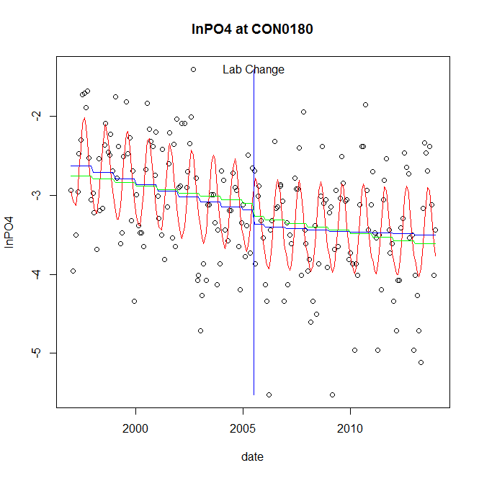

GAM analysis for station CON0180 dependent variable lnPO4

|  |  |  |  |  |
| --- | --- | --- | --- | --- |
| **Type** | **Source** | **edf** | **F-stat** | **p-value** |
| parametric terms | step | 1 | 1.0872 | 0.2984 |
|  | year | 1 | 1013.4534 | <0.0001 |
| smoothed terms | s(year) | 2.06 | 4.6228 | 0.0069 |
|  | s(doy) | 3.48 | 12.0681 | <0.0001 |

GAM analysis for station CON0180 dependent variable lnPO4

|  |  |  |  |  |
| --- | --- | --- | --- | --- |
| **parameter** | **estimate** | **Std. Err.** | **t value** | **p-value** |
| (Intercept) | 0.00054 | 0.000331 | 1.6301 | 0.1047 |
| step | -0.18469 | 0.177131 | -1.0427 | 0.2984 |
| year | -0.001548 | 4.9e-05 | -31.8348 | <0.0001 |

root mean-square error = 0.5793

adjusted r-square = 0.4308

No title given

|  |  |  |  |
| --- | --- | --- | --- |
| **station** | **dep** | **step.est** | **step.pv** |
| CON0180 | lnTSS | -0.266304 | 0.3286 |
| CON0180 | lnTN | 0.088315 | 0.2963 |
| CON0180 | lnNH4 | -0.38548 | 0.0474 |
| CON0180 | lnNO23 | 0.116094 | 0.2227 |
| CON0180 | lnNO2 | -0.221613 | 0.3582 |
| CON0180 | lnTP | 0.006659 | 0.9731 |
| CON0180 | lnPO4 | -0.18469 | 0.2984 |

station = DER0015 dependent = lnTSS

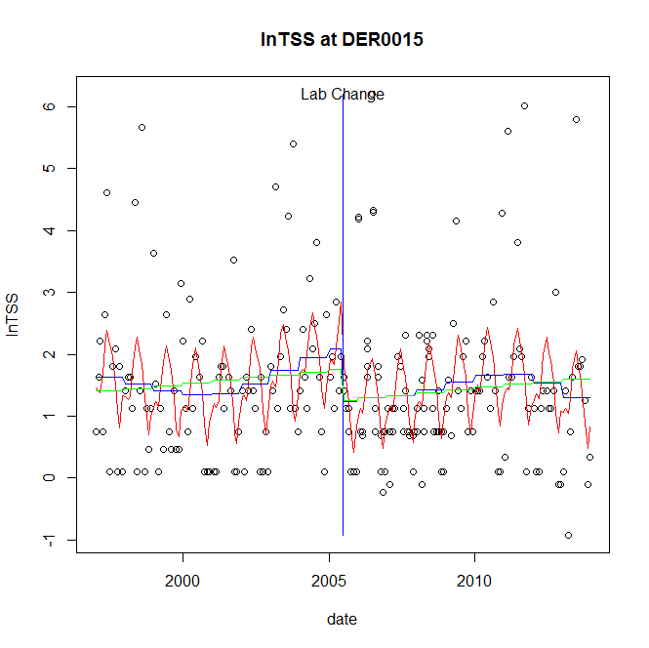

GAM analysis for station DER0015 dependent variable lnTSS

|  |  |  |  |  |
| --- | --- | --- | --- | --- |
| **Type** | **Source** | **edf** | **F-stat** | **p-value** |
| parametric terms | step | 1 | 3.9046 | 0.0493 |
|  | year | 1 | 56.6107 | <0.0001 |
| smoothed terms | s(year) | 4.54 | 1.5778 | 0.1602 |
|  | s(doy) | 5.33 | 5.2256 | <0.0001 |

GAM analysis for station DER0015 dependent variable lnTSS

|  |  |  |  |  |
| --- | --- | --- | --- | --- |
| **parameter** | **estimate** | **Std. Err.** | **t value** | **p-value** |
| (Intercept) | 0.001844 | 0.00145 | 1.2712 | 0.2049 |
| step | -0.842529 | 0.426378 | -1.976 | 0.0493 |
| year | 0.000974 | 0.000129 | 7.524 | <0.0001 |

root mean-square error = 1.1374

adjusted r-square = 0.1615

step significant

station = DER0015 dependent = lnTN

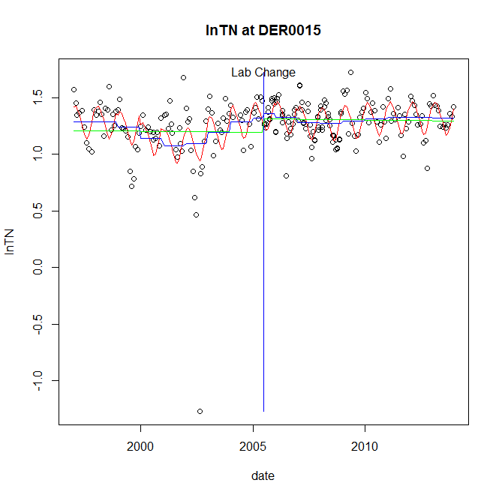

GAM analysis for station DER0015 dependent variable lnTN

|  |  |  |  |  |
| --- | --- | --- | --- | --- |
| **Type** | **Source** | **edf** | **F-stat** | **p-value** |
| parametric terms | step | 1 | 0.2402 | 0.6246 |
|  | year | 1 | 492.3882 | <0.0001 |
| smoothed terms | s(year) | 6.25 | 2.7387 | 0.0103 |
|  | s(doy) | 3.27 | 7.4769 | <0.0001 |

GAM analysis for station DER0015 dependent variable lnTN

|  |  |  |  |  |
| --- | --- | --- | --- | --- |
| **parameter** | **estimate** | **Std. Err.** | **t value** | **p-value** |
| (Intercept) | -3e-05 | 0.000393 | -0.0773 | 0.9385 |
| step | 0.044616 | 0.091043 | 0.4901 | 0.6246 |
| year | 0.000619 | 2.8e-05 | 22.1898 | <0.0001 |

root mean-square error = 0.2068

adjusted r-square = 0.2801

station = DER0015 dependent = lnNH4

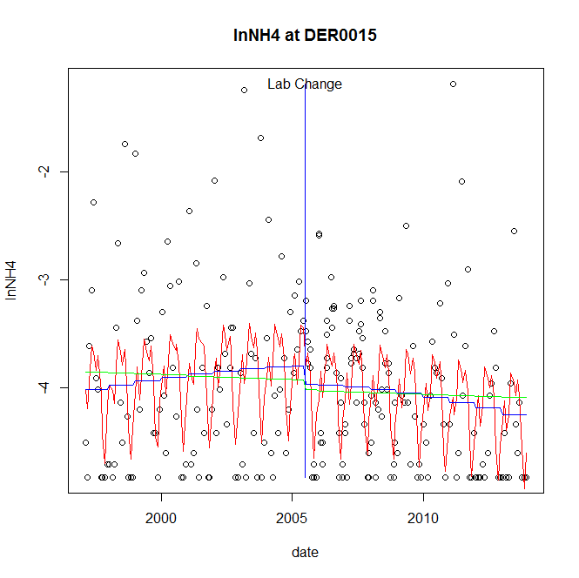

GAM analysis for station DER0015 dependent variable lnNH4

|  |  |  |  |  |
| --- | --- | --- | --- | --- |
| **Type** | **Source** | **edf** | **F-stat** | **p-value** |
| parametric terms | step | 1 | 0.8402 | 0.3603 |
|  | year | 1 | 1147.9628 | <0.0001 |
| smoothed terms | s(year) | 1.99 | 1.8434 | 0.1487 |
|  | s(doy) | 6.46 | 7.1492 | <0.0001 |

GAM analysis for station DER0015 dependent variable lnNH4

|  |  |  |  |  |
| --- | --- | --- | --- | --- |
| **parameter** | **estimate** | **Std. Err.** | **t value** | **p-value** |
| (Intercept) | 7.6e-05 | 0.000304 | 0.2503 | 0.8026 |
| step | -0.166629 | 0.18179 | -0.9166 | 0.3603 |
| year | -0.001947 | 5.7e-05 | -33.8816 | <0.0001 |

root mean-square error = 0.6836

adjusted r-square = 0.2045

station = DER0015 dependent = lnNO23

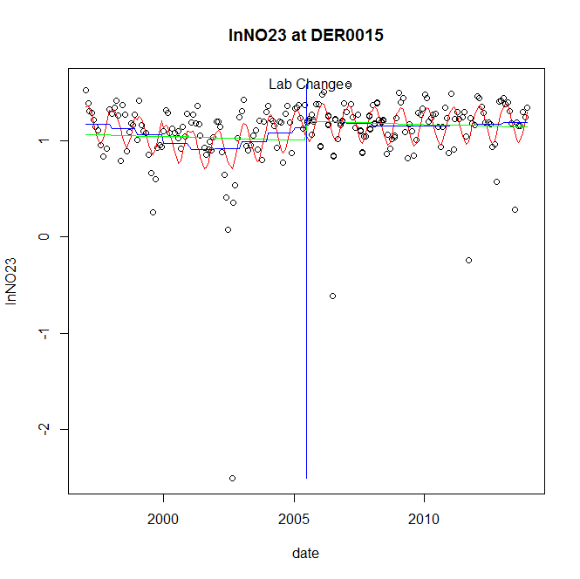

GAM analysis for station DER0015 dependent variable lnNO23

|  |  |  |  |  |
| --- | --- | --- | --- | --- |
| **Type** | **Source** | **edf** | **F-stat** | **p-value** |
| parametric terms | step | 1 | 0.2553 | 0.6138 |
|  | year | 1 | 206.025 | <0.0001 |
| smoothed terms | s(year) | 5.21 | 1.6257 | 0.1393 |
|  | s(doy) | 2.76 | 6.6576 | <0.0001 |

GAM analysis for station DER0015 dependent variable lnNO23

|  |  |  |  |  |
| --- | --- | --- | --- | --- |
| **parameter** | **estimate** | **Std. Err.** | **t value** | **p-value** |
| (Intercept) | 0.000102 | 0.000466 | 0.2198 | 0.8262 |
| step | 0.062536 | 0.123765 | 0.5053 | 0.6138 |
| year | 0.000538 | 3.7e-05 | 14.3536 | <0.0001 |

root mean-square error = 0.311

adjusted r-square = 0.2382

station = DER0015 dependent = lnNO2

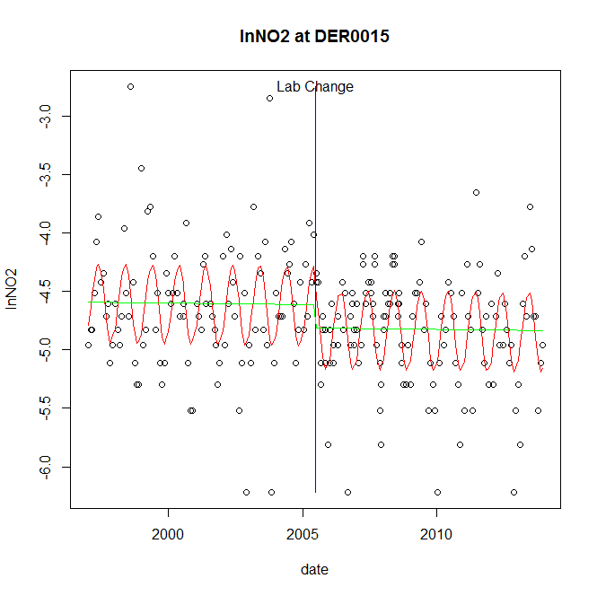

GAM analysis for station DER0015 dependent variable lnNO2

|  |  |  |  |  |
| --- | --- | --- | --- | --- |
| **Type** | **Source** | **edf** | **F-stat** | **p-value** |
| parametric terms | step | 1 | 3.6533 | 0.0572 |
|  | year | 1 | 4772.75 | <0.0001 |
| smoothed terms | s(year) | 1 | 6e-04 | 0.9809 |
|  | s(doy) | 2.95 | 10.208 | <0.0001 |

GAM analysis for station DER0015 dependent variable lnNO2

|  |  |  |  |  |
| --- | --- | --- | --- | --- |
| **parameter** | **estimate** | **Std. Err.** | **t value** | **p-value** |
| (Intercept) | 2e-06 | 0.000116 | 0.0141 | 0.9888 |
| step | -0.199861 | 0.104565 | -1.9114 | 0.0572 |
| year | -0.00231 | 3.3e-05 | -69.0851 | <0.0001 |

root mean-square error = 0.4317

adjusted r-square = 0.2954

station = DER0015 dependent = lnTP

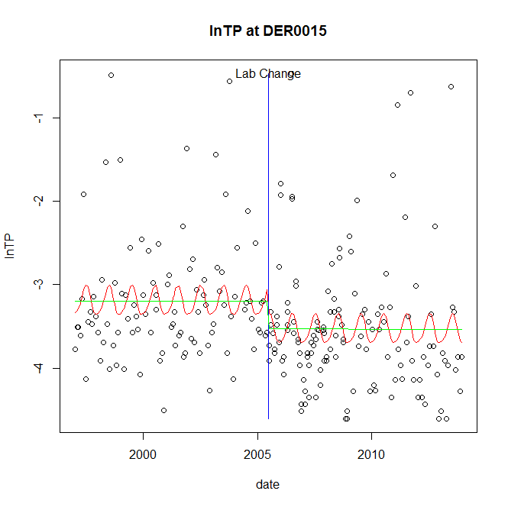

GAM analysis for station DER0015 dependent variable lnTP

|  |  |  |  |  |
| --- | --- | --- | --- | --- |
| **Type** | **Source** | **edf** | **F-stat** | **p-value** |
| parametric terms | step | 1 | 3.3168 | 0.0698 |
|  | year | 1 | 721.6246 | <0.0001 |
| smoothed terms | s(year) | 1 | 0.0049 | 0.9441 |
|  | s(doy) | 2.34 | 1.1279 | 0.0081 |

GAM analysis for station DER0015 dependent variable lnTP

|  |  |  |  |  |
| --- | --- | --- | --- | --- |
| **parameter** | **estimate** | **Std. Err.** | **t value** | **p-value** |
| (Intercept) | -1.5e-05 | 0.000205 | -0.0741 | 0.9410 |
| step | -0.335249 | 0.18408 | -1.8212 | 0.0698 |
| year | -0.001598 | 5.9e-05 | -26.8631 | <0.0001 |

root mean-square error = 0.7466

adjusted r-square = 0.0713

station = DER0015 dependent = lnPO4

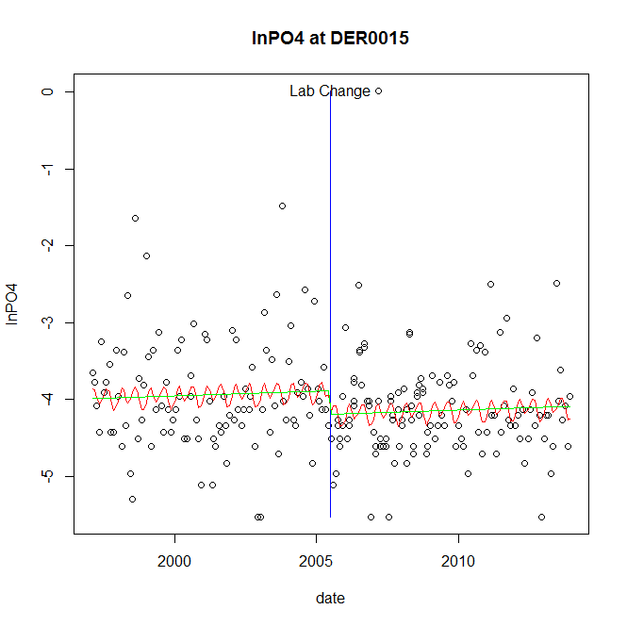

GAM analysis for station DER0015 dependent variable lnPO4

|  |  |  |  |  |
| --- | --- | --- | --- | --- |
| **Type** | **Source** | **edf** | **F-stat** | **p-value** |
| parametric terms | step | 1 | 3.3351 | 0.0691 |
|  | year | 1 | 1315.7723 | <0.0001 |
| smoothed terms | s(year) | 1 | 0.5471 | 0.4602 |
|  | s(doy) | 3.94 | 0.9093 | 0.0971 |

GAM analysis for station DER0015 dependent variable lnPO4

|  |  |  |  |  |
| --- | --- | --- | --- | --- |
| **parameter** | **estimate** | **Std. Err.** | **t value** | **p-value** |
| (Intercept) | -0.000137 | 0.000184 | -0.745 | 0.4570 |
| step | -0.304007 | 0.166468 | -1.8262 | 0.0691 |
| year | -0.001938 | 5.3e-05 | -36.2736 | <0.0001 |

root mean-square error = 0.6859

adjusted r-square = 0.0412

No title given

|  |  |  |  |
| --- | --- | --- | --- |
| **station** | **dep** | **step.est** | **step.pv** |
| DER0015 | lnTSS | -0.842529 | 0.0493 |
| DER0015 | lnTN | 0.044616 | 0.6246 |
| DER0015 | lnNH4 | -0.166629 | 0.3603 |
| DER0015 | lnNO23 | 0.062536 | 0.6138 |
| DER0015 | lnNO2 | -0.199861 | 0.0572 |
| DER0015 | lnTP | -0.335249 | 0.0698 |
| DER0015 | lnPO4 | -0.304007 | 0.0691 |

station = GEO0009 dependent = lnTSS

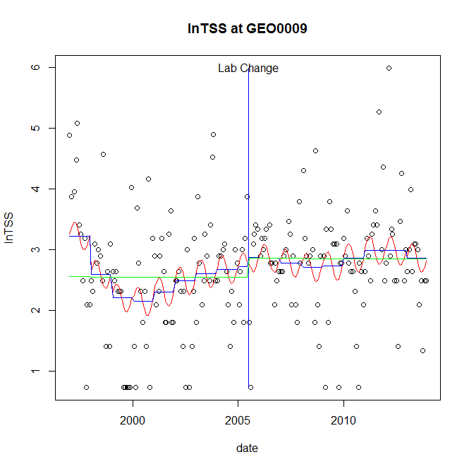

GAM analysis for station GEO0009 dependent variable lnTSS

|  |  |  |  |  |
| --- | --- | --- | --- | --- |
| **Type** | **Source** | **edf** | **F-stat** | **p-value** |
| parametric terms | step | 1 | 0.1349 | 0.7138 |
|  | year | 1 | 146.8091 | <0.0001 |
| smoothed terms | s(year) | 5.61 | 2.5384 | 0.0194 |
|  | s(doy) | 1.92 | 1.1867 | 0.0029 |

GAM analysis for station GEO0009 dependent variable lnTSS

|  |  |  |  |  |
| --- | --- | --- | --- | --- |
| **parameter** | **estimate** | **Std. Err.** | **t value** | **p-value** |
| (Intercept) | 0.004903 | 0.001717 | 2.855 | 0.0048 |
| step | 0.152235 | 0.414469 | 0.3673 | 0.7138 |
| year | 0.001305 | 0.000108 | 12.1165 | <0.0001 |

root mean-square error = 0.87

adjusted r-square = 0.1255

station = GEO0009 dependent = lnTN

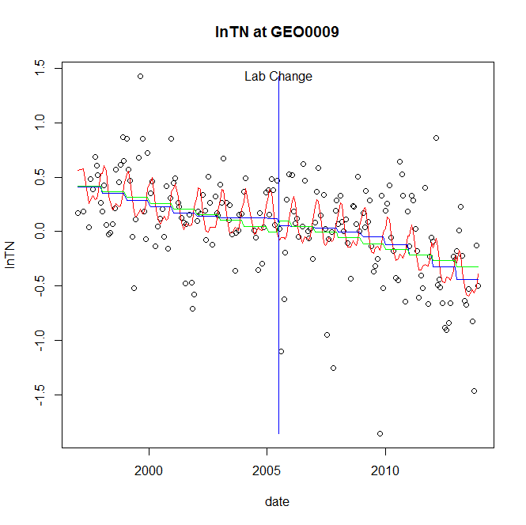

GAM analysis for station GEO0009 dependent variable lnTN

|  |  |  |  |  |
| --- | --- | --- | --- | --- |
| **Type** | **Source** | **edf** | **F-stat** | **p-value** |
| parametric terms | step | 1 | 0.229 | 0.6328 |
|  | year | 1 | 1.2023 | 0.2743 |
| smoothed terms | s(year) | 3.3 | 7.0543 | <0.0001 |
|  | s(doy) | 4.13 | 4.1654 | <0.0001 |

GAM analysis for station GEO0009 dependent variable lnTN

|  |  |  |  |  |
| --- | --- | --- | --- | --- |
| **parameter** | **estimate** | **Std. Err.** | **t value** | **p-value** |
| (Intercept) | 0.001064 | 0.000397 | 2.6834 | 0.0079 |
| step | -0.066685 | 0.139358 | -0.4785 | 0.6328 |
| year | 4.2e-05 | 3.8e-05 | 1.0965 | 0.2743 |

root mean-square error = 0.3655

adjusted r-square = 0.338

station = GEO0009 dependent = lnNH4

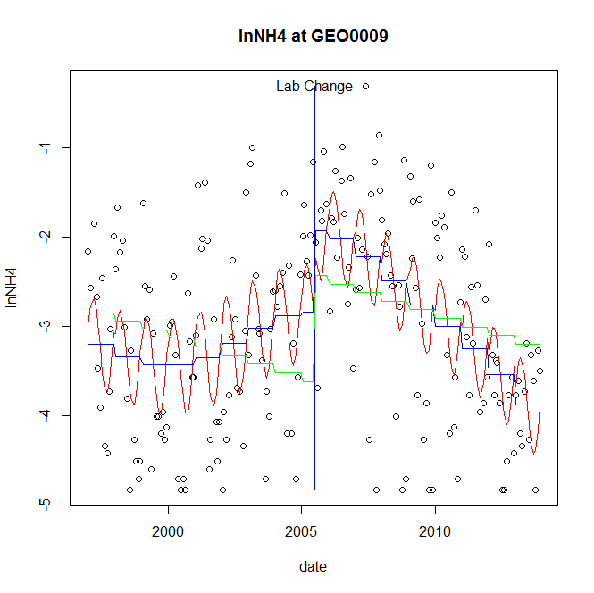

GAM analysis for station GEO0009 dependent variable lnNH4

|  |  |  |  |  |
| --- | --- | --- | --- | --- |
| **Type** | **Source** | **edf** | **F-stat** | **p-value** |
| parametric terms | step | 1 | 5.8052 | 0.0169 |
|  | year | 1 | 308.4554 | <0.0001 |
| smoothed terms | s(year) | 4.23 | 10.9297 | <0.0001 |
|  | s(doy) | 2.65 | 5.082 | <0.0001 |

GAM analysis for station GEO0009 dependent variable lnNH4

|  |  |  |  |  |
| --- | --- | --- | --- | --- |
| **parameter** | **estimate** | **Std. Err.** | **t value** | **p-value** |
| (Intercept) | 0.00295 | 0.001275 | 2.3143 | 0.0217 |
| step | 0.903647 | 0.375052 | 2.4094 | 0.0169 |
| year | -0.001733 | 9.9e-05 | -17.5629 | <0.0001 |

root mean-square error = 0.9008

adjusted r-square = 0.3351

step significant

station = GEO0009 dependent = lnNO23

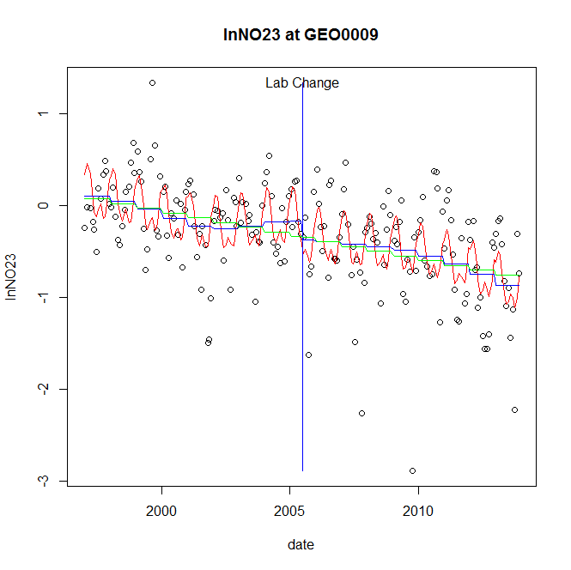

GAM analysis for station GEO0009 dependent variable lnNO23

|  |  |  |  |  |
| --- | --- | --- | --- | --- |
| **Type** | **Source** | **edf** | **F-stat** | **p-value** |
| parametric terms | step | 1 | 1.2466 | 0.2656 |
|  | year | 1 | 5.1774 | 0.0240 |
| smoothed terms | s(year) | 4.34 | 3.947 | 0.0017 |
|  | s(doy) | 4.75 | 6.0927 | <0.0001 |

GAM analysis for station GEO0009 dependent variable lnNO23

|  |  |  |  |  |
| --- | --- | --- | --- | --- |
| **parameter** | **estimate** | **Std. Err.** | **t value** | **p-value** |
| (Intercept) | 0.001016 | 0.000652 | 1.5589 | 0.1207 |
| step | -0.210721 | 0.188732 | -1.1165 | 0.2656 |
| year | -0.000113 | 5e-05 | -2.2754 | 0.0240 |

root mean-square error = 0.4465

adjusted r-square = 0.364

station = GEO0009 dependent = lnNO2

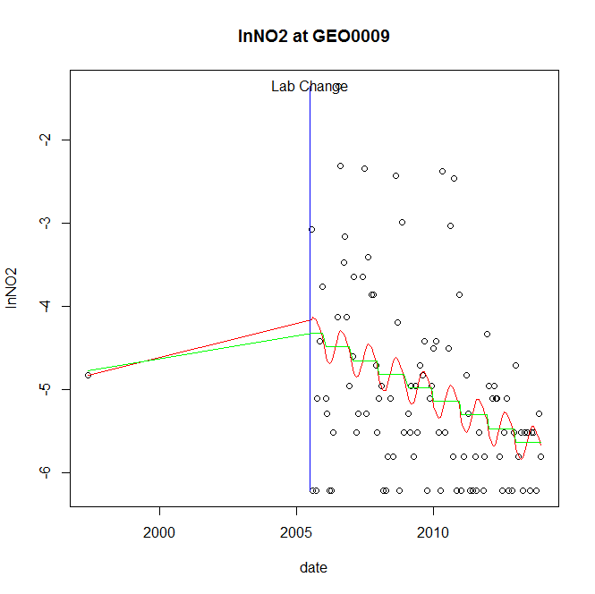

GAM analysis for station GEO0009 dependent variable lnNO2

|  |  |  |  |  |
| --- | --- | --- | --- | --- |
| **Type** | **Source** | **edf** | **F-stat** | **p-value** |
| parametric terms | step | 1 | 2.3827 | 0.1259 |
|  | year | 1 | 35.5465 | <0.0001 |
| smoothed terms | s(year) | 1 | 15.7026 | 0.0001 |
|  | s(doy) | 1.43 | 0.4226 | 0.0803 |

GAM analysis for station GEO0009 dependent variable lnNO2

|  |  |  |  |  |
| --- | --- | --- | --- | --- |
| **parameter** | **estimate** | **Std. Err.** | **t value** | **p-value** |
| (Intercept) | 0.000593 | 0.00015 | 3.9547 | 0.0001 |
| step | 1.761492 | 1.141169 | 1.5436 | 0.1259 |
| year | -0.003367 | 0.000565 | -5.9621 | <0.0001 |

root mean-square error = 1.0091

adjusted r-square = 0.1567

station = GEO0009 dependent = lnTP

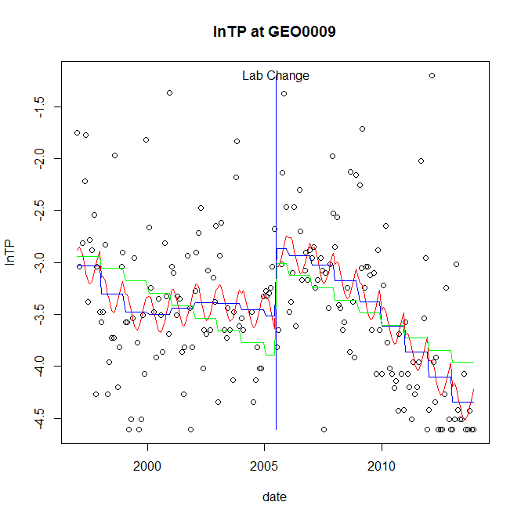

GAM analysis for station GEO0009 dependent variable lnTP

|  |  |  |  |  |
| --- | --- | --- | --- | --- |
| **Type** | **Source** | **edf** | **F-stat** | **p-value** |
| parametric terms | step | 1 | 5.0127 | 0.0263 |
|  | year | 1 | 597.5883 | <0.0001 |
| smoothed terms | s(year) | 4.89 | 11.1841 | <0.0001 |
|  | s(doy) | 1.93 | 1.2458 | 0.0022 |

GAM analysis for station GEO0009 dependent variable lnTP

|  |  |  |  |  |
| --- | --- | --- | --- | --- |
| **parameter** | **estimate** | **Std. Err.** | **t value** | **p-value** |
| (Intercept) | 0.003226 | 0.001094 | 2.9486 | 0.0036 |
| step | 0.648153 | 0.289495 | 2.2389 | 0.0263 |
| year | -0.001883 | 7.7e-05 | -24.4456 | <0.0001 |

root mean-square error = 0.6414

adjusted r-square = 0.2761

step significant

station = GEO0009 dependent = lnPO4

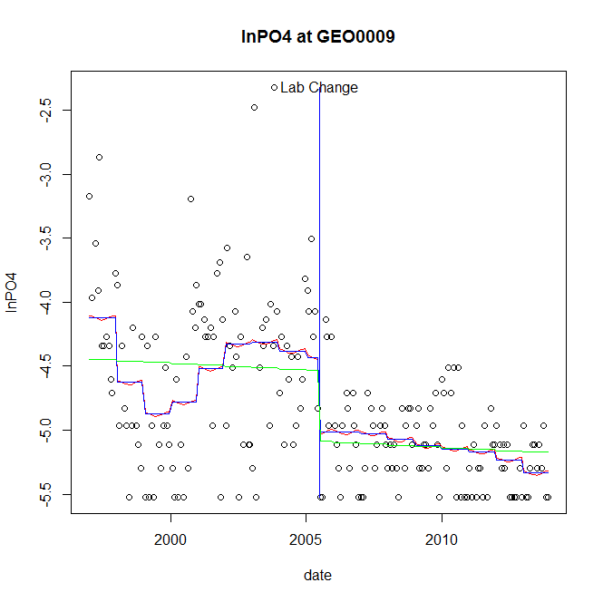

GAM analysis for station GEO0009 dependent variable lnPO4

|  |  |  |  |  |
| --- | --- | --- | --- | --- |
| **Type** | **Source** | **edf** | **F-stat** | **p-value** |
| parametric terms | step | 1 | 5.5795 | 0.0192 |
|  | year | 1 | 1247.718 | <0.0001 |
| smoothed terms | s(year) | 6.28 | 4.5986 | 0.0001 |
|  | s(doy) | 0.47 | 0.0754 | 0.2746 |

GAM analysis for station GEO0009 dependent variable lnPO4

|  |  |  |  |  |
| --- | --- | --- | --- | --- |
| **parameter** | **estimate** | **Std. Err.** | **t value** | **p-value** |
| (Intercept) | 0.003952 | 0.001105 | 3.5776 | 0.0004 |
| step | -0.582876 | 0.246761 | -2.3621 | 0.0192 |
| year | -0.002256 | 6.4e-05 | -35.3231 | <0.0001 |

root mean-square error = 0.4942

adjusted r-square = 0.3567

step significant

No title given

|  |  |  |  |
| --- | --- | --- | --- |
| **station** | **dep** | **step.est** | **step.pv** |
| GEO0009 | lnTSS | 0.152235 | 0.7138 |
| GEO0009 | lnTN | -0.066685 | 0.6328 |
| GEO0009 | lnNH4 | 0.903647 | 0.0169 |
| GEO0009 | lnNO23 | -0.210721 | 0.2656 |
| GEO0009 | lnNO2 | 1.761492 | 0.1259 |
| GEO0009 | lnTP | 0.648153 | 0.0263 |
| GEO0009 | lnPO4 | -0.582876 | 0.0192 |

station = GUN0125 dependent = lnTSS

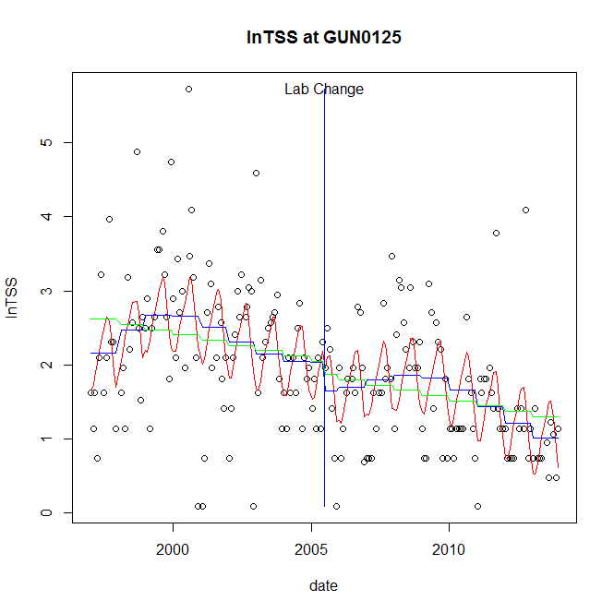

GAM analysis for station GUN0125 dependent variable lnTSS

|  |  |  |  |  |
| --- | --- | --- | --- | --- |
| **Type** | **Source** | **edf** | **F-stat** | **p-value** |
| parametric terms | step | 1 | 1.209 | 0.2729 |
|  | year | 1 | 132.5275 | <0.0001 |
| smoothed terms | s(year) | 4.99 | 4.2405 | 0.0005 |
|  | s(doy) | 3.53 | 5.2885 | <0.0001 |

GAM analysis for station GUN0125 dependent variable lnTSS

|  |  |  |  |  |
| --- | --- | --- | --- | --- |
| **parameter** | **estimate** | **Std. Err.** | **t value** | **p-value** |
| (Intercept) | -0.000873 | 0.001331 | -0.6556 | 0.5129 |
| step | -0.388057 | 0.352932 | -1.0995 | 0.2729 |
| year | 0.001066 | 9.3e-05 | 11.5121 | <0.0001 |

root mean-square error = 0.7825

adjusted r-square = 0.3639

station = GUN0125 dependent = lnTN

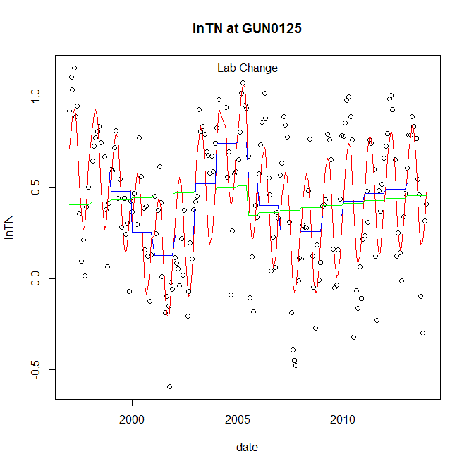

GAM analysis for station GUN0125 dependent variable lnTN

|  |  |  |  |  |
| --- | --- | --- | --- | --- |
| **Type** | **Source** | **edf** | **F-stat** | **p-value** |
| parametric terms | step | 1 | 2.488 | 0.1164 |
|  | year | 1 | 62.6373 | <0.0001 |
| smoothed terms | s(year) | 6.82 | 13.3545 | <0.0001 |
|  | s(doy) | 3.65 | 24.9984 | <0.0001 |

GAM analysis for station GUN0125 dependent variable lnTN

|  |  |  |  |  |
| --- | --- | --- | --- | --- |
| **parameter** | **estimate** | **Std. Err.** | **t value** | **p-value** |
| (Intercept) | -0.000356 | 0.00058 | -0.6149 | 0.5394 |
| step | -0.196058 | 0.124297 | -1.5773 | 0.1164 |
| year | 0.000261 | 3.3e-05 | 7.9144 | <0.0001 |

root mean-square error = 0.2329

adjusted r-square = 0.614

station = GUN0125 dependent = lnNH4

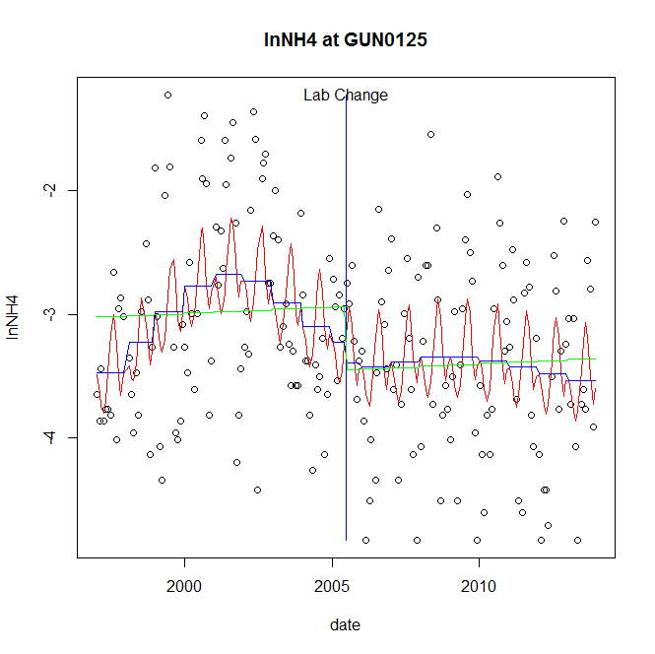

GAM analysis for station GUN0125 dependent variable lnNH4

|  |  |  |  |  |
| --- | --- | --- | --- | --- |
| **Type** | **Source** | **edf** | **F-stat** | **p-value** |
| parametric terms | step | 1 | 0.2932 | 0.5888 |
|  | year | 1 | 360.5045 | <0.0001 |
| smoothed terms | s(year) | 4.62 | 2.812 | 0.0147 |
|  | s(doy) | 4.61 | 3.2143 | <0.0001 |

GAM analysis for station GUN0125 dependent variable lnNH4

|  |  |  |  |  |
| --- | --- | --- | --- | --- |
| **parameter** | **estimate** | **Std. Err.** | **t value** | **p-value** |
| (Intercept) | -0.001157 | 0.001108 | -1.0441 | 0.2978 |
| step | -0.167977 | 0.310226 | -0.5415 | 0.5888 |
| year | -0.001557 | 8.2e-05 | -18.987 | <0.0001 |

root mean-square error = 0.7134

adjusted r-square = 0.2185

station = GUN0125 dependent = lnNO23

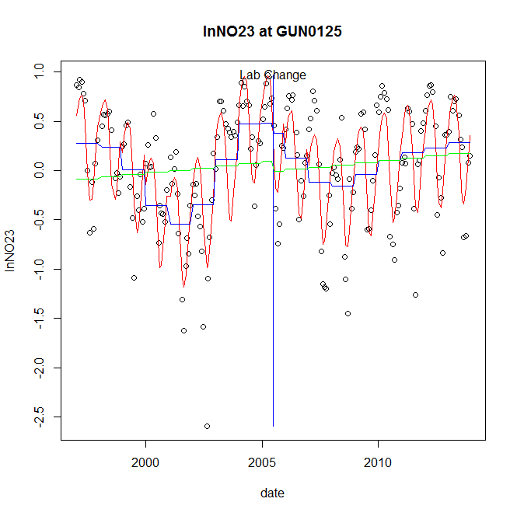

GAM analysis for station GUN0125 dependent variable lnNO23

|  |  |  |  |  |
| --- | --- | --- | --- | --- |
| **Type** | **Source** | **edf** | **F-stat** | **p-value** |
| parametric terms | step | 1 | 0.2873 | 0.5926 |
|  | year | 1 | 1.1115 | 0.2931 |
| smoothed terms | s(year) | 6.8 | 16.2999 | <0.0001 |
|  | s(doy) | 4.53 | 29.0074 | <0.0001 |

GAM analysis for station GUN0125 dependent variable lnNO23

|  |  |  |  |  |
| --- | --- | --- | --- | --- |
| **parameter** | **estimate** | **Std. Err.** | **t value** | **p-value** |
| (Intercept) | -0.000287 | 0.000885 | -0.3242 | 0.7462 |
| step | -0.103301 | 0.19271 | -0.536 | 0.5926 |
| year | 5.3e-05 | 5e-05 | 1.0543 | 0.2931 |

root mean-square error = 0.3628

adjusted r-square = 0.6464

station = GUN0125 dependent = lnNO2

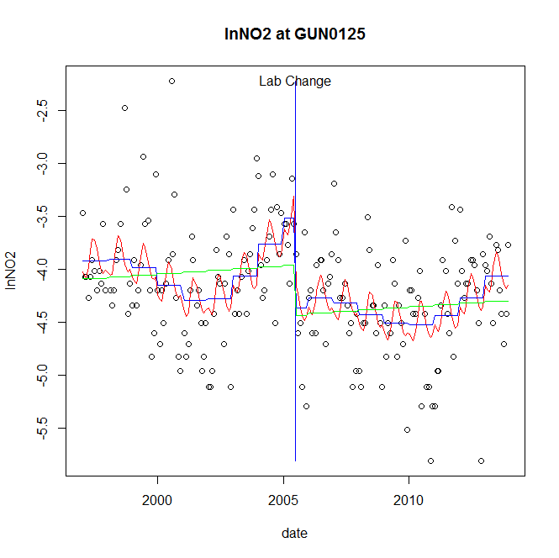

GAM analysis for station GUN0125 dependent variable lnNO2

|  |  |  |  |  |
| --- | --- | --- | --- | --- |
| **Type** | **Source** | **edf** | **F-stat** | **p-value** |
| parametric terms | step | 1 | 12.7072 | 0.0005 |
|  | year | 1 | 921.0996 | <0.0001 |
| smoothed terms | s(year) | 5.85 | 4.3551 | 0.0003 |
|  | s(doy) | 3.69 | 2.0074 | 0.0011 |

GAM analysis for station GUN0125 dependent variable lnNO2

|  |  |  |  |  |
| --- | --- | --- | --- | --- |
| **parameter** | **estimate** | **Std. Err.** | **t value** | **p-value** |
| (Intercept) | -0.001509 | 0.000989 | -1.5253 | 0.1288 |
| step | -0.843734 | 0.23669 | -3.5647 | 0.0005 |
| year | -0.00188 | 6.2e-05 | -30.3496 | <0.0001 |

root mean-square error = 0.4848

adjusted r-square = 0.2477

step significant

station = GUN0125 dependent = lnTP

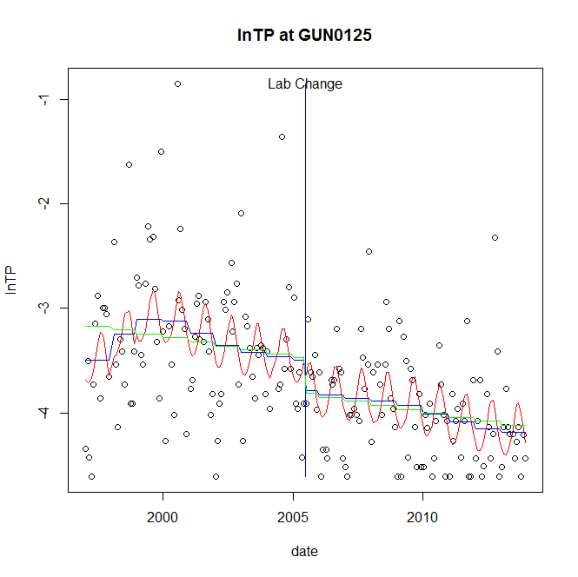

GAM analysis for station GUN0125 dependent variable lnTP

|  |  |  |  |  |
| --- | --- | --- | --- | --- |
| **Type** | **Source** | **edf** | **F-stat** | **p-value** |
| parametric terms | step | 1 | 1.2911 | 0.2573 |
|  | year | 1 | 678.408 | <0.0001 |
| smoothed terms | s(year) | 5.13 | 2.3752 | 0.0307 |
|  | s(doy) | 2.68 | 2.8817 | <0.0001 |

GAM analysis for station GUN0125 dependent variable lnTP

|  |  |  |  |  |
| --- | --- | --- | --- | --- |
| **parameter** | **estimate** | **Std. Err.** | **t value** | **p-value** |
| (Intercept) | -0.001466 | 0.000976 | -1.5026 | 0.1346 |
| step | -0.285873 | 0.251589 | -1.1363 | 0.2573 |
| year | -0.001749 | 6.7e-05 | -26.0463 | <0.0001 |

root mean-square error = 0.5444

adjusted r-square = 0.3542

station = GUN0125 dependent = lnPO4

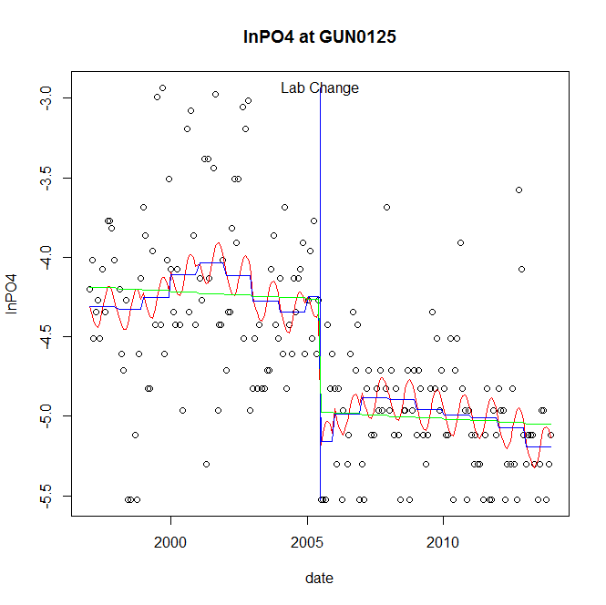

GAM analysis for station GUN0125 dependent variable lnPO4

|  |  |  |  |  |
| --- | --- | --- | --- | --- |
| **Type** | **Source** | **edf** | **F-stat** | **p-value** |
| parametric terms | step | 1 | 14.9603 | 0.0002 |
|  | year | 1 | 1134.5366 | <0.0001 |
| smoothed terms | s(year) | 6.22 | 1.4011 | 0.2080 |
|  | s(doy) | 2.11 | 1.2158 | 0.0036 |

GAM analysis for station GUN0125 dependent variable lnPO4

|  |  |  |  |  |
| --- | --- | --- | --- | --- |
| **parameter** | **estimate** | **Std. Err.** | **t value** | **p-value** |
| (Intercept) | 0.000944 | 0.001025 | 0.9214 | 0.3580 |
| step | -0.907683 | 0.234674 | -3.8679 | 0.0002 |
| year | -0.002074 | 6.2e-05 | -33.6829 | <0.0001 |

root mean-square error = 0.4665

adjusted r-square = 0.4358

step significant

No title given

|  |  |  |  |
| --- | --- | --- | --- |
| **station** | **dep** | **step.est** | **step.pv** |
| GUN0125 | lnTSS | -0.388057 | 0.2729 |
| GUN0125 | lnTN | -0.196058 | 0.1164 |
| GUN0125 | lnNH4 | -0.167977 | 0.5888 |
| GUN0125 | lnNO23 | -0.103301 | 0.5926 |
| GUN0125 | lnNO2 | -0.843734 | 0.0005 |
| GUN0125 | lnTP | -0.285873 | 0.2573 |
| GUN0125 | lnPO4 | -0.907683 | 0.0002 |

station = GUN0258 dependent = lnTSS

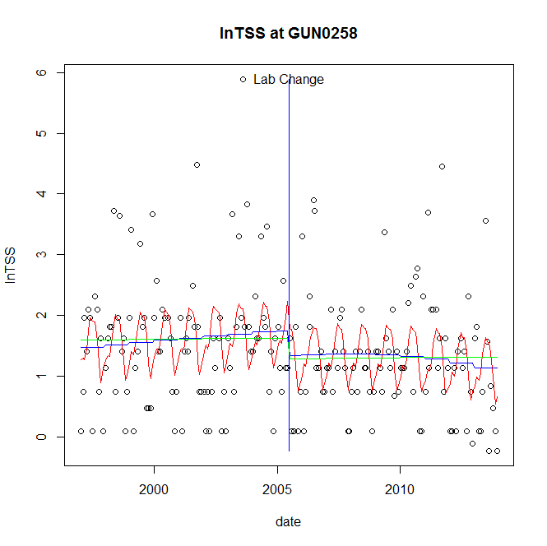

GAM analysis for station GUN0258 dependent variable lnTSS

|  |  |  |  |  |
| --- | --- | --- | --- | --- |
| **Type** | **Source** | **edf** | **F-stat** | **p-value** |
| parametric terms | step | 1 | 1.8564 | 0.1746 |
|  | year | 1 | 100.4648 | <0.0001 |
| smoothed terms | s(year) | 2.22 | 0.5762 | 0.6142 |
|  | s(doy) | 4.94 | 3.8239 | <0.0001 |

GAM analysis for station GUN0258 dependent variable lnTSS

|  |  |  |  |  |
| --- | --- | --- | --- | --- |
| **parameter** | **estimate** | **Std. Err.** | **t value** | **p-value** |
| (Intercept) | 0.000217 | 0.000601 | 0.361 | 0.7185 |
| step | -0.405916 | 0.297919 | -1.3625 | 0.1746 |
| year | 0.00082 | 8.2e-05 | 10.0232 | <0.0001 |

root mean-square error = 0.9512

adjusted r-square = 0.1432

station = GUN0258 dependent = lnTN

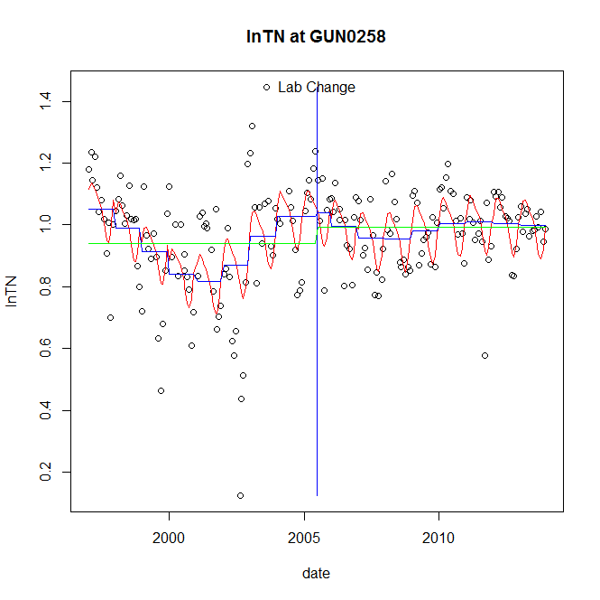

GAM analysis for station GUN0258 dependent variable lnTN

|  |  |  |  |  |
| --- | --- | --- | --- | --- |
| **Type** | **Source** | **edf** | **F-stat** | **p-value** |
| parametric terms | step | 1 | 0.0282 | 0.8668 |
|  | year | 1 | 700.4516 | <0.0001 |
| smoothed terms | s(year) | 6.3 | 5.7912 | <0.0001 |
|  | s(doy) | 3.83 | 6.1947 | <0.0001 |

GAM analysis for station GUN0258 dependent variable lnTN

|  |  |  |  |  |
| --- | --- | --- | --- | --- |
| **parameter** | **estimate** | **Std. Err.** | **t value** | **p-value** |
| (Intercept) | 0.000411 | 0.000306 | 1.3395 | 0.1820 |
| step | 0.011511 | 0.068545 | 0.1679 | 0.8668 |
| year | 0.000478 | 1.8e-05 | 26.466 | <0.0001 |

root mean-square error = 0.134

adjusted r-square = 0.3301

station = GUN0258 dependent = lnNH4

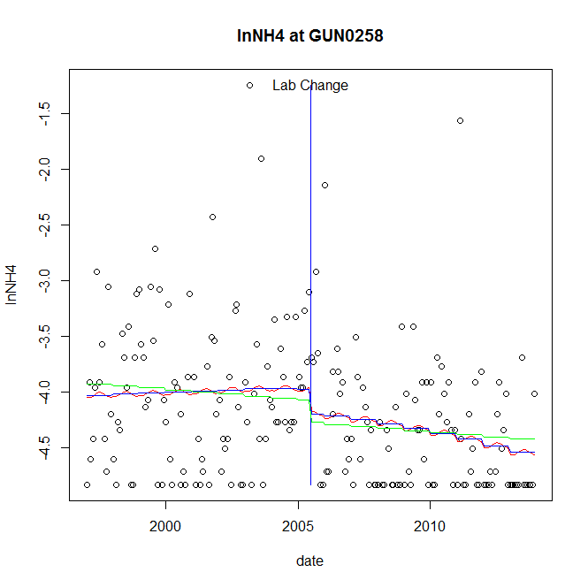

GAM analysis for station GUN0258 dependent variable lnNH4

|  |  |  |  |  |
| --- | --- | --- | --- | --- |
| **Type** | **Source** | **edf** | **F-stat** | **p-value** |
| parametric terms | step | 1 | 1.3541 | 0.2460 |
|  | year | 1 | 1504.5935 | <0.0001 |
| smoothed terms | s(year) | 2.07 | 1.1777 | 0.3087 |
|  | s(doy) | 0.54 | 0.0846 | 0.2783 |

GAM analysis for station GUN0258 dependent variable lnNH4

|  |  |  |  |  |
| --- | --- | --- | --- | --- |
| **parameter** | **estimate** | **Std. Err.** | **t value** | **p-value** |
| (Intercept) | 0.000285 | 0.00036 | 0.7921 | 0.4293 |
| step | -0.22127 | 0.190154 | -1.1636 | 0.2460 |
| year | -0.002027 | 5.2e-05 | -38.7891 | <0.0001 |

root mean-square error = 0.6254

adjusted r-square = 0.087

station = GUN0258 dependent = lnNO23

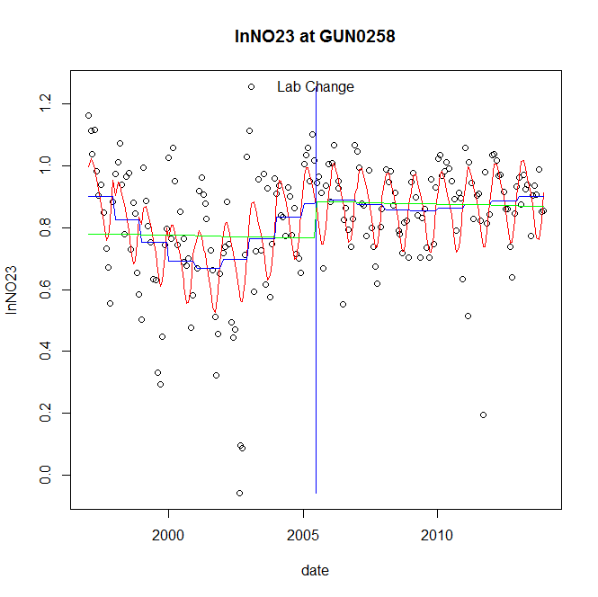

GAM analysis for station GUN0258 dependent variable lnNO23

|  |  |  |  |  |
| --- | --- | --- | --- | --- |
| **Type** | **Source** | **edf** | **F-stat** | **p-value** |
| parametric terms | step | 1 | 0.009 | 0.9246 |
|  | year | 1 | 493.2224 | <0.0001 |
| smoothed terms | s(year) | 5.19 | 4.9712 | <0.0001 |
|  | s(doy) | 3.71 | 8.7778 | <0.0001 |

GAM analysis for station GUN0258 dependent variable lnNO23

|  |  |  |  |  |
| --- | --- | --- | --- | --- |
| **parameter** | **estimate** | **Std. Err.** | **t value** | **p-value** |
| (Intercept) | 0.000378 | 0.000279 | 1.3539 | 0.1774 |
| step | 0.006737 | 0.071125 | 0.0947 | 0.9246 |
| year | 0.00041 | 1.8e-05 | 22.2086 | <0.0001 |

root mean-square error = 0.1547

adjusted r-square = 0.3846

station = GUN0258 dependent = lnNO2

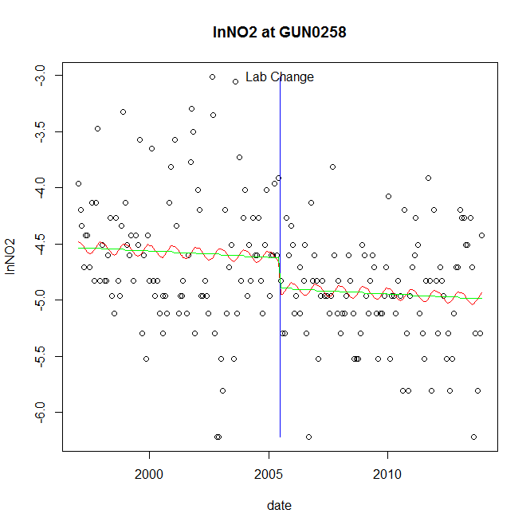

GAM analysis for station GUN0258 dependent variable lnNO2

|  |  |  |  |  |
| --- | --- | --- | --- | --- |
| **Type** | **Source** | **edf** | **F-stat** | **p-value** |
| parametric terms | step | 1 | 3.1911 | 0.0756 |
|  | year | 1 | 2942.1712 | <0.0001 |
| smoothed terms | s(year) | 1 | 0.3269 | 0.5681 |
|  | s(doy) | 1.05 | 0.263 | 0.1219 |

GAM analysis for station GUN0258 dependent variable lnNO2

|  |  |  |  |  |
| --- | --- | --- | --- | --- |
| **parameter** | **estimate** | **Std. Err.** | **t value** | **p-value** |
| (Intercept) | 0.000105 | 0.000185 | 0.5656 | 0.5723 |
| step | -0.271662 | 0.152076 | -1.7864 | 0.0756 |
| year | -0.002305 | 4.2e-05 | -54.2418 | <0.0001 |

root mean-square error = 0.5444

adjusted r-square = 0.1054

station = GUN0258 dependent = lnTP

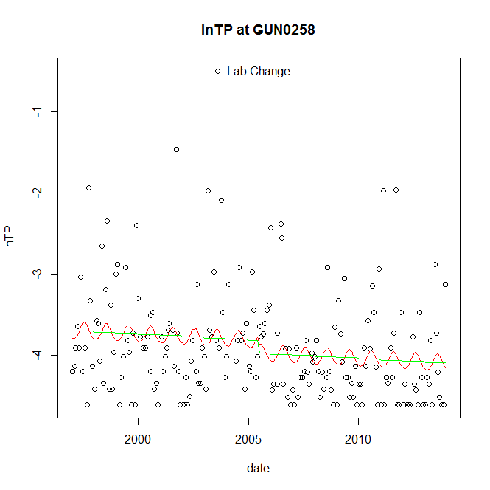

GAM analysis for station GUN0258 dependent variable lnTP

|  |  |  |  |  |
| --- | --- | --- | --- | --- |
| **Type** | **Source** | **edf** | **F-stat** | **p-value** |
| parametric terms | step | 1 | 0.6917 | 0.4066 |
|  | year | 1 | 1265.2052 | <0.0001 |
| smoothed terms | s(year) | 1 | 0.4297 | 0.5129 |
|  | s(doy) | 1.49 | 0.4763 | 0.0611 |

GAM analysis for station GUN0258 dependent variable lnTP

|  |  |  |  |  |
| --- | --- | --- | --- | --- |
| **parameter** | **estimate** | **Std. Err.** | **t value** | **p-value** |
| (Intercept) | 0.000151 | 0.000232 | 0.6515 | 0.5155 |
| step | -0.157209 | 0.189024 | -0.8317 | 0.4066 |
| year | -0.001905 | 5.4e-05 | -35.5697 | <0.0001 |

root mean-square error = 0.6634

adjusted r-square = 0.0537

station = GUN0258 dependent = lnPO4

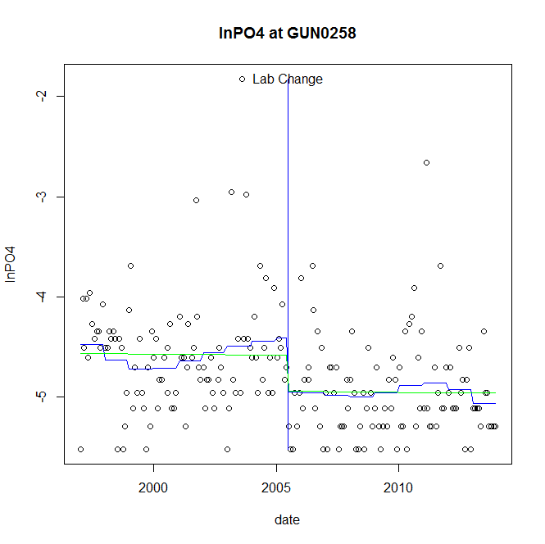

GAM analysis for station GUN0258 dependent variable lnPO4

|  |  |  |  |  |
| --- | --- | --- | --- | --- |
| **Type** | **Source** | **edf** | **F-stat** | **p-value** |
| parametric terms | step | 1 | 5.4151 | 0.0210 |
|  | year | 1 | 1367.0091 | <0.0001 |
| smoothed terms | s(year) | 5.08 | 1.273 | 0.2713 |
|  | s(doy) | 0 | 0 | 0.8897 |

GAM analysis for station GUN0258 dependent variable lnPO4

|  |  |  |  |  |
| --- | --- | --- | --- | --- |
| **parameter** | **estimate** | **Std. Err.** | **t value** | **p-value** |
| (Intercept) | 0.001915 | 0.000906 | 2.1138 | 0.0358 |
| step | -0.538002 | 0.231197 | -2.327 | 0.0210 |
| year | -0.002244 | 6.1e-05 | -36.9731 | <0.0001 |

root mean-square error = 0.5166

adjusted r-square = 0.1336

step significant

No title given

|  |  |  |  |
| --- | --- | --- | --- |
| **station** | **dep** | **step.est** | **step.pv** |
| GUN0258 | lnTSS | -0.405916 | 0.1746 |
| GUN0258 | lnTN | 0.011511 | 0.8668 |
| GUN0258 | lnNH4 | -0.22127 | 0.2460 |
| GUN0258 | lnNO23 | 0.006737 | 0.9246 |
| GUN0258 | lnNO2 | -0.271662 | 0.0756 |
| GUN0258 | lnTP | -0.157209 | 0.4066 |
| GUN0258 | lnPO4 | -0.538002 | 0.0210 |

station = GUN0476 dependent = lnTSS

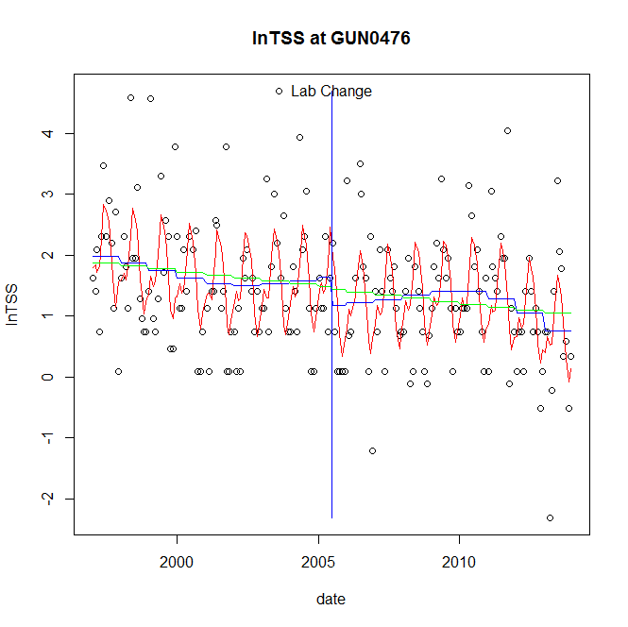

GAM analysis for station GUN0476 dependent variable lnTSS

|  |  |  |  |  |
| --- | --- | --- | --- | --- |
| **Type** | **Source** | **edf** | **F-stat** | **p-value** |
| parametric terms | step | 1 | 1.611 | 0.2059 |
|  | year | 1 | 72.953 | <0.0001 |
| smoothed terms | s(year) | 4.08 | 2.0458 | 0.0740 |
|  | s(doy) | 5.67 | 9.3456 | <0.0001 |

GAM analysis for station GUN0476 dependent variable lnTSS

|  |  |  |  |  |
| --- | --- | --- | --- | --- |
| **parameter** | **estimate** | **Std. Err.** | **t value** | **p-value** |
| (Intercept) | 0.002476 | 0.001201 | 2.061 | 0.0407 |
| step | -0.459772 | 0.36224 | -1.2692 | 0.2059 |
| year | 0.000819 | 9.6e-05 | 8.5413 | <0.0001 |

root mean-square error = 0.8822

adjusted r-square = 0.3178

station = GUN0476 dependent = lnTN

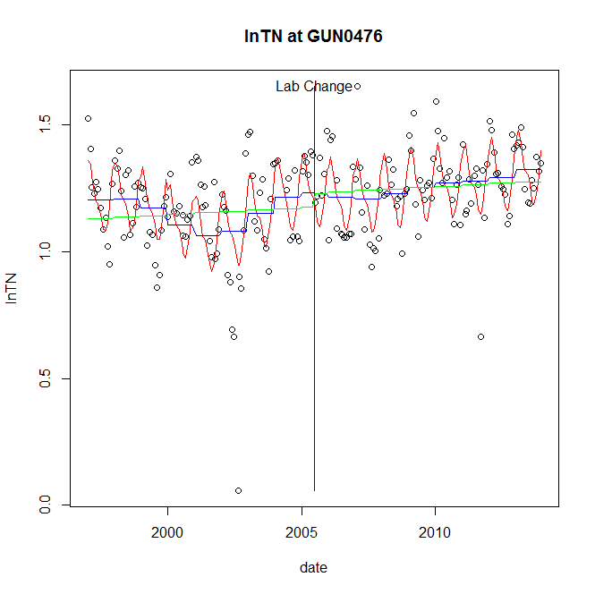

GAM analysis for station GUN0476 dependent variable lnTN

|  |  |  |  |  |
| --- | --- | --- | --- | --- |
| **Type** | **Source** | **edf** | **F-stat** | **p-value** |
| parametric terms | step | 1 | 7e-04 | 0.9788 |
|  | year | 1 | 1011.6522 | <0.0001 |
| smoothed terms | s(year) | 6.25 | 3.8201 | 0.0008 |
|  | s(doy) | 4.9 | 10.9922 | <0.0001 |

GAM analysis for station GUN0476 dependent variable lnTN

|  |  |  |  |  |
| --- | --- | --- | --- | --- |
| **parameter** | **estimate** | **Std. Err.** | **t value** | **p-value** |
| (Intercept) | -0.000262 | 0.000323 | -0.8113 | 0.4182 |
| step | -0.001925 | 0.072349 | -0.0266 | 0.9788 |
| year | 0.000603 | 1.9e-05 | 31.8065 | <0.0001 |

root mean-square error = 0.1418

adjusted r-square = 0.411

station = GUN0476 dependent = lnNH4

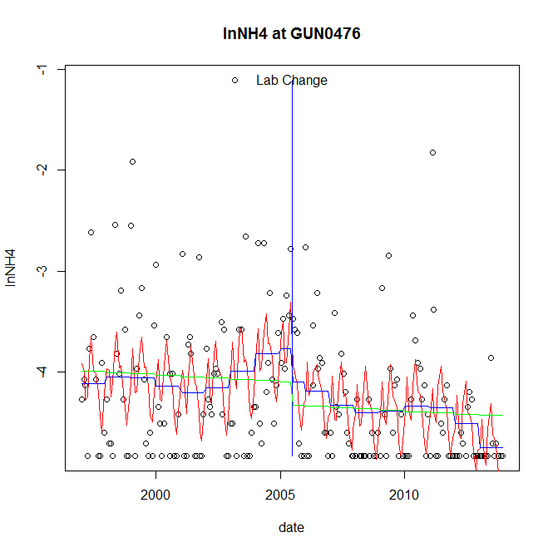

GAM analysis for station GUN0476 dependent variable lnNH4

|  |  |  |  |  |
| --- | --- | --- | --- | --- |
| **Type** | **Source** | **edf** | **F-stat** | **p-value** |
| parametric terms | step | 1 | 1.2752 | 0.2602 |
|  | year | 1 | 720.3651 | <0.0001 |
| smoothed terms | s(year) | 5.7 | 2.1538 | 0.0448 |
|  | s(doy) | 6.68 | 4.9012 | <0.0001 |

GAM analysis for station GUN0476 dependent variable lnNH4

|  |  |  |  |  |
| --- | --- | --- | --- | --- |
| **parameter** | **estimate** | **Std. Err.** | **t value** | **p-value** |
| (Intercept) | 0.001036 | 0.001208 | 0.8577 | 0.3922 |
| step | -0.328877 | 0.291242 | -1.1292 | 0.2602 |
| year | -0.002029 | 7.6e-05 | -26.8396 | <0.0001 |

root mean-square error = 0.603

adjusted r-square = 0.241

station = GUN0476 dependent = lnNO23

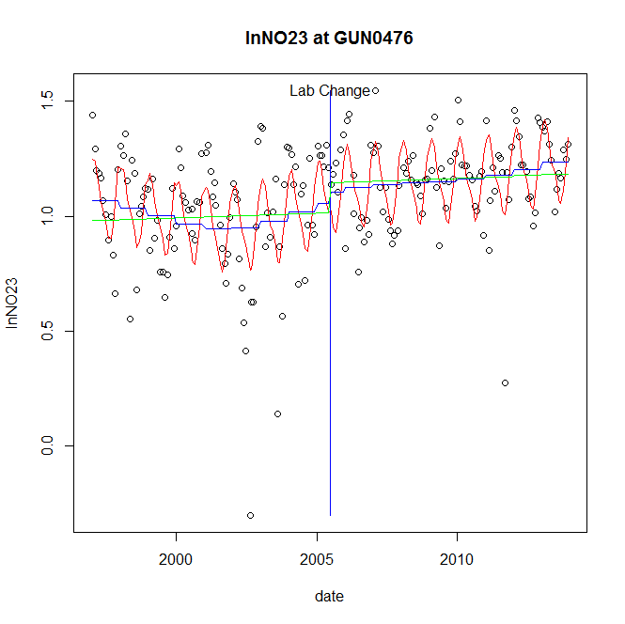

GAM analysis for station GUN0476 dependent variable lnNO23

|  |  |  |  |  |
| --- | --- | --- | --- | --- |
| **Type** | **Source** | **edf** | **F-stat** | **p-value** |
| parametric terms | step | 1 | 0.3605 | 0.5490 |
|  | year | 1 | 647.0628 | <0.0001 |
| smoothed terms | s(year) | 4.15 | 1.9216 | 0.0914 |
|  | s(doy) | 4.36 | 10.3307 | <0.0001 |

GAM analysis for station GUN0476 dependent variable lnNO23

|  |  |  |  |  |
| --- | --- | --- | --- | --- |
| **parameter** | **estimate** | **Std. Err.** | **t value** | **p-value** |
| (Intercept) | -1.3e-05 | 0.000267 | -0.049 | 0.9610 |
| step | 0.047718 | 0.07948 | 0.6004 | 0.5490 |
| year | 0.00053 | 2.1e-05 | 25.4374 | <0.0001 |

root mean-square error = 0.1923

adjusted r-square = 0.3891

station = GUN0476 dependent = lnNO2

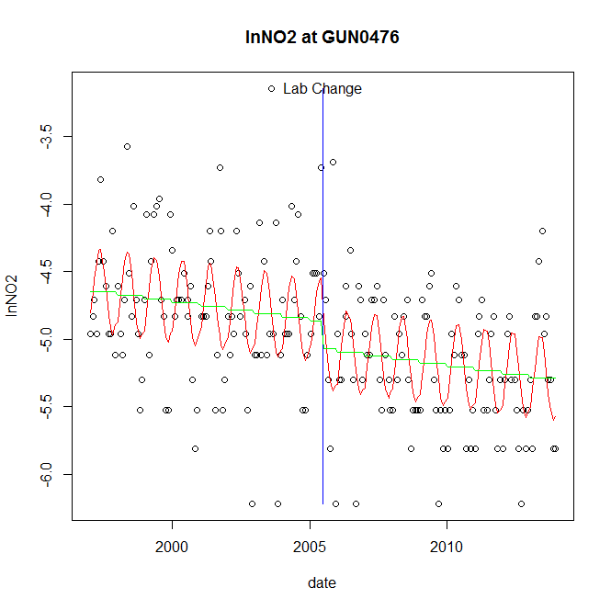

GAM analysis for station GUN0476 dependent variable lnNO2

|  |  |  |  |  |
| --- | --- | --- | --- | --- |
| **Type** | **Source** | **edf** | **F-stat** | **p-value** |
| parametric terms | step | 1 | 2.6644 | 0.1042 |
|  | year | 1 | 5062.3604 | <0.0001 |
| smoothed terms | s(year) | 1 | 3.9781 | 0.0474 |
|  | s(doy) | 2.8 | 7.3317 | <0.0001 |

GAM analysis for station GUN0476 dependent variable lnNO2

|  |  |  |  |  |
| --- | --- | --- | --- | --- |
| **parameter** | **estimate** | **Std. Err.** | **t value** | **p-value** |
| (Intercept) | 0.000296 | 0.000149 | 1.9866 | 0.0483 |
| step | -0.199992 | 0.122522 | -1.6323 | 0.1042 |
| year | -0.002435 | 3.4e-05 | -71.1503 | <0.0001 |

root mean-square error = 0.4374

adjusted r-square = 0.3655

station = GUN0476 dependent = lnTP

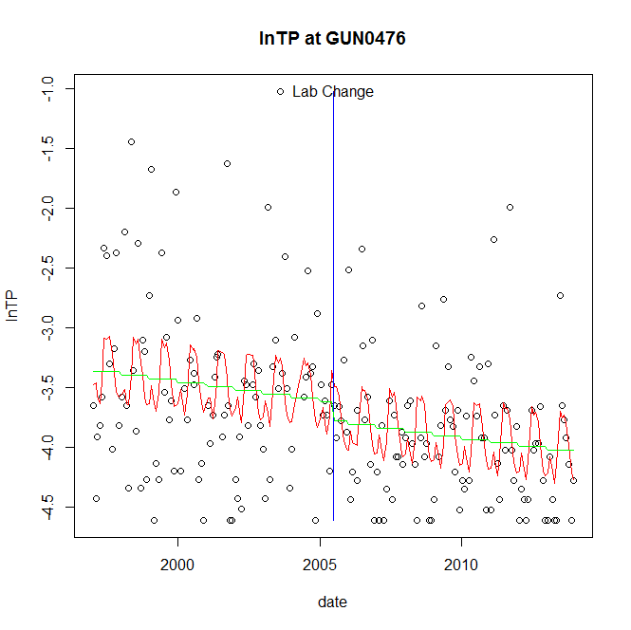

GAM analysis for station GUN0476 dependent variable lnTP

|  |  |  |  |  |
| --- | --- | --- | --- | --- |
| **Type** | **Source** | **edf** | **F-stat** | **p-value** |
| parametric terms | step | 1 | 0.8227 | 0.3655 |
|  | year | 1 | 1287.4176 | <0.0001 |
| smoothed terms | s(year) | 1 | 2.6378 | 0.1060 |
|  | s(doy) | 5.68 | 3.2173 | 0.0001 |

GAM analysis for station GUN0476 dependent variable lnTP

|  |  |  |  |  |
| --- | --- | --- | --- | --- |
| **parameter** | **estimate** | **Std. Err.** | **t value** | **p-value** |
| (Intercept) | 0.000353 | 0.000218 | 1.6201 | 0.1069 |
| step | -0.161312 | 0.177845 | -0.907 | 0.3655 |
| year | -0.001807 | 5e-05 | -35.8806 | <0.0001 |

root mean-square error = 0.6221

adjusted r-square = 0.1919

station = GUN0476 dependent = lnPO4

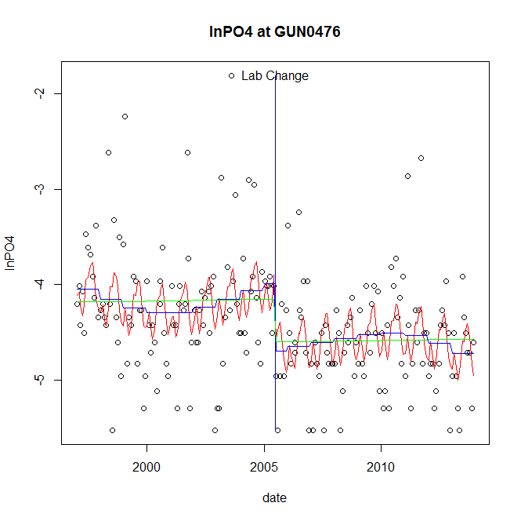

GAM analysis for station GUN0476 dependent variable lnPO4

|  |  |  |  |  |
| --- | --- | --- | --- | --- |
| **Type** | **Source** | **edf** | **F-stat** | **p-value** |
| parametric terms | step | 1 | 9.7772 | 0.0020 |
|  | year | 1 | 1139.0353 | <0.0001 |
| smoothed terms | s(year) | 3.93 | 1.2315 | 0.2946 |
|  | s(doy) | 5.85 | 3.1994 | 0.0002 |

GAM analysis for station GUN0476 dependent variable lnPO4

|  |  |  |  |  |
| --- | --- | --- | --- | --- |
| **parameter** | **estimate** | **Std. Err.** | **t value** | **p-value** |
| (Intercept) | 0.001356 | 0.000729 | 1.8606 | 0.0643 |
| step | -0.707697 | 0.226329 | -3.1268 | 0.0020 |
| year | -0.002016 | 6e-05 | -33.7496 | <0.0001 |

root mean-square error = 0.5616

adjusted r-square = 0.2074

step significant

No title given

|  |  |  |  |
| --- | --- | --- | --- |
| **station** | **dep** | **step.est** | **step.pv** |
| GUN0476 | lnTSS | -0.459772 | 0.2059 |
| GUN0476 | lnTN | -0.001925 | 0.9788 |
| GUN0476 | lnNH4 | -0.328877 | 0.2602 |
| GUN0476 | lnNO23 | 0.047718 | 0.5490 |
| GUN0476 | lnNO2 | -0.199992 | 0.1042 |
| GUN0476 | lnTP | -0.161312 | 0.3655 |
| GUN0476 | lnPO4 | -0.707697 | 0.0020 |

station = GWN0115 dependent = lnTSS

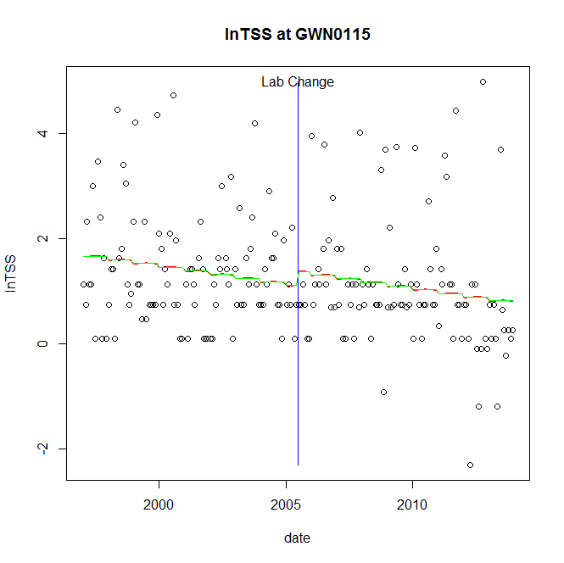

GAM analysis for station GWN0115 dependent variable lnTSS

|  |  |  |  |  |
| --- | --- | --- | --- | --- |
| **Type** | **Source** | **edf** | **F-stat** | **p-value** |
| parametric terms | step | 1 | 0.7141 | 0.3991 |
|  | year | 1 | 37.7277 | <0.0001 |
| smoothed terms | s(year) | 1 | 4.6752 | 0.0318 |
|  | s(doy) | 0.16 | 0.0217 | 0.3398 |

GAM analysis for station GWN0115 dependent variable lnTSS

|  |  |  |  |  |
| --- | --- | --- | --- | --- |
| **parameter** | **estimate** | **Std. Err.** | **t value** | **p-value** |
| (Intercept) | 0.000845 | 0.000391 | 2.1631 | 0.0317 |
| step | 0.270907 | 0.320572 | 0.8451 | 0.3991 |
| year | 0.00055 | 9e-05 | 6.1423 | <0.0001 |

root mean-square error = 1.1501

adjusted r-square = 0.0323

station = GWN0115 dependent = lnTN

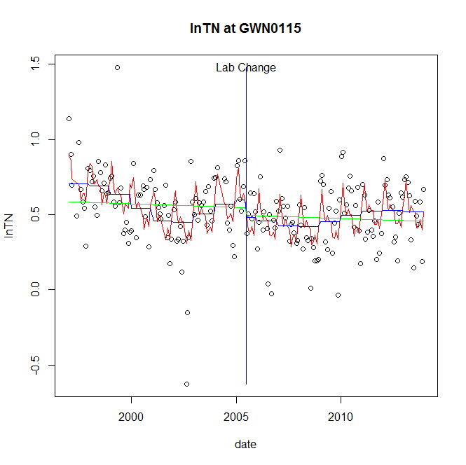

GAM analysis for station GWN0115 dependent variable lnTN

|  |  |  |  |  |
| --- | --- | --- | --- | --- |
| **Type** | **Source** | **edf** | **F-stat** | **p-value** |
| parametric terms | step | 1 | 1.4626 | 0.2281 |
|  | year | 1 | 124.7035 | <0.0001 |
| smoothed terms | s(year) | 5.96 | 3.8217 | 0.0009 |
|  | s(doy) | 7.07 | 5.7495 | <0.0001 |

GAM analysis for station GWN0115 dependent variable lnTN

|  |  |  |  |  |
| --- | --- | --- | --- | --- |
| **parameter** | **estimate** | **Std. Err.** | **t value** | **p-value** |
| (Intercept) | 9.9e-05 | 0.000423 | 0.2339 | 0.8153 |
| step | -0.118479 | 0.097966 | -1.2094 | 0.2281 |
| year | 0.000291 | 2.6e-05 | 11.1671 | <0.0001 |

root mean-square error = 0.1962

adjusted r-square = 0.2914

station = GWN0115 dependent = lnNH4

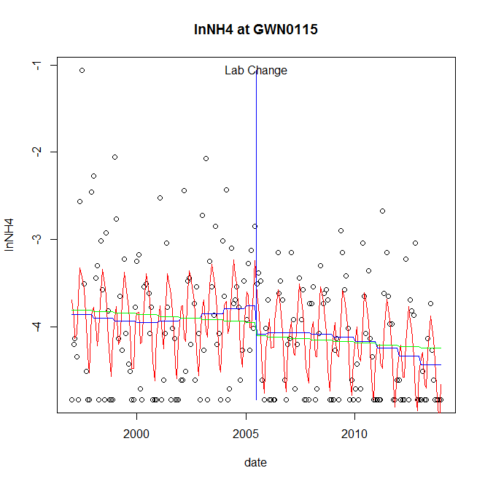

GAM analysis for station GWN0115 dependent variable lnNH4

|  |  |  |  |  |
| --- | --- | --- | --- | --- |
| **Type** | **Source** | **edf** | **F-stat** | **p-value** |
| parametric terms | step | 1 | 1.9697 | 0.1621 |
|  | year | 1 | 1016.1728 | <0.0001 |
| smoothed terms | s(year) | 3.04 | 1.6153 | 0.1737 |
|  | s(doy) | 6.14 | 8.0887 | <0.0001 |

GAM analysis for station GWN0115 dependent variable lnNH4

|  |  |  |  |  |
| --- | --- | --- | --- | --- |
| **parameter** | **estimate** | **Std. Err.** | **t value** | **p-value** |
| (Intercept) | 0.00082 | 0.000608 | 1.35 | 0.1786 |
| step | -0.318958 | 0.227266 | -1.4035 | 0.1621 |
| year | -0.001939 | 6.1e-05 | -31.8775 | <0.0001 |

root mean-square error = 0.6334

adjusted r-square = 0.2813

station = GWN0115 dependent = lnNO23

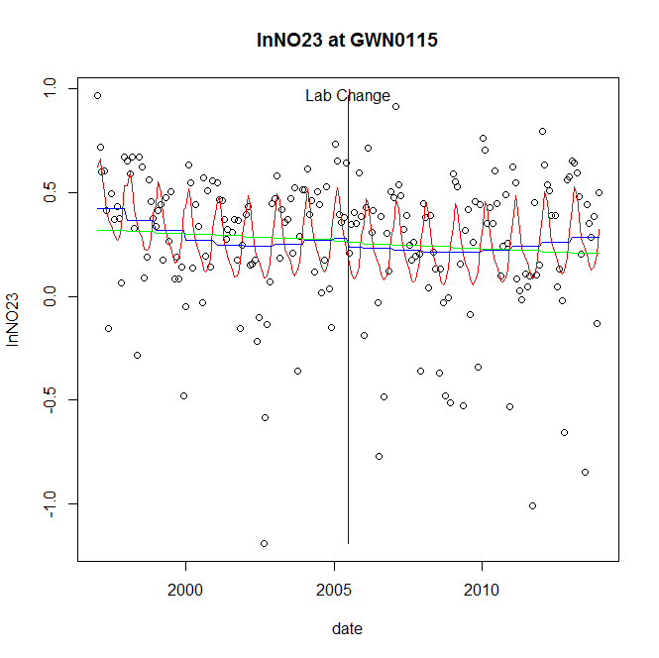

GAM analysis for station GWN0115 dependent variable lnNO23

|  |  |  |  |  |
| --- | --- | --- | --- | --- |
| **Type** | **Source** | **edf** | **F-stat** | **p-value** |
| parametric terms | step | 1 | 0.1296 | 0.7192 |
|  | year | 1 | 21.59 | <0.0001 |
| smoothed terms | s(year) | 3.38 | 1.3017 | 0.2682 |
|  | s(doy) | 4.26 | 4.7474 | <0.0001 |

GAM analysis for station GWN0115 dependent variable lnNO23

|  |  |  |  |  |
| --- | --- | --- | --- | --- |
| **parameter** | **estimate** | **Std. Err.** | **t value** | **p-value** |
| (Intercept) | 0.000192 | 0.000339 | 0.5656 | 0.5723 |
| step | -0.042242 | 0.117317 | -0.3601 | 0.7192 |
| year | 0.000145 | 3.1e-05 | 4.6465 | <0.0001 |

root mean-square error = 0.3123

adjusted r-square = 0.1768

station = GWN0115 dependent = lnNO2

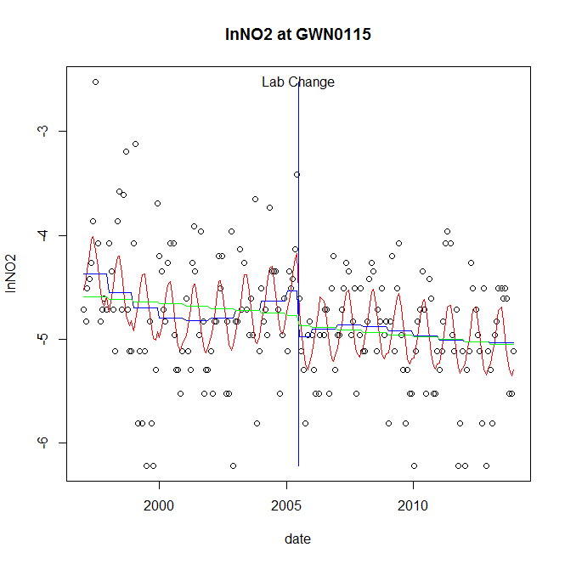

GAM analysis for station GWN0115 dependent variable lnNO2

|  |  |  |  |  |
| --- | --- | --- | --- | --- |
| **Type** | **Source** | **edf** | **F-stat** | **p-value** |
| parametric terms | step | 1 | 4.0896 | 0.0445 |
|  | year | 1 | 1618.1672 | <0.0001 |
| smoothed terms | s(year) | 4.05 | 2.1653 | 0.0600 |
|  | s(doy) | 3.18 | 5.0431 | <0.0001 |

GAM analysis for station GWN0115 dependent variable lnNO2

|  |  |  |  |  |
| --- | --- | --- | --- | --- |
| **parameter** | **estimate** | **Std. Err.** | **t value** | **p-value** |
| (Intercept) | 0.001139 | 0.000715 | 1.5946 | 0.1124 |
| step | -0.438221 | 0.216697 | -2.0223 | 0.0445 |
| year | -0.002297 | 5.7e-05 | -40.2264 | <0.0001 |

root mean-square error = 0.5309

adjusted r-square = 0.2501

step significant

station = GWN0115 dependent = lnTP

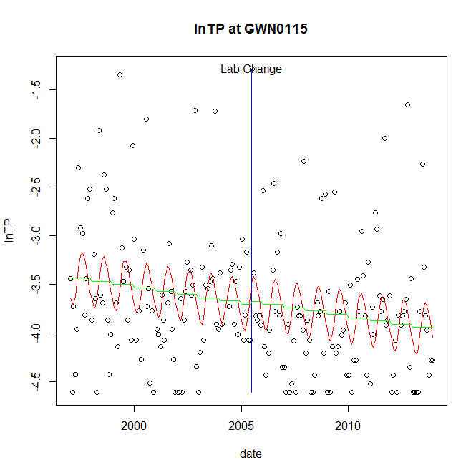

GAM analysis for station GWN0115 dependent variable lnTP

|  |  |  |  |  |
| --- | --- | --- | --- | --- |
| **Type** | **Source** | **edf** | **F-stat** | **p-value** |
| parametric terms | step | 1 | 0.0306 | 0.8612 |
|  | year | 1 | 1199.6452 | <0.0001 |
| smoothed terms | s(year) | 1 | 2.8352 | 0.0938 |
|  | s(doy) | 2.34 | 2.3088 | <0.0001 |

GAM analysis for station GWN0115 dependent variable lnTP

|  |  |  |  |  |
| --- | --- | --- | --- | --- |
| **parameter** | **estimate** | **Std. Err.** | **t value** | **p-value** |
| (Intercept) | 0.000389 | 0.000231 | 1.68 | 0.0946 |
| step | 0.033016 | 0.188618 | 0.175 | 0.8612 |
| year | -0.001851 | 5.3e-05 | -34.6359 | <0.0001 |

root mean-square error = 0.6614

adjusted r-square = 0.125

station = GWN0115 dependent = lnPO4

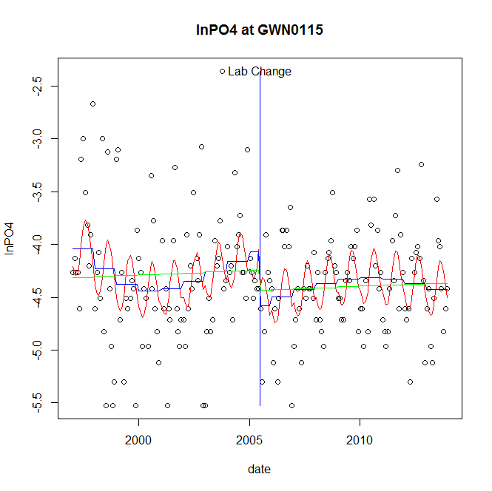

GAM analysis for station GWN0115 dependent variable lnPO4

|  |  |  |  |  |
| --- | --- | --- | --- | --- |
| **Type** | **Source** | **edf** | **F-stat** | **p-value** |
| parametric terms | step | 1 | 5.7391 | 0.0175 |
|  | year | 1 | 1339.3234 | <0.0001 |
| smoothed terms | s(year) | 4.19 | 2.311 | 0.0443 |
|  | s(doy) | 2.7 | 3.7359 | <0.0001 |

GAM analysis for station GWN0115 dependent variable lnPO4

|  |  |  |  |  |
| --- | --- | --- | --- | --- |
| **parameter** | **estimate** | **Std. Err.** | **t value** | **p-value** |
| (Intercept) | 0.001538 | 0.000715 | 2.1516 | 0.0327 |
| step | -0.506787 | 0.211545 | -2.3957 | 0.0175 |
| year | -0.002037 | 5.6e-05 | -36.5968 | <0.0001 |

root mean-square error = 0.5106

adjusted r-square = 0.1657

step significant

No title given

|  |  |  |  |
| --- | --- | --- | --- |
| **station** | **dep** | **step.est** | **step.pv** |
| GWN0115 | lnTSS | 0.270907 | 0.3991 |
| GWN0115 | lnTN | -0.118479 | 0.2281 |
| GWN0115 | lnNH4 | -0.318958 | 0.1621 |
| GWN0115 | lnNO23 | -0.042242 | 0.7192 |
| GWN0115 | lnNO2 | -0.438221 | 0.0445 |
| GWN0115 | lnTP | 0.033016 | 0.8612 |
| GWN0115 | lnPO4 | -0.506787 | 0.0175 |

station = JON0184 dependent = lnTSS

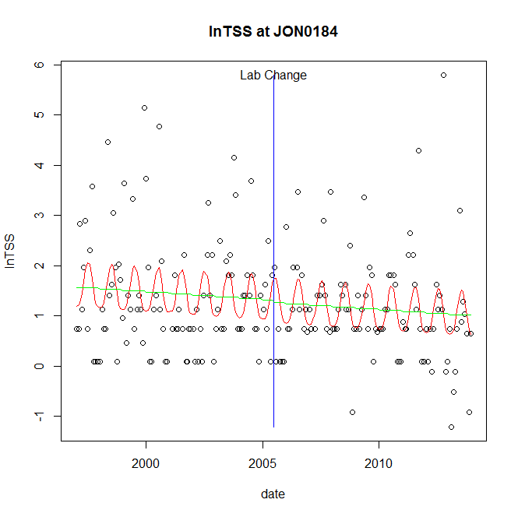

GAM analysis for station JON0184 dependent variable lnTSS

|  |  |  |  |  |
| --- | --- | --- | --- | --- |
| **Type** | **Source** | **edf** | **F-stat** | **p-value** |
| parametric terms | step | 1 | 0.0227 | 0.8804 |
|  | year | 1 | 62.2655 | <0.0001 |
| smoothed terms | s(year) | 1 | 1.16 | 0.2828 |
|  | s(doy) | 2.97 | 2.8458 | <0.0001 |

GAM analysis for station JON0184 dependent variable lnTSS

|  |  |  |  |  |
| --- | --- | --- | --- | --- |
| **parameter** | **estimate** | **Std. Err.** | **t value** | **p-value** |
| (Intercept) | 0.000386 | 0.000358 | 1.078 | 0.2823 |
| step | -0.044275 | 0.293805 | -0.1507 | 0.8804 |
| year | 0.000647 | 8.2e-05 | 7.8909 | <0.0001 |

root mean-square error = 1.0427

adjusted r-square = 0.1153

station = JON0184 dependent = lnTN

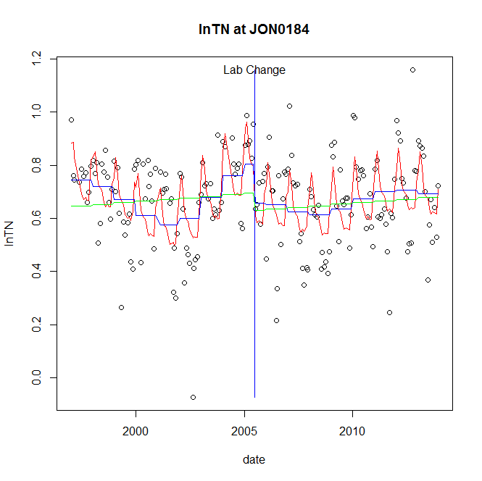

GAM analysis for station JON0184 dependent variable lnTN

|  |  |  |  |  |
| --- | --- | --- | --- | --- |
| **Type** | **Source** | **edf** | **F-stat** | **p-value** |
| parametric terms | step | 1 | 4.1939 | 0.0420 |
|  | year | 1 | 373.6833 | <0.0001 |
| smoothed terms | s(year) | 6.01 | 4.1246 | 0.0004 |
|  | s(doy) | 5.61 | 7.0958 | <0.0001 |

GAM analysis for station JON0184 dependent variable lnTN

|  |  |  |  |  |
| --- | --- | --- | --- | --- |
| **parameter** | **estimate** | **Std. Err.** | **t value** | **p-value** |
| (Intercept) | 0.000242 | 0.000313 | 0.773 | 0.4405 |
| step | -0.147135 | 0.071847 | -2.0479 | 0.0420 |
| year | 0.000372 | 1.9e-05 | 19.3309 | <0.0001 |

root mean-square error = 0.1435

adjusted r-square = 0.3178

step significant

station = JON0184 dependent = lnNH4

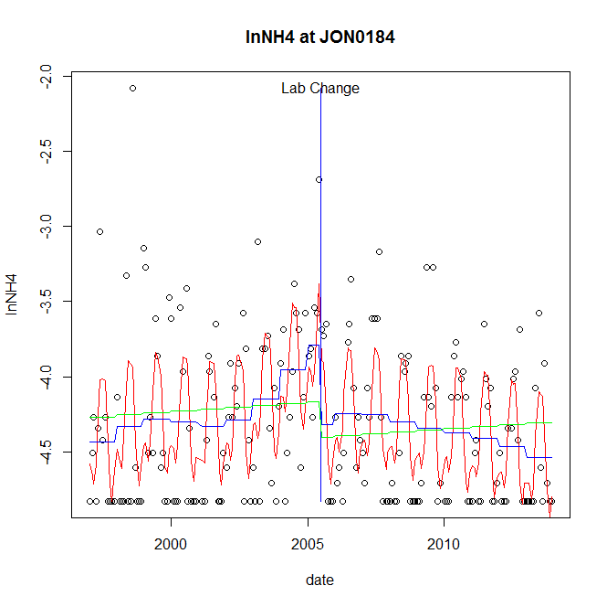

GAM analysis for station JON0184 dependent variable lnNH4

|  |  |  |  |  |
| --- | --- | --- | --- | --- |
| **Type** | **Source** | **edf** | **F-stat** | **p-value** |
| parametric terms | step | 1 | 7.1248 | 0.0083 |
|  | year | 1 | 1507.3173 | <0.0001 |
| smoothed terms | s(year) | 5.38 | 3.9911 | 0.0008 |
|  | s(doy) | 5.93 | 12.2859 | <0.0001 |

GAM analysis for station JON0184 dependent variable lnNH4

|  |  |  |  |  |
| --- | --- | --- | --- | --- |
| **parameter** | **estimate** | **Std. Err.** | **t value** | **p-value** |
| (Intercept) | -0.000257 | 8e-04 | -0.3217 | 0.7481 |
| step | -0.532702 | 0.199572 | -2.6692 | 0.0083 |
| year | -0.002017 | 5.2e-05 | -38.8242 | <0.0001 |

root mean-square error = 0.4252

adjusted r-square = 0.3754

step significant

station = JON0184 dependent = lnNO23

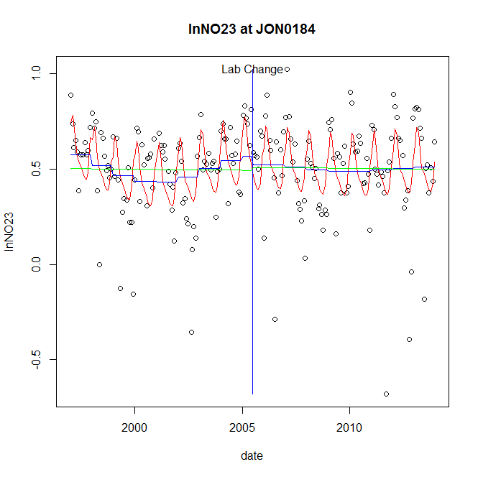

GAM analysis for station JON0184 dependent variable lnNO23

|  |  |  |  |  |
| --- | --- | --- | --- | --- |
| **Type** | **Source** | **edf** | **F-stat** | **p-value** |
| parametric terms | step | 1 | 0.2595 | 0.6110 |
|  | year | 1 | 127.6998 | <0.0001 |
| smoothed terms | s(year) | 4.16 | 1.6795 | 0.1400 |
|  | s(doy) | 4.51 | 7.196 | <0.0001 |

GAM analysis for station JON0184 dependent variable lnNO23

|  |  |  |  |  |
| --- | --- | --- | --- | --- |
| **parameter** | **estimate** | **Std. Err.** | **t value** | **p-value** |
| (Intercept) | 0.000307 | 0.000295 | 1.0399 | 0.2997 |
| step | -0.044704 | 0.087751 | -0.5094 | 0.6110 |
| year | 0.000262 | 2.3e-05 | 11.3004 | <0.0001 |

root mean-square error = 0.2119

adjusted r-square = 0.2502

station = JON0184 dependent = lnNO2

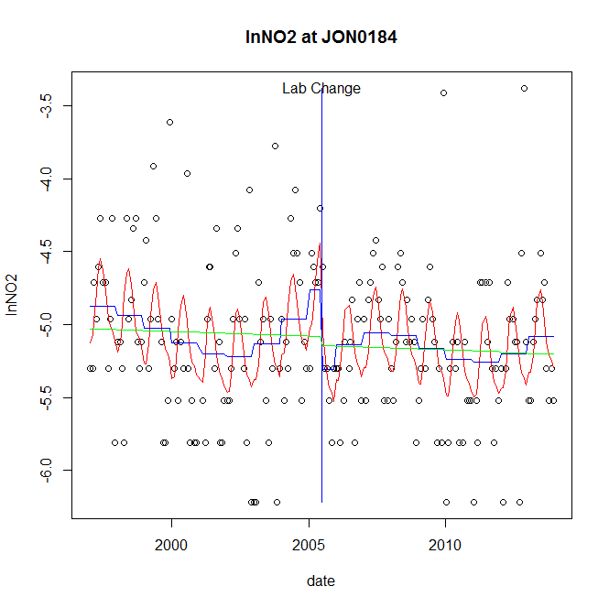

GAM analysis for station JON0184 dependent variable lnNO2

|  |  |  |  |  |
| --- | --- | --- | --- | --- |
| **Type** | **Source** | **edf** | **F-stat** | **p-value** |
| parametric terms | step | 1 | 6.0396 | 0.0149 |
|  | year | 1 | 1741.562 | <0.0001 |
| smoothed terms | s(year) | 5.22 | 2.1148 | 0.0522 |
|  | s(doy) | 3.56 | 4.607 | <0.0001 |

GAM analysis for station JON0184 dependent variable lnNO2

|  |  |  |  |  |
| --- | --- | --- | --- | --- |
| **parameter** | **estimate** | **Std. Err.** | **t value** | **p-value** |
| (Intercept) | -0.000394 | 0.000868 | -0.4541 | 0.6502 |
| step | -0.543296 | 0.221071 | -2.4576 | 0.0149 |
| year | -0.002415 | 5.8e-05 | -41.732 | <0.0001 |

root mean-square error = 0.4796

adjusted r-square = 0.2011

step significant

station = JON0184 dependent = lnTP

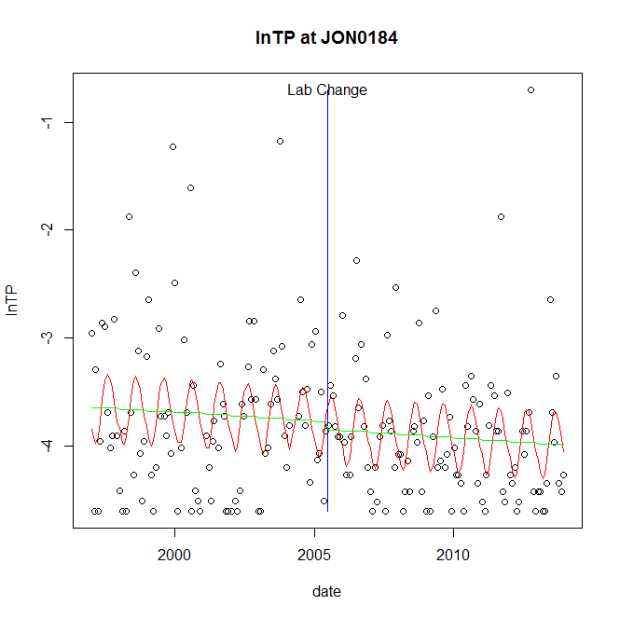

GAM analysis for station JON0184 dependent variable lnTP

|  |  |  |  |  |
| --- | --- | --- | --- | --- |
| **Type** | **Source** | **edf** | **F-stat** | **p-value** |
| parametric terms | step | 1 | 0.1602 | 0.6894 |
|  | year | 1 | 1238.318 | <0.0001 |
| smoothed terms | s(year) | 1 | 0.5876 | 0.4443 |
|  | s(doy) | 2.65 | 3.1825 | <0.0001 |

GAM analysis for station JON0184 dependent variable lnTP

|  |  |  |  |  |
| --- | --- | --- | --- | --- |
| **parameter** | **estimate** | **Std. Err.** | **t value** | **p-value** |
| (Intercept) | 0.000176 | 0.00023 | 0.7625 | 0.4467 |
| step | -0.074961 | 0.187299 | -0.4002 | 0.6894 |
| year | -0.001883 | 5.4e-05 | -35.1897 | <0.0001 |

root mean-square error = 0.6547

adjusted r-square = 0.1346

station = JON0184 dependent = lnPO4

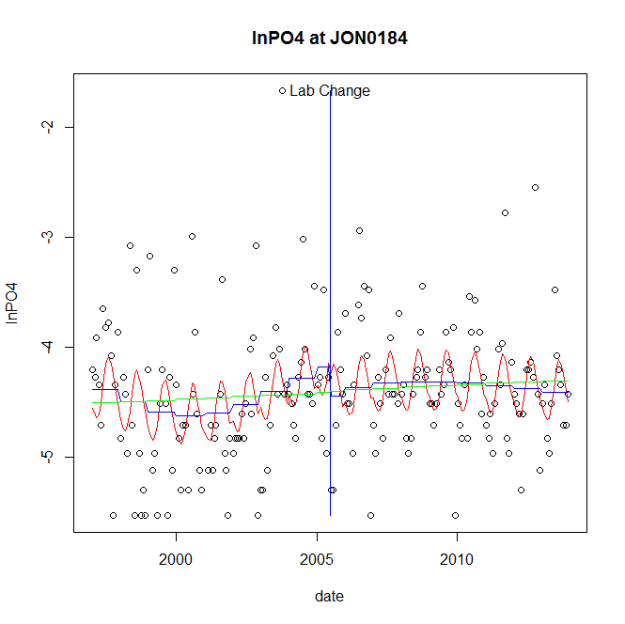

GAM analysis for station JON0184 dependent variable lnPO4

|  |  |  |  |  |
| --- | --- | --- | --- | --- |
| **Type** | **Source** | **edf** | **F-stat** | **p-value** |
| parametric terms | step | 1 | 1.3444 | 0.2477 |
|  | year | 1 | 1269.101 | <0.0001 |
| smoothed terms | s(year) | 3.76 | 1.4546 | 0.2087 |
|  | s(doy) | 2.74 | 3.2199 | <0.0001 |

GAM analysis for station JON0184 dependent variable lnPO4

|  |  |  |  |  |
| --- | --- | --- | --- | --- |
| **parameter** | **estimate** | **Std. Err.** | **t value** | **p-value** |
| (Intercept) | 0.000893 | 0.000708 | 1.2622 | 0.2084 |
| step | -0.261483 | 0.225521 | -1.1595 | 0.2477 |
| year | -0.002135 | 6e-05 | -35.6244 | <0.0001 |

root mean-square error = 0.5719

adjusted r-square = 0.1401

No title given

|  |  |  |  |
| --- | --- | --- | --- |
| **station** | **dep** | **step.est** | **step.pv** |
| JON0184 | lnTSS | -0.044275 | 0.8804 |
| JON0184 | lnTN | -0.147135 | 0.0420 |
| JON0184 | lnNH4 | -0.532702 | 0.0083 |
| JON0184 | lnNO23 | -0.044704 | 0.6110 |
| JON0184 | lnNO2 | -0.543296 | 0.0149 |
| JON0184 | lnTP | -0.074961 | 0.6894 |
| JON0184 | lnPO4 | -0.261483 | 0.2477 |

station = LYO0004 dependent = lnTSS

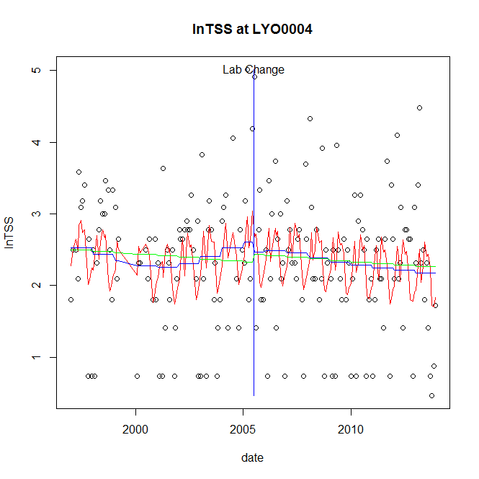

GAM analysis for station LYO0004 dependent variable lnTSS

|  |  |  |  |  |
| --- | --- | --- | --- | --- |
| **Type** | **Source** | **edf** | **F-stat** | **p-value** |
| parametric terms | step | 1 | 0.1648 | 0.6852 |
|  | year | 1 | 147.1136 | <0.0001 |
| smoothed terms | s(year) | 3.58 | 1.0426 | 0.3870 |
|  | s(doy) | 6.68 | 2.9271 | 0.0010 |

GAM analysis for station LYO0004 dependent variable lnTSS

|  |  |  |  |  |
| --- | --- | --- | --- | --- |
| **parameter** | **estimate** | **Std. Err.** | **t value** | **p-value** |
| (Intercept) | 0.000771 | 0.001042 | 0.7396 | 0.4606 |
| step | -0.141724 | 0.349066 | -0.406 | 0.6852 |
| year | 0.001203 | 9.9e-05 | 12.129 | <0.0001 |

root mean-square error = 0.8721

adjusted r-square = 0.1006

station = LYO0004 dependent = lnTN

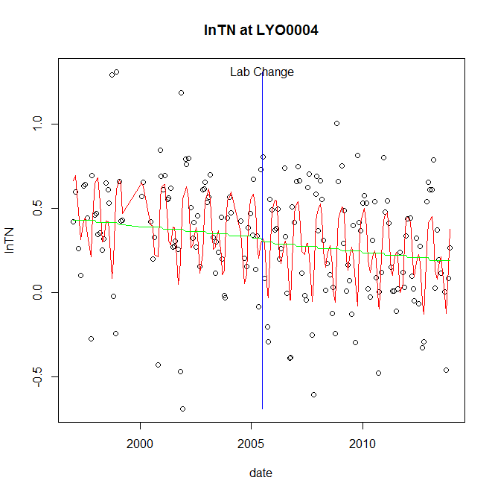

GAM analysis for station LYO0004 dependent variable lnTN

|  |  |  |  |  |
| --- | --- | --- | --- | --- |
| **Type** | **Source** | **edf** | **F-stat** | **p-value** |
| parametric terms | step | 1 | 0.0544 | 0.8159 |
|  | year | 1 | 41.5228 | <0.0001 |
| smoothed terms | s(year) | 1 | 2.4831 | 0.1169 |
|  | s(doy) | 6.19 | 8.8036 | <0.0001 |

GAM analysis for station LYO0004 dependent variable lnTN

|  |  |  |  |  |
| --- | --- | --- | --- | --- |
| **parameter** | **estimate** | **Std. Err.** | **t value** | **p-value** |
| (Intercept) | 0.000159 | 0.000101 | 1.5768 | 0.1167 |
| step | -0.019811 | 0.084952 | -0.2332 | 0.8159 |
| year | 0.000166 | 2.6e-05 | 6.4438 | <0.0001 |

root mean-square error = 0.2898

adjusted r-square = 0.313

station = LYO0004 dependent = lnNH4

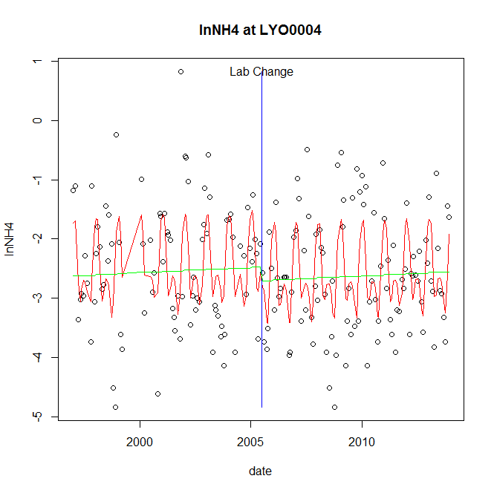

GAM analysis for station LYO0004 dependent variable lnNH4

|  |  |  |  |  |
| --- | --- | --- | --- | --- |
| **Type** | **Source** | **edf** | **F-stat** | **p-value** |
| parametric terms | step | 1 | 0.8804 | 0.3494 |
|  | year | 1 | 263.1147 | <0.0001 |
| smoothed terms | s(year) | 1 | 0.5627 | 0.4542 |
|  | s(doy) | 5.76 | 9.2106 | <0.0001 |

GAM analysis for station LYO0004 dependent variable lnNH4

|  |  |  |  |  |
| --- | --- | --- | --- | --- |
| **parameter** | **estimate** | **Std. Err.** | **t value** | **p-value** |
| (Intercept) | -0.000222 | 0.000295 | -0.7522 | 0.4529 |
| step | -0.231679 | 0.246913 | -0.9383 | 0.3494 |
| year | -0.001198 | 7.4e-05 | -16.2208 | <0.0001 |

root mean-square error = 0.8585

adjusted r-square = 0.2842

station = LYO0004 dependent = lnNO23

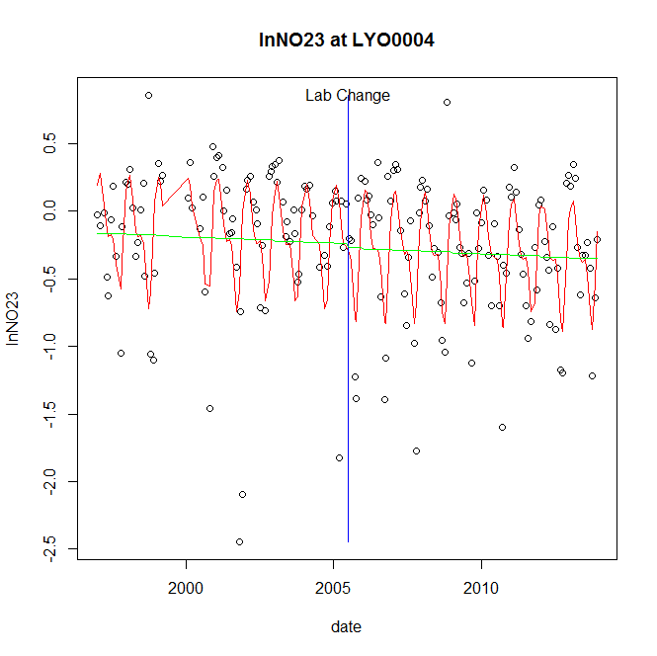

GAM analysis for station LYO0004 dependent variable lnNO23

|  |  |  |  |  |
| --- | --- | --- | --- | --- |
| **Type** | **Source** | **edf** | **F-stat** | **p-value** |
| parametric terms | step | 1 | 0.0599 | 0.8069 |
|  | year | 1 | 8.8147 | 0.0034 |
| smoothed terms | s(year) | 1 | 0.6021 | 0.4388 |
|  | s(doy) | 5.28 | 11.3208 | <0.0001 |

GAM analysis for station LYO0004 dependent variable lnNO23

|  |  |  |  |  |
| --- | --- | --- | --- | --- |
| **parameter** | **estimate** | **Std. Err.** | **t value** | **p-value** |
| (Intercept) | 0.000113 | 0.000146 | 0.7756 | 0.4390 |
| step | -0.02991 | 0.122175 | -0.2448 | 0.8069 |
| year | -0.000108 | 3.7e-05 | -2.969 | 0.0034 |

root mean-square error = 0.4249

adjusted r-square = 0.3401

station = LYO0004 dependent = lnNO2

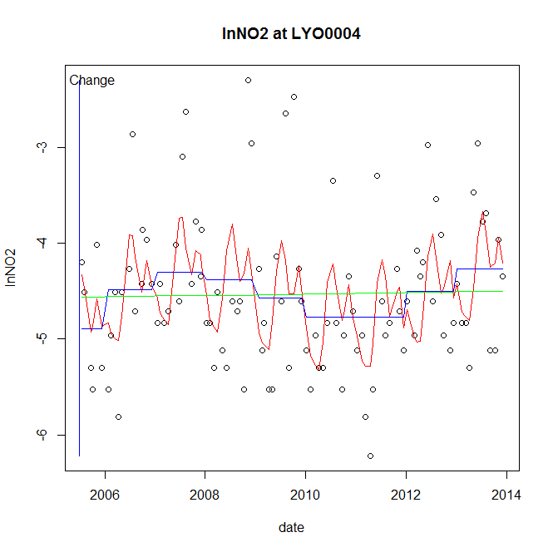

GAM analysis for station LYO0004 dependent variable lnNO2

|  |  |  |  |  |
| --- | --- | --- | --- | --- |
| **Type** | **Source** | **edf** | **F-stat** | **p-value** |
| parametric terms | step | 1 | 3.4634 | 0.0659 |
|  | year | 1 | 4654.6659 | <0.0001 |
| smoothed terms | s(year) | 3.94 | 2.2042 | 0.0629 |
|  | s(doy) | 5.41 | 3.9604 | <0.0001 |

GAM analysis for station LYO0004 dependent variable lnNO2

|  |  |  |  |  |
| --- | --- | --- | --- | --- |
| **parameter** | **estimate** | **Std. Err.** | **t value** | **p-value** |
| (Intercept) | -0.000982 | 0.000528 | -1.861 | 0.0659 |
| step | -0.000982 | 0.000528 | -1.861 | 0.0659 |
| year | -0.002254 | 3.3e-05 | -68.2251 | <0.0001 |

root mean-square error = 0.6704

adjusted r-square = 0.2773

station = LYO0004 dependent = lnTP

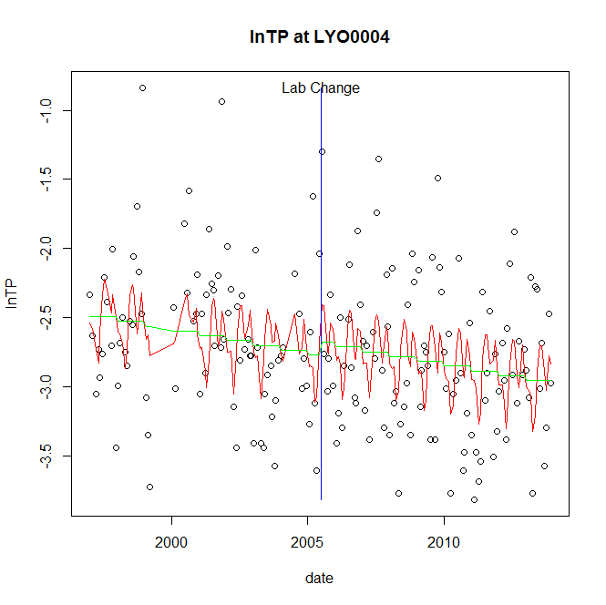

GAM analysis for station LYO0004 dependent variable lnTP

|  |  |  |  |  |
| --- | --- | --- | --- | --- |
| **Type** | **Source** | **edf** | **F-stat** | **p-value** |
| parametric terms | step | 1 | 0.4003 | 0.5278 |
|  | year | 1 | 972.3967 | <0.0001 |
| smoothed terms | s(year) | 1 | 4.908 | 0.0280 |
|  | s(doy) | 6.47 | 3.3531 | 0.0002 |

GAM analysis for station LYO0004 dependent variable lnTP

|  |  |  |  |  |
| --- | --- | --- | --- | --- |
| **parameter** | **estimate** | **Std. Err.** | **t value** | **p-value** |
| (Intercept) | 0.00039 | 0.000176 | 2.2117 | 0.0283 |
| step | 0.093031 | 0.147039 | 0.6327 | 0.5278 |
| year | -0.001388 | 4.5e-05 | -31.1833 | <0.0001 |

root mean-square error = 0.5043

adjusted r-square = 0.16

station = LYO0004 dependent = lnPO4

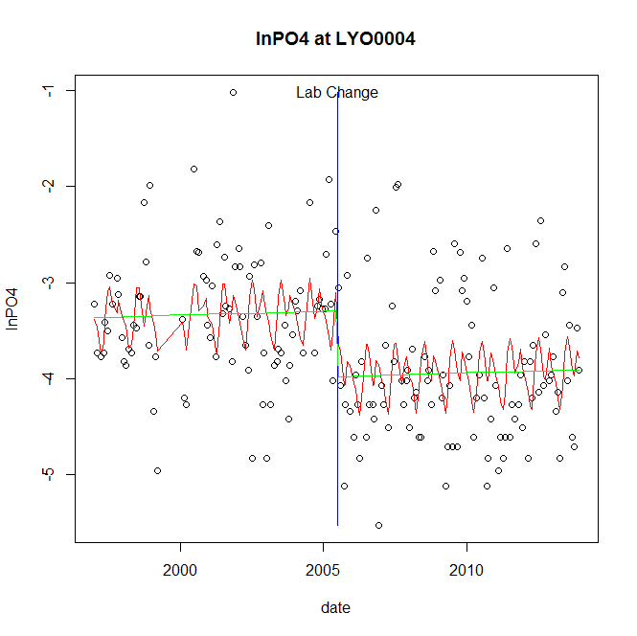

GAM analysis for station LYO0004 dependent variable lnPO4

|  |  |  |  |  |
| --- | --- | --- | --- | --- |
| **Type** | **Source** | **edf** | **F-stat** | **p-value** |
| parametric terms | step | 1 | 12.1177 | 0.0006 |
|  | year | 1 | 772.3346 | <0.0001 |
| smoothed terms | s(year) | 1 | 0.258 | 0.6121 |
|  | s(doy) | 5.64 | 2.6808 | 0.0008 |

GAM analysis for station LYO0004 dependent variable lnPO4

|  |  |  |  |  |
| --- | --- | --- | --- | --- |
| **parameter** | **estimate** | **Std. Err.** | **t value** | **p-value** |
| (Intercept) | -0.000121 | 0.000236 | -0.5114 | 0.6097 |
| step | -0.686817 | 0.197302 | -3.4811 | 0.0006 |
| year | -0.00164 | 5.9e-05 | -27.7909 | <0.0001 |

root mean-square error = 0.686

adjusted r-square = 0.2211

step significant

No title given

|  |  |  |  |
| --- | --- | --- | --- |
| **station** | **dep** | **step.est** | **step.pv** |
| LYO0004 | lnTSS | -0.141724 | 0.6852 |
| LYO0004 | lnTN | -0.019811 | 0.8159 |
| LYO0004 | lnNH4 | -0.231679 | 0.3494 |
| LYO0004 | lnNO23 | -0.02991 | 0.8069 |
| LYO0004 | lnNO2 | -0.000982 | 0.0659 |
| LYO0004 | lnTP | 0.093031 | 0.5278 |
| LYO0004 | lnPO4 | -0.686817 | 0.0006 |

station = MON0020 dependent = lnTSS

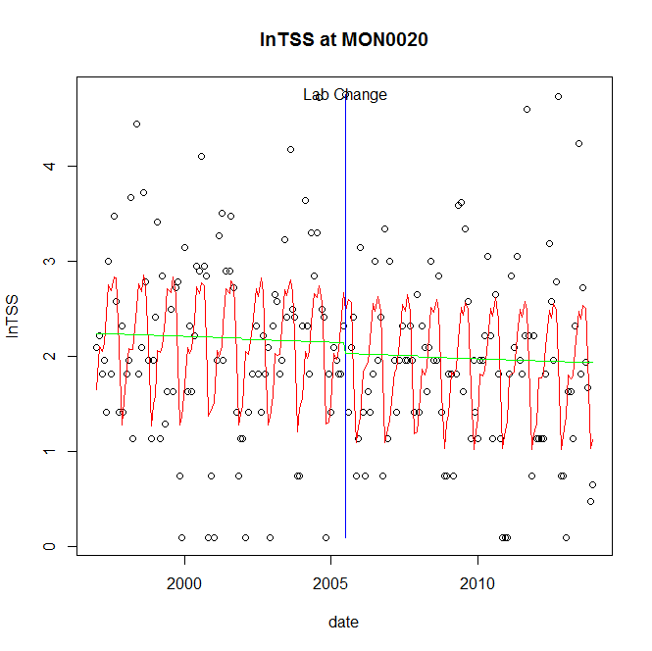

GAM analysis for station MON0020 dependent variable lnTSS

|  |  |  |  |  |
| --- | --- | --- | --- | --- |
| **Type** | **Source** | **edf** | **F-stat** | **p-value** |
| parametric terms | step | 1 | 0.2487 | 0.6185 |
|  | year | 1 | 259.5108 | <0.0001 |
| smoothed terms | s(year) | 1 | 0.2972 | 0.5863 |
|  | s(doy) | 6.08 | 10.1003 | <0.0001 |

GAM analysis for station MON0020 dependent variable lnTSS

|  |  |  |  |  |
| --- | --- | --- | --- | --- |
| **parameter** | **estimate** | **Std. Err.** | **t value** | **p-value** |
| (Intercept) | 0.000155 | 0.000283 | 0.5471 | 0.5850 |
| step | -0.115681 | 0.231944 | -0.4987 | 0.6185 |
| year | 0.001043 | 6.5e-05 | 16.1093 | <0.0001 |

root mean-square error = 0.822

adjusted r-square = 0.2878

station = MON0020 dependent = lnTN

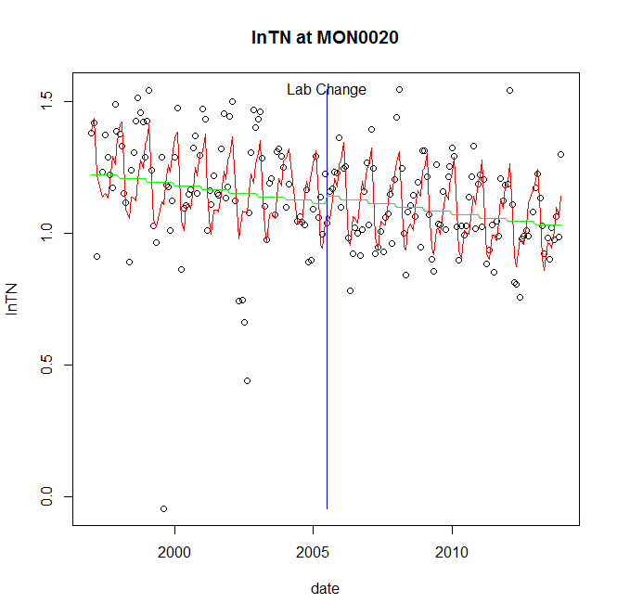

GAM analysis for station MON0020 dependent variable lnTN

|  |  |  |  |  |
| --- | --- | --- | --- | --- |
| **Type** | **Source** | **edf** | **F-stat** | **p-value** |
| parametric terms | step | 1 | 0.3751 | 0.5410 |
|  | year | 1 | 1750.9476 | <0.0001 |
| smoothed terms | s(year) | 1 | 8.9543 | 0.0031 |
|  | s(doy) | 6.55 | 12.5059 | <0.0001 |

GAM analysis for station MON0020 dependent variable lnTN

|  |  |  |  |  |
| --- | --- | --- | --- | --- |
| **parameter** | **estimate** | **Std. Err.** | **t value** | **p-value** |
| (Intercept) | 0.00017 | 5.7e-05 | 2.9976 | 0.0031 |
| step | 0.028534 | 0.046591 | 0.6124 | 0.5410 |
| year | 0.00056 | 1.3e-05 | 41.8443 | <0.0001 |

root mean-square error = 0.1621

adjusted r-square = 0.3871

station = MON0020 dependent = lnNH4

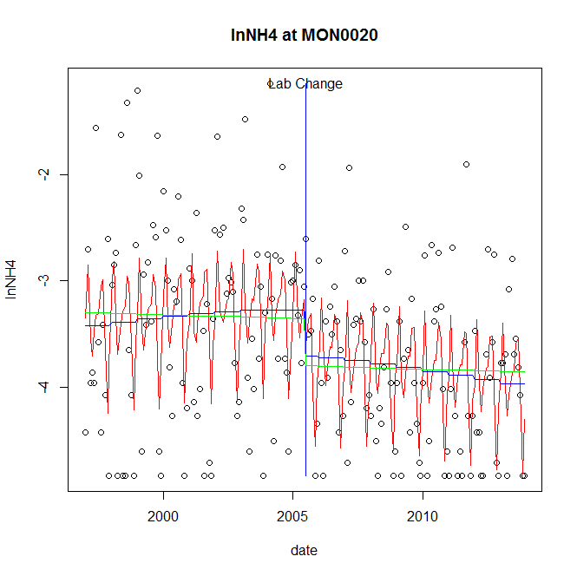

GAM analysis for station MON0020 dependent variable lnNH4

|  |  |  |  |  |
| --- | --- | --- | --- | --- |
| **Type** | **Source** | **edf** | **F-stat** | **p-value** |
| parametric terms | step | 1 | 3.59 | 0.0596 |
|  | year | 1 | 715.6062 | <0.0001 |
| smoothed terms | s(year) | 1.82 | 1.1881 | 0.3048 |
|  | s(doy) | 6.69 | 6.4692 | <0.0001 |

GAM analysis for station MON0020 dependent variable lnNH4

|  |  |  |  |  |
| --- | --- | --- | --- | --- |
| **parameter** | **estimate** | **Std. Err.** | **t value** | **p-value** |
| (Intercept) | 1e-05 | 0.00038 | 0.0254 | 0.9798 |
| step | -0.430037 | 0.226964 | -1.8947 | 0.0596 |
| year | -0.001684 | 6.3e-05 | -26.7508 | <0.0001 |

root mean-square error = 0.7663

adjusted r-square = 0.2676

station = MON0020 dependent = lnNO23

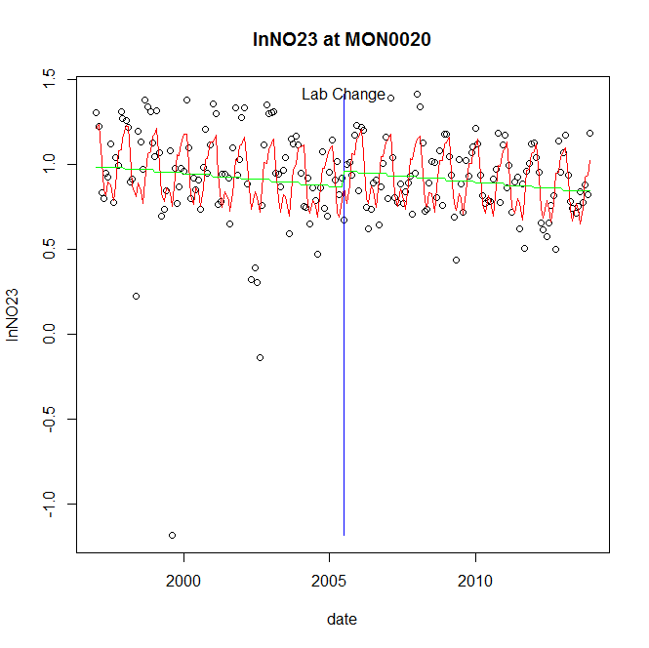

GAM analysis for station MON0020 dependent variable lnNO23

|  |  |  |  |  |
| --- | --- | --- | --- | --- |
| **Type** | **Source** | **edf** | **F-stat** | **p-value** |
| parametric terms | step | 1 | 2.0884 | 0.1500 |
|  | year | 1 | 582.6089 | <0.0001 |
| smoothed terms | s(year) | 1 | 5.1663 | 0.0241 |
|  | s(doy) | 6.47 | 11.2662 | <0.0001 |

GAM analysis for station MON0020 dependent variable lnNO23

|  |  |  |  |  |
| --- | --- | --- | --- | --- |
| **parameter** | **estimate** | **Std. Err.** | **t value** | **p-value** |
| (Intercept) | 0.000181 | 7.9e-05 | 2.2759 | 0.0239 |
| step | 0.094099 | 0.065114 | 1.4451 | 0.1500 |
| year | 0.000441 | 1.8e-05 | 24.1373 | <0.0001 |

root mean-square error = 0.2319

adjusted r-square = 0.3128

station = MON0020 dependent = lnNO2

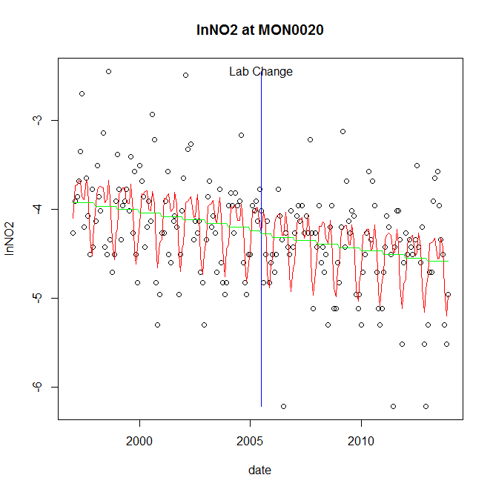

GAM analysis for station MON0020 dependent variable lnNO2

|  |  |  |  |  |
| --- | --- | --- | --- | --- |
| **Type** | **Source** | **edf** | **F-stat** | **p-value** |
| parametric terms | step | 1 | 0.0723 | 0.7883 |
|  | year | 1 | 3258.9657 | <0.0001 |
| smoothed terms | s(year) | 1 | 7.529 | 0.0066 |
|  | s(doy) | 6.24 | 9.9112 | <0.0001 |

GAM analysis for station MON0020 dependent variable lnNO2

|  |  |  |  |  |
| --- | --- | --- | --- | --- |
| **parameter** | **estimate** | **Std. Err.** | **t value** | **p-value** |
| (Intercept) | 0.000443 | 0.000162 | 2.7376 | 0.0068 |
| step | -0.035703 | 0.132797 | -0.2689 | 0.7883 |
| year | -0.002126 | 3.7e-05 | -57.0874 | <0.0001 |

root mean-square error = 0.473

adjusted r-square = 0.3658

station = MON0020 dependent = lnTP

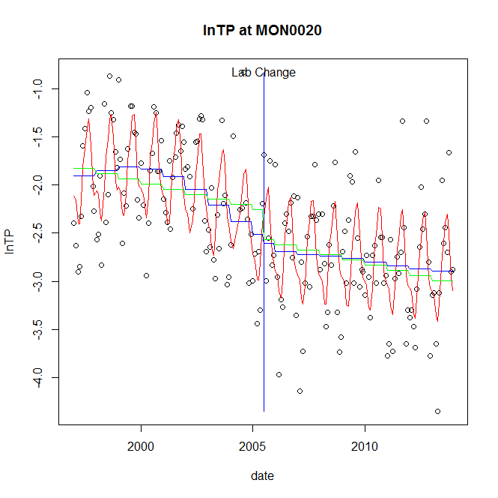

GAM analysis for station MON0020 dependent variable lnTP

|  |  |  |  |  |
| --- | --- | --- | --- | --- |
| **Type** | **Source** | **edf** | **F-stat** | **p-value** |
| parametric terms | step | 1 | 0.254 | 0.6149 |
|  | year | 1 | 500.8238 | <0.0001 |
| smoothed terms | s(year) | 4.19 | 5.1876 | 0.0002 |
|  | s(doy) | 5.78 | 14.7573 | <0.0001 |

GAM analysis for station MON0020 dependent variable lnTP

|  |  |  |  |  |
| --- | --- | --- | --- | --- |
| **parameter** | **estimate** | **Std. Err.** | **t value** | **p-value** |
| (Intercept) | -0.000266 | 0.000664 | -0.4002 | 0.6895 |
| step | -0.098439 | 0.195315 | -0.504 | 0.6149 |
| year | -0.001176 | 5.3e-05 | -22.3791 | <0.0001 |

root mean-square error = 0.4632

adjusted r-square = 0.5868

station = MON0020 dependent = lnPO4

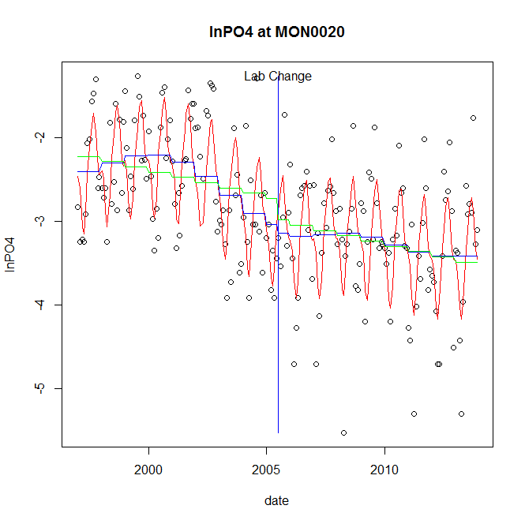

GAM analysis for station MON0020 dependent variable lnPO4

|  |  |  |  |  |
| --- | --- | --- | --- | --- |
| **Type** | **Source** | **edf** | **F-stat** | **p-value** |
| parametric terms | step | 1 | 0.1761 | 0.6752 |
|  | year | 1 | 480.8599 | <0.0001 |
| smoothed terms | s(year) | 4.89 | 4.8338 | 0.0002 |
|  | s(doy) | 5.71 | 16.7215 | <0.0001 |

GAM analysis for station MON0020 dependent variable lnPO4

|  |  |  |  |  |
| --- | --- | --- | --- | --- |
| **parameter** | **estimate** | **Std. Err.** | **t value** | **p-value** |
| (Intercept) | -0.000728 | 0.000919 | -0.7919 | 0.4294 |
| step | -0.102423 | 0.244057 | -0.4197 | 0.6752 |
| year | -0.001405 | 6.4e-05 | -21.9285 | <0.0001 |

root mean-square error = 0.5468

adjusted r-square = 0.5701

No title given

|  |  |  |  |
| --- | --- | --- | --- |
| **station** | **dep** | **step.est** | **step.pv** |
| MON0020 | lnTSS | -0.115681 | 0.6185 |
| MON0020 | lnTN | 0.028534 | 0.5410 |
| MON0020 | lnNH4 | -0.430037 | 0.0596 |
| MON0020 | lnNO23 | 0.094099 | 0.1500 |
| MON0020 | lnNO2 | -0.035703 | 0.7883 |
| MON0020 | lnTP | -0.098439 | 0.6149 |
| MON0020 | lnPO4 | -0.102423 | 0.6752 |

station = MON0155 dependent = lnTSS

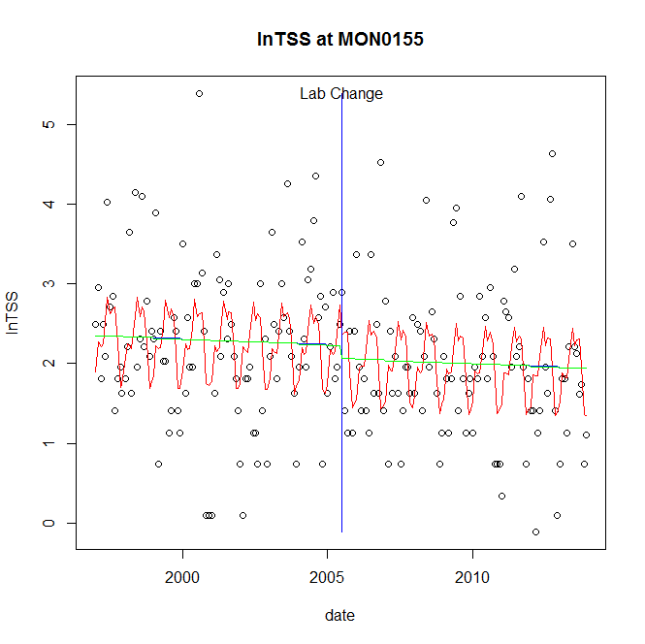

GAM analysis for station MON0155 dependent variable lnTSS

|  |  |  |  |  |
| --- | --- | --- | --- | --- |
| **Type** | **Source** | **edf** | **F-stat** | **p-value** |
| parametric terms | step | 1 | 0.4452 | 0.5054 |
|  | year | 1 | 247.1414 | <0.0001 |
| smoothed terms | s(year) | 1 | 0.3678 | 0.5451 |
|  | s(doy) | 5.82 | 4.5036 | <0.0001 |

GAM analysis for station MON0155 dependent variable lnTSS

|  |  |  |  |  |
| --- | --- | --- | --- | --- |
| **parameter** | **estimate** | **Std. Err.** | **t value** | **p-value** |
| (Intercept) | 0.000184 | 0.000303 | 0.6087 | 0.5434 |
| step | -0.166043 | 0.248839 | -0.6673 | 0.5054 |
| year | 0.001092 | 6.9e-05 | 15.7207 | <0.0001 |

root mean-square error = 0.888

adjusted r-square = 0.1556

station = MON0155 dependent = lnTN

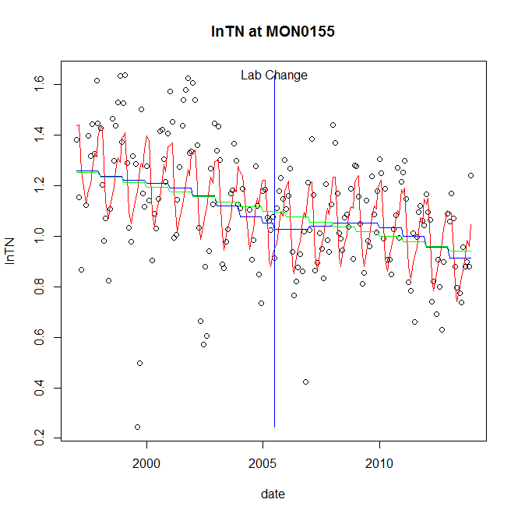

GAM analysis for station MON0155 dependent variable lnTN

|  |  |  |  |  |
| --- | --- | --- | --- | --- |
| **Type** | **Source** | **edf** | **F-stat** | **p-value** |
| parametric terms | step | 1 | 0.0871 | 0.7683 |
|  | year | 1 | 668.2189 | <0.0001 |
| smoothed terms | s(year) | 4.22 | 3.5078 | 0.0044 |
|  | s(doy) | 5.95 | 9.3446 | <0.0001 |

GAM analysis for station MON0155 dependent variable lnTN

|  |  |  |  |  |
| --- | --- | --- | --- | --- |
| **parameter** | **estimate** | **Std. Err.** | **t value** | **p-value** |
| (Intercept) | 0.000404 | 0.000272 | 1.4873 | 0.1386 |
| step | -0.023646 | 0.080134 | -0.2951 | 0.7683 |
| year | 0.000557 | 2.2e-05 | 25.8499 | <0.0001 |

root mean-square error = 0.1892

adjusted r-square = 0.3958

station = MON0155 dependent = lnNH4

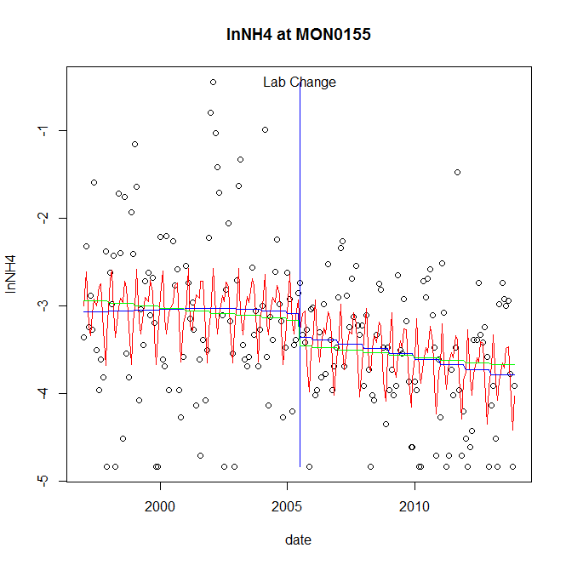

GAM analysis for station MON0155 dependent variable lnNH4

|  |  |  |  |  |
| --- | --- | --- | --- | --- |
| **Type** | **Source** | **edf** | **F-stat** | **p-value** |
| parametric terms | step | 1 | 1.3376 | 0.2489 |
|  | year | 1 | 594.9 | <0.0001 |
| smoothed terms | s(year) | 1.83 | 1.7347 | 0.1726 |
|  | s(doy) | 6.42 | 3.8862 | <0.0001 |

GAM analysis for station MON0155 dependent variable lnNH4

|  |  |  |  |  |
| --- | --- | --- | --- | --- |
| **parameter** | **estimate** | **Std. Err.** | **t value** | **p-value** |
| (Intercept) | 0.000264 | 0.000393 | 0.6732 | 0.5016 |
| step | -0.271208 | 0.2345 | -1.1565 | 0.2489 |
| year | -0.001587 | 6.5e-05 | -24.3906 | <0.0001 |

root mean-square error = 0.792

adjusted r-square = 0.2093

station = MON0155 dependent = lnNO23

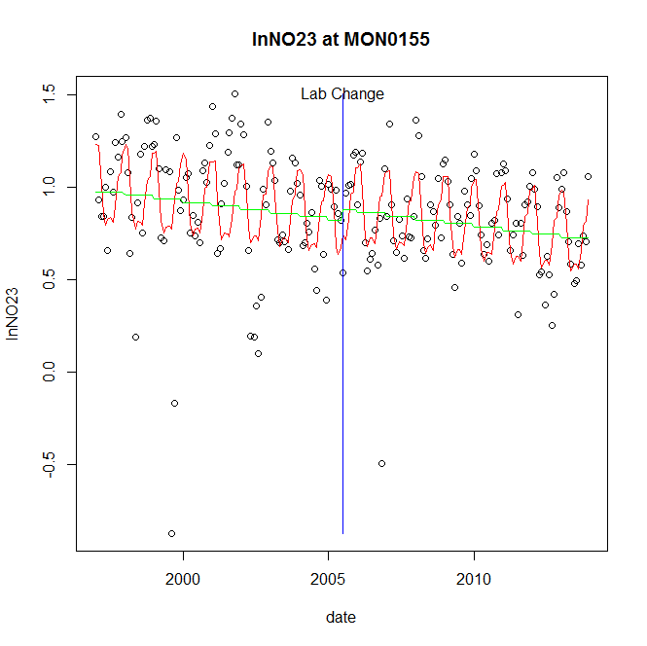

GAM analysis for station MON0155 dependent variable lnNO23

|  |  |  |  |  |
| --- | --- | --- | --- | --- |
| **Type** | **Source** | **edf** | **F-stat** | **p-value** |
| parametric terms | step | 1 | 0.6442 | 0.4232 |
|  | year | 1 | 391.0369 | <0.0001 |
| smoothed terms | s(year) | 1 | 6.6242 | 0.0108 |
|  | s(doy) | 5.91 | 9.1911 | <0.0001 |

GAM analysis for station MON0155 dependent variable lnNO23

|  |  |  |  |  |
| --- | --- | --- | --- | --- |
| **parameter** | **estimate** | **Std. Err.** | **t value** | **p-value** |
| (Intercept) | 0.000237 | 9.2e-05 | 2.5762 | 0.0107 |
| step | 0.060645 | 0.075562 | 0.8026 | 0.4232 |
| year | 0.000417 | 2.1e-05 | 19.7747 | <0.0001 |

root mean-square error = 0.2696

adjusted r-square = 0.2905

station = MON0155 dependent = lnNO2

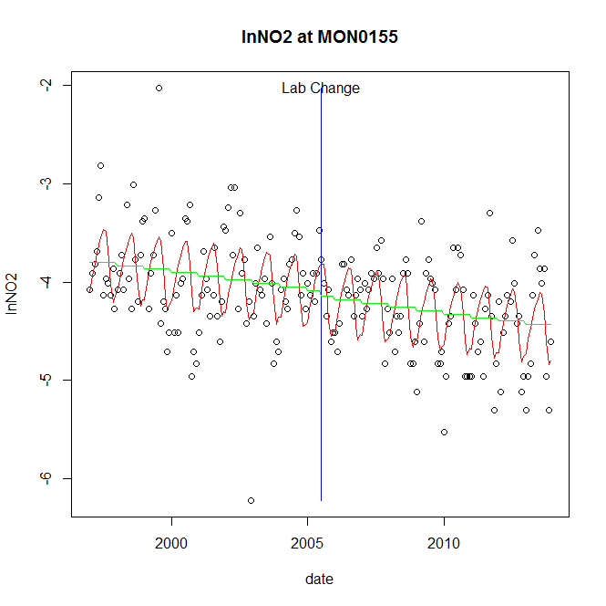

GAM analysis for station MON0155 dependent variable lnNO2

|  |  |  |  |  |
| --- | --- | --- | --- | --- |
| **Type** | **Source** | **edf** | **F-stat** | **p-value** |
| parametric terms | step | 1 | 0.1975 | 0.6573 |
|  | year | 1 | 3699.7959 | <0.0001 |
| smoothed terms | s(year) | 1 | 7.9186 | 0.0054 |
|  | s(doy) | 4.3 | 9.3252 | <0.0001 |

GAM analysis for station MON0155 dependent variable lnNO2

|  |  |  |  |  |
| --- | --- | --- | --- | --- |
| **parameter** | **estimate** | **Std. Err.** | **t value** | **p-value** |
| (Intercept) | 0.00041 | 0.000146 | 2.8072 | 0.0055 |
| step | -0.053428 | 0.120237 | -0.4444 | 0.6573 |
| year | -0.002051 | 3.4e-05 | -60.8259 | <0.0001 |

root mean-square error = 0.4292

adjusted r-square = 0.3706

station = MON0155 dependent = lnTP

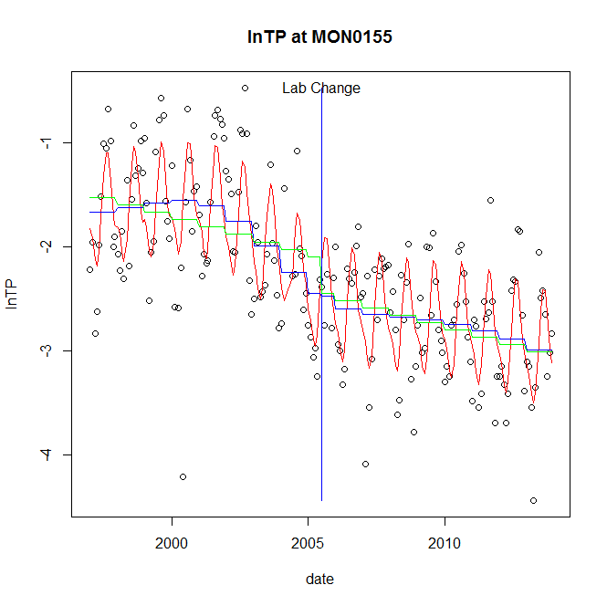

GAM analysis for station MON0155 dependent variable lnTP

|  |  |  |  |  |
| --- | --- | --- | --- | --- |
| **Type** | **Source** | **edf** | **F-stat** | **p-value** |
| parametric terms | step | 1 | 0.0141 | 0.9057 |
|  | year | 1 | 391.1636 | <0.0001 |
| smoothed terms | s(year) | 4.73 | 7.2404 | <0.0001 |
|  | s(doy) | 4.57 | 14.7154 | <0.0001 |

GAM analysis for station MON0155 dependent variable lnTP

|  |  |  |  |  |
| --- | --- | --- | --- | --- |
| **parameter** | **estimate** | **Std. Err.** | **t value** | **p-value** |
| (Intercept) | 0.000359 | 0.00078 | 0.4604 | 0.6458 |
| step | -0.025489 | 0.214801 | -0.1187 | 0.9057 |
| year | -0.001124 | 5.7e-05 | -19.7779 | <0.0001 |

root mean-square error = 0.4715

adjusted r-square = 0.65

station = MON0155 dependent = lnPO4

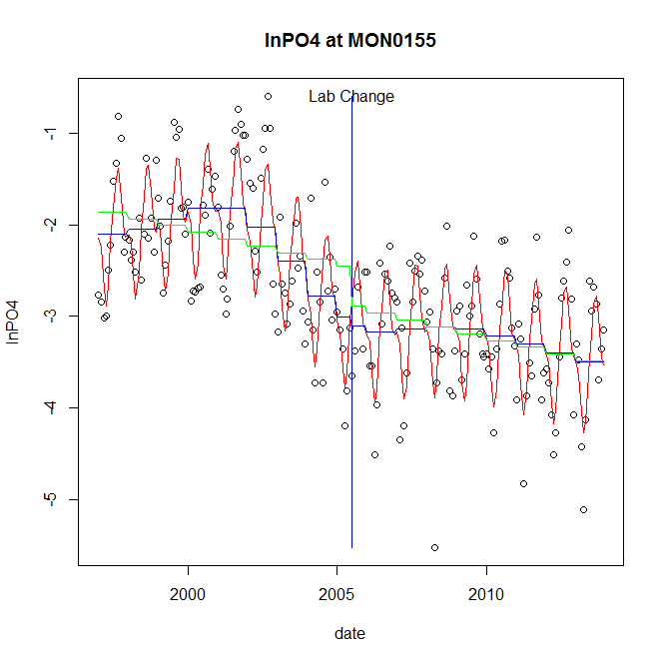

GAM analysis for station MON0155 dependent variable lnPO4

|  |  |  |  |  |
| --- | --- | --- | --- | --- |
| **Type** | **Source** | **edf** | **F-stat** | **p-value** |
| parametric terms | step | 1 | 0.1634 | 0.6865 |
|  | year | 1 | 426.8252 | <0.0001 |
| smoothed terms | s(year) | 5.79 | 8.8112 | <0.0001 |
|  | s(doy) | 5.97 | 20.9433 | <0.0001 |

GAM analysis for station MON0155 dependent variable lnPO4

|  |  |  |  |  |
| --- | --- | --- | --- | --- |
| **parameter** | **estimate** | **Std. Err.** | **t value** | **p-value** |
| (Intercept) | 0.000346 | 0.001021 | 0.3389 | 0.7351 |
| step | -0.100608 | 0.248855 | -0.4043 | 0.6865 |
| year | -0.001325 | 6.4e-05 | -20.6597 | <0.0001 |

root mean-square error = 0.4979

adjusted r-square = 0.696

No title given

|  |  |  |  |
| --- | --- | --- | --- |
| **station** | **dep** | **step.est** | **step.pv** |
| MON0155 | lnTSS | -0.166043 | 0.5054 |
| MON0155 | lnTN | -0.023646 | 0.7683 |
| MON0155 | lnNH4 | -0.271208 | 0.2489 |
| MON0155 | lnNO23 | 0.060645 | 0.4232 |
| MON0155 | lnNO2 | -0.053428 | 0.6573 |
| MON0155 | lnTP | -0.025489 | 0.9057 |
| MON0155 | lnPO4 | -0.100608 | 0.6865 |

station = MON0269 dependent = lnTSS

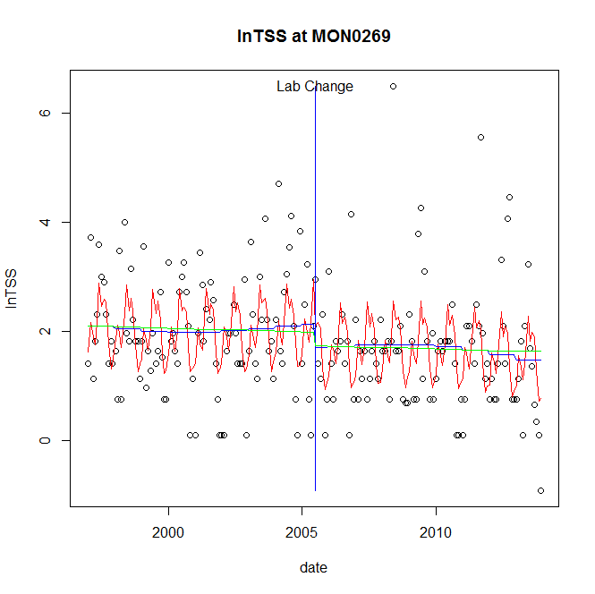

GAM analysis for station MON0269 dependent variable lnTSS

|  |  |  |  |  |
| --- | --- | --- | --- | --- |
| **Type** | **Source** | **edf** | **F-stat** | **p-value** |
| parametric terms | step | 1 | 1.6638 | 0.1986 |
|  | year | 1 | 125.3175 | <0.0001 |
| smoothed terms | s(year) | 2.68 | 0.6005 | 0.6322 |
|  | s(doy) | 6.75 | 6.2496 | <0.0001 |

GAM analysis for station MON0269 dependent variable lnTSS

|  |  |  |  |  |
| --- | --- | --- | --- | --- |
| **parameter** | **estimate** | **Std. Err.** | **t value** | **p-value** |
| (Intercept) | 0.00094 | 0.000802 | 1.1723 | 0.2425 |
| step | -0.428927 | 0.33253 | -1.2899 | 0.1986 |
| year | 0.001005 | 9e-05 | 11.1945 | <0.0001 |

root mean-square error = 0.9838

adjusted r-square = 0.2081

station = MON0269 dependent = lnTN

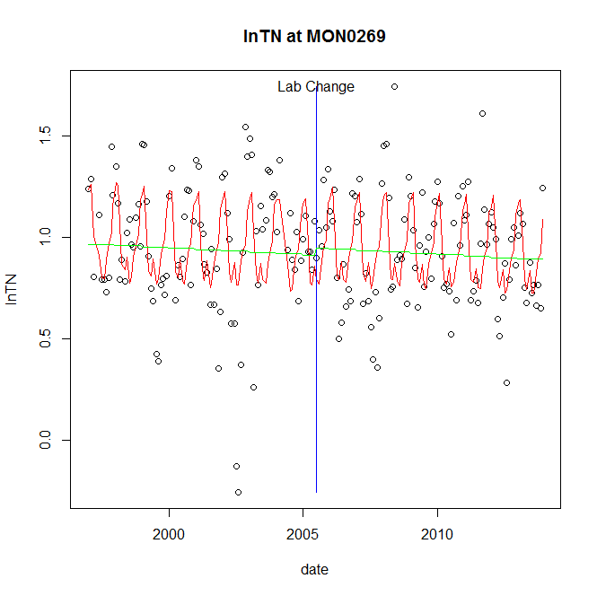

GAM analysis for station MON0269 dependent variable lnTN

|  |  |  |  |  |
| --- | --- | --- | --- | --- |
| **Type** | **Source** | **edf** | **F-stat** | **p-value** |
| parametric terms | step | 1 | 0.2414 | 0.6238 |
|  | year | 1 | 514.1995 | <0.0001 |
| smoothed terms | s(year) | 1 | 0.9652 | 0.3271 |
|  | s(doy) | 6.26 | 10.4059 | <0.0001 |

GAM analysis for station MON0269 dependent variable lnTN

|  |  |  |  |  |
| --- | --- | --- | --- | --- |
| **parameter** | **estimate** | **Std. Err.** | **t value** | **p-value** |
| (Intercept) | 8.6e-05 | 8.7e-05 | 0.9852 | 0.3258 |
| step | 0.035128 | 0.071498 | 0.4913 | 0.6238 |
| year | 0.000463 | 2e-05 | 22.676 | <0.0001 |

root mean-square error = 0.2495

adjusted r-square = 0.2923

station = MON0269 dependent = lnNH4

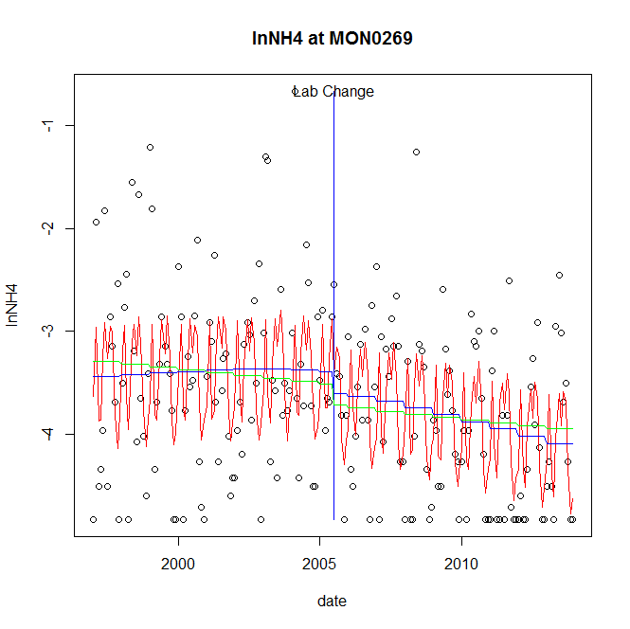

GAM analysis for station MON0269 dependent variable lnNH4

|  |  |  |  |  |
| --- | --- | --- | --- | --- |
| **Type** | **Source** | **edf** | **F-stat** | **p-value** |
| parametric terms | step | 1 | 0.8936 | 0.3457 |
|  | year | 1 | 822.6534 | <0.0001 |
| smoothed terms | s(year) | 1.99 | 2.0135 | 0.1242 |
|  | s(doy) | 7.31 | 8.7462 | <0.0001 |

GAM analysis for station MON0269 dependent variable lnNH4

|  |  |  |  |  |
| --- | --- | --- | --- | --- |
| **parameter** | **estimate** | **Std. Err.** | **t value** | **p-value** |
| (Intercept) | 0.000288 | 0.000407 | 0.7079 | 0.4799 |
| step | -0.212169 | 0.224449 | -0.9453 | 0.3457 |
| year | -0.001771 | 6.2e-05 | -28.6819 | <0.0001 |

root mean-square error = 0.7424

adjusted r-square = 0.306

station = MON0269 dependent = lnNO23

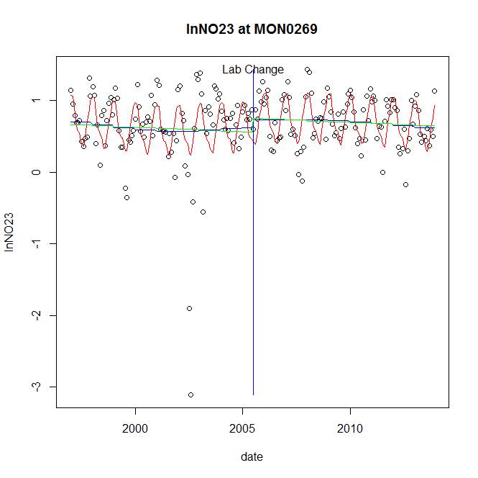

GAM analysis for station MON0269 dependent variable lnNO23

|  |  |  |  |  |
| --- | --- | --- | --- | --- |
| **Type** | **Source** | **edf** | **F-stat** | **p-value** |
| parametric terms | step | 1 | 0.5681 | 0.4519 |
|  | year | 1 | 64.4123 | <0.0001 |
| smoothed terms | s(year) | 2.87 | 0.9159 | 0.4421 |
|  | s(doy) | 5.12 | 8.9037 | <0.0001 |

GAM analysis for station MON0269 dependent variable lnNO23

|  |  |  |  |  |
| --- | --- | --- | --- | --- |
| **parameter** | **estimate** | **Std. Err.** | **t value** | **p-value** |
| (Intercept) | 0.000418 | 0.000366 | 1.1416 | 0.2550 |
| step | 0.107972 | 0.14325 | 0.7537 | 0.4519 |
| year | 0.000309 | 3.9e-05 | 8.0257 | <0.0001 |

root mean-square error = 0.4112

adjusted r-square = 0.2627

station = MON0269 dependent = lnNO2

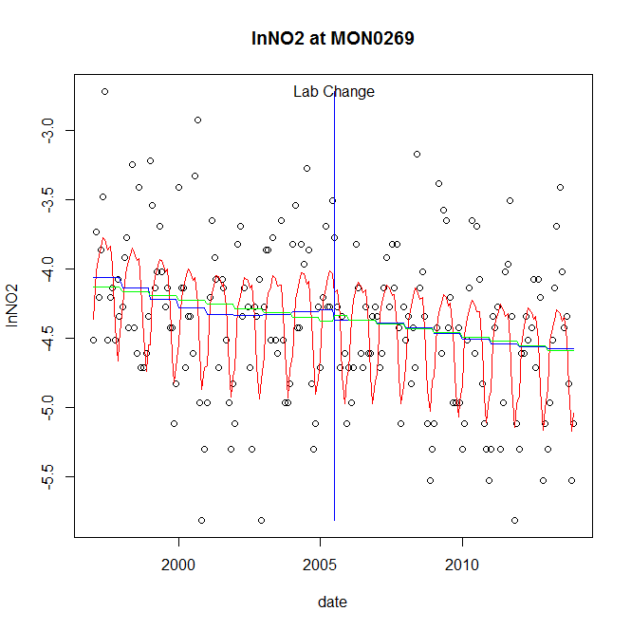

GAM analysis for station MON0269 dependent variable lnNO2

|  |  |  |  |  |
| --- | --- | --- | --- | --- |
| **Type** | **Source** | **edf** | **F-stat** | **p-value** |
| parametric terms | step | 1 | 0.1824 | 0.6698 |
|  | year | 1 | 2259.5856 | <0.0001 |
| smoothed terms | s(year) | 3.29 | 1.748 | 0.1392 |
|  | s(doy) | 5.53 | 11.3173 | <0.0001 |

GAM analysis for station MON0269 dependent variable lnNO2

|  |  |  |  |  |
| --- | --- | --- | --- | --- |
| **parameter** | **estimate** | **Std. Err.** | **t value** | **p-value** |
| (Intercept) | 0.000513 | 0.000487 | 1.0543 | 0.2931 |
| step | -0.07319 | 0.171382 | -0.4271 | 0.6698 |
| year | -0.002171 | 4.6e-05 | -47.5351 | <0.0001 |

root mean-square error = 0.4623

adjusted r-square = 0.3486

station = MON0269 dependent = lnTP

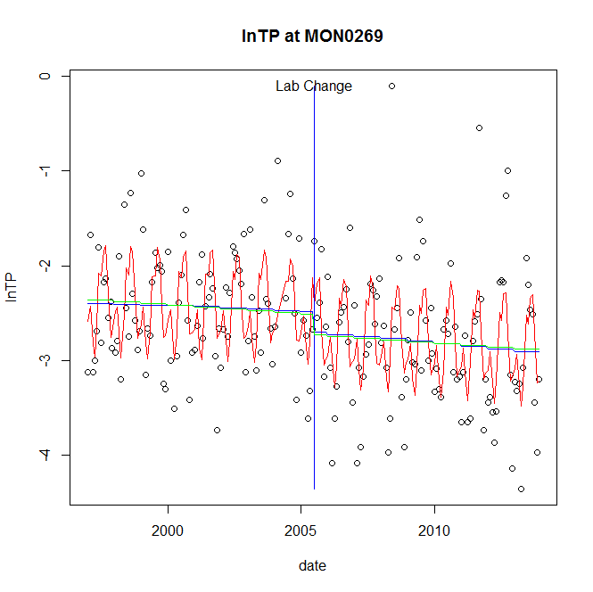

GAM analysis for station MON0269 dependent variable lnTP

|  |  |  |  |  |
| --- | --- | --- | --- | --- |
| **Type** | **Source** | **edf** | **F-stat** | **p-value** |
| parametric terms | step | 1 | 1.6983 | 0.1941 |
|  | year | 1 | 715.844 | <0.0001 |
| smoothed terms | s(year) | 1.41 | 0.5602 | 0.5441 |
|  | s(doy) | 6.82 | 10.9495 | <0.0001 |

GAM analysis for station MON0269 dependent variable lnTP

|  |  |  |  |  |
| --- | --- | --- | --- | --- |
| **parameter** | **estimate** | **Std. Err.** | **t value** | **p-value** |
| (Intercept) | 0.000208 | 0.000233 | 0.893 | 0.3730 |
| step | -0.216967 | 0.16649 | -1.3032 | 0.1941 |
| year | -0.001257 | 4.7e-05 | -26.7553 | <0.0001 |

root mean-square error = 0.5725

adjusted r-square = 0.347

station = MON0269 dependent = lnPO4

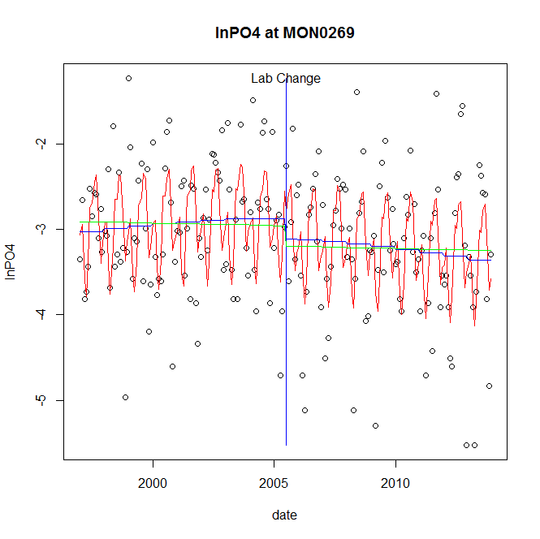

GAM analysis for station MON0269 dependent variable lnPO4

|  |  |  |  |  |
| --- | --- | --- | --- | --- |
| **Type** | **Source** | **edf** | **F-stat** | **p-value** |
| parametric terms | step | 1 | 1.3732 | 0.2427 |
|  | year | 1 | 714.5395 | <0.0001 |
| smoothed terms | s(year) | 1.84 | 1.3395 | 0.2601 |
|  | s(doy) | 6.64 | 10.5322 | <0.0001 |

GAM analysis for station MON0269 dependent variable lnPO4

|  |  |  |  |  |
| --- | --- | --- | --- | --- |
| **parameter** | **estimate** | **Std. Err.** | **t value** | **p-value** |
| (Intercept) | 6.8e-05 | 0.000339 | 0.2002 | 0.8416 |
| step | -0.235667 | 0.201107 | -1.1718 | 0.2427 |
| year | -0.001484 | 5.6e-05 | -26.7309 | <0.0001 |

root mean-square error = 0.6783

adjusted r-square = 0.31

No title given

|  |  |  |  |
| --- | --- | --- | --- |
| **station** | **dep** | **step.est** | **step.pv** |
| MON0269 | lnTSS | -0.428927 | 0.1986 |
| MON0269 | lnTN | 0.035128 | 0.6238 |
| MON0269 | lnNH4 | -0.212169 | 0.3457 |
| MON0269 | lnNO23 | 0.107972 | 0.4519 |
| MON0269 | lnNO2 | -0.07319 | 0.6698 |
| MON0269 | lnTP | -0.216967 | 0.1941 |
| MON0269 | lnPO4 | -0.235667 | 0.2427 |

station = MON0528 dependent = lnTSS

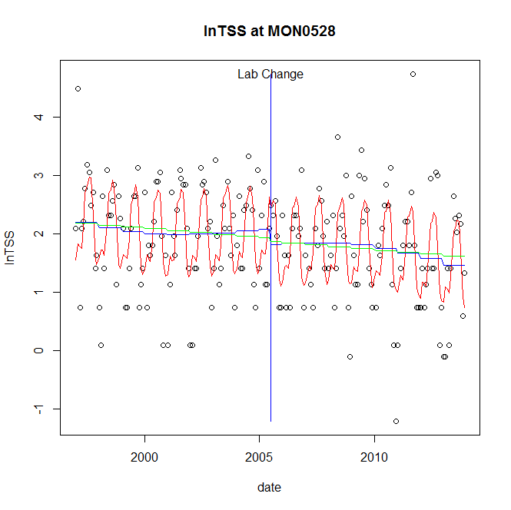

GAM analysis for station MON0528 dependent variable lnTSS

|  |  |  |  |  |
| --- | --- | --- | --- | --- |
| **Type** | **Source** | **edf** | **F-stat** | **p-value** |
| parametric terms | step | 1 | 1.0387 | 0.3094 |
|  | year | 1 | 203.6094 | <0.0001 |
| smoothed terms | s(year) | 3.01 | 1.5298 | 0.1965 |
|  | s(doy) | 6 | 14.4875 | <0.0001 |

GAM analysis for station MON0528 dependent variable lnTSS

|  |  |  |  |  |
| --- | --- | --- | --- | --- |
| **parameter** | **estimate** | **Std. Err.** | **t value** | **p-value** |
| (Intercept) | 0.001253 | 0.000693 | 1.8081 | 0.0722 |
| step | -0.266038 | 0.261034 | -1.0192 | 0.3094 |
| year | 0.00099 | 6.9e-05 | 14.2692 | <0.0001 |

root mean-square error = 0.7298

adjusted r-square = 0.3872

station = MON0528 dependent = lnTN

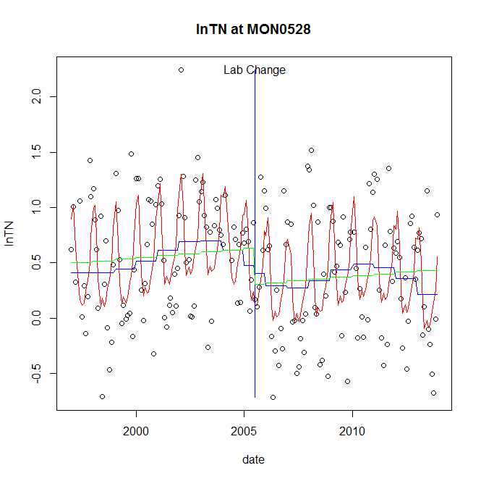

GAM analysis for station MON0528 dependent variable lnTN

|  |  |  |  |  |
| --- | --- | --- | --- | --- |
| **Type** | **Source** | **edf** | **F-stat** | **p-value** |
| parametric terms | step | 1 | 0.1328 | 0.7159 |
|  | year | 1 | 21.0092 | <0.0001 |
| smoothed terms | s(year) | 5.35 | 2.0049 | 0.0648 |
|  | s(doy) | 5.7 | 12.0007 | <0.0001 |

GAM analysis for station MON0528 dependent variable lnTN

|  |  |  |  |  |
| --- | --- | --- | --- | --- |
| **parameter** | **estimate** | **Std. Err.** | **t value** | **p-value** |
| (Intercept) | 0.000898 | 0.000849 | 1.057 | 0.2919 |
| step | -0.07618 | 0.209018 | -0.3645 | 0.7159 |
| year | 0.000254 | 5.5e-05 | 4.5836 | <0.0001 |

root mean-square error = 0.4421

adjusted r-square = 0.3731

station = MON0528 dependent = lnNH4

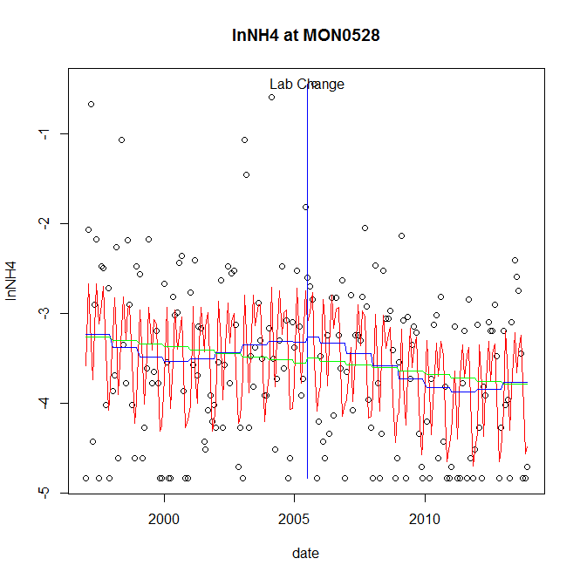

GAM analysis for station MON0528 dependent variable lnNH4

|  |  |  |  |  |
| --- | --- | --- | --- | --- |
| **Type** | **Source** | **edf** | **F-stat** | **p-value** |
| parametric terms | step | 1 | 0.0309 | 0.8608 |
|  | year | 1 | 454.5475 | <0.0001 |
| smoothed terms | s(year) | 3.99 | 2.0081 | 0.0808 |
|  | s(doy) | 7.18 | 9.1629 | <0.0001 |

GAM analysis for station MON0528 dependent variable lnNH4

|  |  |  |  |  |
| --- | --- | --- | --- | --- |
| **parameter** | **estimate** | **Std. Err.** | **t value** | **p-value** |
| (Intercept) | 0.00038 | 0.001052 | 0.3608 | 0.7186 |
| step | 0.056425 | 0.321245 | 0.1756 | 0.8608 |
| year | -0.001791 | 8.4e-05 | -21.3201 | <0.0001 |

root mean-square error = 0.7892

adjusted r-square = 0.2974

station = MON0528 dependent = lnNO23

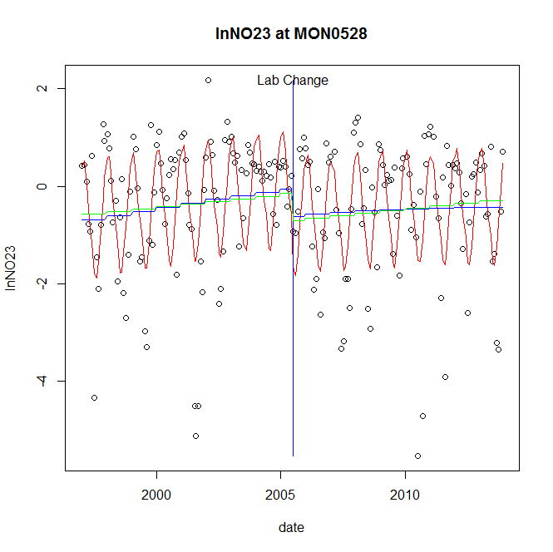

GAM analysis for station MON0528 dependent variable lnNO23

|  |  |  |  |  |
| --- | --- | --- | --- | --- |
| **Type** | **Source** | **edf** | **F-stat** | **p-value** |
| parametric terms | step | 1 | 2.898 | 0.0903 |
|  | year | 1 | 0.4086 | 0.5235 |
| smoothed terms | s(year) | 1.71 | 2.0682 | 0.1264 |
|  | s(doy) | 4.76 | 13.3353 | <0.0001 |

GAM analysis for station MON0528 dependent variable lnNO23

|  |  |  |  |  |
| --- | --- | --- | --- | --- |
| **parameter** | **estimate** | **Std. Err.** | **t value** | **p-value** |
| (Intercept) | -0.000572 | 0.000513 | -1.1148 | 0.2663 |
| step | -0.553645 | 0.325226 | -1.7023 | 0.0903 |
| year | -5.7e-05 | 8.9e-05 | -0.6392 | 0.5235 |

root mean-square error = 1.1078

adjusted r-square = 0.3603

station = MON0528 dependent = lnNO2

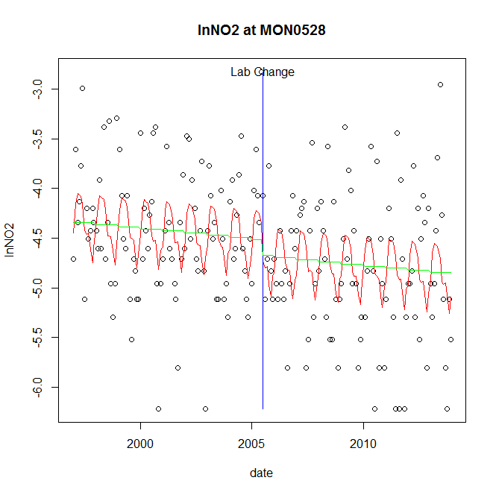

GAM analysis for station MON0528 dependent variable lnNO2

|  |  |  |  |  |
| --- | --- | --- | --- | --- |
| **Type** | **Source** | **edf** | **F-stat** | **p-value** |
| parametric terms | step | 1 | 0.8104 | 0.3691 |
|  | year | 1 | 2067.7912 | <0.0001 |
| smoothed terms | s(year) | 1 | 1.1042 | 0.2947 |
|  | s(doy) | 5 | 3.6032 | <0.0001 |

GAM analysis for station MON0528 dependent variable lnNO2

|  |  |  |  |  |
| --- | --- | --- | --- | --- |
| **parameter** | **estimate** | **Std. Err.** | **t value** | **p-value** |
| (Intercept) | 0.000228 | 0.000218 | 1.0457 | 0.2970 |
| step | -0.161264 | 0.179142 | -0.9002 | 0.3691 |
| year | -0.002259 | 5e-05 | -45.473 | <0.0001 |

root mean-square error = 0.6361

adjusted r-square = 0.1754

station = MON0528 dependent = lnTP

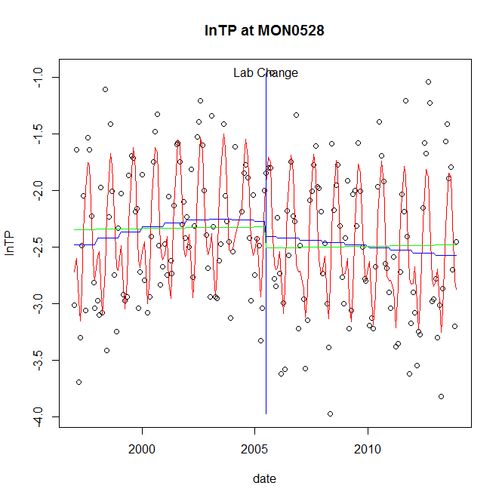

GAM analysis for station MON0528 dependent variable lnTP

|  |  |  |  |  |
| --- | --- | --- | --- | --- |
| **Type** | **Source** | **edf** | **F-stat** | **p-value** |
| parametric terms | step | 1 | 0.7912 | 0.3749 |
|  | year | 1 | 824.8085 | <0.0001 |
| smoothed terms | s(year) | 2.45 | 1.777 | 0.1527 |
|  | s(doy) | 6.28 | 24.5945 | <0.0001 |

GAM analysis for station MON0528 dependent variable lnTP

|  |  |  |  |  |
| --- | --- | --- | --- | --- |
| **parameter** | **estimate** | **Std. Err.** | **t value** | **p-value** |
| (Intercept) | -0.00023 | 0.000331 | -0.6935 | 0.4889 |
| step | -0.132407 | 0.148856 | -0.8895 | 0.3749 |
| year | -0.001171 | 4.1e-05 | -28.7195 | <0.0001 |

root mean-square error = 0.447

adjusted r-square = 0.5132

station = MON0528 dependent = lnPO4

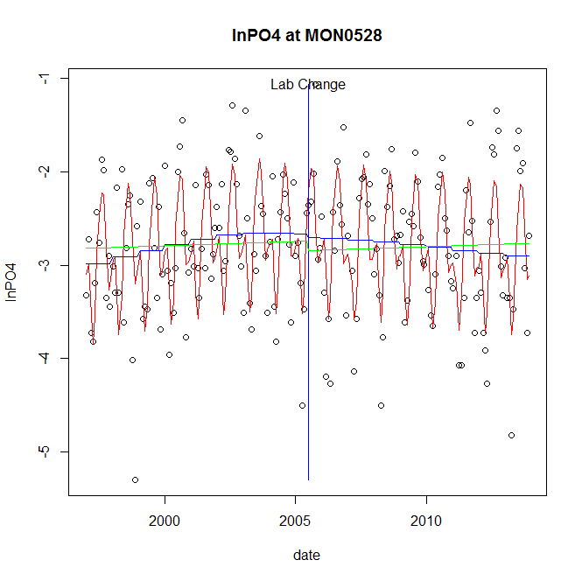

GAM analysis for station MON0528 dependent variable lnPO4

|  |  |  |  |  |
| --- | --- | --- | --- | --- |
| **Type** | **Source** | **edf** | **F-stat** | **p-value** |
| parametric terms | step | 1 | 0.0328 | 0.8564 |
|  | year | 1 | 845.7758 | <0.0001 |
| smoothed terms | s(year) | 2.48 | 2.3683 | 0.0710 |
|  | s(doy) | 6.38 | 21.4224 | <0.0001 |

GAM analysis for station MON0528 dependent variable lnPO4

|  |  |  |  |  |
| --- | --- | --- | --- | --- |
| **parameter** | **estimate** | **Std. Err.** | **t value** | **p-value** |
| (Intercept) | -0.000276 | 0.000398 | -0.6934 | 0.4889 |
| step | -0.032098 | 0.177147 | -0.1812 | 0.8564 |
| year | -0.001388 | 4.8e-05 | -29.0822 | <0.0001 |

root mean-square error = 0.5397

adjusted r-square = 0.4693

No title given

|  |  |  |  |
| --- | --- | --- | --- |
| **station** | **dep** | **step.est** | **step.pv** |
| MON0528 | lnTSS | -0.266038 | 0.3094 |
| MON0528 | lnTN | -0.07618 | 0.7159 |
| MON0528 | lnNH4 | 0.056425 | 0.8608 |
| MON0528 | lnNO23 | -0.553645 | 0.0903 |
| MON0528 | lnNO2 | -0.161264 | 0.3691 |
| MON0528 | lnTP | -0.132407 | 0.3749 |
| MON0528 | lnPO4 | -0.032098 | 0.8564 |

station = NBP0023 dependent = lnTSS

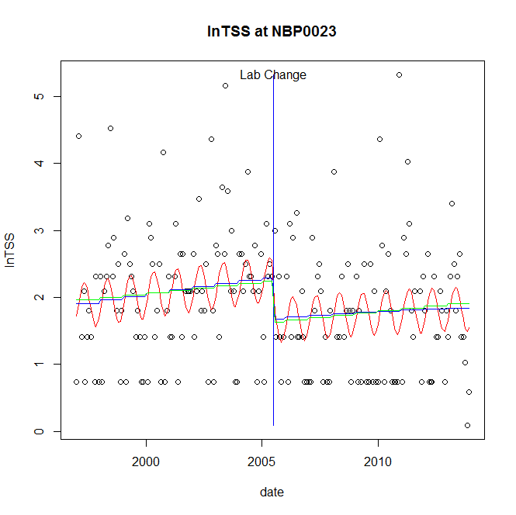

GAM analysis for station NBP0023 dependent variable lnTSS

|  |  |  |  |  |
| --- | --- | --- | --- | --- |
| **Type** | **Source** | **edf** | **F-stat** | **p-value** |
| parametric terms | step | 1 | 5.3084 | 0.0223 |
|  | year | 1 | 232.2784 | <0.0001 |
| smoothed terms | s(year) | 1.46 | 1.537 | 0.2119 |
|  | s(doy) | 2.17 | 2.0028 | 0.0001 |

GAM analysis for station NBP0023 dependent variable lnTSS

|  |  |  |  |  |
| --- | --- | --- | --- | --- |
| **parameter** | **estimate** | **Std. Err.** | **t value** | **p-value** |
| (Intercept) | -0.000395 | 0.000376 | -1.0491 | 0.2954 |
| step | -0.610561 | 0.265 | -2.304 | 0.0223 |
| year | 0.00111 | 7.3e-05 | 15.2407 | <0.0001 |

root mean-square error = 0.9185

adjusted r-square = 0.1131

step significant

station = NBP0023 dependent = lnTN

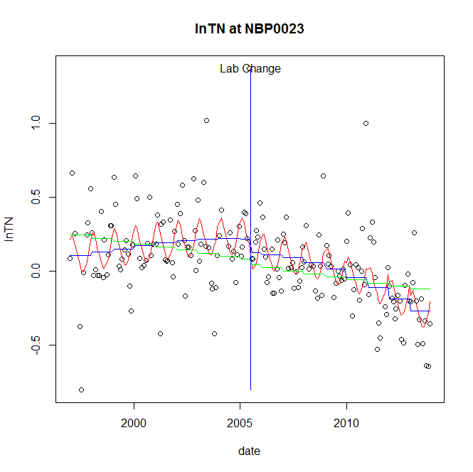

GAM analysis for station NBP0023 dependent variable lnTN

|  |  |  |  |  |
| --- | --- | --- | --- | --- |
| **Type** | **Source** | **edf** | **F-stat** | **p-value** |
| parametric terms | step | 1 | 1.2223 | 0.2704 |
|  | year | 1 | 6.7347 | 0.0102 |
| smoothed terms | s(year) | 2.7 | 10.7399 | <0.0001 |
|  | s(doy) | 3.44 | 3.2942 | <0.0001 |

GAM analysis for station NBP0023 dependent variable lnTN

|  |  |  |  |  |
| --- | --- | --- | --- | --- |
| **parameter** | **estimate** | **Std. Err.** | **t value** | **p-value** |
| (Intercept) | 0.000343 | 0.000205 | 1.6778 | 0.0951 |
| step | -0.092894 | 0.084024 | -1.1056 | 0.2704 |
| year | 6e-05 | 2.3e-05 | 2.5951 | 0.0102 |

root mean-square error = 0.2405

adjusted r-square = 0.3382

station = NBP0023 dependent = lnNH4

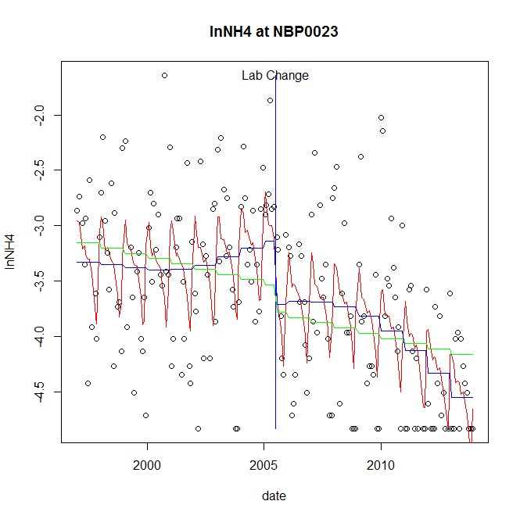

GAM analysis for station NBP0023 dependent variable lnNH4

|  |  |  |  |  |
| --- | --- | --- | --- | --- |
| **Type** | **Source** | **edf** | **F-stat** | **p-value** |
| parametric terms | step | 1 | 5.6639 | 0.0183 |
|  | year | 1 | 694.0461 | <0.0001 |
| smoothed terms | s(year) | 3.5 | 6.1165 | <0.0001 |
|  | s(doy) | 6.63 | 4.7919 | <0.0001 |

GAM analysis for station NBP0023 dependent variable lnNH4

|  |  |  |  |  |
| --- | --- | --- | --- | --- |
| **parameter** | **estimate** | **Std. Err.** | **t value** | **p-value** |
| (Intercept) | 0.00139 | 0.000713 | 1.9486 | 0.0528 |
| step | -0.572192 | 0.240427 | -2.3799 | 0.0183 |
| year | -0.001675 | 6.4e-05 | -26.3448 | <0.0001 |

root mean-square error = 0.624

adjusted r-square = 0.3725

step significant

station = NBP0023 dependent = lnNO23

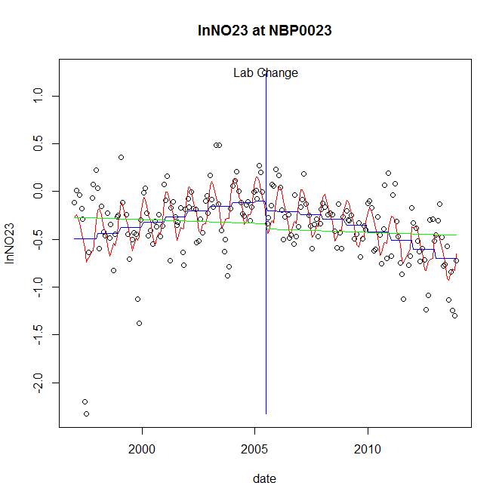

GAM analysis for station NBP0023 dependent variable lnNO23

|  |  |  |  |  |
| --- | --- | --- | --- | --- |
| **Type** | **Source** | **edf** | **F-stat** | **p-value** |
| parametric terms | step | 1 | 0.8035 | 0.3712 |
|  | year | 1 | 24.5206 | <0.0001 |
| smoothed terms | s(year) | 2.83 | 14.6038 | <0.0001 |
|  | s(doy) | 6.01 | 7.2903 | <0.0001 |

GAM analysis for station NBP0023 dependent variable lnNO23

|  |  |  |  |  |
| --- | --- | --- | --- | --- |
| **parameter** | **estimate** | **Std. Err.** | **t value** | **p-value** |
| (Intercept) | 0.000225 | 0.000274 | 0.8201 | 0.4132 |
| step | -0.097594 | 0.108874 | -0.8964 | 0.3712 |
| year | -0.000144 | 2.9e-05 | -4.9518 | <0.0001 |

root mean-square error = 0.3116

adjusted r-square = 0.371

station = NBP0023 dependent = lnNO2

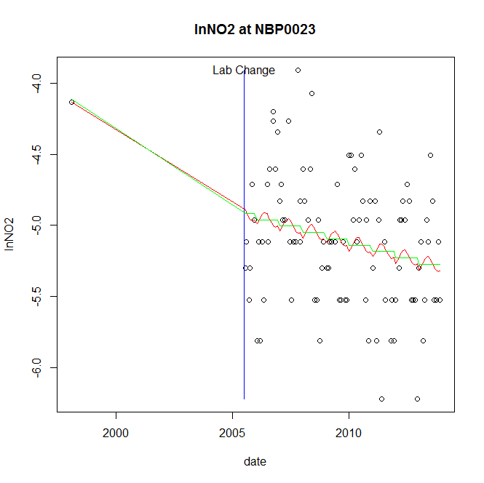

GAM analysis for station NBP0023 dependent variable lnNO2

|  |  |  |  |  |
| --- | --- | --- | --- | --- |
| **Type** | **Source** | **edf** | **F-stat** | **p-value** |
| parametric terms | step | 1 | 0.9954 | 0.3209 |
|  | year | 1 | 89.5059 | <0.0001 |
| smoothed terms | s(year) | 1 | 5.6225 | 0.0197 |
|  | s(doy) | 0.97 | 0.2056 | 0.1667 |

GAM analysis for station NBP0023 dependent variable lnNO2

|  |  |  |  |  |
| --- | --- | --- | --- | --- |
| **parameter** | **estimate** | **Std. Err.** | **t value** | **p-value** |
| (Intercept) | 0.000154 | 6.6e-05 | 2.3555 | 0.0205 |
| step | -0.489512 | 0.490654 | -0.9977 | 0.3209 |
| year | -0.002297 | 0.000243 | -9.4608 | <0.0001 |

root mean-square error = 0.4424

adjusted r-square = 0.0946

station = NBP0023 dependent = lnTP

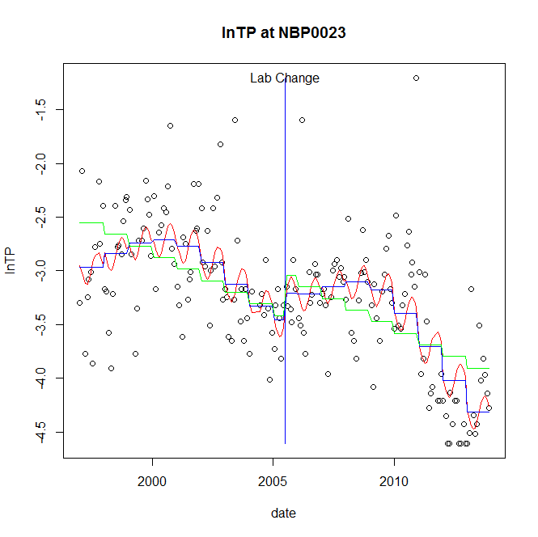

GAM analysis for station NBP0023 dependent variable lnTP

|  |  |  |  |  |
| --- | --- | --- | --- | --- |
| **Type** | **Source** | **edf** | **F-stat** | **p-value** |
| parametric terms | step | 1 | 1.3173 | 0.2526 |
|  | year | 1 | 847.5177 | <0.0001 |
| smoothed terms | s(year) | 5.31 | 17.4488 | <0.0001 |
|  | s(doy) | 2.09 | 1.584 | 0.0006 |

GAM analysis for station NBP0023 dependent variable lnTP

|  |  |  |  |  |
| --- | --- | --- | --- | --- |
| **parameter** | **estimate** | **Std. Err.** | **t value** | **p-value** |
| (Intercept) | 0.00092 | 0.000876 | 1.0501 | 0.2950 |
| step | 0.248284 | 0.216327 | 1.1477 | 0.2526 |
| year | -0.001672 | 5.7e-05 | -29.1122 | <0.0001 |

root mean-square error = 0.4595

adjusted r-square = 0.5024

station = NBP0023 dependent = lnPO4

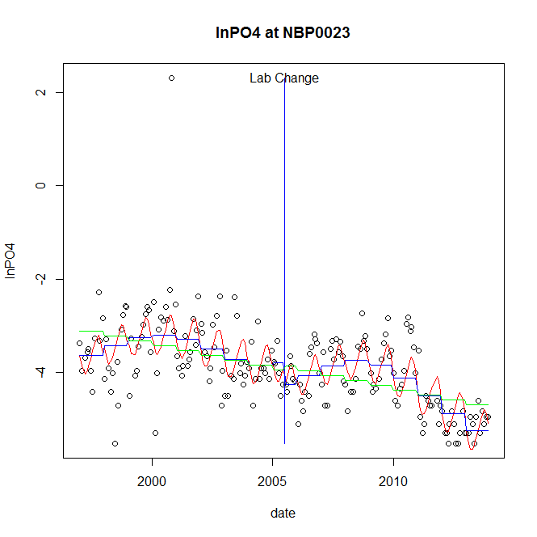

GAM analysis for station NBP0023 dependent variable lnPO4

|  |  |  |  |  |
| --- | --- | --- | --- | --- |
| **Type** | **Source** | **edf** | **F-stat** | **p-value** |
| parametric terms | step | 1 | 2.3564 | 0.1264 |
|  | year | 1 | 530.3396 | <0.0001 |
| smoothed terms | s(year) | 5.43 | 11.5731 | <0.0001 |
|  | s(doy) | 3.05 | 5.1457 | <0.0001 |

GAM analysis for station NBP0023 dependent variable lnPO4

|  |  |  |  |  |
| --- | --- | --- | --- | --- |
| **parameter** | **estimate** | **Std. Err.** | **t value** | **p-value** |
| (Intercept) | 0.000828 | 0.001242 | 0.6669 | 0.5056 |
| step | -0.469356 | 0.305756 | -1.5351 | 0.1264 |
| year | -0.001825 | 7.9e-05 | -23.0291 | <0.0001 |

root mean-square error = 0.6489

adjusted r-square = 0.4902

No title given

|  |  |  |  |
| --- | --- | --- | --- |
| **station** | **dep** | **step.est** | **step.pv** |
| NBP0023 | lnTSS | -0.610561 | 0.0223 |
| NBP0023 | lnTN | -0.092894 | 0.2704 |
| NBP0023 | lnNH4 | -0.572192 | 0.0183 |
| NBP0023 | lnNO23 | -0.097594 | 0.3712 |
| NBP0023 | lnNO2 | -0.489512 | 0.3209 |
| NBP0023 | lnTP | 0.248284 | 0.2526 |
| NBP0023 | lnPO4 | -0.469356 | 0.1264 |

station = NBP0103 dependent = lnTSS

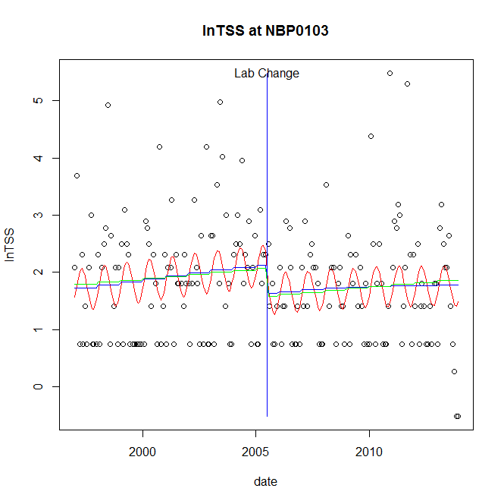

GAM analysis for station NBP0103 dependent variable lnTSS

|  |  |  |  |  |
| --- | --- | --- | --- | --- |
| **Type** | **Source** | **edf** | **F-stat** | **p-value** |
| parametric terms | step | 1 | 3.0955 | 0.0801 |
|  | year | 1 | 172.7481 | <0.0001 |
| smoothed terms | s(year) | 1.59 | 1.3781 | 0.2517 |
|  | s(doy) | 2.18 | 2.0272 | <0.0001 |

GAM analysis for station NBP0103 dependent variable lnTSS

|  |  |  |  |  |
| --- | --- | --- | --- | --- |
| **parameter** | **estimate** | **Std. Err.** | **t value** | **p-value** |
| (Intercept) | -0.000323 | 0.00043 | -0.7526 | 0.4526 |
| step | -0.502149 | 0.285408 | -1.7594 | 0.0801 |
| year | 0.001029 | 7.8e-05 | 13.1434 | <0.0001 |

root mean-square error = 0.9814

adjusted r-square = 0.0957

station = NBP0103 dependent = lnTN

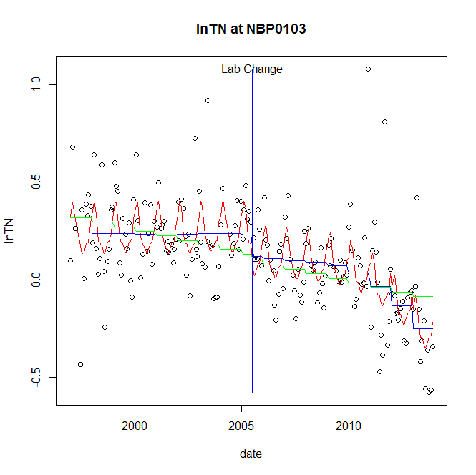

GAM analysis for station NBP0103 dependent variable lnTN

|  |  |  |  |  |
| --- | --- | --- | --- | --- |
| **Type** | **Source** | **edf** | **F-stat** | **p-value** |
| parametric terms | step | 1 | 1.7573 | 0.1866 |
|  | year | 1 | 15.1156 | 0.0001 |
| smoothed terms | s(year) | 4.11 | 7.7099 | <0.0001 |
|  | s(doy) | 5.14 | 4.7996 | <0.0001 |

GAM analysis for station NBP0103 dependent variable lnTN

|  |  |  |  |  |
| --- | --- | --- | --- | --- |
| **parameter** | **estimate** | **Std. Err.** | **t value** | **p-value** |
| (Intercept) | 0.000678 | 0.000282 | 2.4043 | 0.0172 |
| step | -0.111153 | 0.083849 | -1.3256 | 0.1866 |
| year | 8.8e-05 | 2.3e-05 | 3.8879 | 0.0001 |

root mean-square error = 0.1993

adjusted r-square = 0.4184

station = NBP0103 dependent = lnNH4

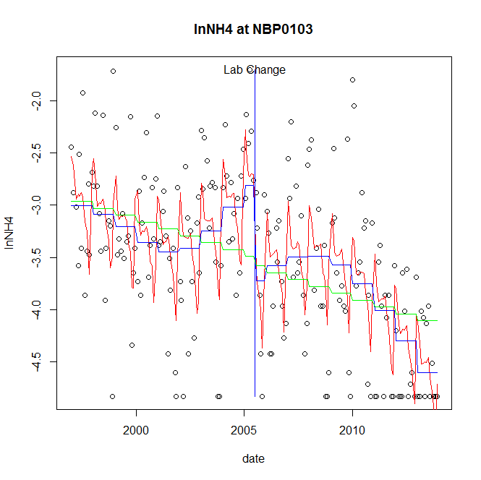

GAM analysis for station NBP0103 dependent variable lnNH4

|  |  |  |  |  |
| --- | --- | --- | --- | --- |
| **Type** | **Source** | **edf** | **F-stat** | **p-value** |
| parametric terms | step | 1 | 11.4398 | 0.0009 |
|  | year | 1 | 477.9386 | <0.0001 |
| smoothed terms | s(year) | 4.84 | 8.8572 | <0.0001 |
|  | s(doy) | 7.13 | 6.4144 | <0.0001 |

GAM analysis for station NBP0103 dependent variable lnNH4

|  |  |  |  |  |
| --- | --- | --- | --- | --- |
| **parameter** | **estimate** | **Std. Err.** | **t value** | **p-value** |
| (Intercept) | 0.002239 | 0.001007 | 2.2247 | 0.0273 |
| step | -0.912913 | 0.269911 | -3.3823 | 0.0009 |
| year | -0.001528 | 7e-05 | -21.8618 | <0.0001 |

root mean-square error = 0.6034

adjusted r-square = 0.4495

step significant

station = NBP0103 dependent = lnNO23

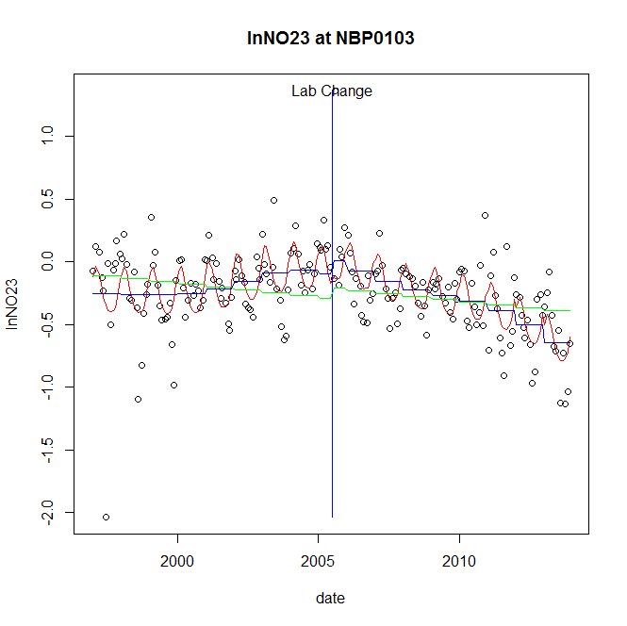

GAM analysis for station NBP0103 dependent variable lnNO23

|  |  |  |  |  |
| --- | --- | --- | --- | --- |
| **Type** | **Source** | **edf** | **F-stat** | **p-value** |
| parametric terms | step | 1 | 0.8013 | 0.3718 |
|  | year | 1 | 22.0105 | <0.0001 |
| smoothed terms | s(year) | 5.14 | 10.1292 | <0.0001 |
|  | s(doy) | 3.72 | 6.6317 | <0.0001 |

GAM analysis for station NBP0103 dependent variable lnNO23

|  |  |  |  |  |
| --- | --- | --- | --- | --- |
| **parameter** | **estimate** | **Std. Err.** | **t value** | **p-value** |
| (Intercept) | 0.000901 | 0.000473 | 1.9034 | 0.0585 |
| step | 0.108709 | 0.12144 | 0.8952 | 0.3718 |
| year | -0.000147 | 3.1e-05 | -4.6915 | <0.0001 |

root mean-square error = 0.2651

adjusted r-square = 0.3729

station = NBP0103 dependent = lnNO2

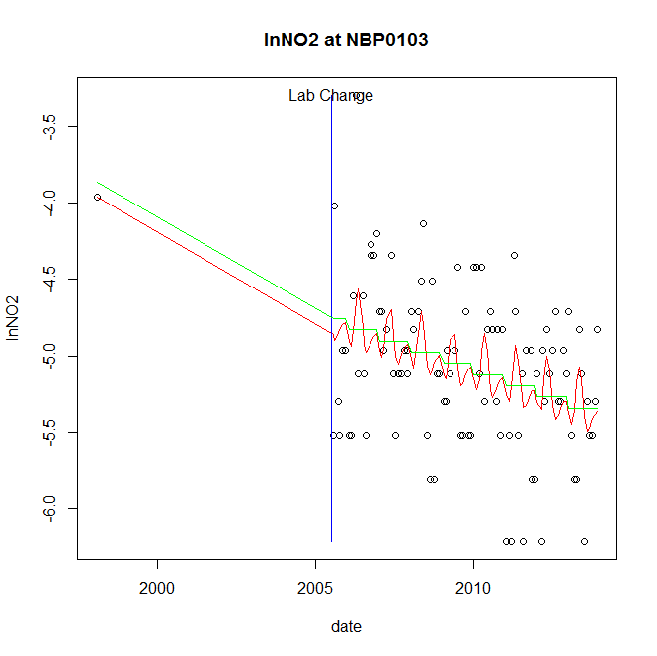

GAM analysis for station NBP0103 dependent variable lnNO2

|  |  |  |  |  |
| --- | --- | --- | --- | --- |
| **Type** | **Source** | **edf** | **F-stat** | **p-value** |
| parametric terms | step | 1 | 0.4924 | 0.4846 |
|  | year | 1 | 76.3885 | <0.0001 |
| smoothed terms | s(year) | 1 | 13.3098 | 0.0004 |
|  | s(doy) | 3.9 | 1.0291 | 0.0669 |

GAM analysis for station NBP0103 dependent variable lnNO2

|  |  |  |  |  |
| --- | --- | --- | --- | --- |
| **parameter** | **estimate** | **Std. Err.** | **t value** | **p-value** |
| (Intercept) | 0.000258 | 7.1e-05 | 3.6346 | 0.0005 |
| step | -0.379165 | 0.540363 | -0.7017 | 0.4846 |
| year | -0.002337 | 0.000267 | -8.7401 | <0.0001 |

root mean-square error = 0.481

adjusted r-square = 0.1818

station = NBP0103 dependent = lnTP

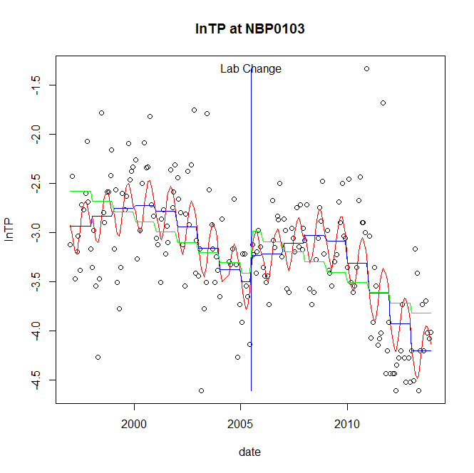

GAM analysis for station NBP0103 dependent variable lnTP

|  |  |  |  |  |
| --- | --- | --- | --- | --- |
| **Type** | **Source** | **edf** | **F-stat** | **p-value** |
| parametric terms | step | 1 | 1.4277 | 0.2337 |
|  | year | 1 | 814.1249 | <0.0001 |
| smoothed terms | s(year) | 5.54 | 16.1824 | <0.0001 |
|  | s(doy) | 2.82 | 4.2156 | <0.0001 |

GAM analysis for station NBP0103 dependent variable lnTP

|  |  |  |  |  |
| --- | --- | --- | --- | --- |
| **parameter** | **estimate** | **Std. Err.** | **t value** | **p-value** |
| (Intercept) | 0.000951 | 0.000912 | 1.0427 | 0.2984 |
| step | 0.263474 | 0.220508 | 1.1948 | 0.2337 |
| year | -0.001659 | 5.8e-05 | -28.5329 | <0.0001 |

root mean-square error = 0.4594

adjusted r-square = 0.4988

station = NBP0103 dependent = lnPO4

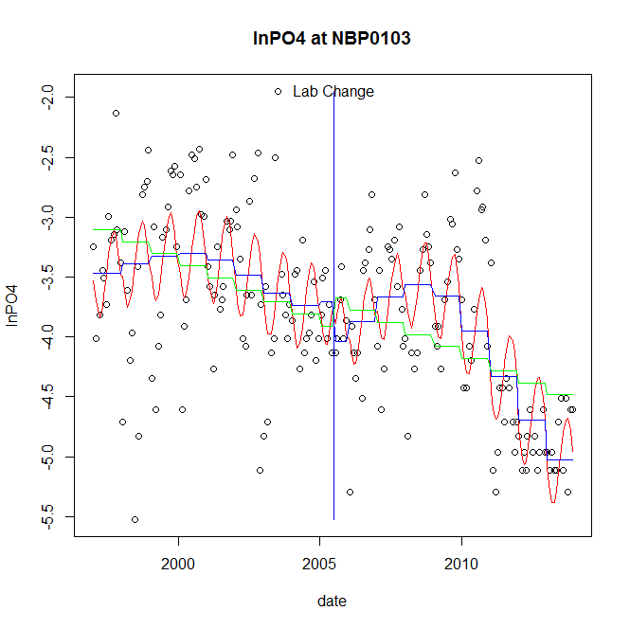

GAM analysis for station NBP0103 dependent variable lnPO4

|  |  |  |  |  |
| --- | --- | --- | --- | --- |
| **Type** | **Source** | **edf** | **F-stat** | **p-value** |
| parametric terms | step | 1 | 1.6775 | 0.1968 |
|  | year | 1 | 759.4612 | <0.0001 |
| smoothed terms | s(year) | 5.55 | 14.6192 | <0.0001 |
|  | s(doy) | 2.72 | 5.9459 | <0.0001 |

GAM analysis for station NBP0103 dependent variable lnPO4

|  |  |  |  |  |
| --- | --- | --- | --- | --- |
| **parameter** | **estimate** | **Std. Err.** | **t value** | **p-value** |
| (Intercept) | 0.001447 | 0.001045 | 1.3851 | 0.1676 |
| step | -0.329577 | 0.254465 | -1.2952 | 0.1968 |
| year | -0.001807 | 6.6e-05 | -27.5583 | <0.0001 |

root mean-square error = 0.5357

adjusted r-square = 0.5149

No title given

|  |  |  |  |
| --- | --- | --- | --- |
| **station** | **dep** | **step.est** | **step.pv** |
| NBP0103 | lnTSS | -0.502149 | 0.0801 |
| NBP0103 | lnTN | -0.111153 | 0.1866 |
| NBP0103 | lnNH4 | -0.912913 | 0.0009 |
| NBP0103 | lnNO23 | 0.108709 | 0.3718 |
| NBP0103 | lnNO2 | -0.379165 | 0.4846 |
| NBP0103 | lnTP | 0.263474 | 0.2337 |
| NBP0103 | lnPO4 | -0.329577 | 0.1968 |

station = NBP0326 dependent = lnTSS

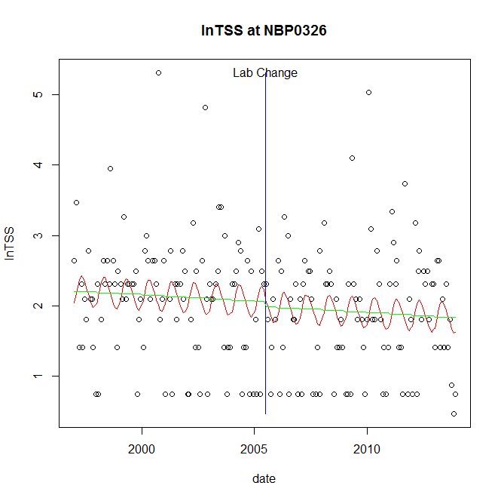

GAM analysis for station NBP0326 dependent variable lnTSS

|  |  |  |  |  |
| --- | --- | --- | --- | --- |
| **Type** | **Source** | **edf** | **F-stat** | **p-value** |
| parametric terms | step | 1 | 0.087 | 0.7684 |
|  | year | 1 | 241.3983 | <0.0001 |
| smoothed terms | s(year) | 1 | 0.6504 | 0.4209 |
|  | s(doy) | 2.13 | 1.1815 | 0.0046 |

GAM analysis for station NBP0326 dependent variable lnTSS

|  |  |  |  |  |
| --- | --- | --- | --- | --- |
| **parameter** | **estimate** | **Std. Err.** | **t value** | **p-value** |
| (Intercept) | 0.000232 | 0.000287 | 0.8083 | 0.4199 |
| step | -0.069411 | 0.235381 | -0.2949 | 0.7684 |
| year | 0.001022 | 6.6e-05 | 15.537 | <0.0001 |

root mean-square error = 0.8372

adjusted r-square = 0.0548

station = NBP0326 dependent = lnTN

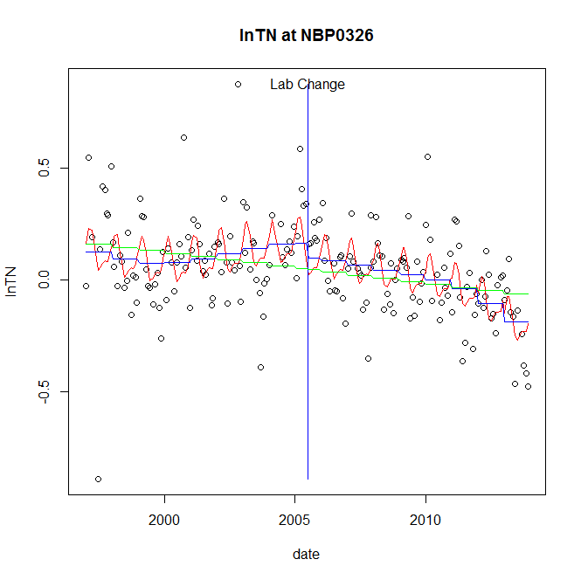

GAM analysis for station NBP0326 dependent variable lnTN

|  |  |  |  |  |
| --- | --- | --- | --- | --- |
| **Type** | **Source** | **edf** | **F-stat** | **p-value** |
| parametric terms | step | 1 | 0.7956 | 0.3736 |
|  | year | 1 | 4.3373 | 0.0387 |
| smoothed terms | s(year) | 4.4 | 5.42 | <0.0001 |
|  | s(doy) | 3.98 | 3.7294 | <0.0001 |

GAM analysis for station NBP0326 dependent variable lnTN

|  |  |  |  |  |
| --- | --- | --- | --- | --- |
| **parameter** | **estimate** | **Std. Err.** | **t value** | **p-value** |
| (Intercept) | 0.000713 | 0.000272 | 2.6229 | 0.0094 |
| step | -0.068997 | 0.077356 | -0.8919 | 0.3736 |
| year | 4.3e-05 | 2.1e-05 | 2.0826 | 0.0387 |

root mean-square error = 0.1786

adjusted r-square = 0.2779

station = NBP0326 dependent = lnNH4

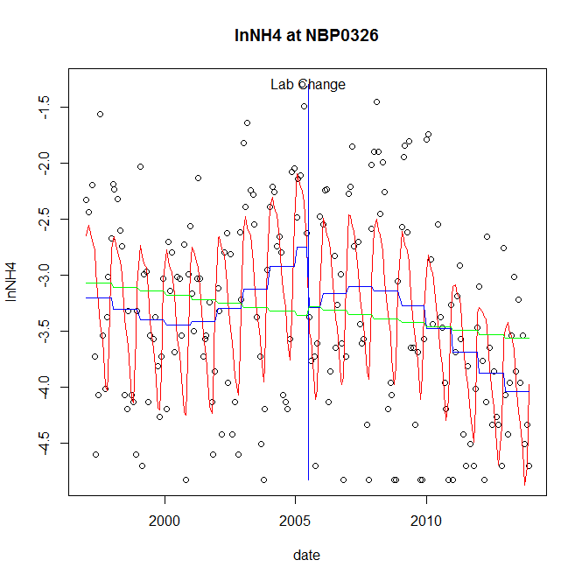

GAM analysis for station NBP0326 dependent variable lnNH4

|  |  |  |  |  |
| --- | --- | --- | --- | --- |
| **Type** | **Source** | **edf** | **F-stat** | **p-value** |
| parametric terms | step | 1 | 3.7516 | 0.0542 |
|  | year | 1 | 438.4516 | <0.0001 |
| smoothed terms | s(year) | 4.29 | 7.1542 | <0.0001 |
|  | s(doy) | 5.99 | 14.846 | <0.0001 |

GAM analysis for station NBP0326 dependent variable lnNH4

|  |  |  |  |  |
| --- | --- | --- | --- | --- |
| **parameter** | **estimate** | **Std. Err.** | **t value** | **p-value** |
| (Intercept) | 0.001545 | 0.000957 | 1.6145 | 0.1081 |
| step | -0.541426 | 0.279532 | -1.9369 | 0.0542 |
| year | -0.001531 | 7.3e-05 | -20.9392 | <0.0001 |

root mean-square error = 0.6626

adjusted r-square = 0.4533

station = NBP0326 dependent = lnNO23

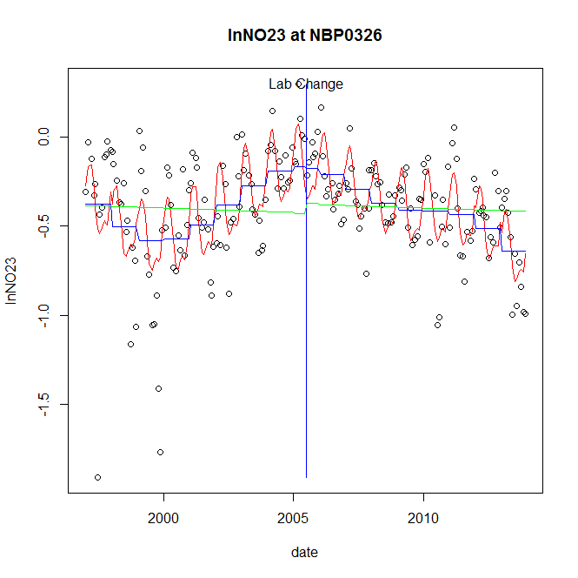

GAM analysis for station NBP0326 dependent variable lnNO23

|  |  |  |  |  |
| --- | --- | --- | --- | --- |
| **Type** | **Source** | **edf** | **F-stat** | **p-value** |
| parametric terms | step | 1 | 0.0103 | 0.9192 |
|  | year | 1 | 43.4107 | <0.0001 |
| smoothed terms | s(year) | 5.72 | 10.7256 | <0.0001 |
|  | s(doy) | 5.01 | 9.4899 | <0.0001 |

GAM analysis for station NBP0326 dependent variable lnNO23

|  |  |  |  |  |
| --- | --- | --- | --- | --- |
| **parameter** | **estimate** | **Std. Err.** | **t value** | **p-value** |
| (Intercept) | 0.00166 | 0.000479 | 3.4647 | 0.0007 |
| step | -0.011718 | 0.115319 | -0.1016 | 0.9192 |
| year | -0.000196 | 3e-05 | -6.5887 | <0.0001 |

root mean-square error = 0.2381

adjusted r-square = 0.416

station = NBP0326 dependent = lnNO2

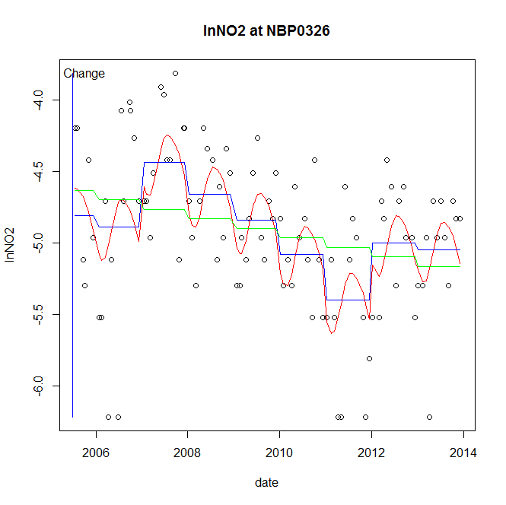

GAM analysis for station NBP0326 dependent variable lnNO2

|  |  |  |  |  |
| --- | --- | --- | --- | --- |
| **Type** | **Source** | **edf** | **F-stat** | **p-value** |
| parametric terms | step | 1 | 1.5769 | 0.2124 |
|  | year | 1 | 12780.0193 | <0.0001 |
| smoothed terms | s(year) | 6.54 | 5.3581 | <0.0001 |
|  | s(doy) | 2.38 | 1.7657 | 0.0006 |

GAM analysis for station NBP0326 dependent variable lnNO2

|  |  |  |  |  |
| --- | --- | --- | --- | --- |
| **parameter** | **estimate** | **Std. Err.** | **t value** | **p-value** |
| (Intercept) | 0.00073 | 0.000581 | 1.2558 | 0.2124 |
| step | 0.00073 | 0.000581 | 1.2558 | 0.2124 |
| year | -0.002448 | 2.2e-05 | -113.0487 | <0.0001 |

root mean-square error = 0.4393

adjusted r-square = 0.3308

station = NBP0326 dependent = lnTP

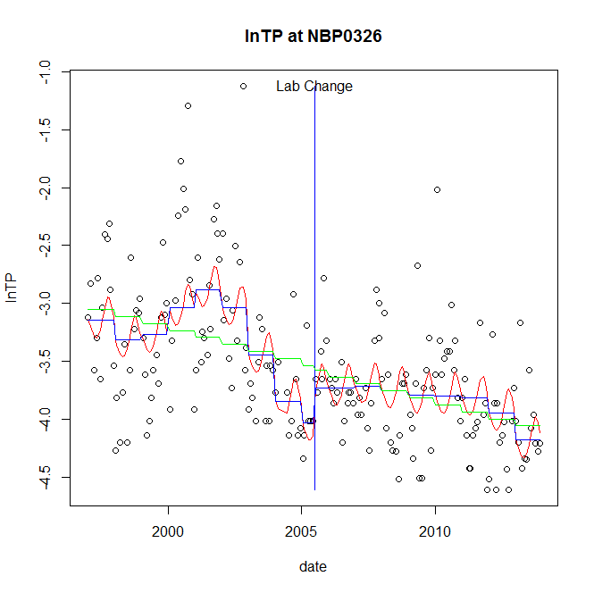

GAM analysis for station NBP0326 dependent variable lnTP

|  |  |  |  |  |
| --- | --- | --- | --- | --- |
| **Type** | **Source** | **edf** | **F-stat** | **p-value** |
| parametric terms | step | 1 | 1.3824 | 0.2412 |
|  | year | 1 | 749.4369 | <0.0001 |
| smoothed terms | s(year) | 6.54 | 6.7796 | <0.0001 |
|  | s(doy) | 2.71 | 1.7004 | 0.0011 |

GAM analysis for station NBP0326 dependent variable lnTP

|  |  |  |  |  |
| --- | --- | --- | --- | --- |
| **parameter** | **estimate** | **Std. Err.** | **t value** | **p-value** |
| (Intercept) | 0.002786 | 0.001178 | 2.3645 | 0.0191 |
| step | 0.302383 | 0.257184 | 1.1757 | 0.2412 |
| year | -0.001851 | 6.8e-05 | -27.3758 | <0.0001 |

root mean-square error = 0.493

adjusted r-square = 0.3889

station = NBP0326 dependent = lnPO4

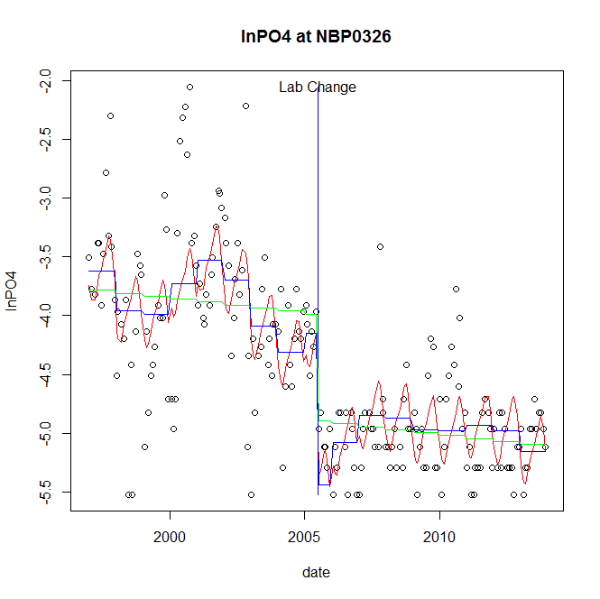

GAM analysis for station NBP0326 dependent variable lnPO4

|  |  |  |  |  |
| --- | --- | --- | --- | --- |
| **Type** | **Source** | **edf** | **F-stat** | **p-value** |
| parametric terms | step | 1 | 23.9859 | <0.0001 |
|  | year | 1 | 782.2809 | <0.0001 |
| smoothed terms | s(year) | 6.8 | 5.3816 | <0.0001 |
|  | s(doy) | 3.59 | 3.8238 | <0.0001 |

GAM analysis for station NBP0326 dependent variable lnPO4

|  |  |  |  |  |
| --- | --- | --- | --- | --- |
| **parameter** | **estimate** | **Std. Err.** | **t value** | **p-value** |
| (Intercept) | 0.003582 | 0.00122 | 2.936 | 0.0037 |
| step | -1.289811 | 0.263359 | -4.8975 | <0.0001 |
| year | -0.001897 | 6.8e-05 | -27.9693 | <0.0001 |

root mean-square error = 0.4961

adjusted r-square = 0.6089

step significant

No title given

|  |  |  |  |
| --- | --- | --- | --- |
| **station** | **dep** | **step.est** | **step.pv** |
| NBP0326 | lnTSS | -0.069411 | 0.7684 |
| NBP0326 | lnTN | -0.068997 | 0.3736 |
| NBP0326 | lnNH4 | -0.541426 | 0.0542 |
| NBP0326 | lnNO23 | -0.011718 | 0.9192 |
| NBP0326 | lnNO2 | 0.00073 | 0.2124 |
| NBP0326 | lnTP | 0.302383 | 0.2412 |
| NBP0326 | lnPO4 | -1.289811 | <0.0001 |

station = NBP0461 dependent = lnTSS

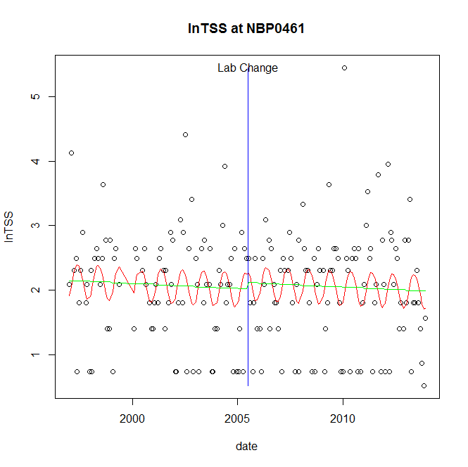

GAM analysis for station NBP0461 dependent variable lnTSS

|  |  |  |  |  |
| --- | --- | --- | --- | --- |
| **Type** | **Source** | **edf** | **F-stat** | **p-value** |
| parametric terms | step | 1 | 0.1841 | 0.6684 |
|  | year | 1 | 209.4314 | <0.0001 |
| smoothed terms | s(year) | 1 | 0.4779 | 0.4903 |
|  | s(doy) | 2.16 | 1.6512 | 0.0005 |

GAM analysis for station NBP0461 dependent variable lnTSS

|  |  |  |  |  |
| --- | --- | --- | --- | --- |
| **parameter** | **estimate** | **Std. Err.** | **t value** | **p-value** |
| (Intercept) | 0.000194 | 0.00028 | 0.6931 | 0.4891 |
| step | 0.100546 | 0.234345 | 0.4291 | 0.6684 |
| year | 0.001 | 6.9e-05 | 14.4717 | <0.0001 |

root mean-square error = 0.8305

adjusted r-square = 0.0606

station = NBP0461 dependent = lnTN

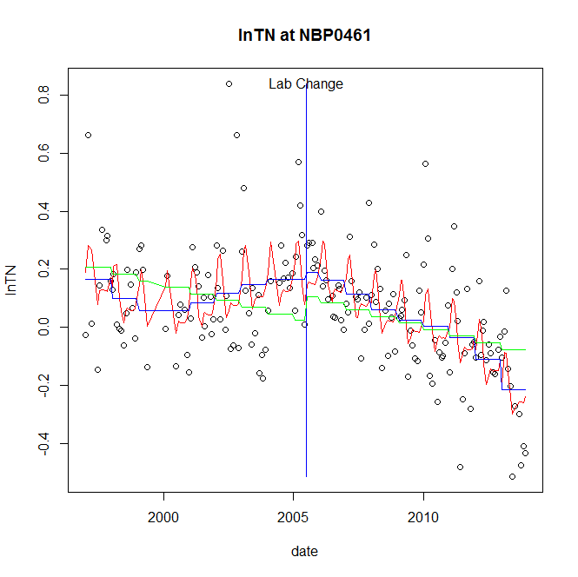

GAM analysis for station NBP0461 dependent variable lnTN

|  |  |  |  |  |
| --- | --- | --- | --- | --- |
| **Type** | **Source** | **edf** | **F-stat** | **p-value** |
| parametric terms | step | 1 | 0.1134 | 0.7367 |
|  | year | 1 | 1.2626 | 0.2627 |
| smoothed terms | s(year) | 5.39 | 10.11 | <0.0001 |
|  | s(doy) | 4.97 | 4.759 | <0.0001 |

GAM analysis for station NBP0461 dependent variable lnTN

|  |  |  |  |  |
| --- | --- | --- | --- | --- |
| **parameter** | **estimate** | **Std. Err.** | **t value** | **p-value** |
| (Intercept) | 0.001047 | 0.000312 | 3.357 | 0.0010 |
| step | 0.02543 | 0.075513 | 0.3368 | 0.7367 |
| year | 2.4e-05 | 2.1e-05 | 1.1236 | 0.2627 |

root mean-square error = 0.1572

adjusted r-square = 0.3884

station = NBP0461 dependent = lnNH4

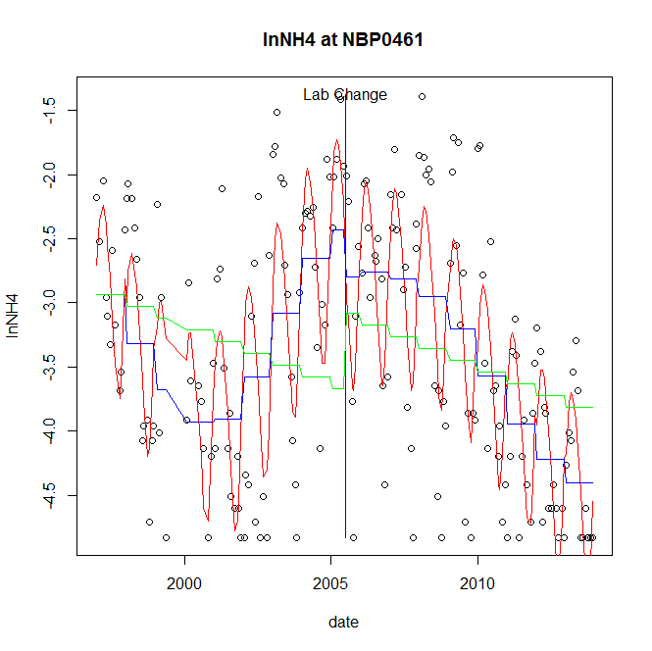

GAM analysis for station NBP0461 dependent variable lnNH4

|  |  |  |  |  |
| --- | --- | --- | --- | --- |
| **Type** | **Source** | **edf** | **F-stat** | **p-value** |
| parametric terms | step | 1 | 1.4273 | 0.2338 |
|  | year | 1 | 336.1943 | <0.0001 |
| smoothed terms | s(year) | 5.71 | 22.6939 | <0.0001 |
|  | s(doy) | 4.12 | 17.2844 | <0.0001 |

GAM analysis for station NBP0461 dependent variable lnNH4

|  |  |  |  |  |
| --- | --- | --- | --- | --- |
| **parameter** | **estimate** | **Std. Err.** | **t value** | **p-value** |
| (Intercept) | 0.00313 | 0.001326 | 2.3609 | 0.0193 |
| step | -0.370608 | 0.31021 | -1.1947 | 0.2338 |
| year | -0.001572 | 8.6e-05 | -18.3356 | <0.0001 |

root mean-square error = 0.6368

adjusted r-square = 0.6088

station = NBP0461 dependent = lnNO23

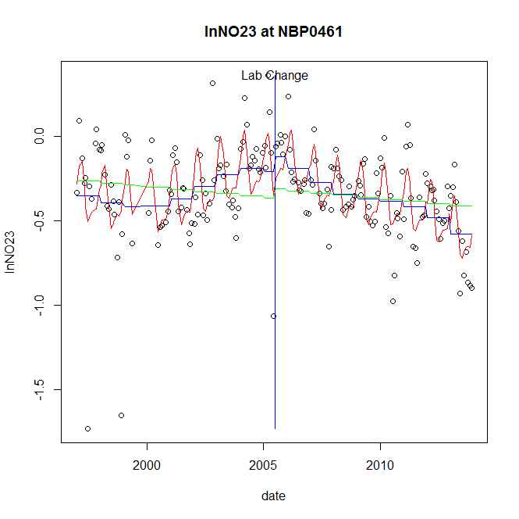

GAM analysis for station NBP0461 dependent variable lnNO23

|  |  |  |  |  |
| --- | --- | --- | --- | --- |
| **Type** | **Source** | **edf** | **F-stat** | **p-value** |
| parametric terms | step | 1 | 0.7935 | 0.3742 |
|  | year | 1 | 45.1754 | <0.0001 |
| smoothed terms | s(year) | 5.29 | 7.8361 | <0.0001 |
|  | s(doy) | 4.64 | 8.3151 | <0.0001 |

GAM analysis for station NBP0461 dependent variable lnNO23

|  |  |  |  |  |
| --- | --- | --- | --- | --- |
| **parameter** | **estimate** | **Std. Err.** | **t value** | **p-value** |
| (Intercept) | 0.000816 | 0.000415 | 1.9642 | 0.0511 |
| step | 0.091607 | 0.102838 | 0.8908 | 0.3742 |
| year | -0.000192 | 2.8e-05 | -6.7213 | <0.0001 |

root mean-square error = 0.219

adjusted r-square = 0.369

station = NBP0461 dependent = lnNO2

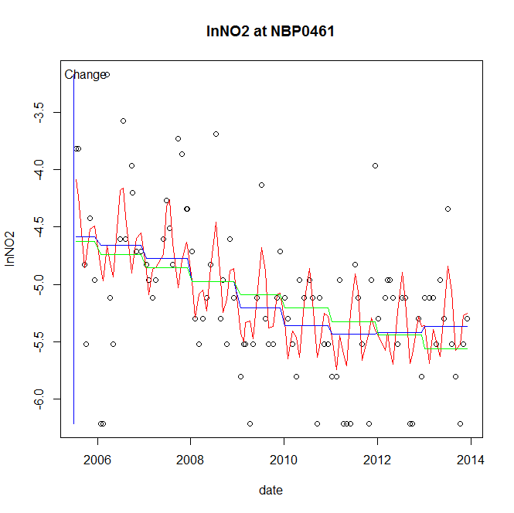

GAM analysis for station NBP0461 dependent variable lnNO2

|  |  |  |  |  |
| --- | --- | --- | --- | --- |
| **Type** | **Source** | **edf** | **F-stat** | **p-value** |
| parametric terms | step | 1 | 1e-04 | 0.9933 |
|  | year | 1 | 9662.7598 | <0.0001 |
| smoothed terms | s(year) | 2.93 | 9.296 | <0.0001 |
|  | s(doy) | 6.4 | 2.9735 | 0.0010 |

GAM analysis for station NBP0461 dependent variable lnNO2

|  |  |  |  |  |
| --- | --- | --- | --- | --- |
| **parameter** | **estimate** | **Std. Err.** | **t value** | **p-value** |
| (Intercept) | 2e-06 | 0.000293 | 0.0084 | 0.9933 |
| step | 2e-06 | 0.000293 | 0.0084 | 0.9933 |
| year | -0.002542 | 2.6e-05 | -98.2993 | <0.0001 |

root mean-square error = 0.5248

adjusted r-square = 0.3751

station = NBP0461 dependent = lnTP

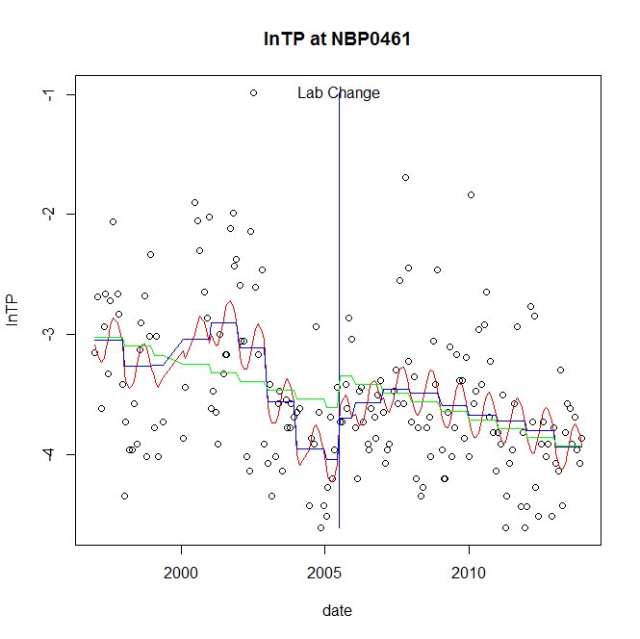

GAM analysis for station NBP0461 dependent variable lnTP

|  |  |  |  |  |
| --- | --- | --- | --- | --- |
| **Type** | **Source** | **edf** | **F-stat** | **p-value** |
| parametric terms | step | 1 | 1.4236 | 0.2344 |
|  | year | 1 | 514.9288 | <0.0001 |
| smoothed terms | s(year) | 6.56 | 6.8228 | <0.0001 |
|  | s(doy) | 2.06 | 1.6719 | 0.0004 |

GAM analysis for station NBP0461 dependent variable lnTP

|  |  |  |  |  |
| --- | --- | --- | --- | --- |
| **parameter** | **estimate** | **Std. Err.** | **t value** | **p-value** |
| (Intercept) | 0.002391 | 0.00139 | 1.7202 | 0.0871 |
| step | 0.344948 | 0.289105 | 1.1932 | 0.2344 |
| year | -0.00184 | 8.1e-05 | -22.692 | <0.0001 |

root mean-square error = 0.5524

adjusted r-square = 0.2872

station = NBP0461 dependent = lnPO4

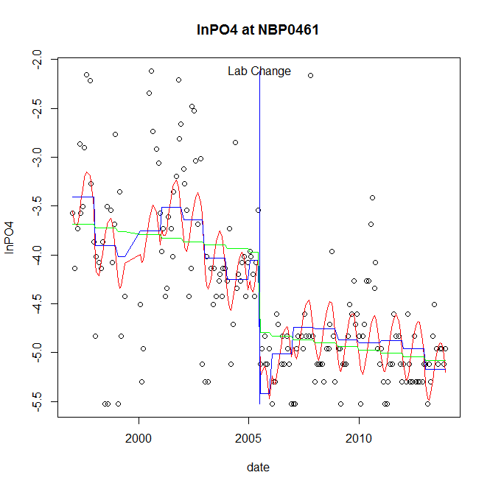

GAM analysis for station NBP0461 dependent variable lnPO4

|  |  |  |  |  |
| --- | --- | --- | --- | --- |
| **Type** | **Source** | **edf** | **F-stat** | **p-value** |
| parametric terms | step | 1 | 20.234 | <0.0001 |
|  | year | 1 | 490.8688 | <0.0001 |
| smoothed terms | s(year) | 6.77 | 4.6946 | <0.0001 |
|  | s(doy) | 2.72 | 3.5273 | <0.0001 |

GAM analysis for station NBP0461 dependent variable lnPO4

|  |  |  |  |  |
| --- | --- | --- | --- | --- |
| **parameter** | **estimate** | **Std. Err.** | **t value** | **p-value** |
| (Intercept) | 0.00468 | 0.001472 | 3.1796 | 0.0017 |
| step | -1.366597 | 0.303808 | -4.4982 | <0.0001 |
| year | -0.001848 | 8.3e-05 | -22.1556 | <0.0001 |

root mean-square error = 0.5727

adjusted r-square = 0.5444

step significant

No title given

|  |  |  |  |
| --- | --- | --- | --- |
| **station** | **dep** | **step.est** | **step.pv** |
| NBP0461 | lnTSS | 0.100546 | 0.6684 |
| NBP0461 | lnTN | 0.02543 | 0.7367 |
| NBP0461 | lnNH4 | -0.370608 | 0.2338 |
| NBP0461 | lnNO23 | 0.091607 | 0.3742 |
| NBP0461 | lnNO2 | 2e-06 | 0.9933 |
| NBP0461 | lnTP | 0.344948 | 0.2344 |
| NBP0461 | lnPO4 | -1.366597 | <0.0001 |

station = NBP0534 dependent = lnTSS

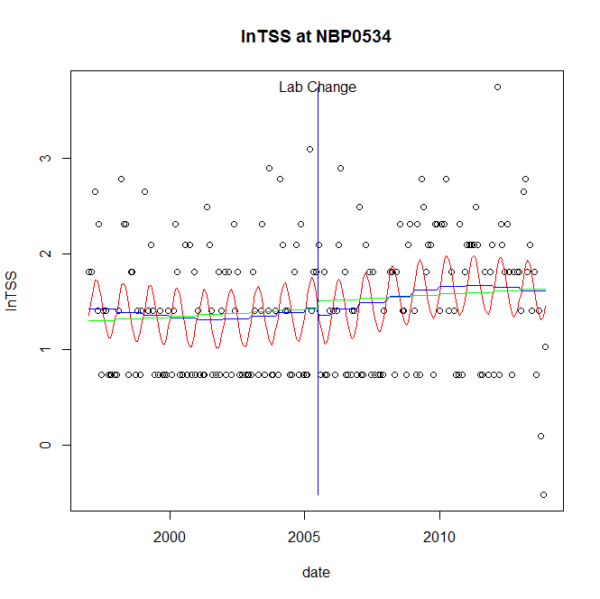

GAM analysis for station NBP0534 dependent variable lnTSS

|  |  |  |  |  |
| --- | --- | --- | --- | --- |
| **Type** | **Source** | **edf** | **F-stat** | **p-value** |
| parametric terms | step | 1 | 0.1043 | 0.7471 |
|  | year | 1 | 150.1845 | <0.0001 |
| smoothed terms | s(year) | 2.97 | 0.8141 | 0.5092 |
|  | s(doy) | 2.38 | 3.3785 | <0.0001 |

GAM analysis for station NBP0534 dependent variable lnTSS

|  |  |  |  |  |
| --- | --- | --- | --- | --- |
| **parameter** | **estimate** | **Std. Err.** | **t value** | **p-value** |
| (Intercept) | 0.000426 | 0.000602 | 0.7083 | 0.4796 |
| step | -0.073646 | 0.228072 | -0.3229 | 0.7471 |
| year | 0.000747 | 6.1e-05 | 12.255 | <0.0001 |

root mean-square error = 0.6434

adjusted r-square = 0.1572

station = NBP0534 dependent = lnTN

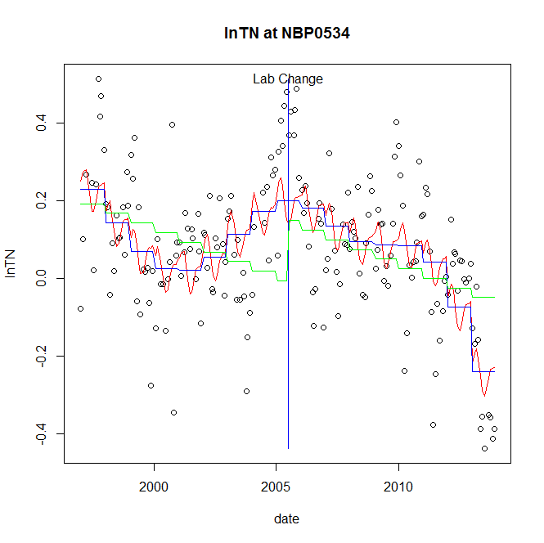

GAM analysis for station NBP0534 dependent variable lnTN

|  |  |  |  |  |
| --- | --- | --- | --- | --- |
| **Type** | **Source** | **edf** | **F-stat** | **p-value** |
| parametric terms | step | 1 | 0 | 0.9986 |
|  | year | 1 | 4.0661 | 0.0452 |
| smoothed terms | s(year) | 5.99 | 15.0621 | <0.0001 |
|  | s(doy) | 3.52 | 1.8662 | 0.0016 |

GAM analysis for station NBP0534 dependent variable lnTN

|  |  |  |  |  |
| --- | --- | --- | --- | --- |
| **parameter** | **estimate** | **Std. Err.** | **t value** | **p-value** |
| (Intercept) | 0.001579 | 0.000314 | 5.0325 | <0.0001 |
| step | -0.000123 | 0.072151 | -0.0017 | 0.9986 |
| year | 3.9e-05 | 1.9e-05 | 2.0165 | 0.0452 |

root mean-square error = 0.1443

adjusted r-square = 0.3784

station = NBP0534 dependent = lnNH4

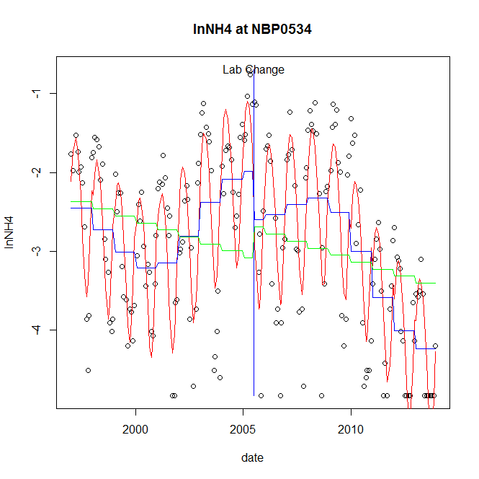

GAM analysis for station NBP0534 dependent variable lnNH4

|  |  |  |  |  |
| --- | --- | --- | --- | --- |
| **Type** | **Source** | **edf** | **F-stat** | **p-value** |
| parametric terms | step | 1 | 3.4449 | 0.0650 |
|  | year | 1 | 224.3472 | <0.0001 |
| smoothed terms | s(year) | 6.37 | 23.9339 | <0.0001 |
|  | s(doy) | 4.14 | 30.1305 | <0.0001 |

GAM analysis for station NBP0534 dependent variable lnNH4

|  |  |  |  |  |
| --- | --- | --- | --- | --- |
| **parameter** | **estimate** | **Std. Err.** | **t value** | **p-value** |
| (Intercept) | 0.002752 | 0.001465 | 1.8778 | 0.0619 |
| step | -0.61128 | 0.329345 | -1.856 | 0.0650 |
| year | -0.001274 | 8.5e-05 | -14.9782 | <0.0001 |

root mean-square error = 0.6434

adjusted r-square = 0.6821

station = NBP0534 dependent = lnNO23

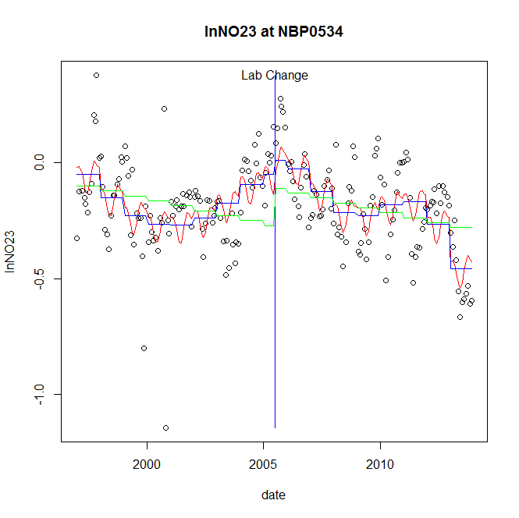

GAM analysis for station NBP0534 dependent variable lnNO23

|  |  |  |  |  |
| --- | --- | --- | --- | --- |
| **Type** | **Source** | **edf** | **F-stat** | **p-value** |
| parametric terms | step | 1 | 0.5526 | 0.4582 |
|  | year | 1 | 25.5638 | <0.0001 |
| smoothed terms | s(year) | 6.52 | 13.6686 | <0.0001 |
|  | s(doy) | 3.67 | 2.4381 | 0.0002 |

GAM analysis for station NBP0534 dependent variable lnNO23

|  |  |  |  |  |
| --- | --- | --- | --- | --- |
| **parameter** | **estimate** | **Std. Err.** | **t value** | **p-value** |
| (Intercept) | 0.001879 | 0.000371 | 5.0605 | <0.0001 |
| step | 0.061167 | 0.082285 | 0.7434 | 0.4582 |
| year | -0.000107 | 2.1e-05 | -5.0561 | <0.0001 |

root mean-square error = 0.1589

adjusted r-square = 0.3491

station = NBP0534 dependent = lnNO2

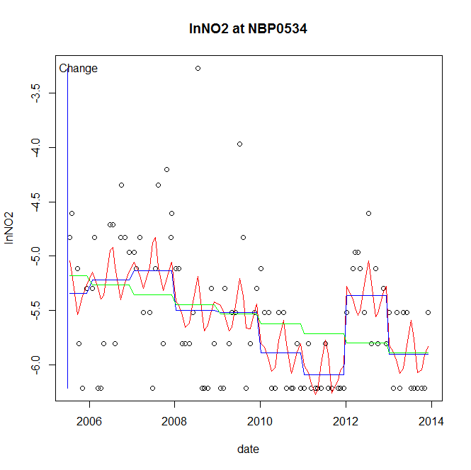

GAM analysis for station NBP0534 dependent variable lnNO2

|  |  |  |  |  |
| --- | --- | --- | --- | --- |
| **Type** | **Source** | **edf** | **F-stat** | **p-value** |
| parametric terms | step | 1 | 3.4372 | 0.0670 |
|  | year | 1 | 11952.9952 | <0.0001 |
| smoothed terms | s(year) | 6.61 | 5.5109 | <0.0001 |
|  | s(doy) | 4.78 | 1.31 | 0.0457 |

GAM analysis for station NBP0534 dependent variable lnNO2

|  |  |  |  |  |
| --- | --- | --- | --- | --- |
| **parameter** | **estimate** | **Std. Err.** | **t value** | **p-value** |
| (Intercept) | 0.001273 | 0.000687 | 1.854 | 0.0670 |
| step | 0.001273 | 0.000687 | 1.854 | 0.0670 |
| year | -0.002767 | 2.5e-05 | -109.3298 | <0.0001 |

root mean-square error = 0.5133

adjusted r-square = 0.323

station = NBP0534 dependent = lnTP

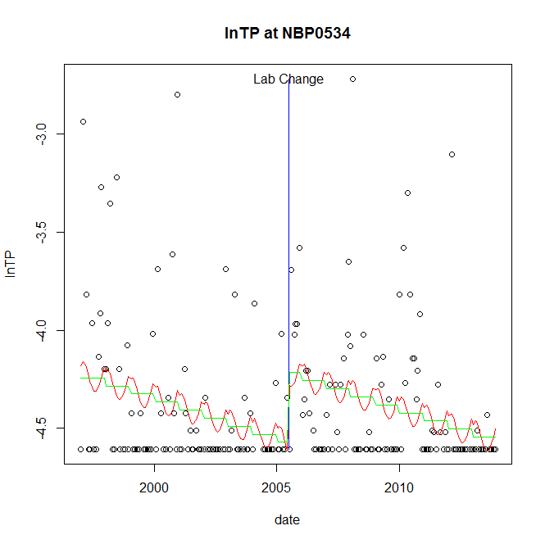

GAM analysis for station NBP0534 dependent variable lnTP

|  |  |  |  |  |
| --- | --- | --- | --- | --- |
| **Type** | **Source** | **edf** | **F-stat** | **p-value** |
| parametric terms | step | 1 | 12.1266 | 0.0006 |
|  | year | 1 | 6211.5551 | <0.0001 |
| smoothed terms | s(year) | 1 | 14.1461 | 0.0002 |
|  | s(doy) | 1.76 | 0.814 | 0.0146 |

GAM analysis for station NBP0534 dependent variable lnTP

|  |  |  |  |  |
| --- | --- | --- | --- | --- |
| **parameter** | **estimate** | **Std. Err.** | **t value** | **p-value** |
| (Intercept) | 0.00047 | 0.000125 | 3.7524 | 0.0002 |
| step | 0.35557 | 0.102107 | 3.4823 | 0.0006 |
| year | -0.00228 | 2.9e-05 | -78.8134 | <0.0001 |

root mean-square error = 0.3578

adjusted r-square = 0.0896

step significant

station = NBP0534 dependent = lnPO4

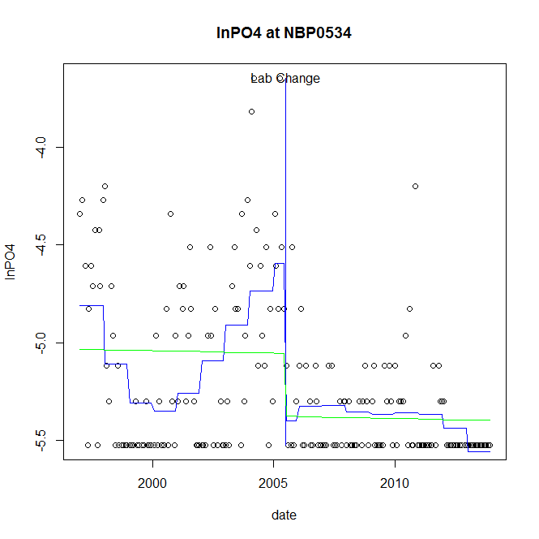

GAM analysis for station NBP0534 dependent variable lnPO4

|  |  |  |  |  |
| --- | --- | --- | --- | --- |
| **Type** | **Source** | **edf** | **F-stat** | **p-value** |
| parametric terms | step | 1 | 26.0383 | <0.0001 |
|  | year | 1 | 3414.9719 | <0.0001 |
| smoothed terms | s(year) | 5.68 | 9.5676 | <0.0001 |
|  | s(doy) | 0 | 0 | 0.7189 |

GAM analysis for station NBP0534 dependent variable lnPO4

|  |  |  |  |  |
| --- | --- | --- | --- | --- |
| **parameter** | **estimate** | **Std. Err.** | **t value** | **p-value** |
| (Intercept) | 0.002674 | 0.000666 | 4.0171 | <0.0001 |
| step | -0.806431 | 0.158038 | -5.1028 | <0.0001 |
| year | -0.002401 | 4.1e-05 | -58.4378 | <0.0001 |

root mean-square error = 0.3345

adjusted r-square = 0.3569

step significant

No title given

|  |  |  |  |
| --- | --- | --- | --- |
| **station** | **dep** | **step.est** | **step.pv** |
| NBP0534 | lnTSS | -0.073646 | 0.7471 |
| NBP0534 | lnTN | -0.000123 | 0.9986 |
| NBP0534 | lnNH4 | -0.61128 | 0.0650 |
| NBP0534 | lnNO23 | 0.061167 | 0.4582 |
| NBP0534 | lnNO2 | 0.001273 | 0.0670 |
| NBP0534 | lnTP | 0.35557 | 0.0006 |
| NBP0534 | lnPO4 | -0.806431 | <0.0001 |

station = NBP0689 dependent = lnTSS

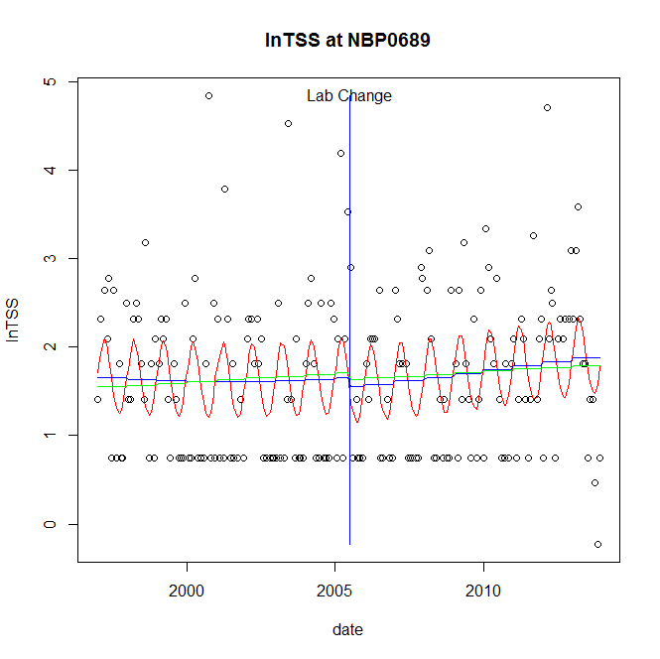

GAM analysis for station NBP0689 dependent variable lnTSS

|  |  |  |  |  |
| --- | --- | --- | --- | --- |
| **Type** | **Source** | **edf** | **F-stat** | **p-value** |
| parametric terms | step | 1 | 0.178 | 0.6735 |
|  | year | 1 | 154.0736 | <0.0001 |
| smoothed terms | s(year) | 1.72 | 1.0667 | 0.3458 |
|  | s(doy) | 2.56 | 3.548 | <0.0001 |

GAM analysis for station NBP0689 dependent variable lnTSS

|  |  |  |  |  |
| --- | --- | --- | --- | --- |
| **parameter** | **estimate** | **Std. Err.** | **t value** | **p-value** |
| (Intercept) | -0.00015 | 0.000402 | -0.3715 | 0.7107 |
| step | -0.106211 | 0.251719 | -0.4219 | 0.6735 |
| year | 0.000861 | 6.9e-05 | 12.4126 | <0.0001 |

root mean-square error = 0.8524

adjusted r-square = 0.137

station = NBP0689 dependent = lnTN

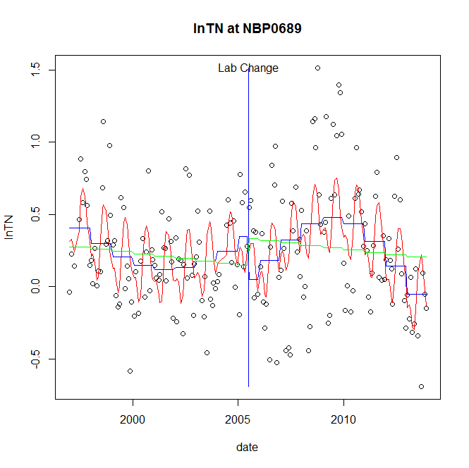

GAM analysis for station NBP0689 dependent variable lnTN

|  |  |  |  |  |
| --- | --- | --- | --- | --- |
| **Type** | **Source** | **edf** | **F-stat** | **p-value** |
| parametric terms | step | 1 | 4.0031 | 0.0469 |
|  | year | 1 | 24.8679 | <0.0001 |
| smoothed terms | s(year) | 4.57 | 6.8332 | <0.0001 |
|  | s(doy) | 4.66 | 6.3558 | <0.0001 |

GAM analysis for station NBP0689 dependent variable lnTN

|  |  |  |  |  |
| --- | --- | --- | --- | --- |
| **parameter** | **estimate** | **Std. Err.** | **t value** | **p-value** |
| (Intercept) | 0.001803 | 0.000538 | 3.3532 | 0.0010 |
| step | -0.298557 | 0.149222 | -2.0008 | 0.0469 |
| year | 0.000199 | 4e-05 | 4.9868 | <0.0001 |

root mean-square error = 0.3385

adjusted r-square = 0.3137

step significant

station = NBP0689 dependent = lnNH4

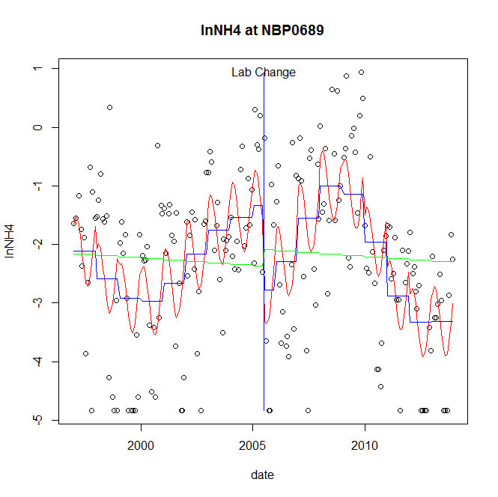

GAM analysis for station NBP0689 dependent variable lnNH4

|  |  |  |  |  |
| --- | --- | --- | --- | --- |
| **Type** | **Source** | **edf** | **F-stat** | **p-value** |
| parametric terms | step | 1 | 5.9499 | 0.0156 |
|  | year | 1 | 24.0114 | <0.0001 |
| smoothed terms | s(year) | 6.44 | 12.1472 | <0.0001 |
|  | s(doy) | 2.42 | 3.8833 | <0.0001 |

GAM analysis for station NBP0689 dependent variable lnNH4

|  |  |  |  |  |
| --- | --- | --- | --- | --- |
| **parameter** | **estimate** | **Std. Err.** | **t value** | **p-value** |
| (Intercept) | 0.002269 | 0.002667 | 0.8506 | 0.3960 |
| step | -1.448227 | 0.593719 | -2.4392 | 0.0156 |
| year | -0.000751 | 0.000153 | -4.9001 | <0.0001 |

root mean-square error = 1.1568

adjusted r-square = 0.3595

step significant

station = NBP0689 dependent = lnNO23

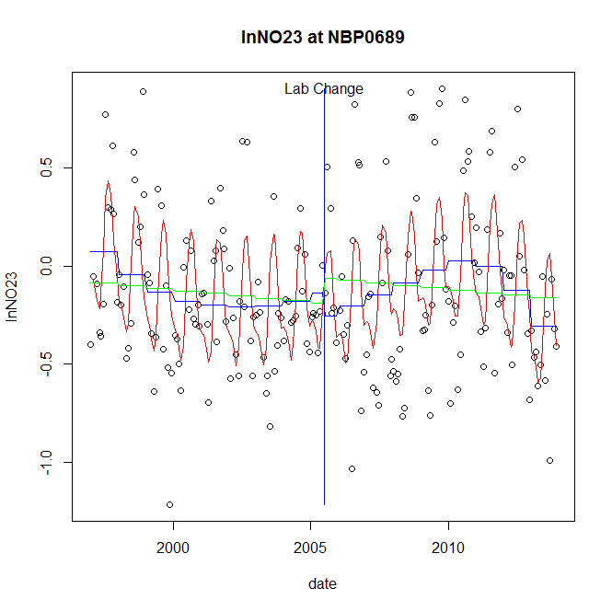

GAM analysis for station NBP0689 dependent variable lnNO23

|  |  |  |  |  |
| --- | --- | --- | --- | --- |
| **Type** | **Source** | **edf** | **F-stat** | **p-value** |
| parametric terms | step | 1 | 0.6069 | 0.4369 |
|  | year | 1 | 0.7753 | 0.3797 |
| smoothed terms | s(year) | 4.99 | 3.2462 | 0.0049 |
|  | s(doy) | 4.52 | 11.0079 | <0.0001 |

GAM analysis for station NBP0689 dependent variable lnNO23

|  |  |  |  |  |
| --- | --- | --- | --- | --- |
| **parameter** | **estimate** | **Std. Err.** | **t value** | **p-value** |
| (Intercept) | 0.001912 | 0.000585 | 3.2674 | 0.0013 |
| step | -0.119986 | 0.154015 | -0.7791 | 0.4369 |
| year | -3.5e-05 | 4e-05 | -0.8805 | 0.3797 |

root mean-square error = 0.3409

adjusted r-square = 0.3416

station = NBP0689 dependent = lnNO2

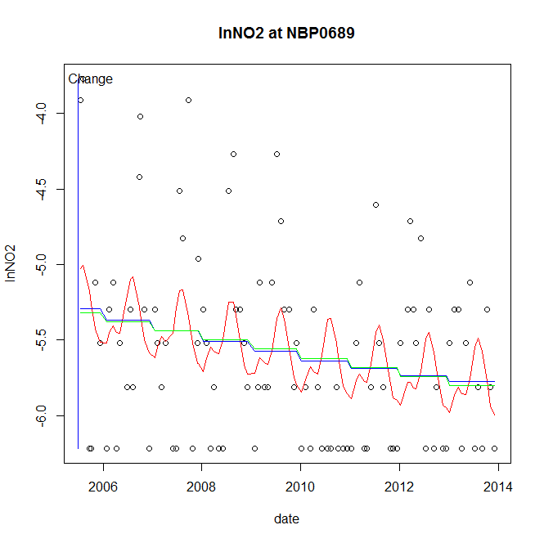

GAM analysis for station NBP0689 dependent variable lnNO2

|  |  |  |  |  |
| --- | --- | --- | --- | --- |
| **Type** | **Source** | **edf** | **F-stat** | **p-value** |
| parametric terms | step | 1 | 2.6305 | 0.1081 |
|  | year | 1 | 9395.3396 | <0.0001 |
| smoothed terms | s(year) | 1.27 | 4.6398 | 0.0212 |
|  | s(doy) | 3.42 | 1.2361 | 0.0194 |

GAM analysis for station NBP0689 dependent variable lnNO2

|  |  |  |  |  |
| --- | --- | --- | --- | --- |
| **parameter** | **estimate** | **Std. Err.** | **t value** | **p-value** |
| (Intercept) | 0.000163 | 1e-04 | 1.6219 | 0.1081 |
| step | 0.000163 | 1e-04 | 1.6219 | 0.1081 |
| year | -0.002777 | 2.9e-05 | -96.9296 | <0.0001 |

root mean-square error = 0.5813

adjusted r-square = 0.1361

station = NBP0689 dependent = lnTP

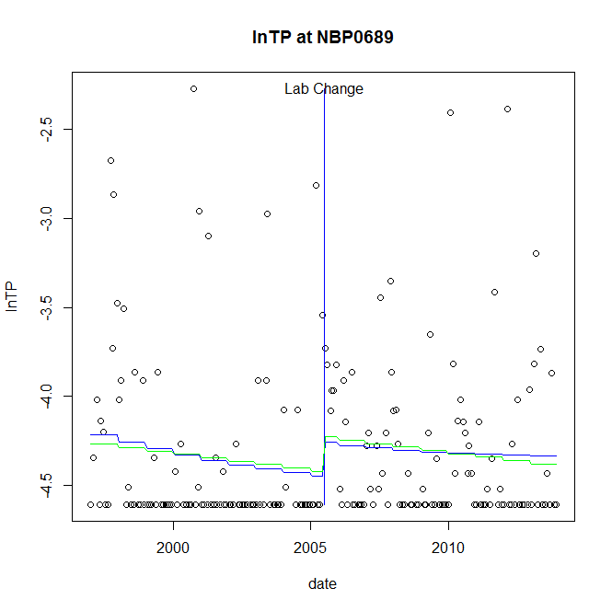

GAM analysis for station NBP0689 dependent variable lnTP

|  |  |  |  |  |
| --- | --- | --- | --- | --- |
| **Type** | **Source** | **edf** | **F-stat** | **p-value** |
| parametric terms | step | 1 | 1.7608 | 0.1861 |
|  | year | 1 | 3098.9937 | <0.0001 |
| smoothed terms | s(year) | 1.73 | 1.238 | 0.2906 |
|  | s(doy) | 0 | 0 | 0.3874 |

GAM analysis for station NBP0689 dependent variable lnTP

|  |  |  |  |  |
| --- | --- | --- | --- | --- |
| **parameter** | **estimate** | **Std. Err.** | **t value** | **p-value** |
| (Intercept) | 0.000238 | 0.000227 | 1.0485 | 0.2957 |
| step | 0.187589 | 0.141368 | 1.327 | 0.1861 |
| year | -0.002203 | 4e-05 | -55.6686 | <0.0001 |

root mean-square error = 0.475

adjusted r-square = 0.0067

station = NBP0689 dependent = lnPO4

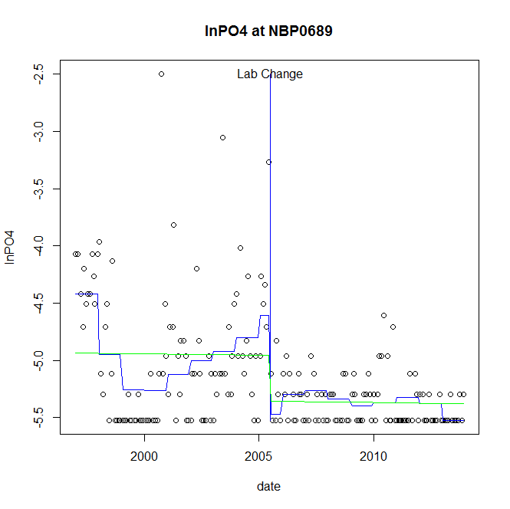

GAM analysis for station NBP0689 dependent variable lnPO4

|  |  |  |  |  |
| --- | --- | --- | --- | --- |
| **Type** | **Source** | **edf** | **F-stat** | **p-value** |
| parametric terms | step | 1 | 17.5644 | <0.0001 |
|  | year | 1 | 1950.0208 | <0.0001 |
| smoothed terms | s(year) | 6.5 | 7.0644 | <0.0001 |
|  | s(doy) | 0 | 0 | 0.5649 |

GAM analysis for station NBP0689 dependent variable lnPO4

|  |  |  |  |  |
| --- | --- | --- | --- | --- |
| **parameter** | **estimate** | **Std. Err.** | **t value** | **p-value** |
| (Intercept) | 0.00442 | 0.00095 | 4.6543 | <0.0001 |
| step | -0.865874 | 0.206604 | -4.191 | <0.0001 |
| year | -0.002358 | 5.3e-05 | -44.159 | <0.0001 |

root mean-square error = 0.4079

adjusted r-square = 0.3252

step significant

No title given

|  |  |  |  |
| --- | --- | --- | --- |
| **station** | **dep** | **step.est** | **step.pv** |
| NBP0689 | lnTSS | -0.106211 | 0.6735 |
| NBP0689 | lnTN | -0.298557 | 0.0469 |
| NBP0689 | lnNH4 | -1.448227 | 0.0156 |
| NBP0689 | lnNO23 | -0.119986 | 0.4369 |
| NBP0689 | lnNO2 | 0.000163 | 0.1081 |
| NBP0689 | lnTP | 0.187589 | 0.1861 |
| NBP0689 | lnPO4 | -0.865874 | <0.0001 |

station = NPA0165 dependent = lnTSS

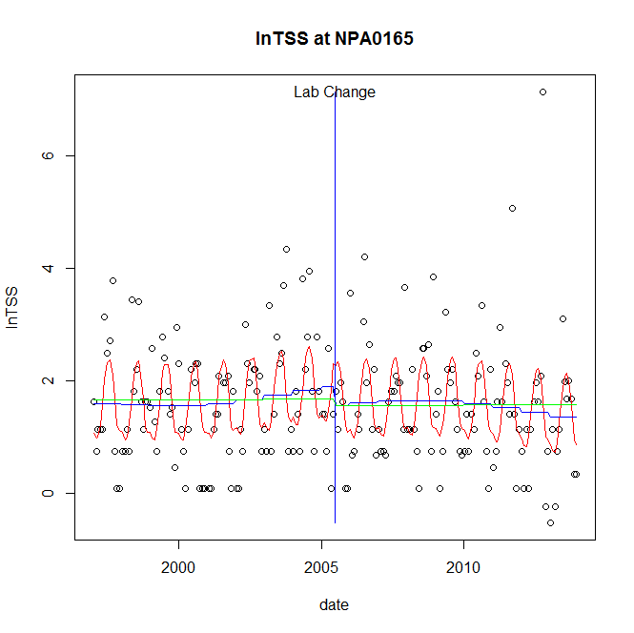

GAM analysis for station NPA0165 dependent variable lnTSS

|  |  |  |  |  |
| --- | --- | --- | --- | --- |
| **Type** | **Source** | **edf** | **F-stat** | **p-value** |
| parametric terms | step | 1 | 1.0796 | 0.3001 |
|  | year | 1 | 99.5429 | <0.0001 |
| smoothed terms | s(year) | 2.8 | 0.8895 | 0.4546 |
|  | s(doy) | 4.66 | 8.0392 | <0.0001 |

GAM analysis for station NPA0165 dependent variable lnTSS

|  |  |  |  |  |
| --- | --- | --- | --- | --- |
| **parameter** | **estimate** | **Std. Err.** | **t value** | **p-value** |
| (Intercept) | 0.000719 | 0.000816 | 0.8806 | 0.3796 |
| step | -0.338934 | 0.326194 | -1.0391 | 0.3001 |
| year | 0.000876 | 8.8e-05 | 9.9771 | <0.0001 |

root mean-square error = 0.9454

adjusted r-square = 0.2387

station = NPA0165 dependent = lnTN

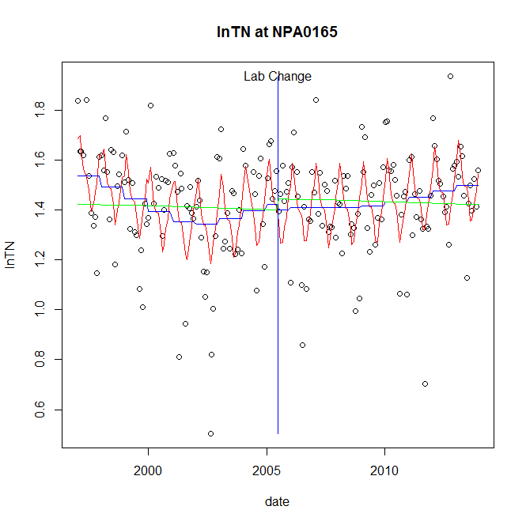

GAM analysis for station NPA0165 dependent variable lnTN

|  |  |  |  |  |
| --- | --- | --- | --- | --- |
| **Type** | **Source** | **edf** | **F-stat** | **p-value** |
| parametric terms | step | 1 | 0.0848 | 0.7713 |
|  | year | 1 | 1155.8837 | <0.0001 |
| smoothed terms | s(year) | 4.41 | 3.0246 | 0.0104 |
|  | s(doy) | 5.64 | 7.1097 | <0.0001 |

GAM analysis for station NPA0165 dependent variable lnTN

|  |  |  |  |  |
| --- | --- | --- | --- | --- |
| **parameter** | **estimate** | **Std. Err.** | **t value** | **p-value** |
| (Intercept) | 0.000109 | 0.000273 | 0.3974 | 0.6915 |
| step | -0.02281 | 0.078346 | -0.2911 | 0.7713 |
| year | 0.000718 | 2.1e-05 | 33.9983 | <0.0001 |

root mean-square error = 0.1811

adjusted r-square = 0.2681

station = NPA0165 dependent = lnNH4

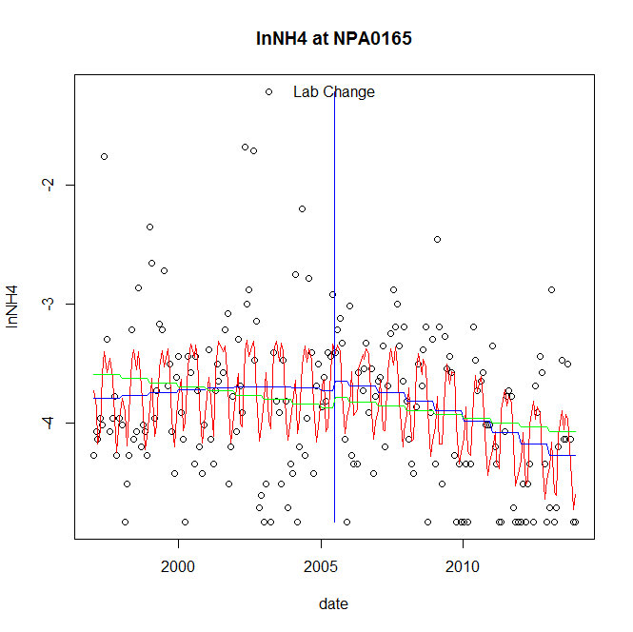

GAM analysis for station NPA0165 dependent variable lnNH4

|  |  |  |  |  |
| --- | --- | --- | --- | --- |
| **Type** | **Source** | **edf** | **F-stat** | **p-value** |
| parametric terms | step | 1 | 0.1955 | 0.6589 |
|  | year | 1 | 1586.4692 | <0.0001 |
| smoothed terms | s(year) | 2.2 | 4.6702 | 0.0054 |
|  | s(doy) | 6.75 | 6.8502 | <0.0001 |

GAM analysis for station NPA0165 dependent variable lnNH4

|  |  |  |  |  |
| --- | --- | --- | --- | --- |
| **parameter** | **estimate** | **Std. Err.** | **t value** | **p-value** |
| (Intercept) | 0.000372 | 0.000355 | 1.047 | 0.2964 |
| step | 0.078617 | 0.177802 | 0.4422 | 0.6589 |
| year | -0.001936 | 4.9e-05 | -39.8305 | <0.0001 |

root mean-square error = 0.5686

adjusted r-square = 0.2686

station = NPA0165 dependent = lnNO23

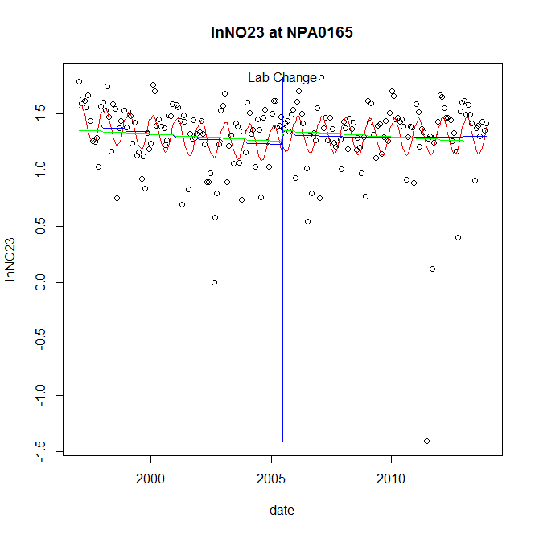

GAM analysis for station NPA0165 dependent variable lnNO23

|  |  |  |  |  |
| --- | --- | --- | --- | --- |
| **Type** | **Source** | **edf** | **F-stat** | **p-value** |
| parametric terms | step | 1 | 0.9223 | 0.3381 |
|  | year | 1 | 591.4883 | <0.0001 |
| smoothed terms | s(year) | 1.95 | 1.9099 | 0.1401 |
|  | s(doy) | 2.55 | 4.1719 | <0.0001 |

GAM analysis for station NPA0165 dependent variable lnNO23

|  |  |  |  |  |
| --- | --- | --- | --- | --- |
| **parameter** | **estimate** | **Std. Err.** | **t value** | **p-value** |
| (Intercept) | 0.000154 | 0.000165 | 0.9333 | 0.3518 |
| step | 0.089549 | 0.093246 | 0.9604 | 0.3381 |
| year | 0.000627 | 2.6e-05 | 24.3205 | <0.0001 |

root mean-square error = 0.3104

adjusted r-square = 0.1556

station = NPA0165 dependent = lnNO2

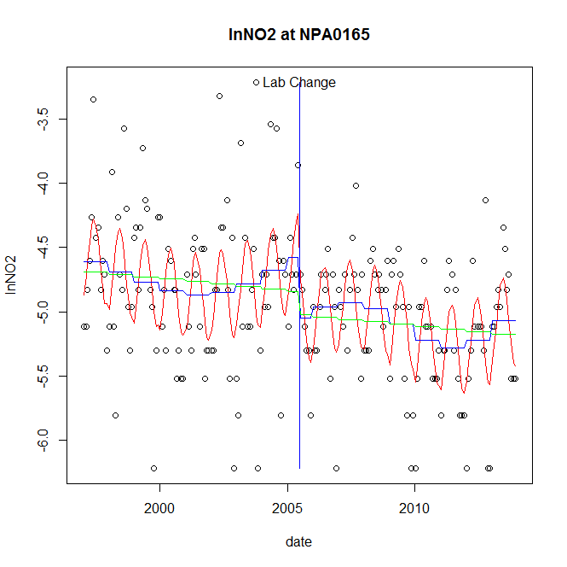

GAM analysis for station NPA0165 dependent variable lnNO2

|  |  |  |  |  |
| --- | --- | --- | --- | --- |
| **Type** | **Source** | **edf** | **F-stat** | **p-value** |
| parametric terms | step | 1 | 5.0105 | 0.0263 |
|  | year | 1 | 1800.5677 | <0.0001 |
| smoothed terms | s(year) | 5.17 | 2.1364 | 0.0503 |
|  | s(doy) | 2.8 | 7.666 | <0.0001 |

GAM analysis for station NPA0165 dependent variable lnNO2

|  |  |  |  |  |
| --- | --- | --- | --- | --- |
| **parameter** | **estimate** | **Std. Err.** | **t value** | **p-value** |
| (Intercept) | -0.000555 | 0.000827 | -0.671 | 0.5030 |
| step | -0.474461 | 0.211963 | -2.2384 | 0.0263 |
| year | -0.002345 | 5.5e-05 | -42.4331 | <0.0001 |

root mean-square error = 0.4628

adjusted r-square = 0.3427

step significant

station = NPA0165 dependent = lnTP

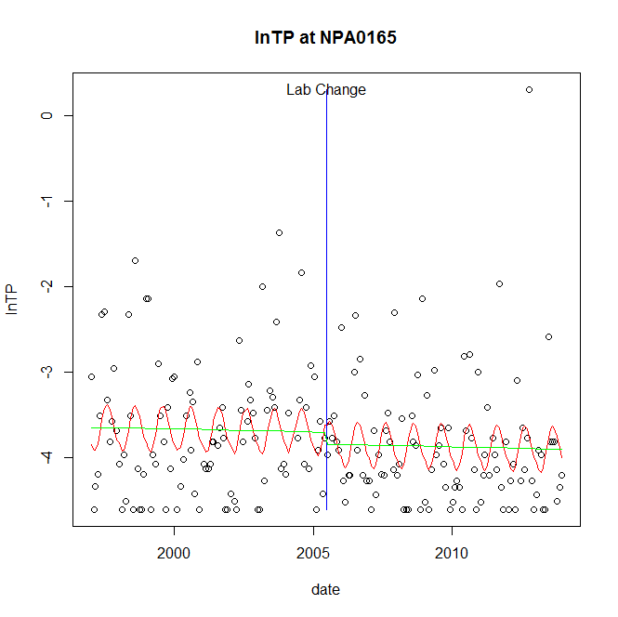

GAM analysis for station NPA0165 dependent variable lnTP

|  |  |  |  |  |
| --- | --- | --- | --- | --- |
| **Type** | **Source** | **edf** | **F-stat** | **p-value** |
| parametric terms | step | 1 | 0.4579 | 0.4994 |
|  | year | 1 | 994.0411 | <0.0001 |
| smoothed terms | s(year) | 1 | 0.0627 | 0.8026 |
|  | s(doy) | 2.3 | 2.0534 | 0.0001 |

GAM analysis for station NPA0165 dependent variable lnTP

|  |  |  |  |  |
| --- | --- | --- | --- | --- |
| **parameter** | **estimate** | **Std. Err.** | **t value** | **p-value** |
| (Intercept) | 6.2e-05 | 0.000253 | 0.2467 | 0.8054 |
| step | -0.139426 | 0.206035 | -0.6767 | 0.4994 |
| year | -0.001848 | 5.9e-05 | -31.5284 | <0.0001 |

root mean-square error = 0.721

adjusted r-square = 0.0877

station = NPA0165 dependent = lnPO4

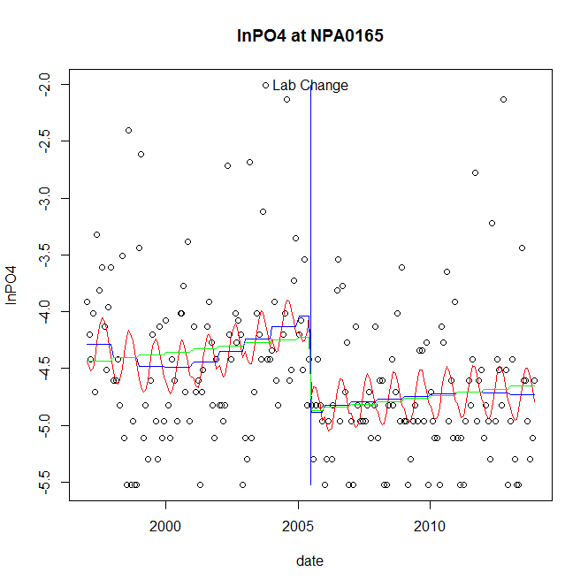

GAM analysis for station NPA0165 dependent variable lnPO4

|  |  |  |  |  |
| --- | --- | --- | --- | --- |
| **Type** | **Source** | **edf** | **F-stat** | **p-value** |
| parametric terms | step | 1 | 11.2096 | 0.0010 |
|  | year | 1 | 935.5757 | <0.0001 |
| smoothed terms | s(year) | 3.76 | 1.178 | 0.3188 |
|  | s(doy) | 2.31 | 2.024 | 0.0001 |

GAM analysis for station NPA0165 dependent variable lnPO4

|  |  |  |  |  |
| --- | --- | --- | --- | --- |
| **parameter** | **estimate** | **Std. Err.** | **t value** | **p-value** |
| (Intercept) | 0.000848 | 0.000793 | 1.069 | 0.2864 |
| step | -0.848251 | 0.253355 | -3.3481 | 0.0010 |
| year | -0.002059 | 6.7e-05 | -30.5872 | <0.0001 |

root mean-square error = 0.6403

adjusted r-square = 0.1654

step significant

No title given

|  |  |  |  |
| --- | --- | --- | --- |
| **station** | **dep** | **step.est** | **step.pv** |
| NPA0165 | lnTSS | -0.338934 | 0.3001 |
| NPA0165 | lnTN | -0.02281 | 0.7713 |
| NPA0165 | lnNH4 | 0.078617 | 0.6589 |
| NPA0165 | lnNO23 | 0.089549 | 0.3381 |
| NPA0165 | lnNO2 | -0.474461 | 0.0263 |
| NPA0165 | lnTP | -0.139426 | 0.4994 |
| NPA0165 | lnPO4 | -0.848251 | 0.0010 |

station = PAT0176 dependent = lnTSS

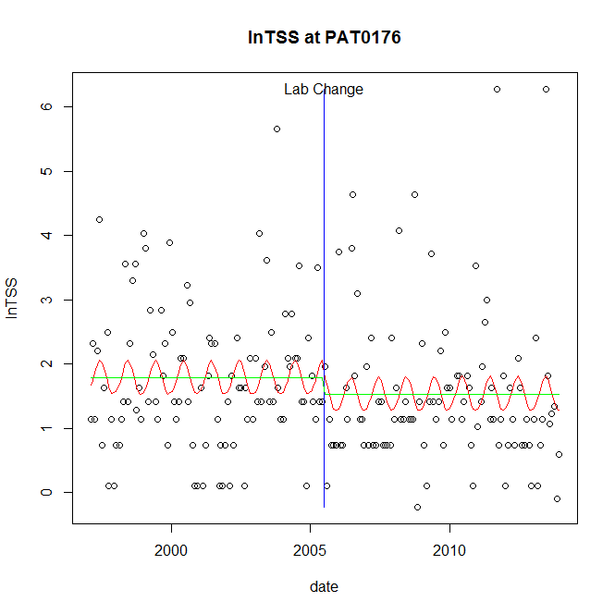

GAM analysis for station PAT0176 dependent variable lnTSS

|  |  |  |  |  |
| --- | --- | --- | --- | --- |
| **Type** | **Source** | **edf** | **F-stat** | **p-value** |
| parametric terms | step | 1 | 0.6783 | 0.4112 |
|  | year | 1 | 103.6036 | <0.0001 |
| smoothed terms | s(year) | 1 | 3e-04 | 0.9874 |
|  | s(doy) | 1.87 | 0.9663 | 0.0080 |

GAM analysis for station PAT0176 dependent variable lnTSS

|  |  |  |  |  |
| --- | --- | --- | --- | --- |
| **parameter** | **estimate** | **Std. Err.** | **t value** | **p-value** |
| (Intercept) | 6e-06 | 0.000378 | 0.017 | 0.9864 |
| step | -0.256545 | 0.311493 | -0.8236 | 0.4112 |
| year | 0.000886 | 8.7e-05 | 10.1786 | <0.0001 |

root mean-square error = 1.1108

adjusted r-square = 0.0419

station = PAT0176 dependent = lnTN

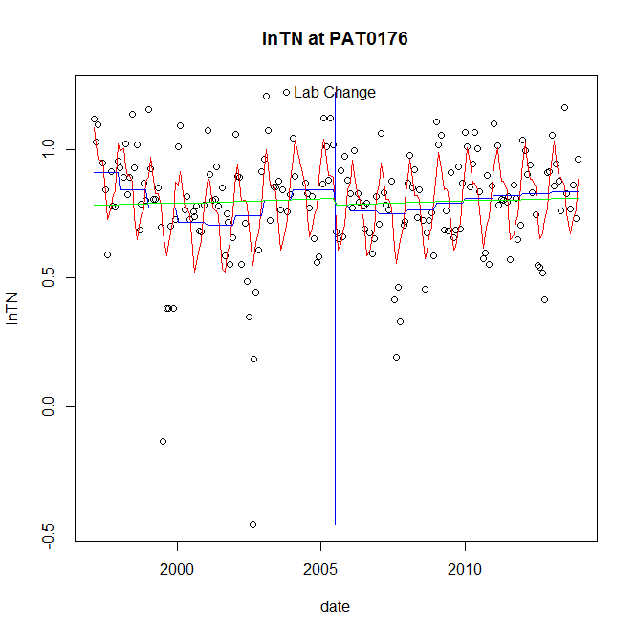

GAM analysis for station PAT0176 dependent variable lnTN

|  |  |  |  |  |
| --- | --- | --- | --- | --- |
| **Type** | **Source** | **edf** | **F-stat** | **p-value** |
| parametric terms | step | 1 | 0.5323 | 0.4666 |
|  | year | 1 | 338.1604 | <0.0001 |
| smoothed terms | s(year) | 5.44 | 2.7346 | 0.0131 |
|  | s(doy) | 5.96 | 10.7482 | <0.0001 |

GAM analysis for station PAT0176 dependent variable lnTN

|  |  |  |  |  |
| --- | --- | --- | --- | --- |
| **parameter** | **estimate** | **Std. Err.** | **t value** | **p-value** |
| (Intercept) | 0.000347 | 0.000342 | 1.0139 | 0.3119 |
| step | -0.061347 | 0.084083 | -0.7296 | 0.4666 |
| year | 0.000412 | 2.2e-05 | 18.3891 | <0.0001 |

root mean-square error = 0.1761

adjusted r-square = 0.3447

station = PAT0176 dependent = lnNH4

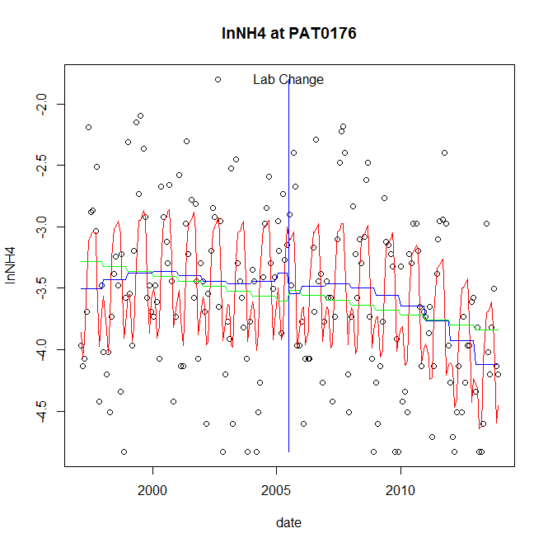

GAM analysis for station PAT0176 dependent variable lnNH4

|  |  |  |  |  |
| --- | --- | --- | --- | --- |
| **Type** | **Source** | **edf** | **F-stat** | **p-value** |
| parametric terms | step | 1 | 0.5361 | 0.4649 |
|  | year | 1 | 845.1147 | <0.0001 |
| smoothed terms | s(year) | 4.34 | 3.5885 | 0.0035 |
|  | s(doy) | 6.61 | 13.4011 | <0.0001 |

GAM analysis for station PAT0176 dependent variable lnNH4

|  |  |  |  |  |
| --- | --- | --- | --- | --- |
| **parameter** | **estimate** | **Std. Err.** | **t value** | **p-value** |
| (Intercept) | 0.000724 | 0.000782 | 0.926 | 0.3556 |
| step | -0.165619 | 0.226188 | -0.7322 | 0.4649 |
| year | -0.001735 | 6e-05 | -29.0709 | <0.0001 |

root mean-square error = 0.5344

adjusted r-square = 0.3969

station = PAT0176 dependent = lnNO23

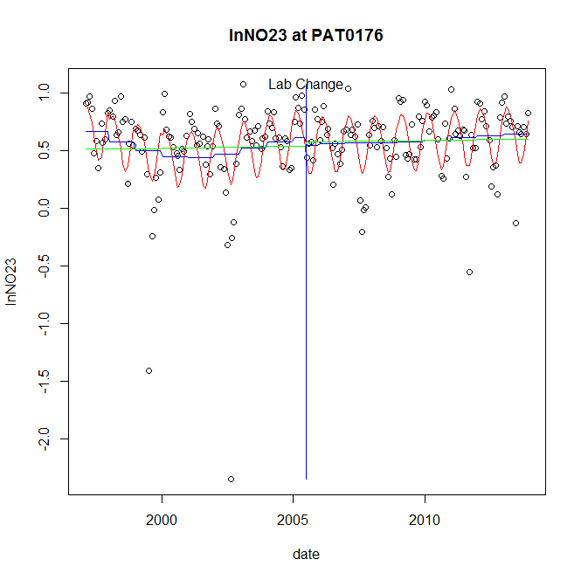

GAM analysis for station PAT0176 dependent variable lnNO23

|  |  |  |  |  |
| --- | --- | --- | --- | --- |
| **Type** | **Source** | **edf** | **F-stat** | **p-value** |
| parametric terms | step | 1 | 0.2821 | 0.5959 |
|  | year | 1 | 80.3863 | <0.0001 |
| smoothed terms | s(year) | 4.02 | 1.6441 | 0.1508 |
|  | s(doy) | 3.07 | 8.4957 | <0.0001 |

GAM analysis for station PAT0176 dependent variable lnNO23

|  |  |  |  |  |
| --- | --- | --- | --- | --- |
| **parameter** | **estimate** | **Std. Err.** | **t value** | **p-value** |
| (Intercept) | 0.000469 | 0.000411 | 1.1408 | 0.2553 |
| step | -0.066657 | 0.125495 | -0.5312 | 0.5959 |
| year | 0.000298 | 3.3e-05 | 8.9658 | <0.0001 |

root mean-square error = 0.3086

adjusted r-square = 0.2899

station = PAT0176 dependent = lnNO2

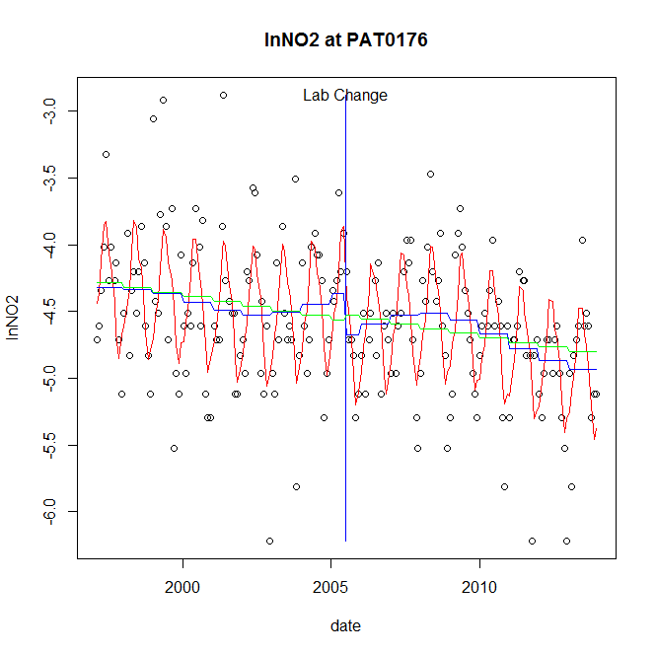

GAM analysis for station PAT0176 dependent variable lnNO2

|  |  |  |  |  |
| --- | --- | --- | --- | --- |
| **Type** | **Source** | **edf** | **F-stat** | **p-value** |
| parametric terms | step | 1 | 3.0832 | 0.0807 |
|  | year | 1 | 2224.9677 | <0.0001 |
| smoothed terms | s(year) | 4.69 | 3.0718 | 0.0084 |
|  | s(doy) | 5.75 | 16.8096 | <0.0001 |

GAM analysis for station PAT0176 dependent variable lnNO2

|  |  |  |  |  |
| --- | --- | --- | --- | --- |
| **parameter** | **estimate** | **Std. Err.** | **t value** | **p-value** |
| (Intercept) | 0.00032 | 0.000648 | 0.4928 | 0.6227 |
| step | -0.31211 | 0.17775 | -1.7559 | 0.0807 |
| year | -0.002205 | 4.7e-05 | -47.1696 | <0.0001 |

root mean-square error = 0.4053

adjusted r-square = 0.4615

station = PAT0176 dependent = lnTP

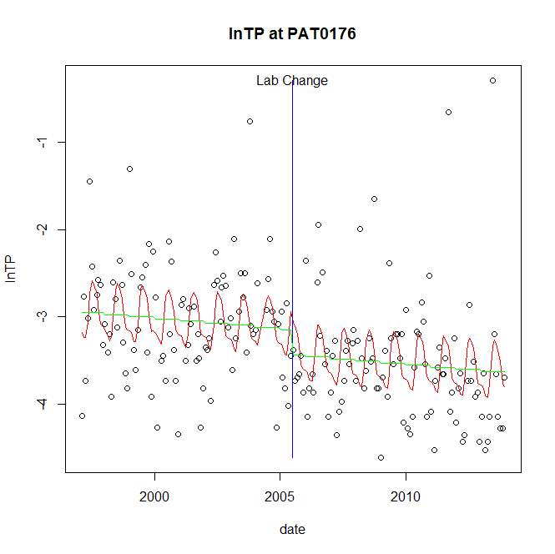

GAM analysis for station PAT0176 dependent variable lnTP

|  |  |  |  |  |
| --- | --- | --- | --- | --- |
| **Type** | **Source** | **edf** | **F-stat** | **p-value** |
| parametric terms | step | 1 | 2.5106 | 0.1147 |
|  | year | 1 | 929.2343 | <0.0001 |
| smoothed terms | s(year) | 1 | 1.5357 | 0.2168 |
|  | s(doy) | 4.56 | 3.6059 | <0.0001 |

GAM analysis for station PAT0176 dependent variable lnTP

|  |  |  |  |  |
| --- | --- | --- | --- | --- |
| **parameter** | **estimate** | **Std. Err.** | **t value** | **p-value** |
| (Intercept) | 0.000273 | 0.000221 | 1.2358 | 0.2180 |
| step | -0.286994 | 0.181128 | -1.5845 | 0.1147 |
| year | -0.00157 | 5.2e-05 | -30.4833 | <0.0001 |

root mean-square error = 0.6329

adjusted r-square = 0.2226

station = PAT0176 dependent = lnPO4

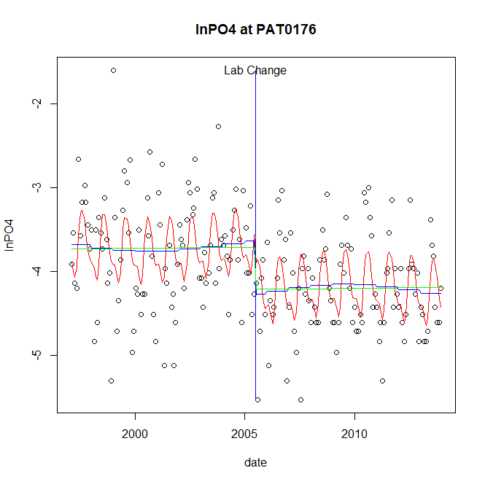

GAM analysis for station PAT0176 dependent variable lnPO4

|  |  |  |  |  |
| --- | --- | --- | --- | --- |
| **Type** | **Source** | **edf** | **F-stat** | **p-value** |
| parametric terms | step | 1 | 10.9055 | 0.0011 |
|  | year | 1 | 1230.5828 | <0.0001 |
| smoothed terms | s(year) | 2.88 | 0.472 | 0.7359 |
|  | s(doy) | 4.79 | 6.4664 | <0.0001 |

GAM analysis for station PAT0176 dependent variable lnPO4

|  |  |  |  |  |
| --- | --- | --- | --- | --- |
| **parameter** | **estimate** | **Std. Err.** | **t value** | **p-value** |
| (Intercept) | 0.000479 | 0.000492 | 0.9732 | 0.3317 |
| step | -0.634307 | 0.192078 | -3.3023 | 0.0011 |
| year | -0.001818 | 5.2e-05 | -35.0797 | <0.0001 |

root mean-square error = 0.5488

adjusted r-square = 0.2941

step significant

No title given

|  |  |  |  |
| --- | --- | --- | --- |
| **station** | **dep** | **step.est** | **step.pv** |
| PAT0176 | lnTSS | -0.256545 | 0.4112 |
| PAT0176 | lnTN | -0.061347 | 0.4666 |
| PAT0176 | lnNH4 | -0.165619 | 0.4649 |
| PAT0176 | lnNO23 | -0.066657 | 0.5959 |
| PAT0176 | lnNO2 | -0.31211 | 0.0807 |
| PAT0176 | lnTP | -0.286994 | 0.1147 |
| PAT0176 | lnPO4 | -0.634307 | 0.0011 |

station = PAT0285 dependent = lnTSS

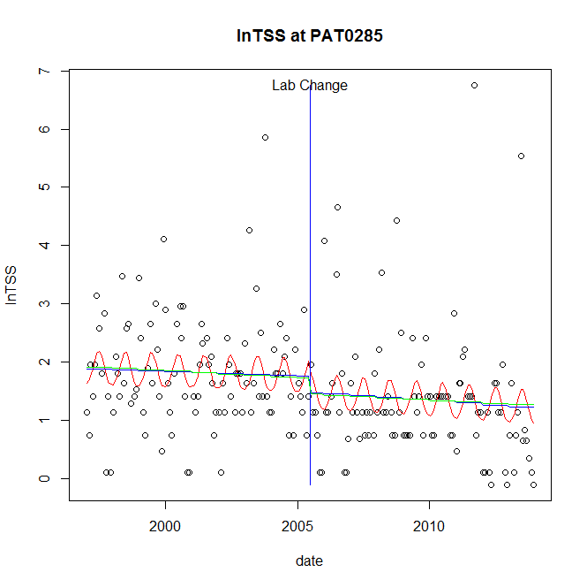

GAM analysis for station PAT0285 dependent variable lnTSS

|  |  |  |  |  |
| --- | --- | --- | --- | --- |
| **Type** | **Source** | **edf** | **F-stat** | **p-value** |
| parametric terms | step | 1 | 0.9357 | 0.3346 |
|  | year | 1 | 114.2955 | <0.0001 |
| smoothed terms | s(year) | 1.28 | 0.3468 | 0.6451 |
|  | s(doy) | 2.22 | 1.35 | 0.0024 |

GAM analysis for station PAT0285 dependent variable lnTSS

|  |  |  |  |  |
| --- | --- | --- | --- | --- |
| **parameter** | **estimate** | **Std. Err.** | **t value** | **p-value** |
| (Intercept) | 0.000307 | 0.000377 | 0.8155 | 0.4158 |
| step | -0.275579 | 0.284895 | -0.9673 | 0.3346 |
| year | 0.000852 | 8e-05 | 10.6909 | <0.0001 |

root mean-square error = 1.006

adjusted r-square = 0.0944

station = PAT0285 dependent = lnTN

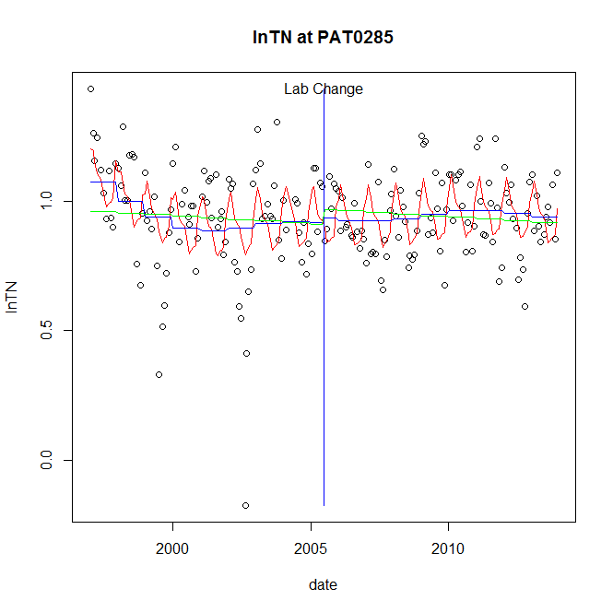

GAM analysis for station PAT0285 dependent variable lnTN

|  |  |  |  |  |
| --- | --- | --- | --- | --- |
| **Type** | **Source** | **edf** | **F-stat** | **p-value** |
| parametric terms | step | 1 | 0.0648 | 0.7994 |
|  | year | 1 | 570.0592 | <0.0001 |
| smoothed terms | s(year) | 4.54 | 2.8499 | 0.0140 |
|  | s(doy) | 5.33 | 5.5544 | <0.0001 |

GAM analysis for station PAT0285 dependent variable lnTN

|  |  |  |  |  |
| --- | --- | --- | --- | --- |
| **parameter** | **estimate** | **Std. Err.** | **t value** | **p-value** |
| (Intercept) | 0.000563 | 0.000258 | 2.1832 | 0.0303 |
| step | 0.018424 | 0.072394 | 0.2545 | 0.7994 |
| year | 0.000465 | 1.9e-05 | 23.8759 | <0.0001 |

root mean-square error = 0.1651

adjusted r-square = 0.2219

station = PAT0285 dependent = lnNH4

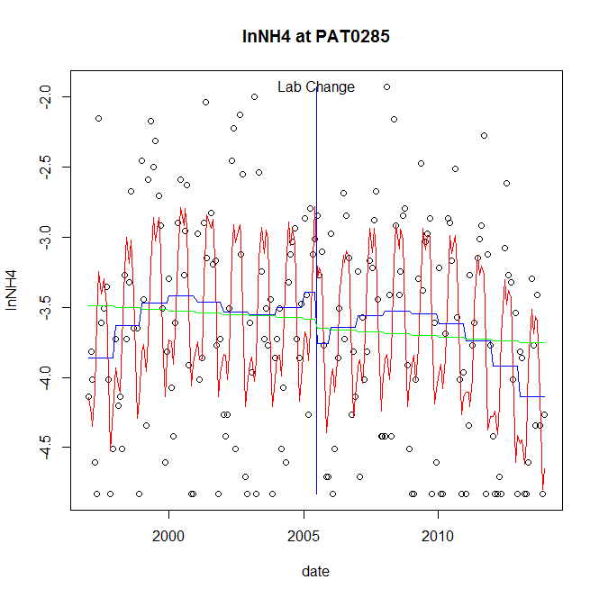

GAM analysis for station PAT0285 dependent variable lnNH4

|  |  |  |  |  |
| --- | --- | --- | --- | --- |
| **Type** | **Source** | **edf** | **F-stat** | **p-value** |
| parametric terms | step | 1 | 1.9123 | 0.1683 |
|  | year | 1 | 619.2225 | <0.0001 |
| smoothed terms | s(year) | 4.83 | 3.0932 | 0.0075 |
|  | s(doy) | 6.5 | 15.2619 | <0.0001 |

GAM analysis for station PAT0285 dependent variable lnNH4

|  |  |  |  |  |
| --- | --- | --- | --- | --- |
| **parameter** | **estimate** | **Std. Err.** | **t value** | **p-value** |
| (Intercept) | -0.000164 | 0.000978 | -0.1679 | 0.8669 |
| step | -0.365767 | 0.264503 | -1.3828 | 0.1683 |
| year | -0.001728 | 6.9e-05 | -24.8842 | <0.0001 |

root mean-square error = 0.5946

adjusted r-square = 0.4091

station = PAT0285 dependent = lnNO23

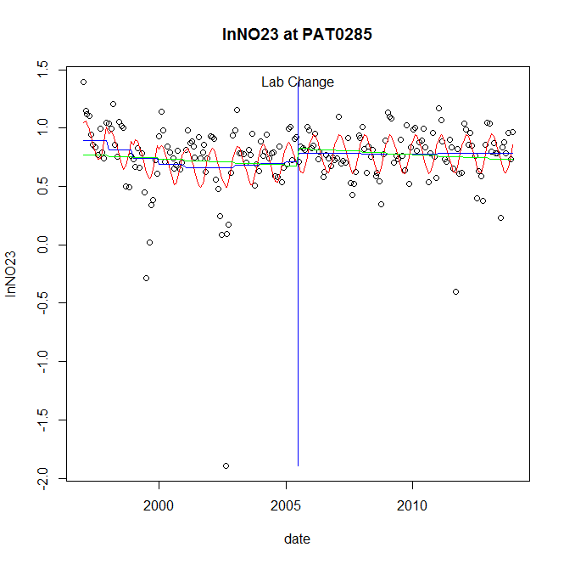

GAM analysis for station PAT0285 dependent variable lnNO23

|  |  |  |  |  |
| --- | --- | --- | --- | --- |
| **Type** | **Source** | **edf** | **F-stat** | **p-value** |
| parametric terms | step | 1 | 0.4404 | 0.5077 |
|  | year | 1 | 170.6467 | <0.0001 |
| smoothed terms | s(year) | 3.62 | 2.1284 | 0.0712 |
|  | s(doy) | 2.84 | 5.2659 | <0.0001 |

GAM analysis for station PAT0285 dependent variable lnNO23

|  |  |  |  |  |
| --- | --- | --- | --- | --- |
| **parameter** | **estimate** | **Std. Err.** | **t value** | **p-value** |
| (Intercept) | 0.00051 | 0.000314 | 1.6252 | 0.1057 |
| step | 0.068841 | 0.103733 | 0.6636 | 0.5077 |
| year | 0.000361 | 2.8e-05 | 13.0632 | <0.0001 |

root mean-square error = 0.2679

adjusted r-square = 0.2112

station = PAT0285 dependent = lnNO2

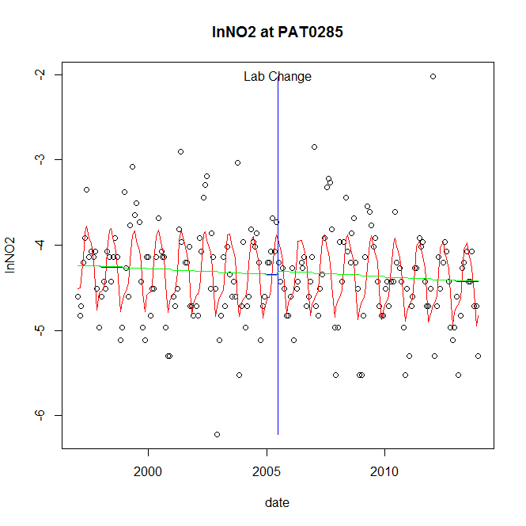

GAM analysis for station PAT0285 dependent variable lnNO2

|  |  |  |  |  |
| --- | --- | --- | --- | --- |
| **Type** | **Source** | **edf** | **F-stat** | **p-value** |
| parametric terms | step | 1 | 0.1185 | 0.7311 |
|  | year | 1 | 3514.2803 | <0.0001 |
| smoothed terms | s(year) | 1.12 | 0.5058 | 0.5158 |
|  | s(doy) | 5.87 | 12.1591 | <0.0001 |

GAM analysis for station PAT0285 dependent variable lnNO2

|  |  |  |  |  |
| --- | --- | --- | --- | --- |
| **parameter** | **estimate** | **Std. Err.** | **t value** | **p-value** |
| (Intercept) | 0.000144 | 0.000165 | 0.8747 | 0.3828 |
| step | 0.045166 | 0.13122 | 0.3442 | 0.7311 |
| year | -0.002179 | 3.7e-05 | -59.2814 | <0.0001 |

root mean-square error = 0.4653

adjusted r-square = 0.322

station = PAT0285 dependent = lnTP

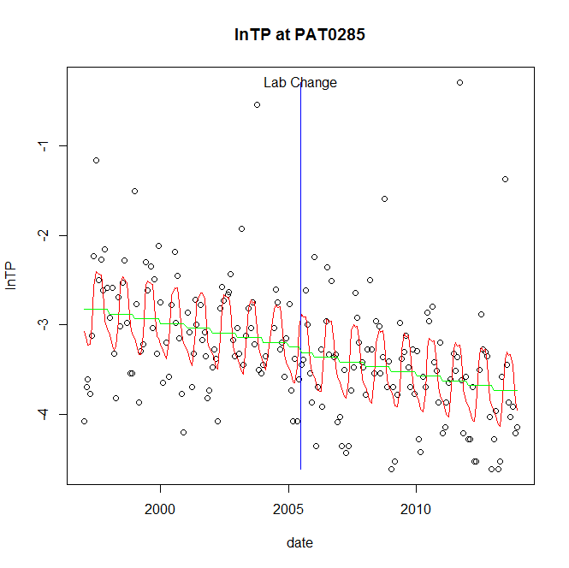

GAM analysis for station PAT0285 dependent variable lnTP

|  |  |  |  |  |
| --- | --- | --- | --- | --- |
| **Type** | **Source** | **edf** | **F-stat** | **p-value** |
| parametric terms | step | 1 | 0.1406 | 0.7081 |
|  | year | 1 | 1259.7404 | <0.0001 |
| smoothed terms | s(year) | 1 | 9.8658 | 0.0019 |
|  | s(doy) | 5.55 | 8.0055 | <0.0001 |

GAM analysis for station PAT0285 dependent variable lnTP

|  |  |  |  |  |
| --- | --- | --- | --- | --- |
| **parameter** | **estimate** | **Std. Err.** | **t value** | **p-value** |
| (Intercept) | 0.000616 | 0.000196 | 3.1371 | 0.0020 |
| step | -0.060287 | 0.160781 | -0.375 | 0.7081 |
| year | -0.001623 | 4.6e-05 | -35.4928 | <0.0001 |

root mean-square error = 0.5622

adjusted r-square = 0.3586

station = PAT0285 dependent = lnPO4

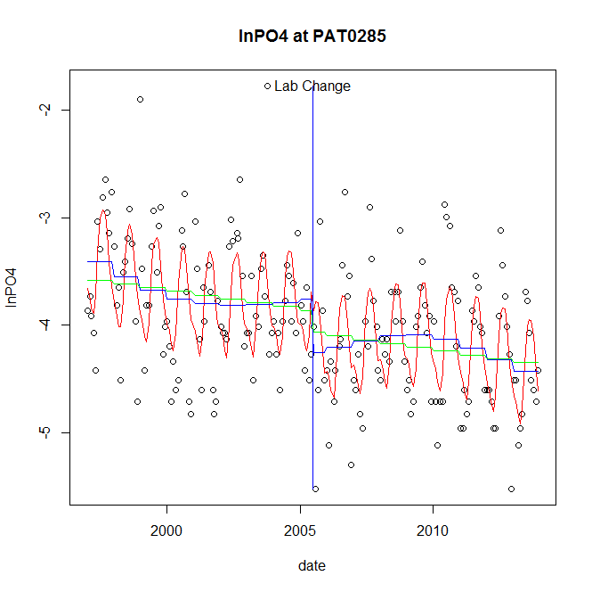

GAM analysis for station PAT0285 dependent variable lnPO4

|  |  |  |  |  |
| --- | --- | --- | --- | --- |
| **Type** | **Source** | **edf** | **F-stat** | **p-value** |
| parametric terms | step | 1 | 6.8573 | 0.0095 |
|  | year | 1 | 1322.5074 | <0.0001 |
| smoothed terms | s(year) | 3.8 | 3.102 | 0.0123 |
|  | s(doy) | 4.92 | 12.9945 | <0.0001 |

GAM analysis for station PAT0285 dependent variable lnPO4

|  |  |  |  |  |
| --- | --- | --- | --- | --- |
| **parameter** | **estimate** | **Std. Err.** | **t value** | **p-value** |
| (Intercept) | 0.001492 | 0.000601 | 2.4827 | 0.0139 |
| step | -0.502696 | 0.191968 | -2.6186 | 0.0095 |
| year | -0.001854 | 5.1e-05 | -36.3663 | <0.0001 |

root mean-square error = 0.4839

adjusted r-square = 0.4468

step significant

No title given

|  |  |  |  |
| --- | --- | --- | --- |
| **station** | **dep** | **step.est** | **step.pv** |
| PAT0285 | lnTSS | -0.275579 | 0.3346 |
| PAT0285 | lnTN | 0.018424 | 0.7994 |
| PAT0285 | lnNH4 | -0.365767 | 0.1683 |
| PAT0285 | lnNO23 | 0.068841 | 0.5077 |
| PAT0285 | lnNO2 | 0.045166 | 0.7311 |
| PAT0285 | lnTP | -0.060287 | 0.7081 |
| PAT0285 | lnPO4 | -0.502696 | 0.0095 |

station = POT1184 dependent = lnTSS

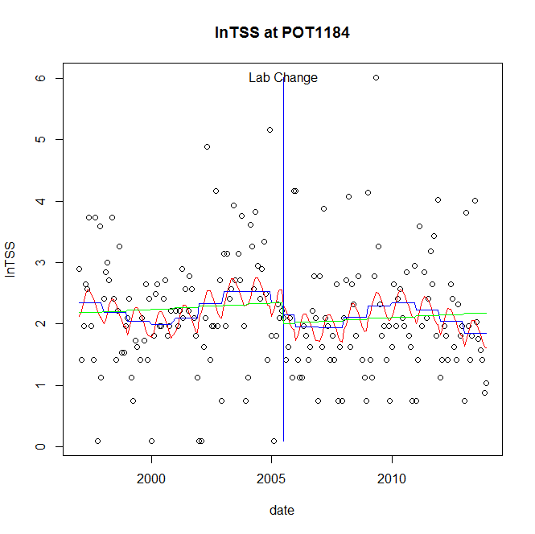

GAM analysis for station POT1184 dependent variable lnTSS

|  |  |  |  |  |
| --- | --- | --- | --- | --- |
| **Type** | **Source** | **edf** | **F-stat** | **p-value** |
| parametric terms | step | 1 | 0.1966 | 0.6580 |
|  | year | 1 | 96.0841 | <0.0001 |
| smoothed terms | s(year) | 5.67 | 1.3541 | 0.2302 |
|  | s(doy) | 2 | 1.0473 | 0.0069 |

GAM analysis for station POT1184 dependent variable lnTSS

|  |  |  |  |  |
| --- | --- | --- | --- | --- |
| **parameter** | **estimate** | **Std. Err.** | **t value** | **p-value** |
| (Intercept) | 0.00207 | 0.001849 | 1.1195 | 0.2643 |
| step | -0.196218 | 0.442534 | -0.4434 | 0.6580 |
| year | 0.001127 | 0.000115 | 9.8022 | <0.0001 |

root mean-square error = 0.9248

adjusted r-square = 0.0693

station = POT1184 dependent = lnTN

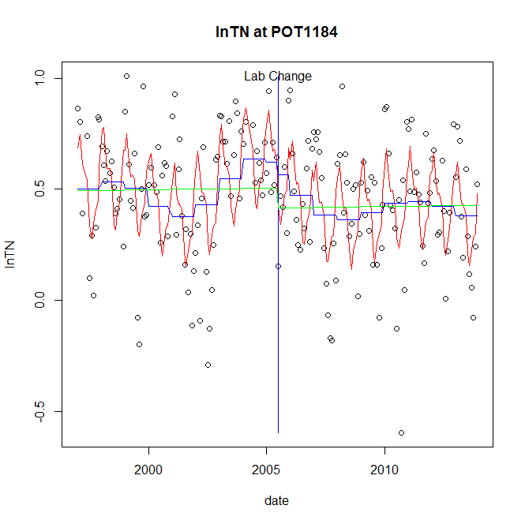

GAM analysis for station POT1184 dependent variable lnTN

|  |  |  |  |  |
| --- | --- | --- | --- | --- |
| **Type** | **Source** | **edf** | **F-stat** | **p-value** |
| parametric terms | step | 1 | 0.2051 | 0.6512 |
|  | year | 1 | 58.7014 | <0.0001 |
| smoothed terms | s(year) | 6.3 | 2.8797 | 0.0077 |
|  | s(doy) | 6.15 | 9.2686 | <0.0001 |

GAM analysis for station POT1184 dependent variable lnTN

|  |  |  |  |  |
| --- | --- | --- | --- | --- |
| **parameter** | **estimate** | **Std. Err.** | **t value** | **p-value** |
| (Intercept) | 1e-05 | 0.000532 | 0.0179 | 0.9858 |
| step | -0.054176 | 0.119619 | -0.4529 | 0.6512 |
| year | 0.000245 | 3.2e-05 | 7.6617 | <0.0001 |

root mean-square error = 0.2335

adjusted r-square = 0.3243

station = POT1184 dependent = lnNH4

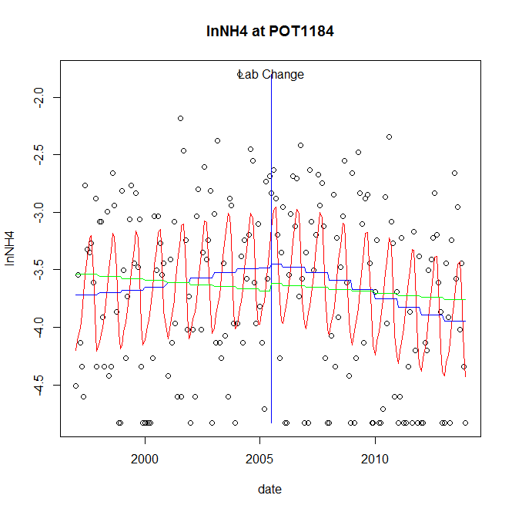

GAM analysis for station POT1184 dependent variable lnNH4

|  |  |  |  |  |
| --- | --- | --- | --- | --- |
| **Type** | **Source** | **edf** | **F-stat** | **p-value** |
| parametric terms | step | 1 | 0.0223 | 0.8815 |
|  | year | 1 | 897.7947 | <0.0001 |
| smoothed terms | s(year) | 2.74 | 2.6738 | 0.0422 |
|  | s(doy) | 4.58 | 7.3537 | <0.0001 |

GAM analysis for station POT1184 dependent variable lnNH4

|  |  |  |  |  |
| --- | --- | --- | --- | --- |
| **parameter** | **estimate** | **Std. Err.** | **t value** | **p-value** |
| (Intercept) | 0.00015 | 0.000559 | 0.2689 | 0.7883 |
| step | 0.033941 | 0.227428 | 0.1492 | 0.8815 |
| year | -0.001845 | 6.2e-05 | -29.9632 | <0.0001 |

root mean-square error = 0.6665

adjusted r-square = 0.2471

station = POT1184 dependent = lnNO23

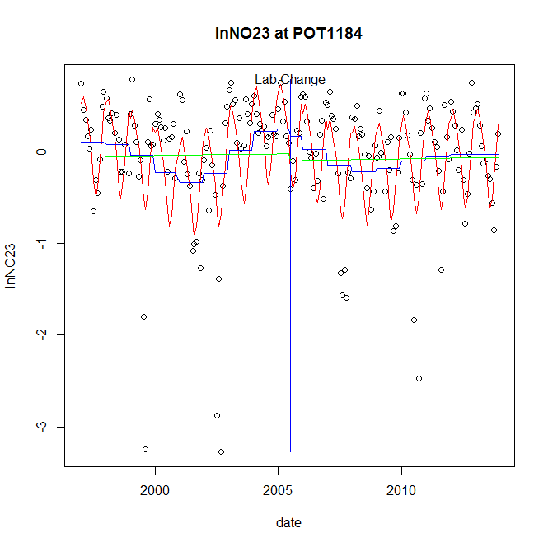

GAM analysis for station POT1184 dependent variable lnNO23

|  |  |  |  |  |
| --- | --- | --- | --- | --- |
| **Type** | **Source** | **edf** | **F-stat** | **p-value** |
| parametric terms | step | 1 | 0.0861 | 0.7696 |
|  | year | 1 | 0.0115 | 0.9149 |
| smoothed terms | s(year) | 6.07 | 2.5879 | 0.0158 |
|  | s(doy) | 4.35 | 12.3057 | <0.0001 |

GAM analysis for station POT1184 dependent variable lnNO23

|  |  |  |  |  |
| --- | --- | --- | --- | --- |
| **parameter** | **estimate** | **Std. Err.** | **t value** | **p-value** |
| (Intercept) | 5.4e-05 | 0.001118 | 0.0483 | 0.9615 |
| step | -0.076046 | 0.259215 | -0.2934 | 0.7696 |
| year | 7e-06 | 6.8e-05 | 0.107 | 0.9149 |

root mean-square error = 0.5211

adjusted r-square = 0.3685

station = POT1184 dependent = lnNO2

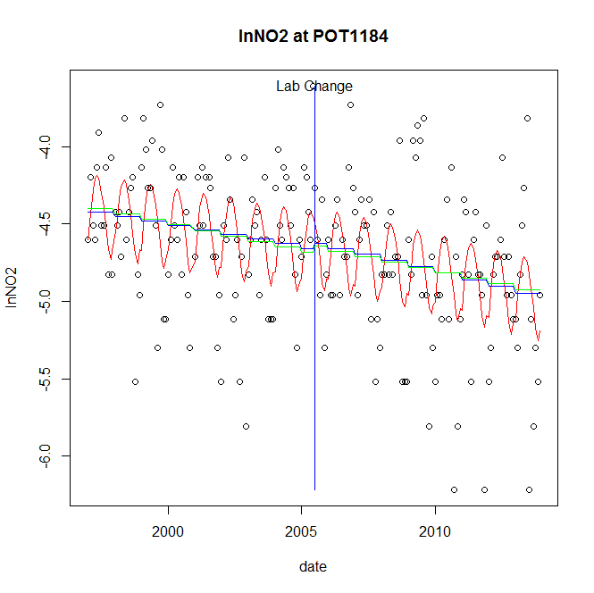

GAM analysis for station POT1184 dependent variable lnNO2

|  |  |  |  |  |
| --- | --- | --- | --- | --- |
| **Type** | **Source** | **edf** | **F-stat** | **p-value** |
| parametric terms | step | 1 | 0.0896 | 0.7650 |
|  | year | 1 | 4696.0284 | <0.0001 |
| smoothed terms | s(year) | 1.48 | 3.4441 | 0.0394 |
|  | s(doy) | 3.25 | 5.4066 | <0.0001 |

GAM analysis for station POT1184 dependent variable lnNO2

|  |  |  |  |  |
| --- | --- | --- | --- | --- |
| **parameter** | **estimate** | **Std. Err.** | **t value** | **p-value** |
| (Intercept) | 0.000409 | 0.000175 | 2.3404 | 0.0203 |
| step | 0.036627 | 0.122386 | 0.2993 | 0.7650 |
| year | -0.002341 | 3.4e-05 | -68.5276 | <0.0001 |

root mean-square error = 0.427

adjusted r-square = 0.2578

station = POT1184 dependent = lnTP

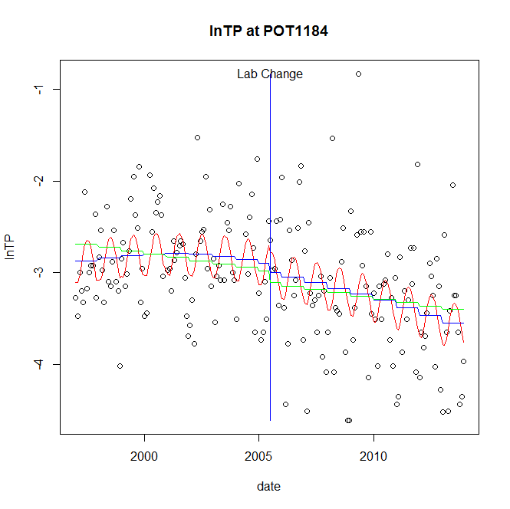

GAM analysis for station POT1184 dependent variable lnTP

|  |  |  |  |  |
| --- | --- | --- | --- | --- |
| **Type** | **Source** | **edf** | **F-stat** | **p-value** |
| parametric terms | step | 1 | 0.255 | 0.6141 |
|  | year | 1 | 825.4877 | <0.0001 |
| smoothed terms | s(year) | 2.32 | 3.2662 | 0.0250 |
|  | s(doy) | 2.26 | 2.6192 | <0.0001 |

GAM analysis for station POT1184 dependent variable lnTP

|  |  |  |  |  |
| --- | --- | --- | --- | --- |
| **parameter** | **estimate** | **Std. Err.** | **t value** | **p-value** |
| (Intercept) | 0.000303 | 0.000399 | 0.76 | 0.4482 |
| step | -0.095085 | 0.188284 | -0.505 | 0.6141 |
| year | -0.001504 | 5.2e-05 | -28.7313 | <0.0001 |

root mean-square error = 0.581

adjusted r-square = 0.2322

station = POT1184 dependent = lnPO4

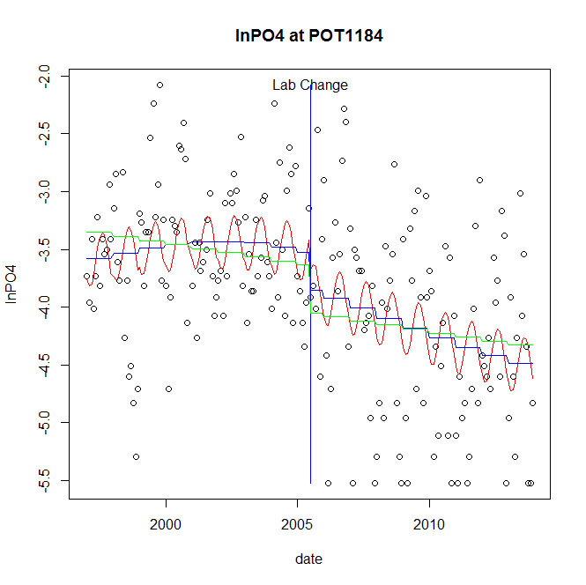

GAM analysis for station POT1184 dependent variable lnPO4

|  |  |  |  |  |
| --- | --- | --- | --- | --- |
| **Type** | **Source** | **edf** | **F-stat** | **p-value** |
| parametric terms | step | 1 | 2.1714 | 0.1422 |
|  | year | 1 | 932.9995 | <0.0001 |
| smoothed terms | s(year) | 2.42 | 3.499 | 0.0169 |
|  | s(doy) | 2.1 | 1.865 | 0.0002 |

GAM analysis for station POT1184 dependent variable lnPO4

|  |  |  |  |  |
| --- | --- | --- | --- | --- |
| **parameter** | **estimate** | **Std. Err.** | **t value** | **p-value** |
| (Intercept) | 9e-05 | 0.000486 | 0.1863 | 0.8524 |
| step | -0.3249 | 0.220483 | -1.4736 | 0.1422 |
| year | -0.00184 | 6e-05 | -30.545 | <0.0001 |

root mean-square error = 0.6828

adjusted r-square = 0.2819

No title given

|  |  |  |  |
| --- | --- | --- | --- |
| **station** | **dep** | **step.est** | **step.pv** |
| POT1184 | lnTSS | -0.196218 | 0.6580 |
| POT1184 | lnTN | -0.054176 | 0.6512 |
| POT1184 | lnNH4 | 0.033941 | 0.8815 |
| POT1184 | lnNO23 | -0.076046 | 0.7696 |
| POT1184 | lnNO2 | 0.036627 | 0.7650 |
| POT1184 | lnTP | -0.095085 | 0.6141 |
| POT1184 | lnPO4 | -0.3249 | 0.1422 |

station = POT1471 dependent = lnTSS

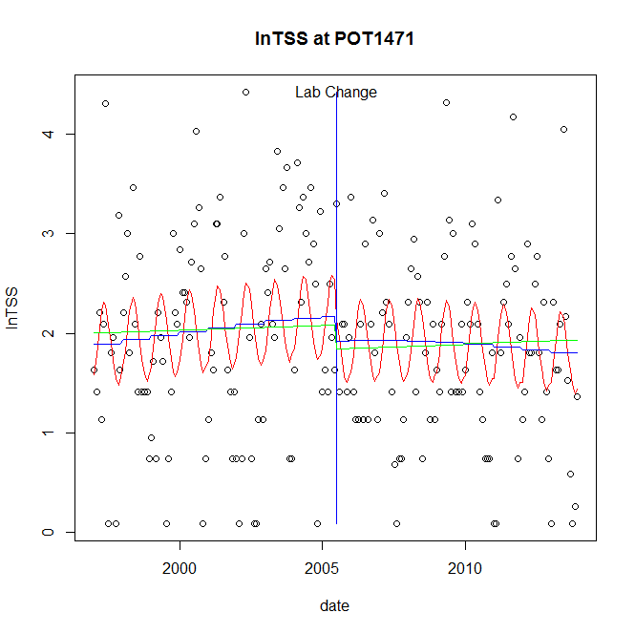

GAM analysis for station POT1471 dependent variable lnTSS

|  |  |  |  |  |
| --- | --- | --- | --- | --- |
| **Type** | **Source** | **edf** | **F-stat** | **p-value** |
| parametric terms | step | 1 | 0.8195 | 0.3664 |
|  | year | 1 | 189.7626 | <0.0001 |
| smoothed terms | s(year) | 1.72 | 0.9032 | 0.4082 |
|  | s(doy) | 2.37 | 3.0436 | <0.0001 |

GAM analysis for station POT1471 dependent variable lnTSS

|  |  |  |  |  |
| --- | --- | --- | --- | --- |
| **parameter** | **estimate** | **Std. Err.** | **t value** | **p-value** |
| (Intercept) | -5.3e-05 | 0.000429 | -0.1243 | 0.9012 |
| step | -0.24387 | 0.269391 | -0.9053 | 0.3664 |
| year | 0.001028 | 7.5e-05 | 13.7754 | <0.0001 |

root mean-square error = 0.922

adjusted r-square = 0.1219

station = POT1471 dependent = lnTN

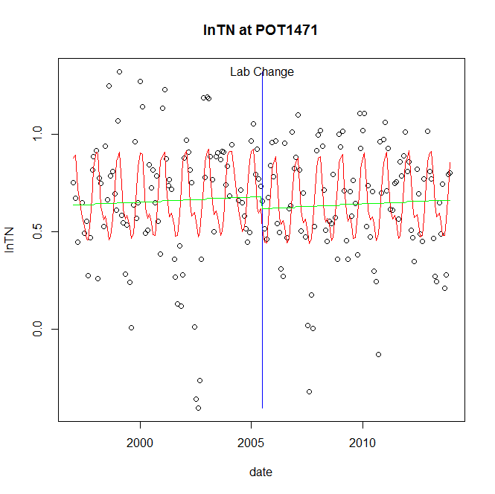

GAM analysis for station POT1471 dependent variable lnTN

|  |  |  |  |  |
| --- | --- | --- | --- | --- |
| **Type** | **Source** | **edf** | **F-stat** | **p-value** |
| parametric terms | step | 1 | 0.6676 | 0.4149 |
|  | year | 1 | 253.9527 | <0.0001 |
| smoothed terms | s(year) | 1 | 0.3995 | 0.5281 |
|  | s(doy) | 4.65 | 8.4072 | <0.0001 |

GAM analysis for station POT1471 dependent variable lnTN

|  |  |  |  |  |
| --- | --- | --- | --- | --- |
| **parameter** | **estimate** | **Std. Err.** | **t value** | **p-value** |
| (Intercept) | -5.8e-05 | 9.3e-05 | -0.6302 | 0.5293 |
| step | -0.062323 | 0.076278 | -0.8171 | 0.4149 |
| year | 0.000346 | 2.2e-05 | 15.9359 | <0.0001 |

root mean-square error = 0.266

adjusted r-square = 0.2542

station = POT1471 dependent = lnNH4

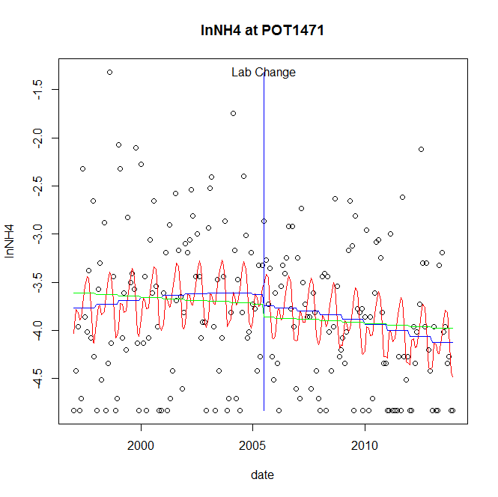

GAM analysis for station POT1471 dependent variable lnNH4

|  |  |  |  |  |
| --- | --- | --- | --- | --- |
| **Type** | **Source** | **edf** | **F-stat** | **p-value** |
| parametric terms | step | 1 | 0.3096 | 0.5785 |
|  | year | 1 | 1008.8386 | <0.0001 |
| smoothed terms | s(year) | 1.96 | 1.9914 | 0.1281 |
|  | s(doy) | 4.76 | 2.8088 | 0.0002 |

GAM analysis for station POT1471 dependent variable lnNH4

|  |  |  |  |  |
| --- | --- | --- | --- | --- |
| **parameter** | **estimate** | **Std. Err.** | **t value** | **p-value** |
| (Intercept) | 0.000114 | 0.000382 | 0.2983 | 0.7658 |
| step | -0.119044 | 0.213937 | -0.5564 | 0.5785 |
| year | -0.001871 | 5.9e-05 | -31.7622 | <0.0001 |

root mean-square error = 0.7111

adjusted r-square = 0.131

station = POT1471 dependent = lnNO23

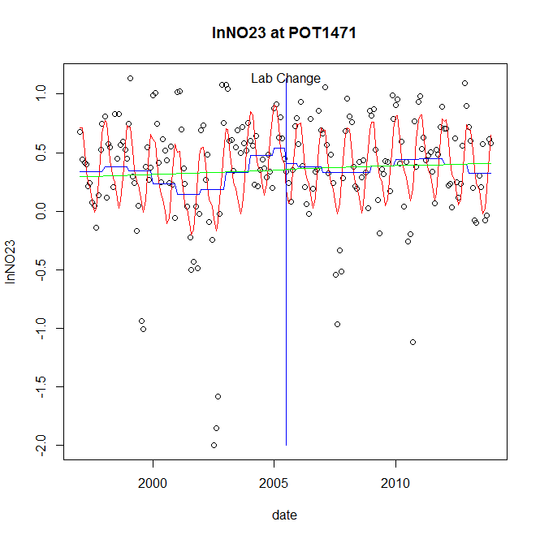

GAM analysis for station POT1471 dependent variable lnNO23

|  |  |  |  |  |
| --- | --- | --- | --- | --- |
| **Type** | **Source** | **edf** | **F-stat** | **p-value** |
| parametric terms | step | 1 | 0.4378 | 0.5090 |
|  | year | 1 | 18.5913 | <0.0001 |
| smoothed terms | s(year) | 5.88 | 1.3759 | 0.2198 |
|  | s(doy) | 4.27 | 10.3724 | <0.0001 |

GAM analysis for station POT1471 dependent variable lnNO23

|  |  |  |  |  |
| --- | --- | --- | --- | --- |
| **parameter** | **estimate** | **Std. Err.** | **t value** | **p-value** |
| (Intercept) | 0.000151 | 0.000823 | 0.184 | 0.8542 |
| step | -0.12843 | 0.1941 | -0.6617 | 0.5090 |
| year | 0.000217 | 5e-05 | 4.3118 | <0.0001 |

root mean-square error = 0.3971

adjusted r-square = 0.3177

station = POT1471 dependent = lnNO2

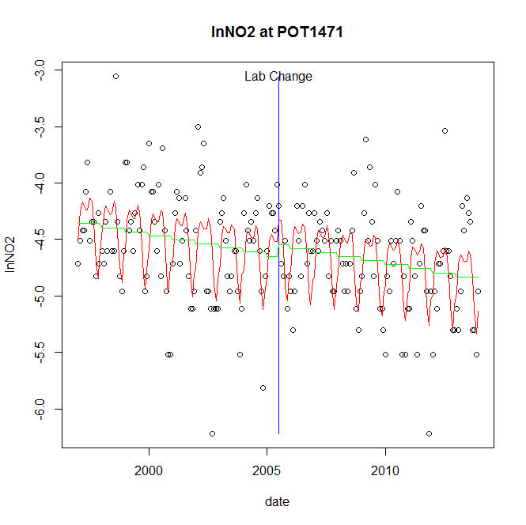

GAM analysis for station POT1471 dependent variable lnNO2

|  |  |  |  |  |
| --- | --- | --- | --- | --- |
| **Type** | **Source** | **edf** | **F-stat** | **p-value** |
| parametric terms | step | 1 | 0.8835 | 0.3484 |
|  | year | 1 | 5587.4828 | <0.0001 |
| smoothed terms | s(year) | 1 | 8.7902 | 0.0034 |
|  | s(doy) | 5.19 | 9.787 | <0.0001 |

GAM analysis for station POT1471 dependent variable lnNO2

|  |  |  |  |  |
| --- | --- | --- | --- | --- |
| **parameter** | **estimate** | **Std. Err.** | **t value** | **p-value** |
| (Intercept) | 0.000401 | 0.000136 | 2.9565 | 0.0035 |
| step | 0.104782 | 0.111479 | 0.9399 | 0.3484 |
| year | -0.002327 | 3.1e-05 | -74.7495 | <0.0001 |

root mean-square error = 0.3978

adjusted r-square = 0.3281

station = POT1471 dependent = lnTP

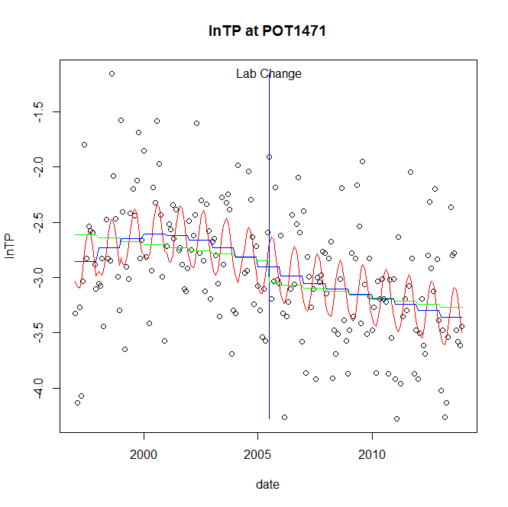

GAM analysis for station POT1471 dependent variable lnTP

|  |  |  |  |  |
| --- | --- | --- | --- | --- |
| **Type** | **Source** | **edf** | **F-stat** | **p-value** |
| parametric terms | step | 1 | 0 | 0.9984 |
|  | year | 1 | 816.7409 | <0.0001 |
| smoothed terms | s(year) | 3.69 | 2.5143 | 0.0363 |
|  | s(doy) | 2.6 | 4.2104 | <0.0001 |

GAM analysis for station POT1471 dependent variable lnTP

|  |  |  |  |  |
| --- | --- | --- | --- | --- |
| **parameter** | **estimate** | **Std. Err.** | **t value** | **p-value** |
| (Intercept) | -0.000415 | 0.000591 | -0.7012 | 0.4840 |
| step | 0.000384 | 0.191055 | 0.002 | 0.9984 |
| year | -0.001471 | 5.1e-05 | -28.5787 | <0.0001 |

root mean-square error = 0.4814

adjusted r-square = 0.3105

station = POT1471 dependent = lnPO4

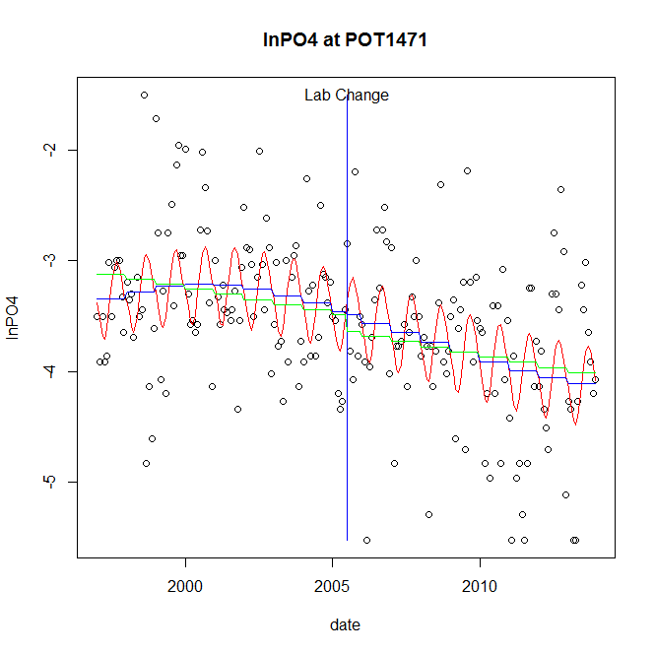

GAM analysis for station POT1471 dependent variable lnPO4

|  |  |  |  |  |
| --- | --- | --- | --- | --- |
| **Type** | **Source** | **edf** | **F-stat** | **p-value** |
| parametric terms | step | 1 | 0.0159 | 0.8999 |
|  | year | 1 | 908.4152 | <0.0001 |
| smoothed terms | s(year) | 2.9 | 3.187 | 0.0184 |
|  | s(doy) | 2.72 | 4.1916 | <0.0001 |

GAM analysis for station POT1471 dependent variable lnPO4

|  |  |  |  |  |
| --- | --- | --- | --- | --- |
| **parameter** | **estimate** | **Std. Err.** | **t value** | **p-value** |
| (Intercept) | -9e-05 | 0.000564 | -0.1591 | 0.8738 |
| step | -0.027541 | 0.218661 | -0.126 | 0.8999 |
| year | -0.00177 | 5.9e-05 | -30.1399 | <0.0001 |

root mean-square error = 0.6257

adjusted r-square = 0.2916

No title given

|  |  |  |  |
| --- | --- | --- | --- |
| **station** | **dep** | **step.est** | **step.pv** |
| POT1471 | lnTSS | -0.24387 | 0.3664 |
| POT1471 | lnTN | -0.062323 | 0.4149 |
| POT1471 | lnNH4 | -0.119044 | 0.5785 |
| POT1471 | lnNO23 | -0.12843 | 0.5090 |
| POT1471 | lnNO2 | 0.104782 | 0.3484 |
| POT1471 | lnTP | 0.000384 | 0.9984 |
| POT1471 | lnPO4 | -0.027541 | 0.8999 |

station = POT1472 dependent = lnTSS

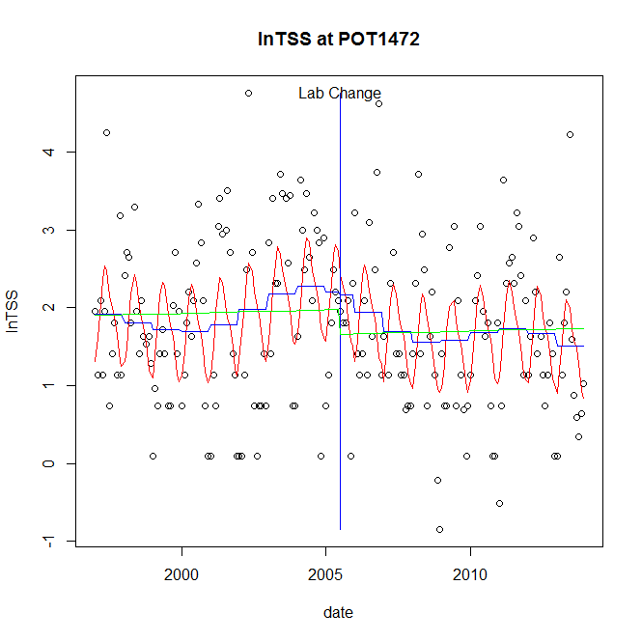

GAM analysis for station POT1472 dependent variable lnTSS

|  |  |  |  |  |
| --- | --- | --- | --- | --- |
| **Type** | **Source** | **edf** | **F-stat** | **p-value** |
| parametric terms | step | 1 | 0.0084 | 0.9272 |
|  | year | 1 | 66.3003 | <0.0001 |
| smoothed terms | s(year) | 5.14 | 1.7334 | 0.1146 |
|  | s(doy) | 3.84 | 5.6389 | <0.0001 |

GAM analysis for station POT1472 dependent variable lnTSS

|  |  |  |  |  |
| --- | --- | --- | --- | --- |
| **parameter** | **estimate** | **Std. Err.** | **t value** | **p-value** |
| (Intercept) | 0.001781 | 0.001672 | 1.0652 | 0.2881 |
| step | -0.039001 | 0.426412 | -0.0915 | 0.9272 |
| year | 0.000894 | 0.00011 | 8.1425 | <0.0001 |

root mean-square error = 0.9327

adjusted r-square = 0.2181

station = POT1472 dependent = lnTN

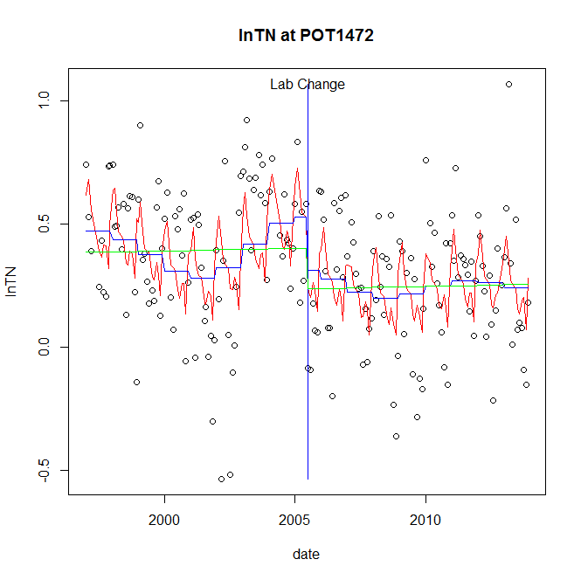

GAM analysis for station POT1472 dependent variable lnTN

|  |  |  |  |  |
| --- | --- | --- | --- | --- |
| **Type** | **Source** | **edf** | **F-stat** | **p-value** |
| parametric terms | step | 1 | 3.2795 | 0.0718 |
|  | year | 1 | 46.6846 | <0.0001 |
| smoothed terms | s(year) | 5.59 | 2.2607 | 0.0364 |
|  | s(doy) | 6.59 | 4.5088 | <0.0001 |

GAM analysis for station POT1472 dependent variable lnTN

|  |  |  |  |  |
| --- | --- | --- | --- | --- |
| **parameter** | **estimate** | **Std. Err.** | **t value** | **p-value** |
| (Intercept) | 0.000338 | 0.000497 | 0.6794 | 0.4977 |
| step | -0.215521 | 0.119011 | -1.8109 | 0.0718 |
| year | 0.000215 | 3.1e-05 | 6.8326 | <0.0001 |

root mean-square error = 0.2462

adjusted r-square = 0.252

station = POT1472 dependent = lnNH4

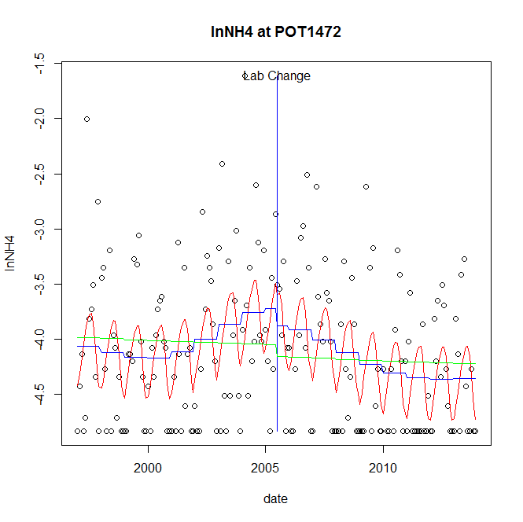

GAM analysis for station POT1472 dependent variable lnNH4

|  |  |  |  |  |
| --- | --- | --- | --- | --- |
| **Type** | **Source** | **edf** | **F-stat** | **p-value** |
| parametric terms | step | 1 | 0.4064 | 0.5245 |
|  | year | 1 | 968.1629 | <0.0001 |
| smoothed terms | s(year) | 4.08 | 3.4868 | 0.0049 |
|  | s(doy) | 3.25 | 4.2449 | <0.0001 |

GAM analysis for station POT1472 dependent variable lnNH4

|  |  |  |  |  |
| --- | --- | --- | --- | --- |
| **parameter** | **estimate** | **Std. Err.** | **t value** | **p-value** |
| (Intercept) | 0.000324 | 0.000834 | 0.3888 | 0.6978 |
| step | -0.15886 | 0.249184 | -0.6375 | 0.5245 |
| year | -0.002017 | 6.5e-05 | -31.1153 | <0.0001 |

root mean-square error = 0.6079

adjusted r-square = 0.2107

station = POT1472 dependent = lnNO23

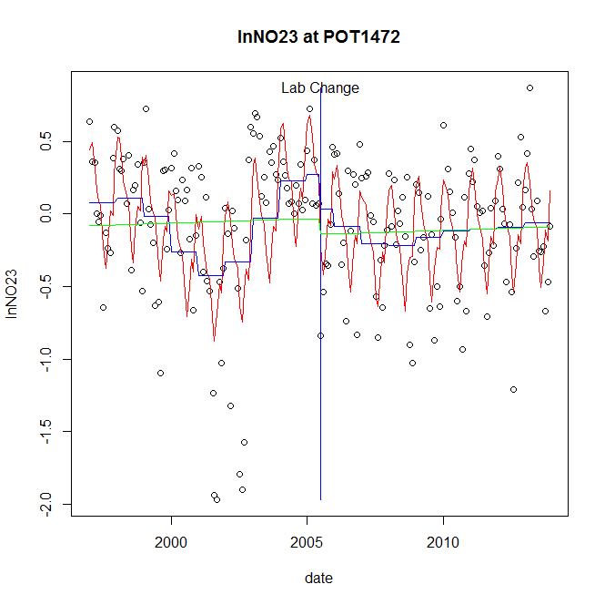

GAM analysis for station POT1472 dependent variable lnNO23

|  |  |  |  |  |
| --- | --- | --- | --- | --- |
| **Type** | **Source** | **edf** | **F-stat** | **p-value** |
| parametric terms | step | 1 | 1.3827 | 0.2411 |
|  | year | 1 | 0.1834 | 0.6690 |
| smoothed terms | s(year) | 6.54 | 5.7833 | <0.0001 |
|  | s(doy) | 6.74 | 10.3435 | <0.0001 |

GAM analysis for station POT1472 dependent variable lnNO23

|  |  |  |  |  |
| --- | --- | --- | --- | --- |
| **parameter** | **estimate** | **Std. Err.** | **t value** | **p-value** |
| (Intercept) | -0.00061 | 0.000946 | -0.6448 | 0.5198 |
| step | -0.243967 | 0.207476 | -1.1759 | 0.2411 |
| year | 2.3e-05 | 5.3e-05 | 0.4283 | 0.6690 |

root mean-square error = 0.3997

adjusted r-square = 0.3742

station = POT1472 dependent = lnNO2

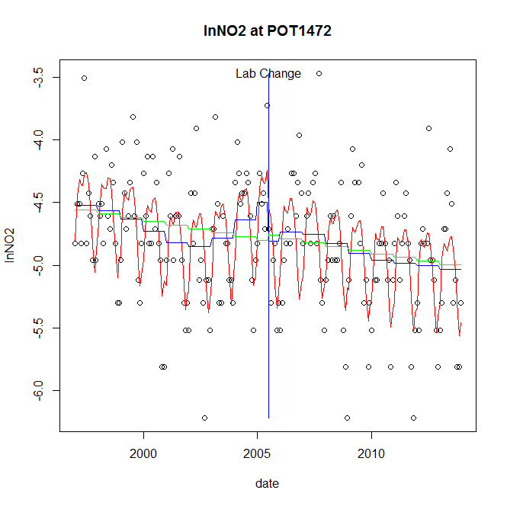

GAM analysis for station POT1472 dependent variable lnNO2

|  |  |  |  |  |
| --- | --- | --- | --- | --- |
| **Type** | **Source** | **edf** | **F-stat** | **p-value** |
| parametric terms | step | 1 | 2.9705 | 0.0864 |
|  | year | 1 | 2465.6558 | <0.0001 |
| smoothed terms | s(year) | 5.3 | 2.9817 | 0.0078 |
|  | s(doy) | 5.25 | 12.8437 | <0.0001 |

GAM analysis for station POT1472 dependent variable lnNO2

|  |  |  |  |  |
| --- | --- | --- | --- | --- |
| **parameter** | **estimate** | **Std. Err.** | **t value** | **p-value** |
| (Intercept) | 0.000373 | 0.000728 | 0.512 | 0.6093 |
| step | -0.314033 | 0.182206 | -1.7235 | 0.0864 |
| year | -0.002325 | 4.7e-05 | -49.6554 | <0.0001 |

root mean-square error = 0.3923

adjusted r-square = 0.4095

station = POT1472 dependent = lnTP

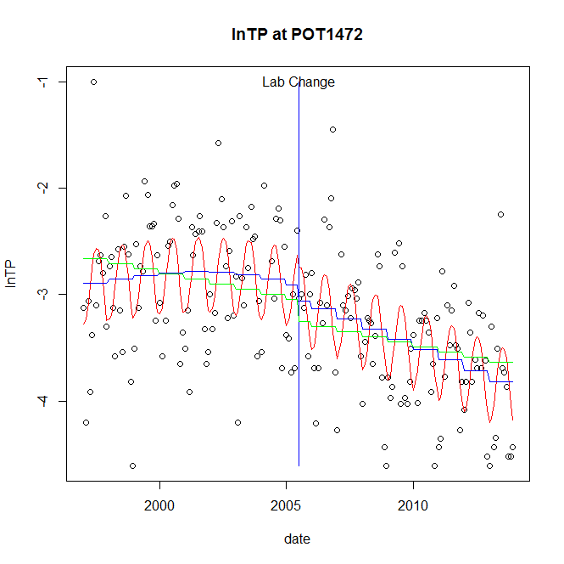

GAM analysis for station POT1472 dependent variable lnTP

|  |  |  |  |  |
| --- | --- | --- | --- | --- |
| **Type** | **Source** | **edf** | **F-stat** | **p-value** |
| parametric terms | step | 1 | 0.7221 | 0.3965 |
|  | year | 1 | 1048.9273 | <0.0001 |
| smoothed terms | s(year) | 2.46 | 7.5311 | <0.0001 |
|  | s(doy) | 3.01 | 6.7644 | <0.0001 |

GAM analysis for station POT1472 dependent variable lnTP

|  |  |  |  |  |
| --- | --- | --- | --- | --- |
| **parameter** | **estimate** | **Std. Err.** | **t value** | **p-value** |
| (Intercept) | 0.000383 | 0.000394 | 0.9735 | 0.3316 |
| step | -0.148318 | 0.174543 | -0.8498 | 0.3965 |
| year | -0.00154 | 4.8e-05 | -32.3871 | <0.0001 |

root mean-square error = 0.5236

adjusted r-square = 0.4293

station = POT1472 dependent = lnPO4

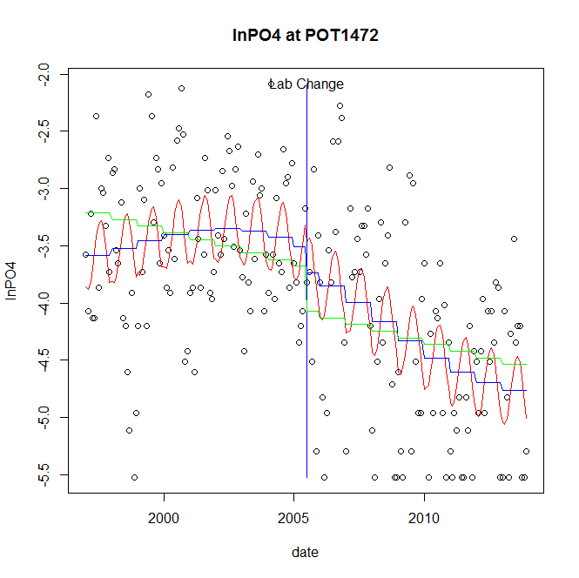

GAM analysis for station POT1472 dependent variable lnPO4

|  |  |  |  |  |
| --- | --- | --- | --- | --- |
| **Type** | **Source** | **edf** | **F-stat** | **p-value** |
| parametric terms | step | 1 | 0.8627 | 0.3542 |
|  | year | 1 | 818.7429 | <0.0001 |
| smoothed terms | s(year) | 3.11 | 6.5611 | <0.0001 |
|  | s(doy) | 2.34 | 2.9786 | <0.0001 |

GAM analysis for station POT1472 dependent variable lnPO4

|  |  |  |  |  |
| --- | --- | --- | --- | --- |
| **parameter** | **estimate** | **Std. Err.** | **t value** | **p-value** |
| (Intercept) | 2.5e-05 | 0.000684 | 0.0366 | 0.9709 |
| step | -0.231375 | 0.249113 | -0.9288 | 0.3542 |
| year | -0.001883 | 6.6e-05 | -28.6137 | <0.0001 |

root mean-square error = 0.6888

adjusted r-square = 0.3995

No title given

|  |  |  |  |
| --- | --- | --- | --- |
| **station** | **dep** | **step.est** | **step.pv** |
| POT1472 | lnTSS | -0.039001 | 0.9272 |
| POT1472 | lnTN | -0.215521 | 0.0718 |
| POT1472 | lnNH4 | -0.15886 | 0.5245 |
| POT1472 | lnNO23 | -0.243967 | 0.2411 |
| POT1472 | lnNO2 | -0.314033 | 0.0864 |
| POT1472 | lnTP | -0.148318 | 0.3965 |
| POT1472 | lnPO4 | -0.231375 | 0.3542 |

station = POT1595 dependent = lnTSS

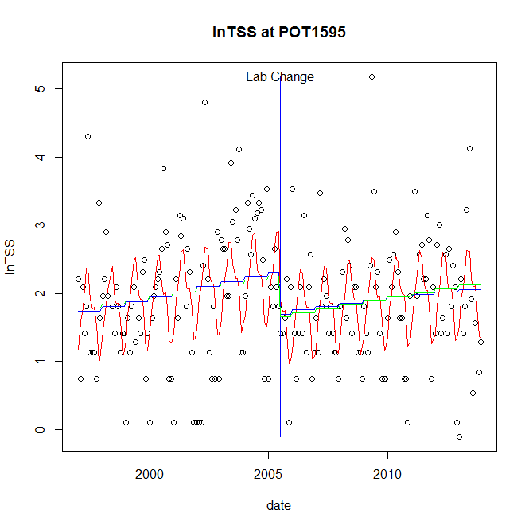

GAM analysis for station POT1595 dependent variable lnTSS

|  |  |  |  |  |
| --- | --- | --- | --- | --- |
| **Type** | **Source** | **edf** | **F-stat** | **p-value** |
| parametric terms | step | 1 | 5.9626 | 0.0155 |
|  | year | 1 | 258.1791 | <0.0001 |
| smoothed terms | s(year) | 1.56 | 3.559 | 0.0328 |
|  | s(doy) | 5.54 | 6.5057 | <0.0001 |

GAM analysis for station POT1595 dependent variable lnTSS

|  |  |  |  |  |
| --- | --- | --- | --- | --- |
| **parameter** | **estimate** | **Std. Err.** | **t value** | **p-value** |
| (Intercept) | -0.000597 | 0.000365 | -1.6377 | 0.1031 |
| step | -0.607478 | 0.248779 | -2.4418 | 0.0155 |
| year | 0.001102 | 6.9e-05 | 16.068 | <0.0001 |

root mean-square error = 0.8596

adjusted r-square = 0.2247

step significant

station = POT1595 dependent = lnTN

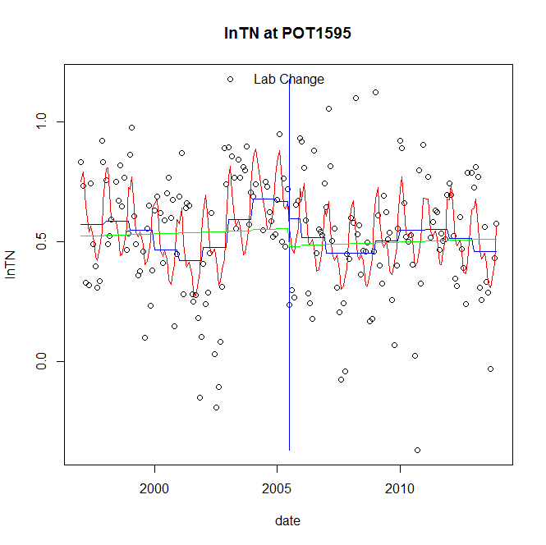

GAM analysis for station POT1595 dependent variable lnTN

|  |  |  |  |  |
| --- | --- | --- | --- | --- |
| **Type** | **Source** | **edf** | **F-stat** | **p-value** |
| parametric terms | step | 1 | 0.3584 | 0.5501 |
|  | year | 1 | 87.6877 | <0.0001 |
| smoothed terms | s(year) | 6.3 | 2.2393 | 0.0344 |
|  | s(doy) | 5.63 | 6.4957 | <0.0001 |

GAM analysis for station POT1595 dependent variable lnTN

|  |  |  |  |  |
| --- | --- | --- | --- | --- |
| **parameter** | **estimate** | **Std. Err.** | **t value** | **p-value** |
| (Intercept) | 0.000178 | 0.000516 | 0.3449 | 0.7306 |
| step | -0.069087 | 0.115393 | -0.5987 | 0.5501 |
| year | 0.000282 | 3e-05 | 9.3642 | <0.0001 |

root mean-square error = 0.2252

adjusted r-square = 0.2575

station = POT1595 dependent = lnNH4

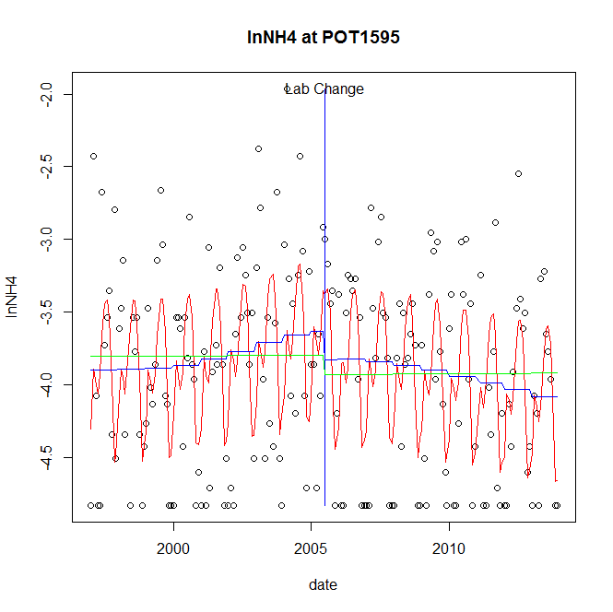

GAM analysis for station POT1595 dependent variable lnNH4

|  |  |  |  |  |
| --- | --- | --- | --- | --- |
| **Type** | **Source** | **edf** | **F-stat** | **p-value** |
| parametric terms | step | 1 | 0.9748 | 0.3248 |
|  | year | 1 | 1256.4703 | <0.0001 |
| smoothed terms | s(year) | 2.82 | 1.5448 | 0.1950 |
|  | s(doy) | 5.88 | 10.1176 | <0.0001 |

GAM analysis for station POT1595 dependent variable lnNH4

|  |  |  |  |  |
| --- | --- | --- | --- | --- |
| **parameter** | **estimate** | **Std. Err.** | **t value** | **p-value** |
| (Intercept) | 0.000225 | 5e-04 | 0.4505 | 0.6528 |
| step | -0.197655 | 0.200195 | -0.9873 | 0.3248 |
| year | -0.001895 | 5.3e-05 | -35.4467 | <0.0001 |

root mean-square error = 0.5771

adjusted r-square = 0.3002

station = POT1595 dependent = lnNO23

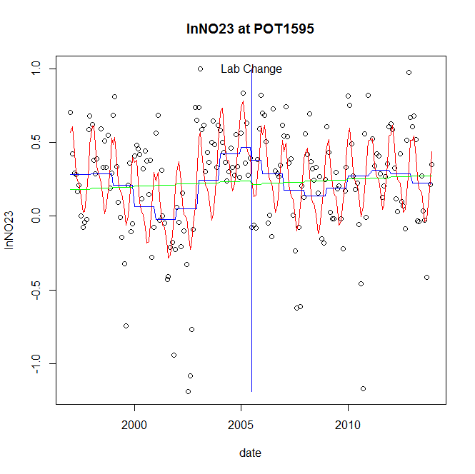

GAM analysis for station POT1595 dependent variable lnNO23

|  |  |  |  |  |
| --- | --- | --- | --- | --- |
| **Type** | **Source** | **edf** | **F-stat** | **p-value** |
| parametric terms | step | 1 | 0.3062 | 0.5807 |
|  | year | 1 | 12.4794 | 0.0005 |
| smoothed terms | s(year) | 6.36 | 4.2741 | 0.0002 |
|  | s(doy) | 5.06 | 9.6847 | <0.0001 |

GAM analysis for station POT1595 dependent variable lnNO23

|  |  |  |  |  |
| --- | --- | --- | --- | --- |
| **parameter** | **estimate** | **Std. Err.** | **t value** | **p-value** |
| (Intercept) | 3e-04 | 0.000695 | 0.4319 | 0.6663 |
| step | -0.086164 | 0.155718 | -0.5533 | 0.5807 |
| year | 0.000141 | 4e-05 | 3.5326 | 0.0005 |

root mean-square error = 0.305

adjusted r-square = 0.3503

station = POT1595 dependent = lnNO2

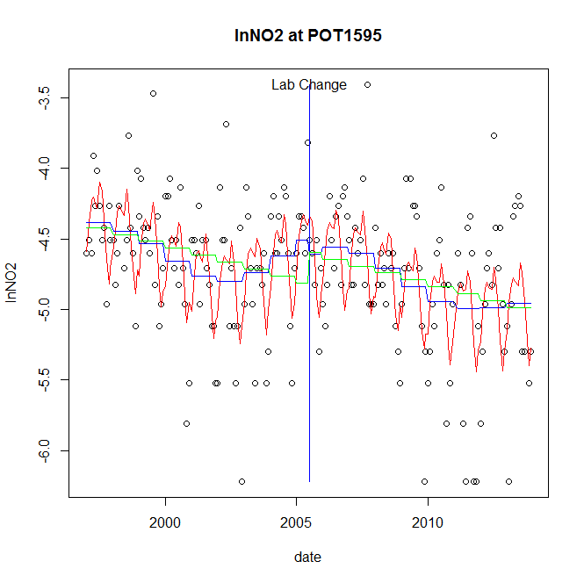

GAM analysis for station POT1595 dependent variable lnNO2

|  |  |  |  |  |
| --- | --- | --- | --- | --- |
| **Type** | **Source** | **edf** | **F-stat** | **p-value** |
| parametric terms | step | 1 | 0.2844 | 0.5944 |
|  | year | 1 | 2153.2185 | <0.0001 |
| smoothed terms | s(year) | 5.17 | 4.6708 | 0.0002 |
|  | s(doy) | 5.62 | 7.4942 | <0.0001 |

GAM analysis for station POT1595 dependent variable lnNO2

|  |  |  |  |  |
| --- | --- | --- | --- | --- |
| **parameter** | **estimate** | **Std. Err.** | **t value** | **p-value** |
| (Intercept) | 6.2e-05 | 0.000756 | 0.0824 | 0.9344 |
| step | -0.103668 | 0.194377 | -0.5333 | 0.5944 |
| year | -0.002331 | 5e-05 | -46.4028 | <0.0001 |

root mean-square error = 0.4231

adjusted r-square = 0.321

station = POT1595 dependent = lnTP

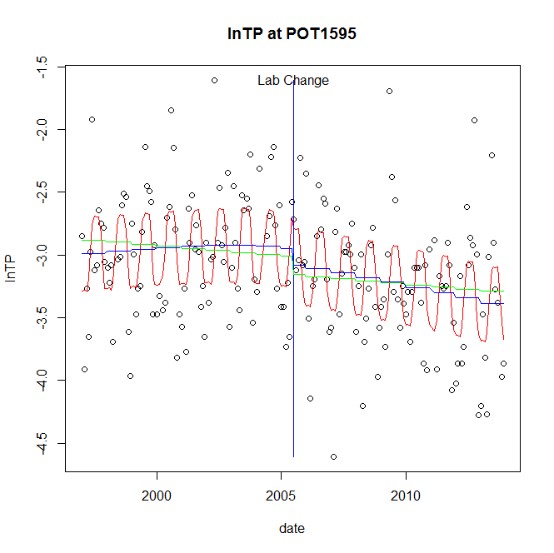

GAM analysis for station POT1595 dependent variable lnTP

|  |  |  |  |  |
| --- | --- | --- | --- | --- |
| **Type** | **Source** | **edf** | **F-stat** | **p-value** |
| parametric terms | step | 1 | 0.9908 | 0.3208 |
|  | year | 1 | 1671.4499 | <0.0001 |
| smoothed terms | s(year) | 2.04 | 2.5567 | 0.0675 |
|  | s(doy) | 5.08 | 8.7277 | <0.0001 |

GAM analysis for station POT1595 dependent variable lnTP

|  |  |  |  |  |
| --- | --- | --- | --- | --- |
| **parameter** | **estimate** | **Std. Err.** | **t value** | **p-value** |
| (Intercept) | 0.000151 | 0.000248 | 0.6096 | 0.5429 |
| step | -0.133372 | 0.133991 | -0.9954 | 0.3208 |
| year | -0.001517 | 3.7e-05 | -40.8834 | <0.0001 |

root mean-square error = 0.4306

adjusted r-square = 0.3246

station = POT1595 dependent = lnPO4

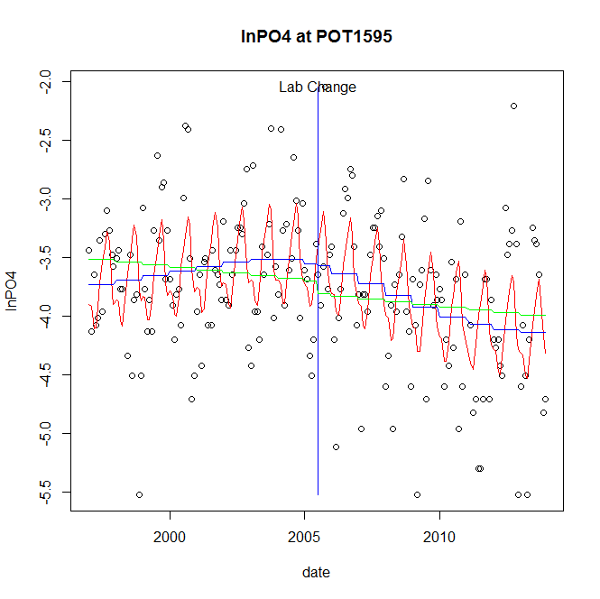

GAM analysis for station POT1595 dependent variable lnPO4

|  |  |  |  |  |
| --- | --- | --- | --- | --- |
| **Type** | **Source** | **edf** | **F-stat** | **p-value** |
| parametric terms | step | 1 | 0.0124 | 0.9114 |
|  | year | 1 | 1288.8199 | <0.0001 |
| smoothed terms | s(year) | 3.13 | 3.8463 | 0.0055 |
|  | s(doy) | 5.45 | 6.7964 | <0.0001 |

GAM analysis for station POT1595 dependent variable lnPO4

|  |  |  |  |  |
| --- | --- | --- | --- | --- |
| **parameter** | **estimate** | **Std. Err.** | **t value** | **p-value** |
| (Intercept) | -7.2e-05 | 0.000533 | -0.1355 | 0.8924 |
| step | -0.021895 | 0.196561 | -0.1114 | 0.9114 |
| year | -0.001872 | 5.2e-05 | -35.9001 | <0.0001 |

root mean-square error = 0.5411

adjusted r-square = 0.2908

No title given

|  |  |  |  |
| --- | --- | --- | --- |
| **station** | **dep** | **step.est** | **step.pv** |
| POT1595 | lnTSS | -0.607478 | 0.0155 |
| POT1595 | lnTN | -0.069087 | 0.5501 |
| POT1595 | lnNH4 | -0.197655 | 0.3248 |
| POT1595 | lnNO23 | -0.086164 | 0.5807 |
| POT1595 | lnNO2 | -0.103668 | 0.5944 |
| POT1595 | lnTP | -0.133372 | 0.3208 |
| POT1595 | lnPO4 | -0.021895 | 0.9114 |

station = POT1596 dependent = lnTSS

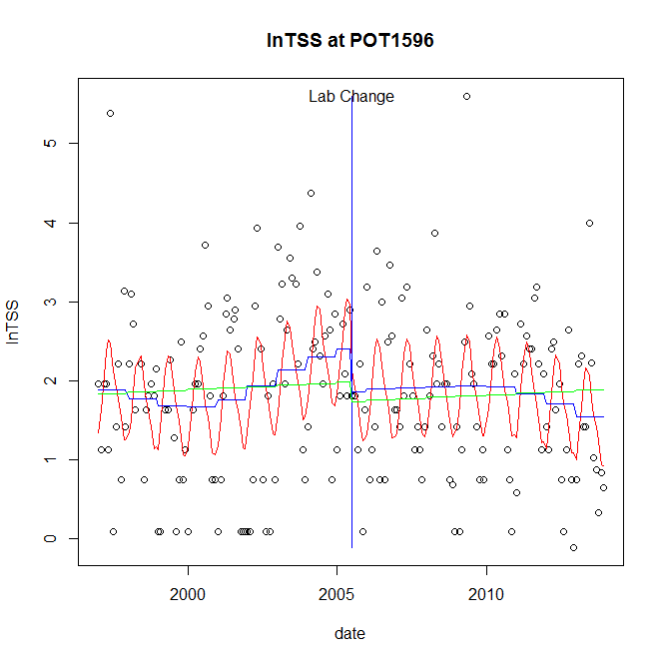

GAM analysis for station POT1596 dependent variable lnTSS

|  |  |  |  |  |
| --- | --- | --- | --- | --- |
| **Type** | **Source** | **edf** | **F-stat** | **p-value** |
| parametric terms | step | 1 | 1.9523 | 0.1640 |
|  | year | 1 | 106.5326 | <0.0001 |
| smoothed terms | s(year) | 3.99 | 2.1403 | 0.0640 |
|  | s(doy) | 3.74 | 5.5248 | <0.0001 |

GAM analysis for station POT1596 dependent variable lnTSS

|  |  |  |  |  |
| --- | --- | --- | --- | --- |
| **parameter** | **estimate** | **Std. Err.** | **t value** | **p-value** |
| (Intercept) | 0.001749 | 0.001248 | 1.4009 | 0.1629 |
| step | -0.536165 | 0.383734 | -1.3972 | 0.1640 |
| year | 0.001051 | 0.000102 | 10.3215 | <0.0001 |

root mean-square error = 0.9453

adjusted r-square = 0.2145

station = POT1596 dependent = lnTN

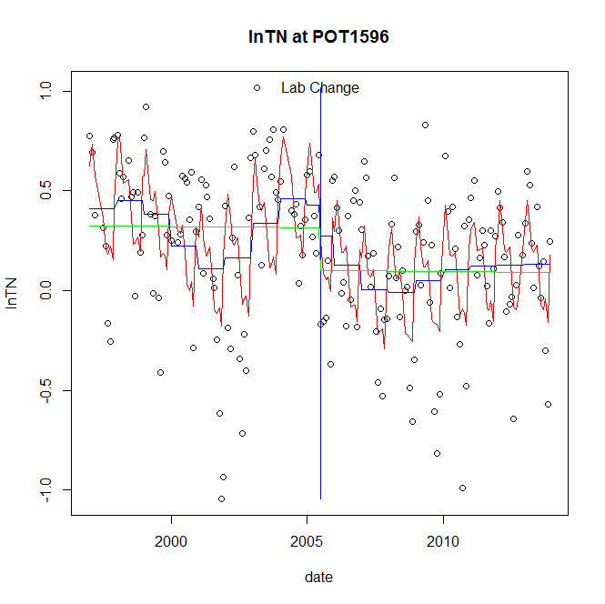

GAM analysis for station POT1596 dependent variable lnTN

|  |  |  |  |  |
| --- | --- | --- | --- | --- |
| **Type** | **Source** | **edf** | **F-stat** | **p-value** |
| parametric terms | step | 1 | 0.8464 | 0.3588 |
|  | year | 1 | 9.9617 | 0.0019 |
| smoothed terms | s(year) | 6.47 | 3.4116 | 0.0020 |
|  | s(doy) | 6.8 | 8.2827 | <0.0001 |

GAM analysis for station POT1596 dependent variable lnTN

|  |  |  |  |  |
| --- | --- | --- | --- | --- |
| **parameter** | **estimate** | **Std. Err.** | **t value** | **p-value** |
| (Intercept) | -4e-04 | 0.000755 | -0.5296 | 0.5971 |
| step | -0.151688 | 0.164874 | -0.92 | 0.3588 |
| year | 0.000139 | 4.4e-05 | 3.1562 | 0.0019 |

root mean-square error = 0.317

adjusted r-square = 0.3582

station = POT1596 dependent = lnNH4

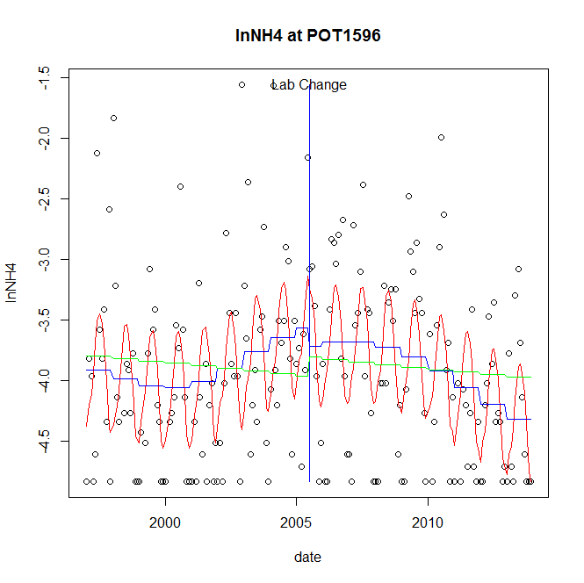

GAM analysis for station POT1596 dependent variable lnNH4

|  |  |  |  |  |
| --- | --- | --- | --- | --- |
| **Type** | **Source** | **edf** | **F-stat** | **p-value** |
| parametric terms | step | 1 | 0.3489 | 0.5554 |
|  | year | 1 | 802.4979 | <0.0001 |
| smoothed terms | s(year) | 3.74 | 4.5411 | 0.0010 |
|  | s(doy) | 4.46 | 7.3244 | <0.0001 |

GAM analysis for station POT1596 dependent variable lnNH4

|  |  |  |  |  |
| --- | --- | --- | --- | --- |
| **parameter** | **estimate** | **Std. Err.** | **t value** | **p-value** |
| (Intercept) | 0.001158 | 0.000792 | 1.4621 | 0.1454 |
| step | -0.15064 | 0.255019 | -0.5907 | 0.5554 |
| year | -0.001922 | 6.8e-05 | -28.3284 | <0.0001 |

root mean-square error = 0.6465

adjusted r-square = 0.2762

station = POT1596 dependent = lnNO23

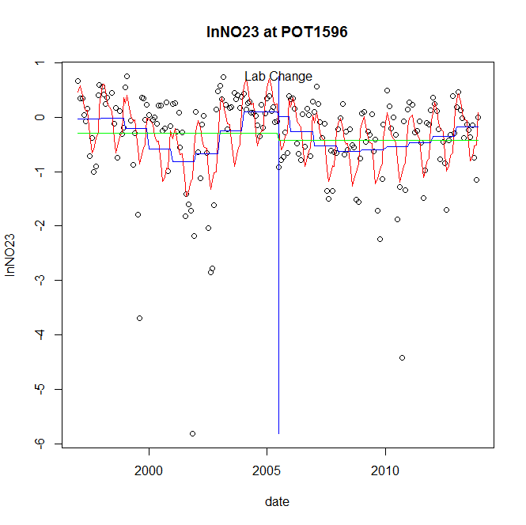

GAM analysis for station POT1596 dependent variable lnNO23

|  |  |  |  |  |
| --- | --- | --- | --- | --- |
| **Type** | **Source** | **edf** | **F-stat** | **p-value** |
| parametric terms | step | 1 | 0.0717 | 0.7891 |
|  | year | 1 | 2.3364 | 0.1281 |
| smoothed terms | s(year) | 6.39 | 3.9047 | 0.0006 |
|  | s(doy) | 6.25 | 8.0031 | <0.0001 |

GAM analysis for station POT1596 dependent variable lnNO23

|  |  |  |  |  |
| --- | --- | --- | --- | --- |
| **parameter** | **estimate** | **Std. Err.** | **t value** | **p-value** |
| (Intercept) | -0.001472 | 0.001642 | -0.8965 | 0.3712 |
| step | -0.098245 | 0.366784 | -0.2679 | 0.7891 |
| year | -0.000146 | 9.5e-05 | -1.5285 | 0.1281 |

root mean-square error = 0.7154

adjusted r-square = 0.3155

station = POT1596 dependent = lnNO2

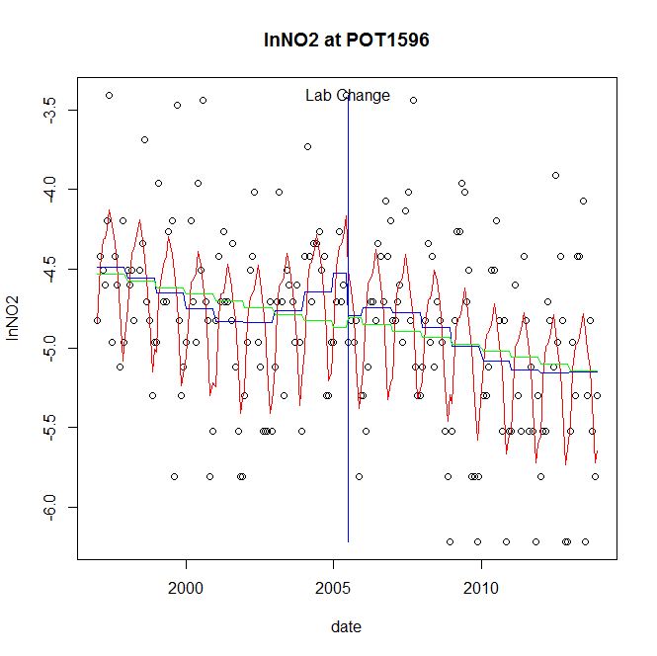

GAM analysis for station POT1596 dependent variable lnNO2

|  |  |  |  |  |
| --- | --- | --- | --- | --- |
| **Type** | **Source** | **edf** | **F-stat** | **p-value** |
| parametric terms | step | 1 | 1.6904 | 0.1951 |
|  | year | 1 | 1983.2794 | <0.0001 |
| smoothed terms | s(year) | 4.85 | 3.8365 | 0.0015 |
|  | s(doy) | 5.51 | 11.6409 | <0.0001 |

GAM analysis for station POT1596 dependent variable lnNO2

|  |  |  |  |  |
| --- | --- | --- | --- | --- |
| **parameter** | **estimate** | **Std. Err.** | **t value** | **p-value** |
| (Intercept) | 0.000306 | 0.000752 | 0.4068 | 0.6846 |
| step | -0.262061 | 0.201559 | -1.3002 | 0.1951 |
| year | -0.002359 | 5.3e-05 | -44.534 | <0.0001 |

root mean-square error = 0.4523

adjusted r-square = 0.4028

station = POT1596 dependent = lnTP

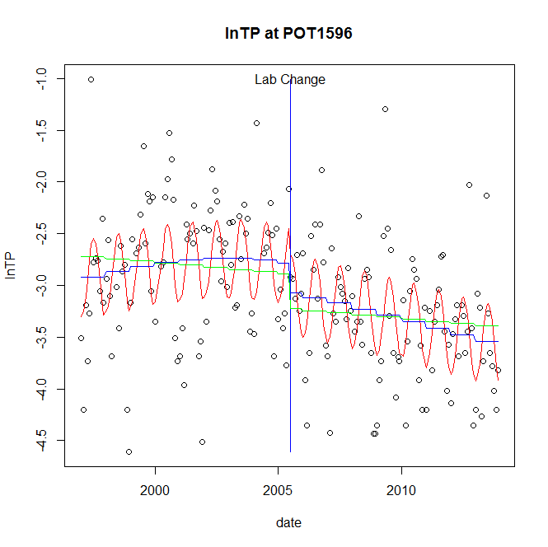

GAM analysis for station POT1596 dependent variable lnTP

|  |  |  |  |  |
| --- | --- | --- | --- | --- |
| **Type** | **Source** | **edf** | **F-stat** | **p-value** |
| parametric terms | step | 1 | 2.605 | 0.1082 |
|  | year | 1 | 852.5041 | <0.0001 |
| smoothed terms | s(year) | 2.32 | 3.5195 | 0.0184 |
|  | s(doy) | 2.94 | 6.6201 | <0.0001 |

GAM analysis for station POT1596 dependent variable lnTP

|  |  |  |  |  |
| --- | --- | --- | --- | --- |
| **parameter** | **estimate** | **Std. Err.** | **t value** | **p-value** |
| (Intercept) | 4.4e-05 | 0.000378 | 0.1168 | 0.9071 |
| step | -0.289875 | 0.179601 | -1.614 | 0.1082 |
| year | -0.001461 | 5e-05 | -29.1977 | <0.0001 |

root mean-square error = 0.5532

adjusted r-square = 0.3497

station = POT1596 dependent = lnPO4

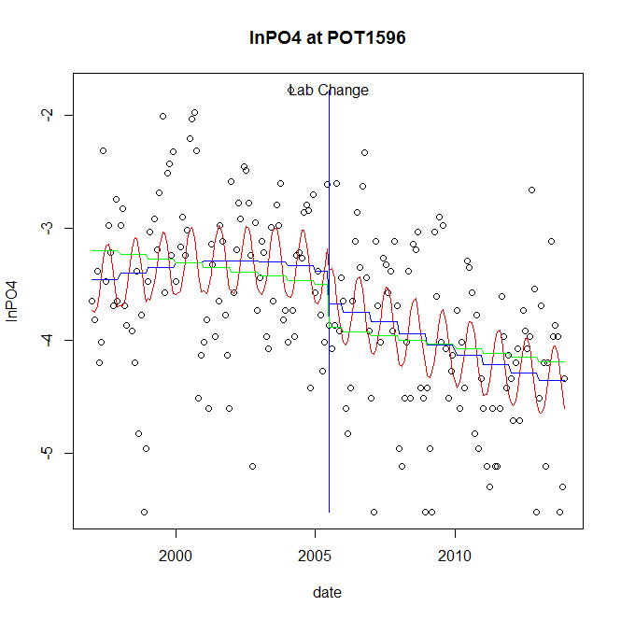

GAM analysis for station POT1596 dependent variable lnPO4

|  |  |  |  |  |
| --- | --- | --- | --- | --- |
| **Type** | **Source** | **edf** | **F-stat** | **p-value** |
| parametric terms | step | 1 | 1.6785 | 0.1967 |
|  | year | 1 | 870.3836 | <0.0001 |
| smoothed terms | s(year) | 2.59 | 3.8737 | 0.0089 |
|  | s(doy) | 2.4 | 3.2676 | <0.0001 |

GAM analysis for station POT1596 dependent variable lnPO4

|  |  |  |  |  |
| --- | --- | --- | --- | --- |
| **parameter** | **estimate** | **Std. Err.** | **t value** | **p-value** |
| (Intercept) | 1e-05 | 0.000517 | 0.0199 | 0.9841 |
| step | -0.28698 | 0.221512 | -1.2956 | 0.1967 |
| year | -0.001779 | 6e-05 | -29.5023 | <0.0001 |

root mean-square error = 0.6647

adjusted r-square = 0.3195

No title given

|  |  |  |  |
| --- | --- | --- | --- |
| **station** | **dep** | **step.est** | **step.pv** |
| POT1596 | lnTSS | -0.536165 | 0.1640 |
| POT1596 | lnTN | -0.151688 | 0.3588 |
| POT1596 | lnNH4 | -0.15064 | 0.5554 |
| POT1596 | lnNO23 | -0.098245 | 0.7891 |
| POT1596 | lnNO2 | -0.262061 | 0.1951 |
| POT1596 | lnTP | -0.289875 | 0.1082 |
| POT1596 | lnPO4 | -0.28698 | 0.1967 |

station = POT1830 dependent = lnTSS

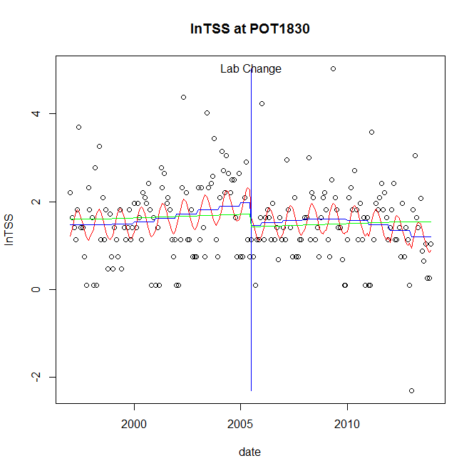

GAM analysis for station POT1830 dependent variable lnTSS

|  |  |  |  |  |
| --- | --- | --- | --- | --- |
| **Type** | **Source** | **edf** | **F-stat** | **p-value** |
| parametric terms | step | 1 | 2.7715 | 0.0976 |
|  | year | 1 | 120.3289 | <0.0001 |
| smoothed terms | s(year) | 3.12 | 1.8448 | 0.1233 |
|  | s(doy) | 2.22 | 2.5779 | <0.0001 |

GAM analysis for station POT1830 dependent variable lnTSS

|  |  |  |  |  |
| --- | --- | --- | --- | --- |
| **parameter** | **estimate** | **Std. Err.** | **t value** | **p-value** |
| (Intercept) | 0.000934 | 0.000842 | 1.1089 | 0.2688 |
| step | -0.511445 | 0.307216 | -1.6648 | 0.0976 |
| year | 0.000897 | 8.2e-05 | 10.9695 | <0.0001 |

root mean-square error = 0.8496

adjusted r-square = 0.1342

station = POT1830 dependent = lnTN

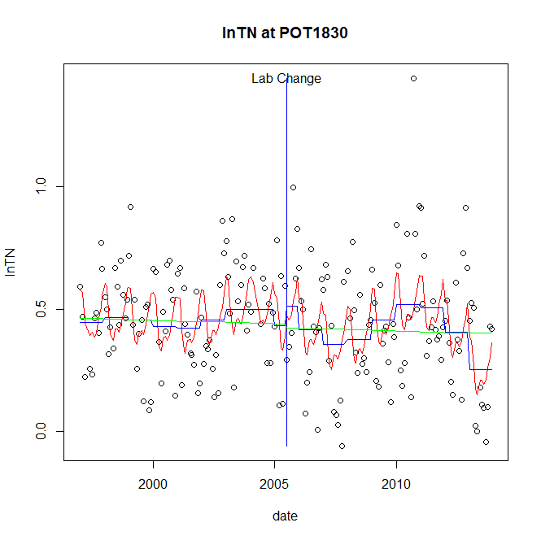

GAM analysis for station POT1830 dependent variable lnTN

|  |  |  |  |  |
| --- | --- | --- | --- | --- |
| **Type** | **Source** | **edf** | **F-stat** | **p-value** |
| parametric terms | step | 1 | 0.5883 | 0.4441 |
|  | year | 1 | 52.5411 | <0.0001 |
| smoothed terms | s(year) | 6.18 | 3.0754 | 0.0049 |
|  | s(doy) | 4.74 | 3.8306 | <0.0001 |

GAM analysis for station POT1830 dependent variable lnTN

|  |  |  |  |  |
| --- | --- | --- | --- | --- |
| **parameter** | **estimate** | **Std. Err.** | **t value** | **p-value** |
| (Intercept) | 0.000831 | 0.000467 | 1.7798 | 0.0768 |
| step | 0.08033 | 0.104731 | 0.767 | 0.4441 |
| year | 0.000201 | 2.8e-05 | 7.2485 | <0.0001 |

root mean-square error = 0.2069

adjusted r-square = 0.1992

station = POT1830 dependent = lnNH4

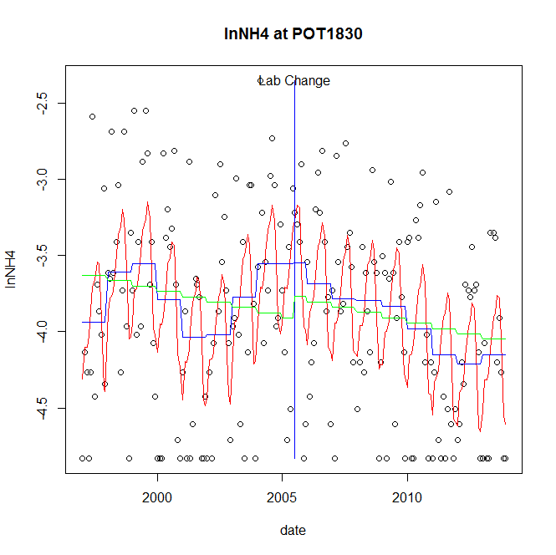

GAM analysis for station POT1830 dependent variable lnNH4

|  |  |  |  |  |
| --- | --- | --- | --- | --- |
| **Type** | **Source** | **edf** | **F-stat** | **p-value** |
| parametric terms | step | 1 | 6e-04 | 0.9811 |
|  | year | 1 | 679.3 | <0.0001 |
| smoothed terms | s(year) | 6.56 | 3.6168 | 0.0012 |
|  | s(doy) | 5.39 | 7.1202 | <0.0001 |

GAM analysis for station POT1830 dependent variable lnNH4

|  |  |  |  |  |
| --- | --- | --- | --- | --- |
| **parameter** | **estimate** | **Std. Err.** | **t value** | **p-value** |
| (Intercept) | -0.002823 | 0.001315 | -2.1462 | 0.0331 |
| step | 0.006852 | 0.288655 | 0.0237 | 0.9811 |
| year | -0.001933 | 7.4e-05 | -26.0634 | <0.0001 |

root mean-square error = 0.5561

adjusted r-square = 0.2873

station = POT1830 dependent = lnNO23

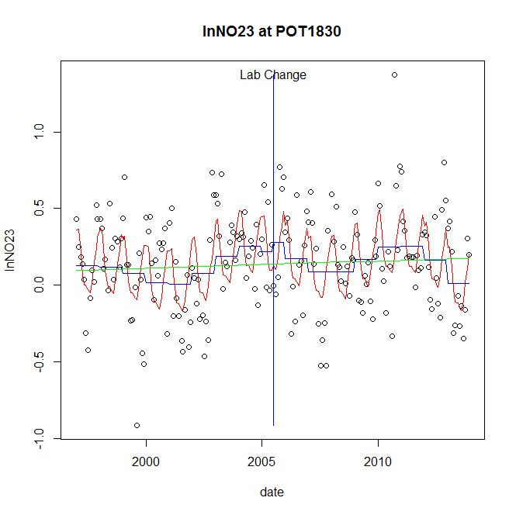

GAM analysis for station POT1830 dependent variable lnNO23

|  |  |  |  |  |
| --- | --- | --- | --- | --- |
| **Type** | **Source** | **edf** | **F-stat** | **p-value** |
| parametric terms | step | 1 | 0.1759 | 0.6754 |
|  | year | 1 | 3.0004 | 0.0849 |
| smoothed terms | s(year) | 6.19 | 2.9568 | 0.0064 |
|  | s(doy) | 4.8 | 8.1104 | <0.0001 |

GAM analysis for station POT1830 dependent variable lnNO23

|  |  |  |  |  |
| --- | --- | --- | --- | --- |
| **parameter** | **estimate** | **Std. Err.** | **t value** | **p-value** |
| (Intercept) | 0.00099 | 0.000593 | 1.6698 | 0.0966 |
| step | 0.056515 | 0.134746 | 0.4194 | 0.6754 |
| year | 6e-05 | 3.5e-05 | 1.7322 | 0.0849 |

root mean-square error = 0.2681

adjusted r-square = 0.2897

station = POT1830 dependent = lnNO2

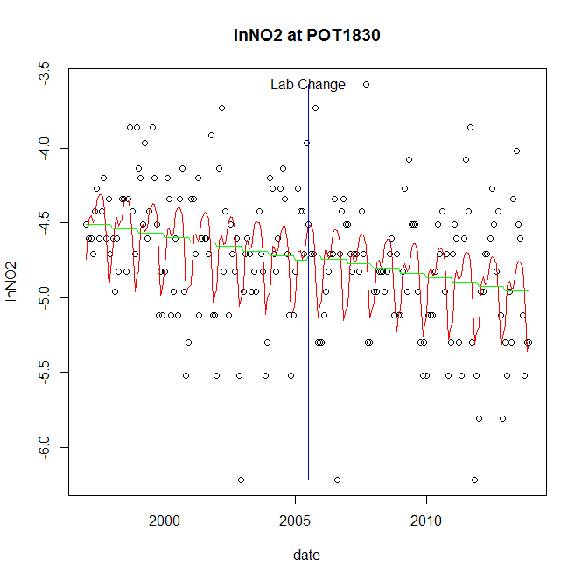

GAM analysis for station POT1830 dependent variable lnNO2

|  |  |  |  |  |
| --- | --- | --- | --- | --- |
| **Type** | **Source** | **edf** | **F-stat** | **p-value** |
| parametric terms | step | 1 | 0.0976 | 0.7550 |
|  | year | 1 | 5914.4129 | <0.0001 |
| smoothed terms | s(year) | 1 | 6.1019 | 0.0143 |
|  | s(doy) | 5.71 | 6.9707 | <0.0001 |

GAM analysis for station POT1830 dependent variable lnNO2

|  |  |  |  |  |
| --- | --- | --- | --- | --- |
| **parameter** | **estimate** | **Std. Err.** | **t value** | **p-value** |
| (Intercept) | 0.000334 | 0.000136 | 2.4617 | 0.0147 |
| step | 0.034749 | 0.111217 | 0.3124 | 0.7550 |
| year | -0.002378 | 3.1e-05 | -76.9052 | <0.0001 |

root mean-square error = 0.3953

adjusted r-square = 0.272

station = POT1830 dependent = lnTP

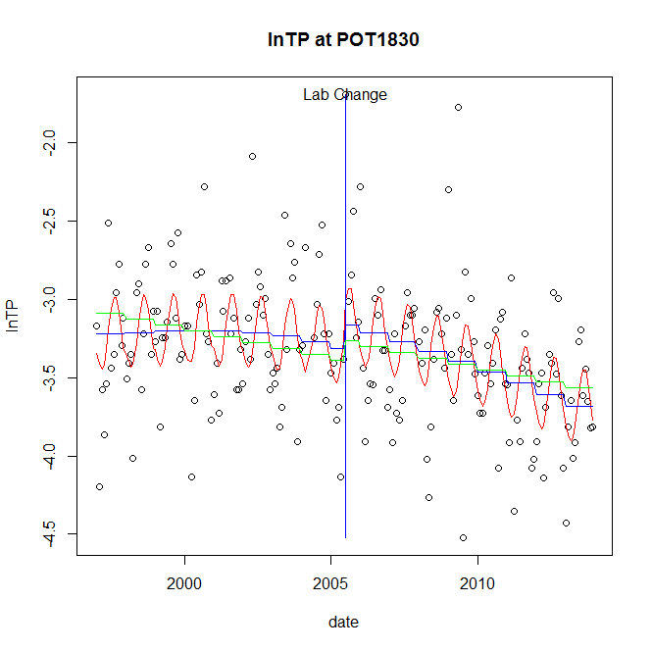

GAM analysis for station POT1830 dependent variable lnTP

|  |  |  |  |  |
| --- | --- | --- | --- | --- |
| **Type** | **Source** | **edf** | **F-stat** | **p-value** |
| parametric terms | step | 1 | 1.4522 | 0.2297 |
|  | year | 1 | 2381.2636 | <0.0001 |
| smoothed terms | s(year) | 2.29 | 7.1416 | 0.0002 |
|  | s(doy) | 2.82 | 4.7145 | <0.0001 |

GAM analysis for station POT1830 dependent variable lnTP

|  |  |  |  |  |
| --- | --- | --- | --- | --- |
| **parameter** | **estimate** | **Std. Err.** | **t value** | **p-value** |
| (Intercept) | 0.00035 | 0.000265 | 1.3214 | 0.1879 |
| step | 0.152129 | 0.126242 | 1.2051 | 0.2297 |
| year | -0.001699 | 3.5e-05 | -48.7982 | <0.0001 |

root mean-square error = 0.3902

adjusted r-square = 0.2678

station = POT1830 dependent = lnPO4

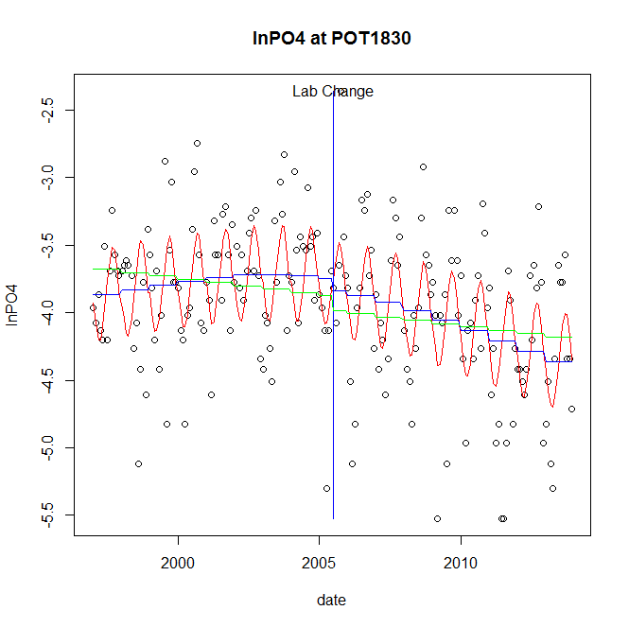

GAM analysis for station POT1830 dependent variable lnPO4

|  |  |  |  |  |
| --- | --- | --- | --- | --- |
| **Type** | **Source** | **edf** | **F-stat** | **p-value** |
| parametric terms | step | 1 | 0.3775 | 0.5397 |
|  | year | 1 | 2442.5701 | <0.0001 |
| smoothed terms | s(year) | 2.29 | 5.6687 | 0.0014 |
|  | s(doy) | 2.96 | 7.7036 | <0.0001 |

GAM analysis for station POT1830 dependent variable lnPO4

|  |  |  |  |  |
| --- | --- | --- | --- | --- |
| **parameter** | **estimate** | **Std. Err.** | **t value** | **p-value** |
| (Intercept) | 0.000223 | 0.000301 | 0.7414 | 0.4593 |
| step | -0.08866 | 0.144298 | -0.6144 | 0.5397 |
| year | -0.001938 | 3.9e-05 | -49.4224 | <0.0001 |

root mean-square error = 0.4553

adjusted r-square = 0.3426

No title given

|  |  |  |  |
| --- | --- | --- | --- |
| **station** | **dep** | **step.est** | **step.pv** |
| POT1830 | lnTSS | -0.511445 | 0.0976 |
| POT1830 | lnTN | 0.08033 | 0.4441 |
| POT1830 | lnNH4 | 0.006852 | 0.9811 |
| POT1830 | lnNO23 | 0.056515 | 0.6754 |
| POT1830 | lnNO2 | 0.034749 | 0.7550 |
| POT1830 | lnTP | 0.152129 | 0.2297 |
| POT1830 | lnPO4 | -0.08866 | 0.5397 |

station = POT2386 dependent = lnTSS

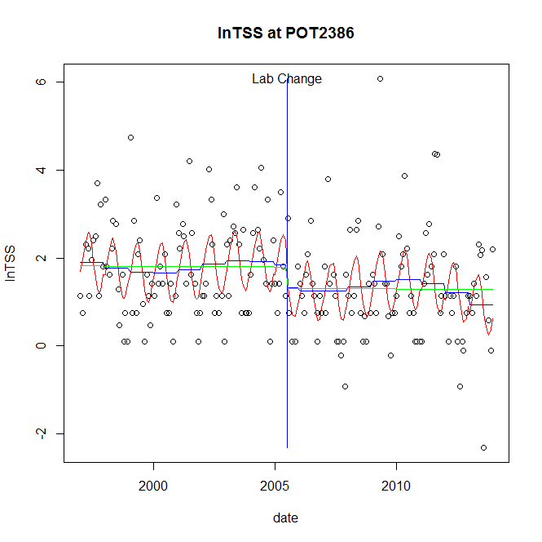

GAM analysis for station POT2386 dependent variable lnTSS

|  |  |  |  |  |
| --- | --- | --- | --- | --- |
| **Type** | **Source** | **edf** | **F-stat** | **p-value** |
| parametric terms | step | 1 | 1.3423 | 0.2481 |
|  | year | 1 | 59.3002 | <0.0001 |
| smoothed terms | s(year) | 4.63 | 1.0362 | 0.3983 |
|  | s(doy) | 3.02 | 6.0893 | <0.0001 |

GAM analysis for station POT2386 dependent variable lnTSS

|  |  |  |  |  |
| --- | --- | --- | --- | --- |
| **parameter** | **estimate** | **Std. Err.** | **t value** | **p-value** |
| (Intercept) | 0.002616 | 0.001588 | 1.6474 | 0.1011 |
| step | -0.516316 | 0.445654 | -1.1586 | 0.2481 |
| year | 0.000893 | 0.000116 | 7.7007 | <0.0001 |

root mean-square error = 1.0023

adjusted r-square = 0.2499

station = POT2386 dependent = lnTN

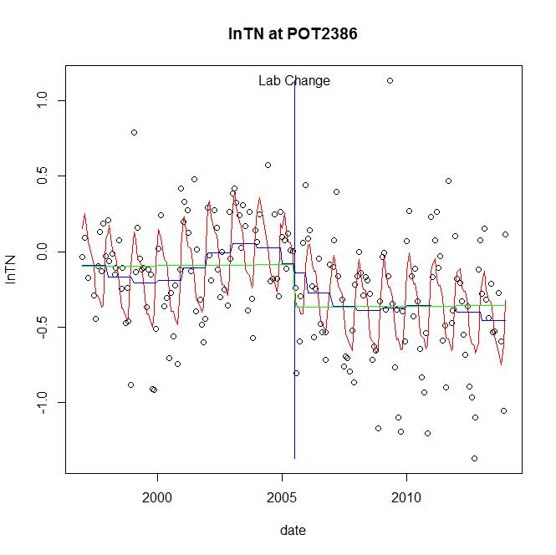

GAM analysis for station POT2386 dependent variable lnTN

|  |  |  |  |  |
| --- | --- | --- | --- | --- |
| **Type** | **Source** | **edf** | **F-stat** | **p-value** |
| parametric terms | step | 1 | 0.1658 | 0.6844 |
|  | year | 1 | 6.1611 | 0.0140 |
| smoothed terms | s(year) | 5.63 | 2.7016 | 0.0135 |
|  | s(doy) | 5.98 | 12.439 | <0.0001 |

GAM analysis for station POT2386 dependent variable lnTN

|  |  |  |  |  |
| --- | --- | --- | --- | --- |
| **parameter** | **estimate** | **Std. Err.** | **t value** | **p-value** |
| (Intercept) | 0.000835 | 0.000609 | 1.3717 | 0.1719 |
| step | -0.059434 | 0.145973 | -0.4072 | 0.6844 |
| year | -9.6e-05 | 3.9e-05 | -2.4821 | 0.0140 |

root mean-square error = 0.2994

adjusted r-square = 0.4358

station = POT2386 dependent = lnNH4

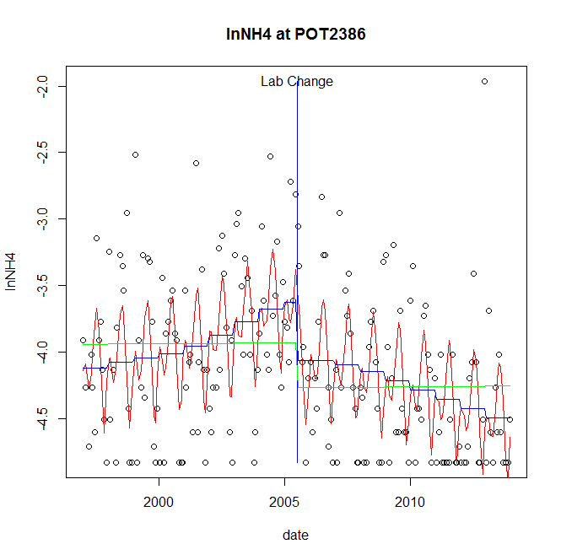

GAM analysis for station POT2386 dependent variable lnNH4

|  |  |  |  |  |
| --- | --- | --- | --- | --- |
| **Type** | **Source** | **edf** | **F-stat** | **p-value** |
| parametric terms | step | 1 | 5.0138 | 0.0263 |
|  | year | 1 | 1357.6698 | <0.0001 |
| smoothed terms | s(year) | 3.54 | 4.6498 | 0.0010 |
|  | s(doy) | 5.91 | 7.1575 | <0.0001 |

GAM analysis for station POT2386 dependent variable lnNH4

|  |  |  |  |  |
| --- | --- | --- | --- | --- |
| **parameter** | **estimate** | **Std. Err.** | **t value** | **p-value** |
| (Intercept) | 0.000134 | 0.00059 | 0.2271 | 0.8206 |
| step | -0.442743 | 0.197727 | -2.2392 | 0.0263 |
| year | -0.001933 | 5.2e-05 | -36.8466 | <0.0001 |

root mean-square error = 0.5131

adjusted r-square = 0.315

step significant

station = POT2386 dependent = lnNO23

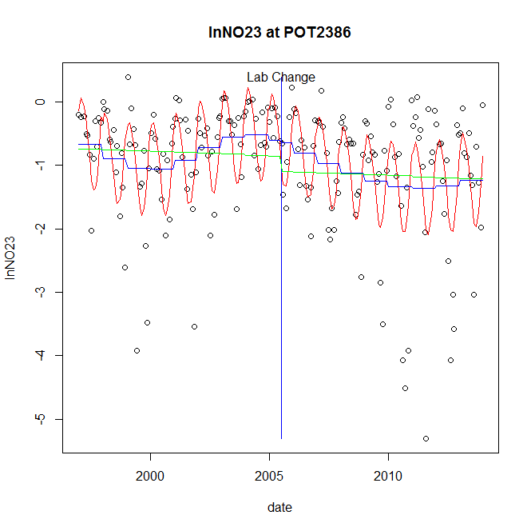

GAM analysis for station POT2386 dependent variable lnNO23

|  |  |  |  |  |
| --- | --- | --- | --- | --- |
| **Type** | **Source** | **edf** | **F-stat** | **p-value** |
| parametric terms | step | 1 | 0.0125 | 0.9109 |
|  | year | 1 | 27.9589 | <0.0001 |
| smoothed terms | s(year) | 4.89 | 3.1041 | 0.0071 |
|  | s(doy) | 3.88 | 12.3976 | <0.0001 |

GAM analysis for station POT2386 dependent variable lnNO23

|  |  |  |  |  |
| --- | --- | --- | --- | --- |
| **parameter** | **estimate** | **Std. Err.** | **t value** | **p-value** |
| (Intercept) | 0.000896 | 0.00126 | 0.7118 | 0.4775 |
| step | -0.037631 | 0.335926 | -0.112 | 0.9109 |
| year | -0.000464 | 8.8e-05 | -5.2876 | <0.0001 |

root mean-square error = 0.7523

adjusted r-square = 0.3887

station = POT2386 dependent = lnNO2

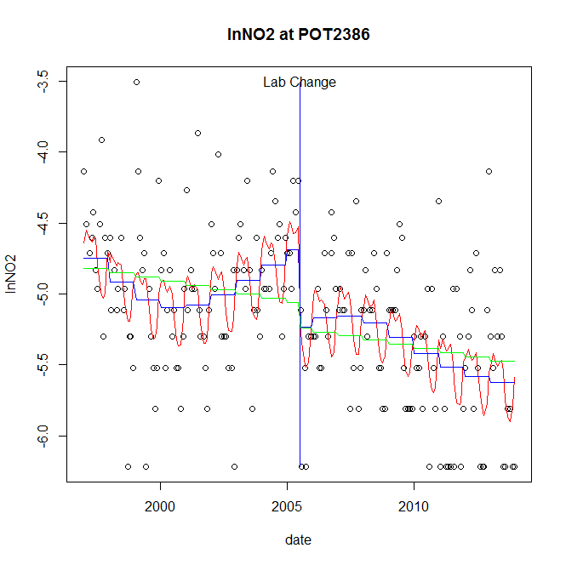

GAM analysis for station POT2386 dependent variable lnNO2

|  |  |  |  |  |
| --- | --- | --- | --- | --- |
| **Type** | **Source** | **edf** | **F-stat** | **p-value** |
| parametric terms | step | 1 | 7.808 | 0.0057 |
|  | year | 1 | 2242.2515 | <0.0001 |
| smoothed terms | s(year) | 4.45 | 4.741 | 0.0003 |
|  | s(doy) | 4.49 | 3.8386 | <0.0001 |

GAM analysis for station POT2386 dependent variable lnNO2

|  |  |  |  |  |
| --- | --- | --- | --- | --- |
| **parameter** | **estimate** | **Std. Err.** | **t value** | **p-value** |
| (Intercept) | 0.001248 | 0.000688 | 1.8146 | 0.0711 |
| step | -0.547096 | 0.195791 | -2.7943 | 0.0057 |
| year | -0.002432 | 5.1e-05 | -47.3524 | <0.0001 |

root mean-square error = 0.4581

adjusted r-square = 0.3351

step significant

station = POT2386 dependent = lnTP

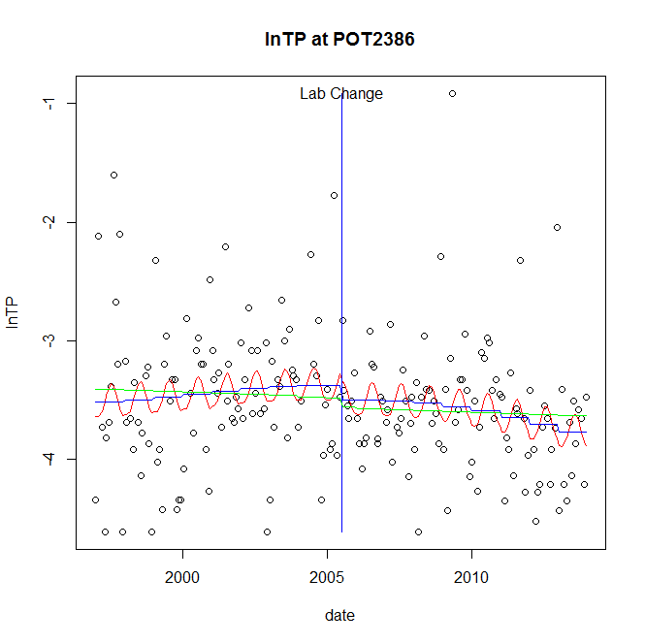

GAM analysis for station POT2386 dependent variable lnTP

|  |  |  |  |  |
| --- | --- | --- | --- | --- |
| **Type** | **Source** | **edf** | **F-stat** | **p-value** |
| parametric terms | step | 1 | 0.4909 | 0.4844 |
|  | year | 1 | 1235.4866 | <0.0001 |
| smoothed terms | s(year) | 2.22 | 1.8401 | 0.1447 |
|  | s(doy) | 2.02 | 1.095 | 0.0057 |

GAM analysis for station POT2386 dependent variable lnTP

|  |  |  |  |  |
| --- | --- | --- | --- | --- |
| **parameter** | **estimate** | **Std. Err.** | **t value** | **p-value** |
| (Intercept) | 0.000255 | 0.000359 | 0.7099 | 0.4786 |
| step | -0.12394 | 0.176903 | -0.7006 | 0.4844 |
| year | -0.001726 | 4.9e-05 | -35.1495 | <0.0001 |

root mean-square error = 0.5541

adjusted r-square = 0.0715

station = POT2386 dependent = lnPO4

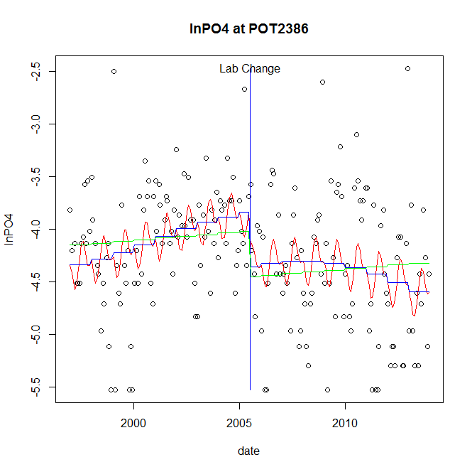

GAM analysis for station POT2386 dependent variable lnPO4

|  |  |  |  |  |
| --- | --- | --- | --- | --- |
| **Type** | **Source** | **edf** | **F-stat** | **p-value** |
| parametric terms | step | 1 | 7.0555 | 0.0086 |
|  | year | 1 | 1455.2031 | <0.0001 |
| smoothed terms | s(year) | 2.72 | 3.8937 | 0.0077 |
|  | s(doy) | 3.6 | 1.8002 | 0.0022 |

GAM analysis for station POT2386 dependent variable lnPO4

|  |  |  |  |  |
| --- | --- | --- | --- | --- |
| **parameter** | **estimate** | **Std. Err.** | **t value** | **p-value** |
| (Intercept) | 0.000188 | 0.000472 | 0.3976 | 0.6914 |
| step | -0.513469 | 0.193308 | -2.6562 | 0.0086 |
| year | -0.001988 | 5.2e-05 | -38.1471 | <0.0001 |

root mean-square error = 0.5672

adjusted r-square = 0.1546

step significant

No title given

|  |  |  |  |
| --- | --- | --- | --- |
| **station** | **dep** | **step.est** | **step.pv** |
| POT2386 | lnTSS | -0.516316 | 0.2481 |
| POT2386 | lnTN | -0.059434 | 0.6844 |
| POT2386 | lnNH4 | -0.442743 | 0.0263 |
| POT2386 | lnNO23 | -0.037631 | 0.9109 |
| POT2386 | lnNO2 | -0.547096 | 0.0057 |
| POT2386 | lnTP | -0.12394 | 0.4844 |
| POT2386 | lnPO4 | -0.513469 | 0.0086 |

station = POT2766 dependent = lnTSS

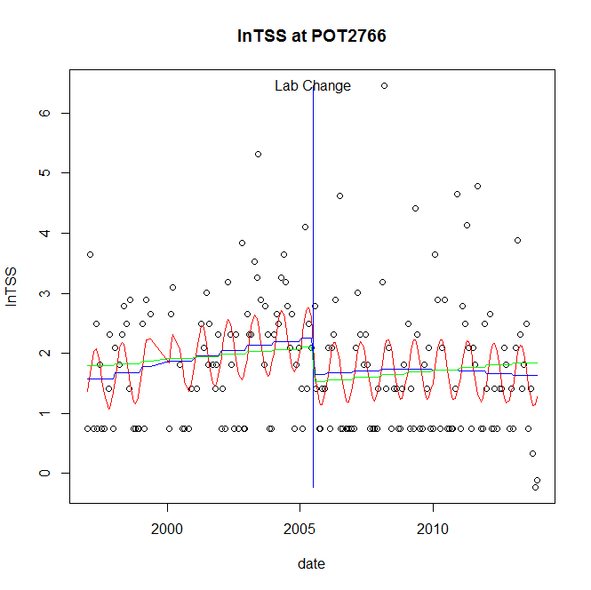

GAM analysis for station POT2766 dependent variable lnTSS

|  |  |  |  |  |
| --- | --- | --- | --- | --- |
| **Type** | **Source** | **edf** | **F-stat** | **p-value** |
| parametric terms | step | 1 | 4.0554 | 0.0455 |
|  | year | 1 | 141.3702 | <0.0001 |
| smoothed terms | s(year) | 1.97 | 2.3955 | 0.0829 |
|  | s(doy) | 2.39 | 3.5745 | <0.0001 |

GAM analysis for station POT2766 dependent variable lnTSS

|  |  |  |  |  |
| --- | --- | --- | --- | --- |
| **parameter** | **estimate** | **Std. Err.** | **t value** | **p-value** |
| (Intercept) | -0.000341 | 0.000533 | -0.6407 | 0.5225 |
| step | -0.60925 | 0.302536 | -2.0138 | 0.0455 |
| year | 0.001061 | 8.9e-05 | 11.8899 | <0.0001 |

root mean-square error = 0.9952

adjusted r-square = 0.1755

step significant

station = POT2766 dependent = lnTN

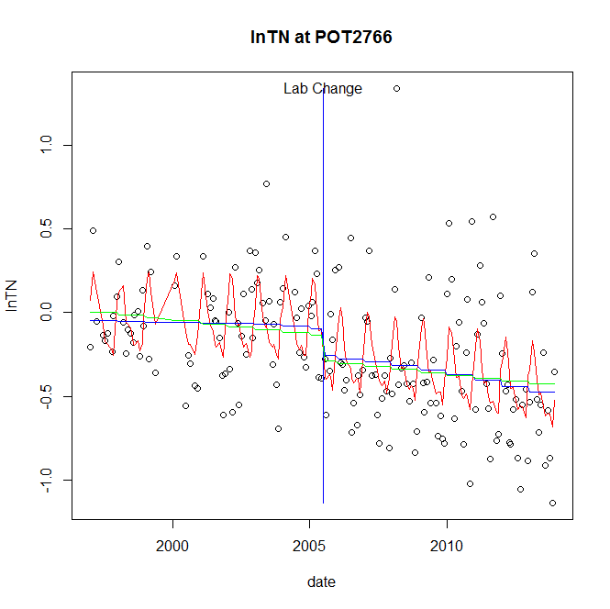

GAM analysis for station POT2766 dependent variable lnTN

|  |  |  |  |  |
| --- | --- | --- | --- | --- |
| **Type** | **Source** | **edf** | **F-stat** | **p-value** |
| parametric terms | step | 1 | 2.713 | 0.1014 |
|  | year | 1 | 5.2223 | 0.0235 |
| smoothed terms | s(year) | 1.86 | 1.9747 | 0.1338 |
|  | s(doy) | 5.79 | 5.9491 | <0.0001 |

GAM analysis for station POT2766 dependent variable lnTN

|  |  |  |  |  |
| --- | --- | --- | --- | --- |
| **parameter** | **estimate** | **Std. Err.** | **t value** | **p-value** |
| (Intercept) | 0.000226 | 0.000163 | 1.3924 | 0.1656 |
| step | -0.162683 | 0.098768 | -1.6471 | 0.1014 |
| year | -6.9e-05 | 3e-05 | -2.2852 | 0.0235 |

root mean-square error = 0.3209

adjusted r-square = 0.3257

station = POT2766 dependent = lnNH4

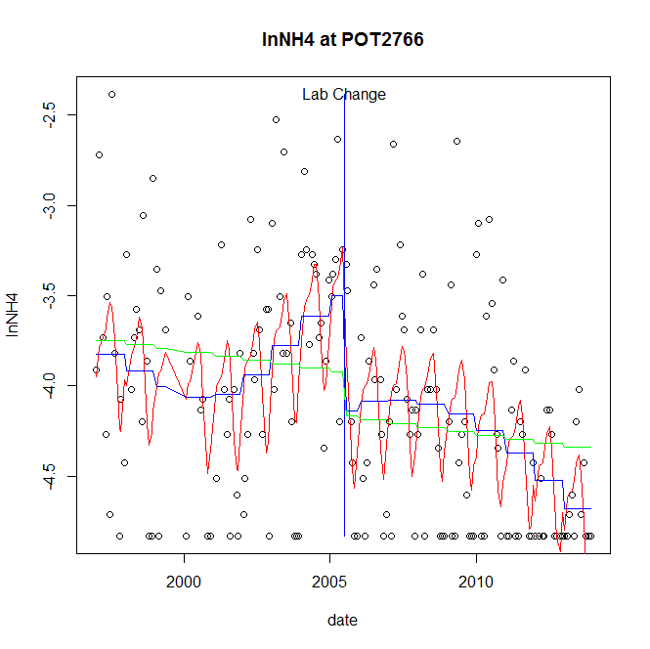

GAM analysis for station POT2766 dependent variable lnNH4

|  |  |  |  |  |
| --- | --- | --- | --- | --- |
| **Type** | **Source** | **edf** | **F-stat** | **p-value** |
| parametric terms | step | 1 | 8.7906 | 0.0034 |
|  | year | 1 | 926.7462 | <0.0001 |
| smoothed terms | s(year) | 4.27 | 5.5043 | <0.0001 |
|  | s(doy) | 4.21 | 5.2421 | <0.0001 |

GAM analysis for station POT2766 dependent variable lnNH4

|  |  |  |  |  |
| --- | --- | --- | --- | --- |
| **parameter** | **estimate** | **Std. Err.** | **t value** | **p-value** |
| (Intercept) | 0.001424 | 0.000739 | 1.9271 | 0.0556 |
| step | -0.640597 | 0.21606 | -2.9649 | 0.0034 |
| year | -0.001866 | 6.1e-05 | -30.4425 | <0.0001 |

root mean-square error = 0.5088

adjusted r-square = 0.3582

step significant

station = POT2766 dependent = lnNO23

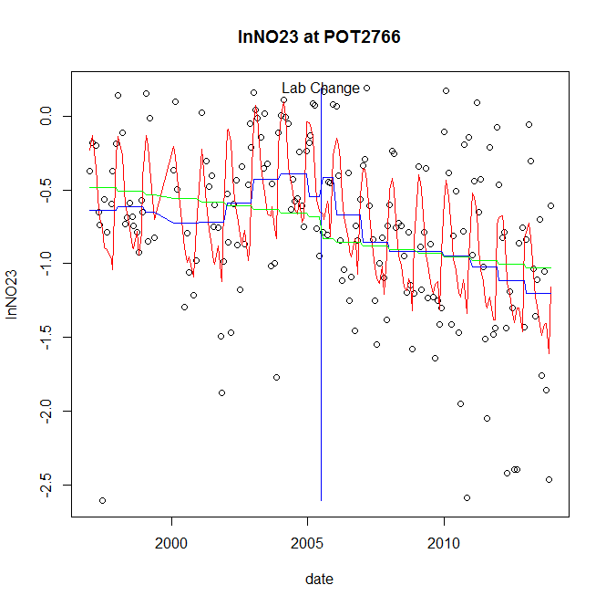

GAM analysis for station POT2766 dependent variable lnNO23

|  |  |  |  |  |
| --- | --- | --- | --- | --- |
| **Type** | **Source** | **edf** | **F-stat** | **p-value** |
| parametric terms | step | 1 | 0.3248 | 0.5695 |
|  | year | 1 | 41.2601 | <0.0001 |
| smoothed terms | s(year) | 6.07 | 3.9399 | 0.0006 |
|  | s(doy) | 6.93 | 9.9823 | <0.0001 |

GAM analysis for station POT2766 dependent variable lnNO23

|  |  |  |  |  |
| --- | --- | --- | --- | --- |
| **parameter** | **estimate** | **Std. Err.** | **t value** | **p-value** |
| (Intercept) | 0.000259 | 0.001015 | 0.2551 | 0.7990 |
| step | 0.13031 | 0.228635 | 0.5699 | 0.5695 |
| year | -0.000411 | 6.4e-05 | -6.4234 | <0.0001 |

root mean-square error = 0.4529

adjusted r-square = 0.4044

station = POT2766 dependent = lnNO2

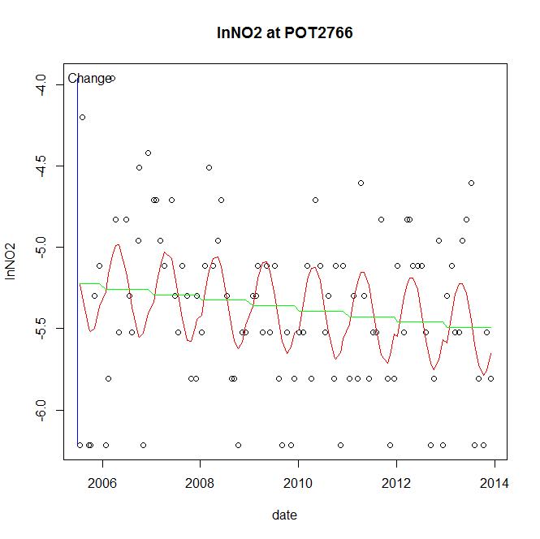

GAM analysis for station POT2766 dependent variable lnNO2

|  |  |  |  |  |
| --- | --- | --- | --- | --- |
| **Type** | **Source** | **edf** | **F-stat** | **p-value** |
| parametric terms | step | 1 | 2.7159 | 0.1026 |
|  | year | 1 | 14148.8515 | <0.0001 |
| smoothed terms | s(year) | 1 | 2.7952 | 0.0977 |
|  | s(doy) | 2.27 | 2.8875 | <0.0001 |

GAM analysis for station POT2766 dependent variable lnNO2

|  |  |  |  |  |
| --- | --- | --- | --- | --- |
| **parameter** | **estimate** | **Std. Err.** | **t value** | **p-value** |
| (Intercept) | 9.2e-05 | 5.6e-05 | 1.648 | 0.1026 |
| step | 9.2e-05 | 5.6e-05 | 1.648 | 0.1026 |
| year | -0.002681 | 2.3e-05 | -118.9489 | <0.0001 |

root mean-square error = 0.4573

adjusted r-square = 0.2028

station = POT2766 dependent = lnTP

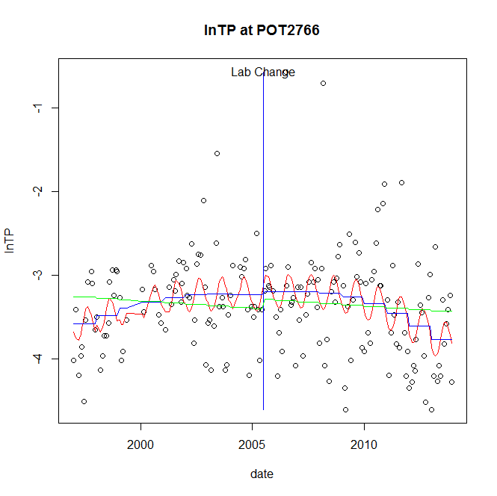

GAM analysis for station POT2766 dependent variable lnTP

|  |  |  |  |  |
| --- | --- | --- | --- | --- |
| **Type** | **Source** | **edf** | **F-stat** | **p-value** |
| parametric terms | step | 1 | 0.034 | 0.8539 |
|  | year | 1 | 728.8184 | <0.0001 |
| smoothed terms | s(year) | 3.17 | 4.604 | 0.0016 |
|  | s(doy) | 2.1 | 1.8134 | 0.0002 |

GAM analysis for station POT2766 dependent variable lnTP

|  |  |  |  |  |
| --- | --- | --- | --- | --- |
| **parameter** | **estimate** | **Std. Err.** | **t value** | **p-value** |
| (Intercept) | 0.000361 | 0.00058 | 0.6226 | 0.5343 |
| step | 0.03924 | 0.212818 | 0.1844 | 0.8539 |
| year | -0.001684 | 6.2e-05 | -26.9966 | <0.0001 |

root mean-square error = 0.5665

adjusted r-square = 0.1558

station = POT2766 dependent = lnPO4

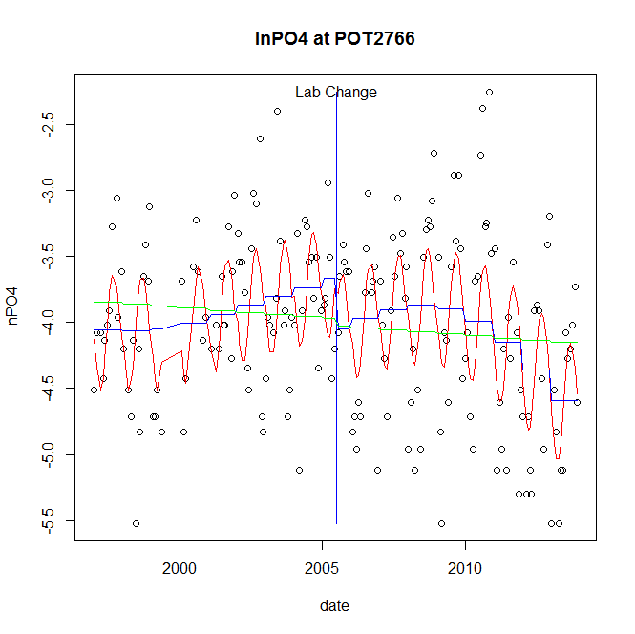

GAM analysis for station POT2766 dependent variable lnPO4

|  |  |  |  |  |
| --- | --- | --- | --- | --- |
| **Type** | **Source** | **edf** | **F-stat** | **p-value** |
| parametric terms | step | 1 | 2.9191 | 0.0893 |
|  | year | 1 | 876.4147 | <0.0001 |
| smoothed terms | s(year) | 3.83 | 5.4609 | 0.0002 |
|  | s(doy) | 2.78 | 7.6974 | <0.0001 |

GAM analysis for station POT2766 dependent variable lnPO4

|  |  |  |  |  |
| --- | --- | --- | --- | --- |
| **parameter** | **estimate** | **Std. Err.** | **t value** | **p-value** |
| (Intercept) | 0.001402 | 0.000707 | 1.9844 | 0.0487 |
| step | -0.383633 | 0.224537 | -1.7085 | 0.0893 |
| year | -0.001895 | 6.4e-05 | -29.6043 | <0.0001 |

root mean-square error = 0.5577

adjusted r-square = 0.3334

No title given

|  |  |  |  |
| --- | --- | --- | --- |
| **station** | **dep** | **step.est** | **step.pv** |
| POT2766 | lnTSS | -0.60925 | 0.0455 |
| POT2766 | lnTN | -0.162683 | 0.1014 |
| POT2766 | lnNH4 | -0.640597 | 0.0034 |
| POT2766 | lnNO23 | 0.13031 | 0.5695 |
| POT2766 | lnNO2 | 9.2e-05 | 0.1026 |
| POT2766 | lnTP | 0.03924 | 0.8539 |
| POT2766 | lnPO4 | -0.383633 | 0.0893 |

station = PXT0809 dependent = lnTSS

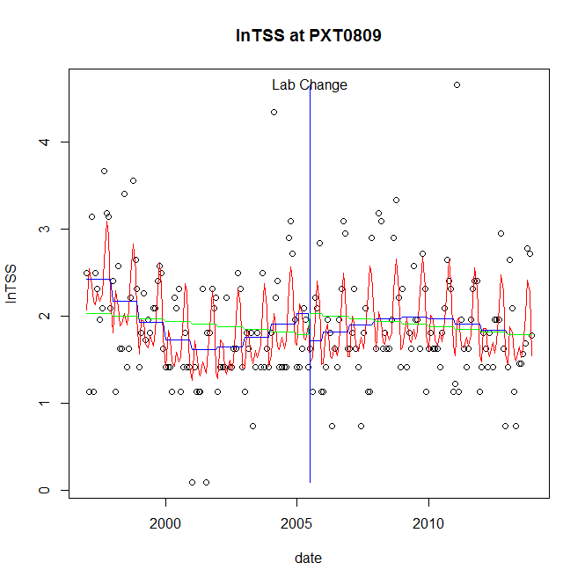

GAM analysis for station PXT0809 dependent variable lnTSS

|  |  |  |  |  |
| --- | --- | --- | --- | --- |
| **Type** | **Source** | **edf** | **F-stat** | **p-value** |
| parametric terms | step | 1 | 1.6927 | 0.1948 |
|  | year | 1 | 270.6282 | <0.0001 |
| smoothed terms | s(year) | 4.45 | 4.9085 | 0.0002 |
|  | s(doy) | 6.99 | 8.8385 | <0.0001 |

GAM analysis for station PXT0809 dependent variable lnTSS

|  |  |  |  |  |
| --- | --- | --- | --- | --- |
| **parameter** | **estimate** | **Std. Err.** | **t value** | **p-value** |
| (Intercept) | 0.001831 | 0.000836 | 2.1895 | 0.0298 |
| step | -0.30773 | 0.236523 | -1.3011 | 0.1948 |
| year | 0.001012 | 6.2e-05 | 16.4508 | <0.0001 |

root mean-square error = 0.5534

adjusted r-square = 0.3152

station = PXT0809 dependent = lnTN

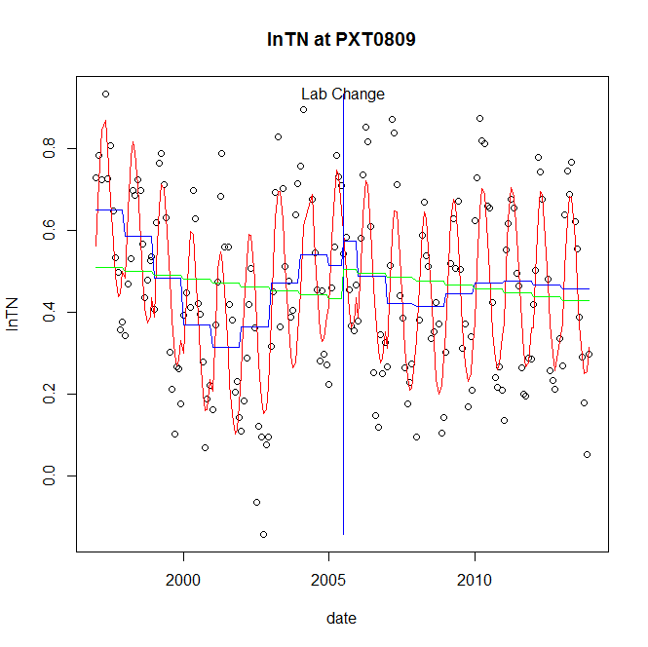

GAM analysis for station PXT0809 dependent variable lnTN

|  |  |  |  |  |
| --- | --- | --- | --- | --- |
| **Type** | **Source** | **edf** | **F-stat** | **p-value** |
| parametric terms | step | 1 | 0.7122 | 0.3998 |
|  | year | 1 | 135.6741 | <0.0001 |
| smoothed terms | s(year) | 6.67 | 10.693 | <0.0001 |
|  | s(doy) | 3.75 | 34.8594 | <0.0001 |

GAM analysis for station PXT0809 dependent variable lnTN

|  |  |  |  |  |
| --- | --- | --- | --- | --- |
| **parameter** | **estimate** | **Std. Err.** | **t value** | **p-value** |
| (Intercept) | 0.000401 | 0.000325 | 1.232 | 0.2195 |
| step | 0.059086 | 0.070013 | 0.8439 | 0.3998 |
| year | 0.000212 | 1.8e-05 | 11.6479 | <0.0001 |

root mean-square error = 0.1328

adjusted r-square = 0.6439

station = PXT0809 dependent = lnNH4

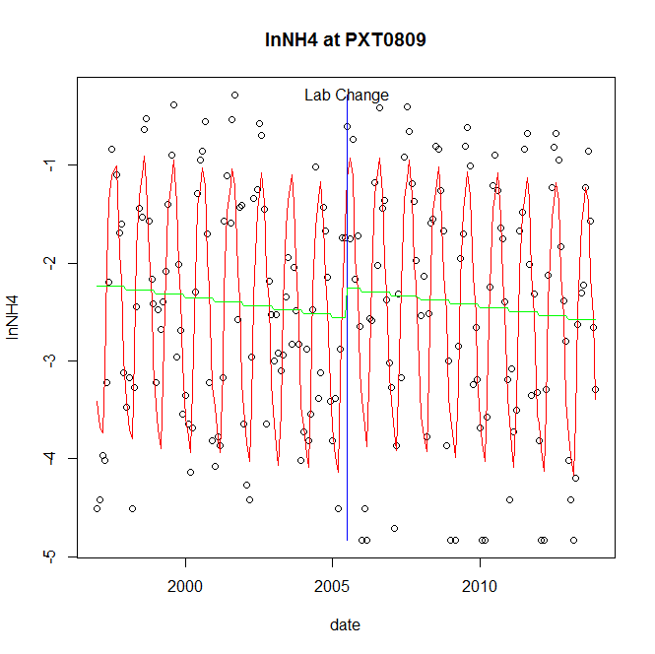

GAM analysis for station PXT0809 dependent variable lnNH4

|  |  |  |  |  |
| --- | --- | --- | --- | --- |
| **Type** | **Source** | **edf** | **F-stat** | **p-value** |
| parametric terms | step | 1 | 2.6115 | 0.1077 |
|  | year | 1 | 628.4504 | <0.0001 |
| smoothed terms | s(year) | 1.07 | 3.5032 | 0.0573 |
|  | s(doy) | 7.19 | 59.5225 | <0.0001 |

GAM analysis for station PXT0809 dependent variable lnNH4

|  |  |  |  |  |
| --- | --- | --- | --- | --- |
| **parameter** | **estimate** | **Std. Err.** | **t value** | **p-value** |
| (Intercept) | 0.000461 | 0.000232 | 1.9912 | 0.0479 |
| step | 0.302647 | 0.187278 | 1.616 | 0.1077 |
| year | -0.001305 | 5.2e-05 | -25.0689 | <0.0001 |

root mean-square error = 0.6617

adjusted r-square = 0.708

station = PXT0809 dependent = lnNO23

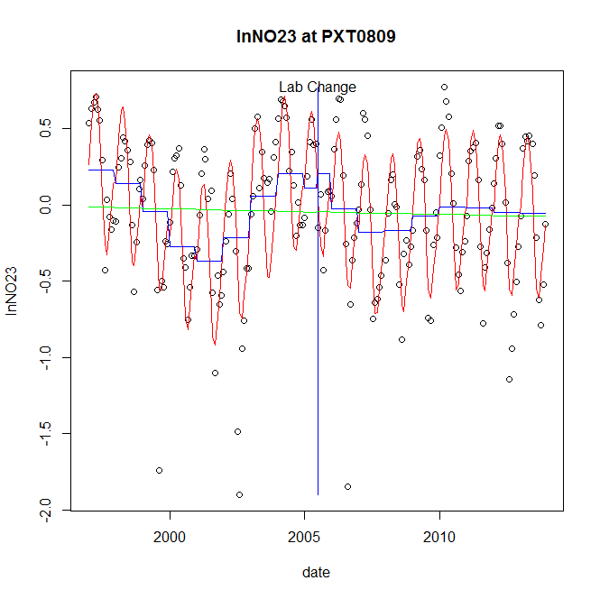

GAM analysis for station PXT0809 dependent variable lnNO23

|  |  |  |  |  |
| --- | --- | --- | --- | --- |
| **Type** | **Source** | **edf** | **F-stat** | **p-value** |
| parametric terms | step | 1 | 0.4152 | 0.5201 |
|  | year | 1 | 1.3986 | 0.2385 |
| smoothed terms | s(year) | 6.78 | 10.1052 | <0.0001 |
|  | s(doy) | 5.21 | 43.0191 | <0.0001 |

GAM analysis for station PXT0809 dependent variable lnNO23

|  |  |  |  |  |
| --- | --- | --- | --- | --- |
| **parameter** | **estimate** | **Std. Err.** | **t value** | **p-value** |
| (Intercept) | 0.000429 | 0.000677 | 0.6335 | 0.5272 |
| step | 0.093684 | 0.145393 | 0.6443 | 0.5201 |
| year | -4.4e-05 | 3.7e-05 | -1.1826 | 0.2385 |

root mean-square error = 0.2746

adjusted r-square = 0.6783

station = PXT0809 dependent = lnNO2

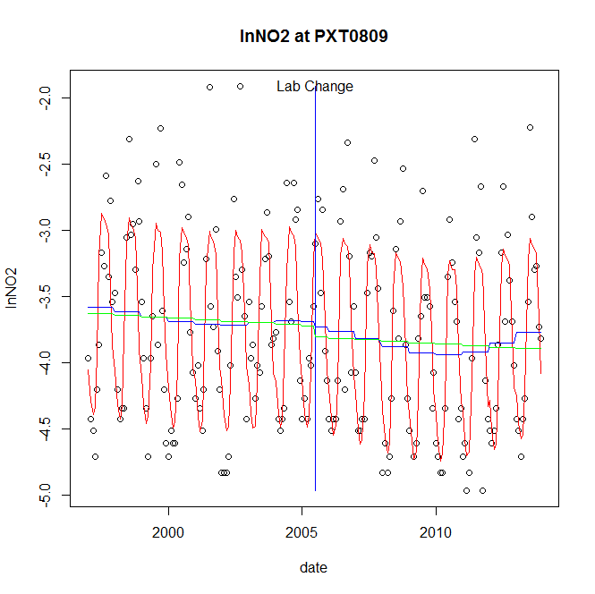

GAM analysis for station PXT0809 dependent variable lnNO2

|  |  |  |  |  |
| --- | --- | --- | --- | --- |
| **Type** | **Source** | **edf** | **F-stat** | **p-value** |
| parametric terms | step | 1 | 0.0689 | 0.7933 |
|  | year | 1 | 1899.6933 | <0.0001 |
| smoothed terms | s(year) | 3.88 | 0.9363 | 0.4529 |
|  | s(doy) | 6.34 | 50.2044 | <0.0001 |

GAM analysis for station PXT0809 dependent variable lnNO2

|  |  |  |  |  |
| --- | --- | --- | --- | --- |
| **parameter** | **estimate** | **Std. Err.** | **t value** | **p-value** |
| (Intercept) | -0.000331 | 0.000528 | -0.628 | 0.5307 |
| step | -0.043067 | 0.164111 | -0.2624 | 0.7933 |
| year | -0.001873 | 4.3e-05 | -43.5855 | <0.0001 |

root mean-square error = 0.4091

adjusted r-square = 0.6746

station = PXT0809 dependent = lnTP

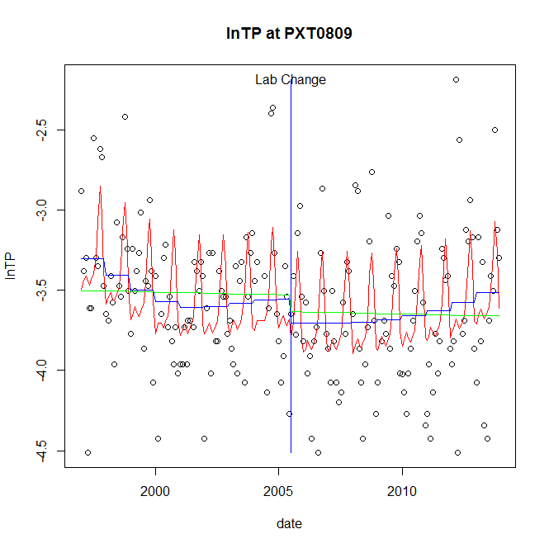

GAM analysis for station PXT0809 dependent variable lnTP

|  |  |  |  |  |
| --- | --- | --- | --- | --- |
| **Type** | **Source** | **edf** | **F-stat** | **p-value** |
| parametric terms | step | 1 | 0.9569 | 0.3292 |
|  | year | 1 | 1843.0393 | <0.0001 |
| smoothed terms | s(year) | 3.67 | 2.2897 | 0.0537 |
|  | s(doy) | 5.62 | 7.406 | <0.0001 |

GAM analysis for station PXT0809 dependent variable lnTP

|  |  |  |  |  |
| --- | --- | --- | --- | --- |
| **parameter** | **estimate** | **Std. Err.** | **t value** | **p-value** |
| (Intercept) | 0.000216 | 0.000473 | 0.4555 | 0.6493 |
| step | -0.149307 | 0.15263 | -0.9782 | 0.3292 |
| year | -0.00175 | 4.1e-05 | -42.9306 | <0.0001 |

root mean-square error = 0.3834

adjusted r-square = 0.267

station = PXT0809 dependent = lnPO4

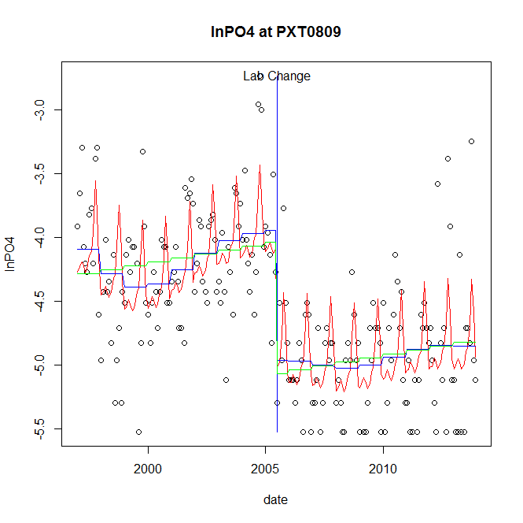

GAM analysis for station PXT0809 dependent variable lnPO4

|  |  |  |  |  |
| --- | --- | --- | --- | --- |
| **Type** | **Source** | **edf** | **F-stat** | **p-value** |
| parametric terms | step | 1 | 27.1423 | <0.0001 |
|  | year | 1 | 1600.0217 | <0.0001 |
| smoothed terms | s(year) | 5.24 | 3.1411 | 0.0056 |
|  | s(doy) | 6.43 | 6.7728 | <0.0001 |

GAM analysis for station PXT0809 dependent variable lnPO4

|  |  |  |  |  |
| --- | --- | --- | --- | --- |
| **parameter** | **estimate** | **Std. Err.** | **t value** | **p-value** |
| (Intercept) | 0.001306 | 0.000773 | 1.6889 | 0.0929 |
| step | -1.018823 | 0.195558 | -5.2098 | <0.0001 |
| year | -0.00202 | 5.1e-05 | -40.0003 | <0.0001 |

root mean-square error = 0.423

adjusted r-square = 0.5264

step significant

No title given

|  |  |  |  |
| --- | --- | --- | --- |
| **station** | **dep** | **step.est** | **step.pv** |
| PXT0809 | lnTSS | -0.30773 | 0.1948 |
| PXT0809 | lnTN | 0.059086 | 0.3998 |
| PXT0809 | lnNH4 | 0.302647 | 0.1077 |
| PXT0809 | lnNO23 | 0.093684 | 0.5201 |
| PXT0809 | lnNO2 | -0.043067 | 0.7933 |
| PXT0809 | lnTP | -0.149307 | 0.3292 |
| PXT0809 | lnPO4 | -1.018823 | <0.0001 |

station = PXT0972 dependent = lnTSS

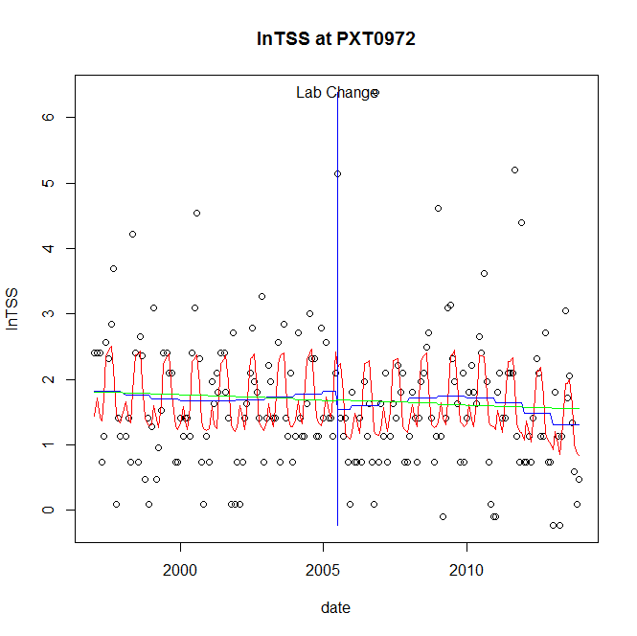

GAM analysis for station PXT0972 dependent variable lnTSS

|  |  |  |  |  |
| --- | --- | --- | --- | --- |
| **Type** | **Source** | **edf** | **F-stat** | **p-value** |
| parametric terms | step | 1 | 0.6228 | 0.4310 |
|  | year | 1 | 90.9256 | <0.0001 |
| smoothed terms | s(year) | 3.27 | 0.795 | 0.5317 |
|  | s(doy) | 6.15 | 5.8759 | <0.0001 |

GAM analysis for station PXT0972 dependent variable lnTSS

|  |  |  |  |  |
| --- | --- | --- | --- | --- |
| **parameter** | **estimate** | **Std. Err.** | **t value** | **p-value** |
| (Intercept) | 0.001493 | 0.000964 | 1.5477 | 0.1234 |
| step | -0.271019 | 0.343422 | -0.7892 | 0.4310 |
| year | 0.000881 | 9.2e-05 | 9.5355 | <0.0001 |

root mean-square error = 0.9266

adjusted r-square = 0.185

station = PXT0972 dependent = lnTN

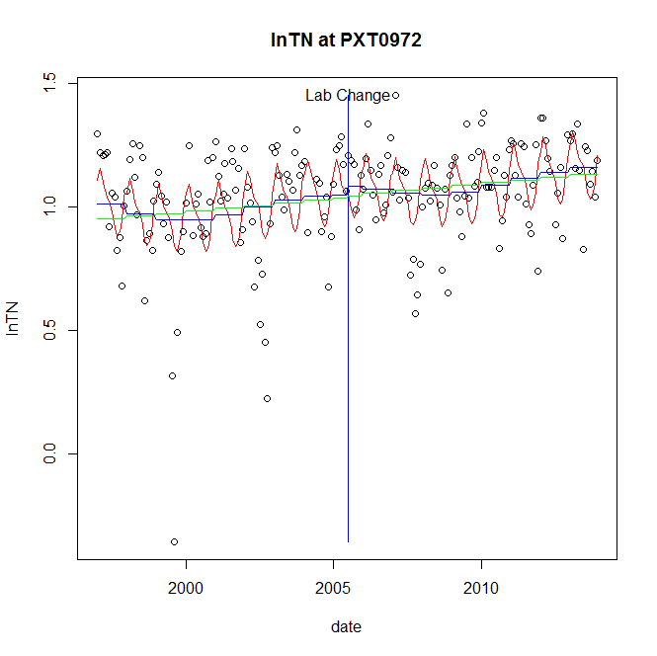

GAM analysis for station PXT0972 dependent variable lnTN

|  |  |  |  |  |
| --- | --- | --- | --- | --- |
| **Type** | **Source** | **edf** | **F-stat** | **p-value** |
| parametric terms | step | 1 | 0.2204 | 0.6393 |
|  | year | 1 | 537.5779 | <0.0001 |
| smoothed terms | s(year) | 4.35 | 1.5889 | 0.1609 |
|  | s(doy) | 4.52 | 5.2976 | <0.0001 |

GAM analysis for station PXT0972 dependent variable lnTN

|  |  |  |  |  |
| --- | --- | --- | --- | --- |
| **parameter** | **estimate** | **Std. Err.** | **t value** | **p-value** |
| (Intercept) | 0.000151 | 0.000286 | 0.5275 | 0.5985 |
| step | 0.038918 | 0.082891 | 0.4695 | 0.6393 |
| year | 0.000512 | 2.2e-05 | 23.1857 | <0.0001 |

root mean-square error = 0.1932

adjusted r-square = 0.2344

station = PXT0972 dependent = lnNH4

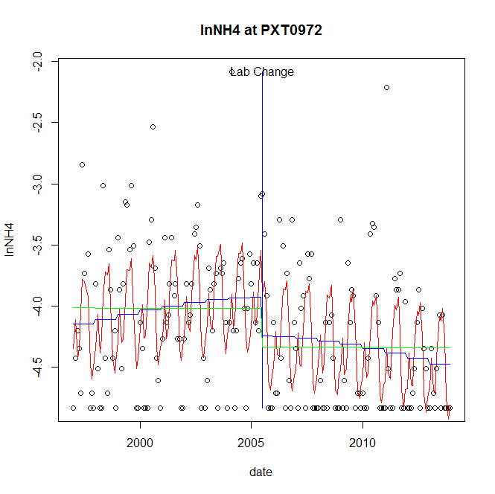

GAM analysis for station PXT0972 dependent variable lnNH4

|  |  |  |  |  |
| --- | --- | --- | --- | --- |
| **Type** | **Source** | **edf** | **F-stat** | **p-value** |
| parametric terms | step | 1 | 4.4651 | 0.0359 |
|  | year | 1 | 2352.81 | <0.0001 |
| smoothed terms | s(year) | 2.11 | 2.3692 | 0.0811 |
|  | s(doy) | 6.71 | 9.7064 | <0.0001 |

GAM analysis for station PXT0972 dependent variable lnNH4

|  |  |  |  |  |
| --- | --- | --- | --- | --- |
| **parameter** | **estimate** | **Std. Err.** | **t value** | **p-value** |
| (Intercept) | 1.8e-05 | 0.000287 | 0.0619 | 0.9507 |
| step | -0.317597 | 0.150301 | -2.1131 | 0.0359 |
| year | -0.002017 | 4.2e-05 | -48.5058 | <0.0001 |

root mean-square error = 0.4876

adjusted r-square = 0.3329

step significant

station = PXT0972 dependent = lnNO23

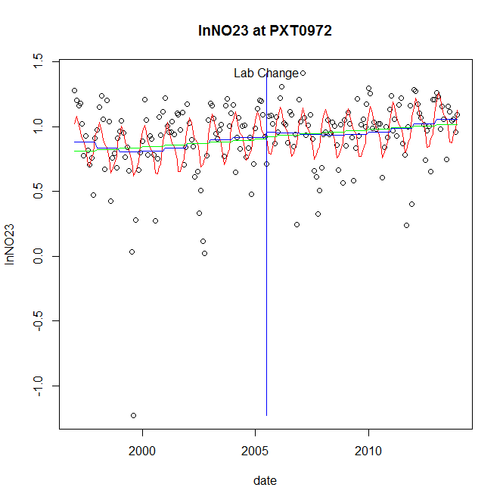

GAM analysis for station PXT0972 dependent variable lnNO23

|  |  |  |  |  |
| --- | --- | --- | --- | --- |
| **Type** | **Source** | **edf** | **F-stat** | **p-value** |
| parametric terms | step | 1 | 0.1677 | 0.6826 |
|  | year | 1 | 268.4179 | <0.0001 |
| smoothed terms | s(year) | 4 | 1.1263 | 0.3463 |
|  | s(doy) | 5.72 | 5.9572 | <0.0001 |

GAM analysis for station PXT0972 dependent variable lnNO23

|  |  |  |  |  |
| --- | --- | --- | --- | --- |
| **parameter** | **estimate** | **Std. Err.** | **t value** | **p-value** |
| (Intercept) | 8.9e-05 | 0.000338 | 0.2634 | 0.7925 |
| step | 0.042439 | 0.103635 | 0.4095 | 0.6826 |
| year | 0.00045 | 2.7e-05 | 16.3835 | <0.0001 |

root mean-square error = 0.2552

adjusted r-square = 0.2252

station = PXT0972 dependent = lnNO2

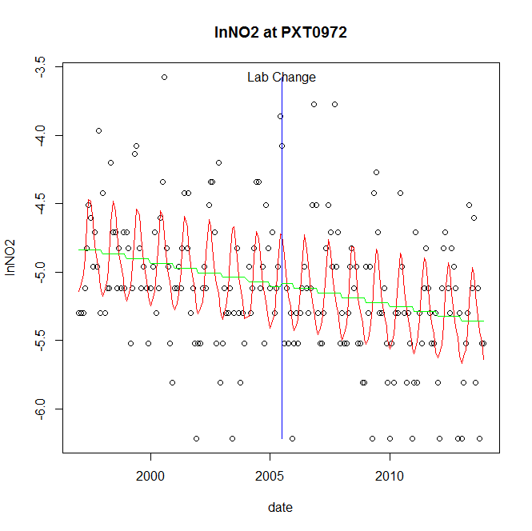

GAM analysis for station PXT0972 dependent variable lnNO2

|  |  |  |  |  |
| --- | --- | --- | --- | --- |
| **Type** | **Source** | **edf** | **F-stat** | **p-value** |
| parametric terms | step | 1 | 0.0278 | 0.8679 |
|  | year | 1 | 5852.2866 | <0.0001 |
| smoothed terms | s(year) | 1 | 6.6976 | 0.0104 |
|  | s(doy) | 4.73 | 7.8932 | <0.0001 |

GAM analysis for station PXT0972 dependent variable lnNO2

|  |  |  |  |  |
| --- | --- | --- | --- | --- |
| **parameter** | **estimate** | **Std. Err.** | **t value** | **p-value** |
| (Intercept) | 0.000373 | 0.000145 | 2.5794 | 0.0106 |
| step | 0.019802 | 0.118862 | 0.1666 | 0.8679 |
| year | -0.002558 | 3.3e-05 | -76.5002 | <0.0001 |

root mean-square error = 0.4211

adjusted r-square = 0.3065

station = PXT0972 dependent = lnTP

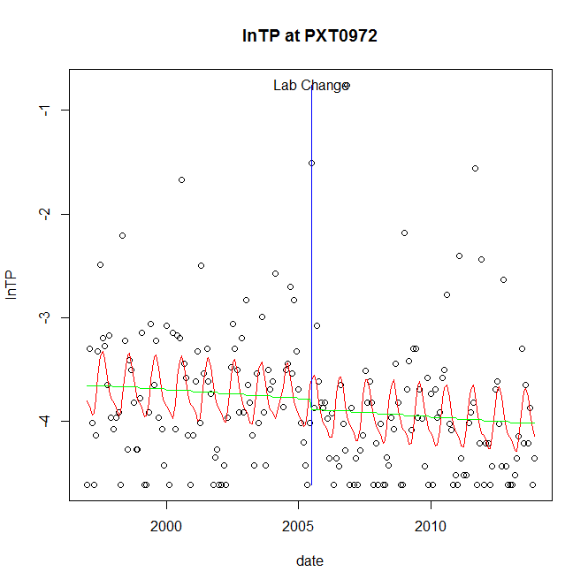

GAM analysis for station PXT0972 dependent variable lnTP

|  |  |  |  |  |
| --- | --- | --- | --- | --- |
| **Type** | **Source** | **edf** | **F-stat** | **p-value** |
| parametric terms | step | 1 | 0.3246 | 0.5695 |
|  | year | 1 | 1395.3586 | <0.0001 |
| smoothed terms | s(year) | 1 | 0.6231 | 0.4309 |
|  | s(doy) | 3.32 | 3.0353 | <0.0001 |

GAM analysis for station PXT0972 dependent variable lnTP

|  |  |  |  |  |
| --- | --- | --- | --- | --- |
| **parameter** | **estimate** | **Std. Err.** | **t value** | **p-value** |
| (Intercept) | 0.000171 | 0.000218 | 0.7851 | 0.4334 |
| step | -0.101287 | 0.177768 | -0.5698 | 0.5695 |
| year | -0.00189 | 5.1e-05 | -37.3545 | <0.0001 |

root mean-square error = 0.6231

adjusted r-square = 0.1307

station = PXT0972 dependent = lnPO4

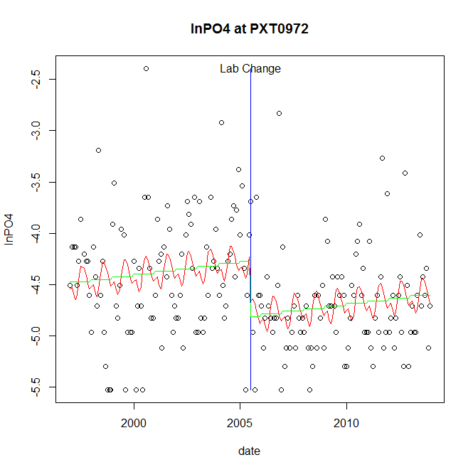

GAM analysis for station PXT0972 dependent variable lnPO4

|  |  |  |  |  |
| --- | --- | --- | --- | --- |
| **Type** | **Source** | **edf** | **F-stat** | **p-value** |
| parametric terms | step | 1 | 13.6335 | 0.0003 |
|  | year | 1 | 2669.9195 | <0.0001 |
| smoothed terms | s(year) | 1 | 3.4326 | 0.0654 |
|  | s(doy) | 3.66 | 1.3828 | 0.0126 |

GAM analysis for station PXT0972 dependent variable lnPO4

|  |  |  |  |  |
| --- | --- | --- | --- | --- |
| **parameter** | **estimate** | **Std. Err.** | **t value** | **p-value** |
| (Intercept) | -0.000329 | 0.000177 | -1.8589 | 0.0645 |
| step | -0.540837 | 0.146475 | -3.6924 | 0.0003 |
| year | -0.002132 | 4.1e-05 | -51.6713 | <0.0001 |

root mean-square error = 0.522

adjusted r-square = 0.1215

step significant

No title given

|  |  |  |  |
| --- | --- | --- | --- |
| **station** | **dep** | **step.est** | **step.pv** |
| PXT0972 | lnTSS | -0.271019 | 0.4310 |
| PXT0972 | lnTN | 0.038918 | 0.6393 |
| PXT0972 | lnNH4 | -0.317597 | 0.0359 |
| PXT0972 | lnNO23 | 0.042439 | 0.6826 |
| PXT0972 | lnNO2 | 0.019802 | 0.8679 |
| PXT0972 | lnTP | -0.101287 | 0.5695 |
| PXT0972 | lnPO4 | -0.540837 | 0.0003 |

station = RCM0111 dependent = lnTSS

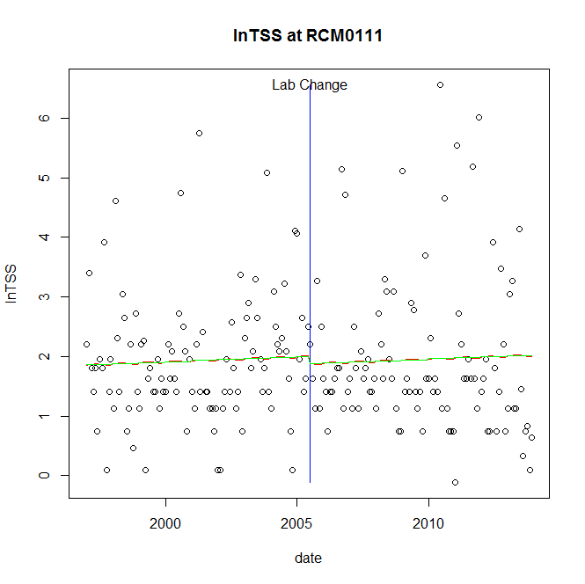

GAM analysis for station RCM0111 dependent variable lnTSS

|  |  |  |  |  |
| --- | --- | --- | --- | --- |
| **Type** | **Source** | **edf** | **F-stat** | **p-value** |
| parametric terms | step | 1 | 0.1478 | 0.7010 |
|  | year | 1 | 118.3146 | <0.0001 |
| smoothed terms | s(year) | 1 | 0.242 | 0.6255 |
|  | s(doy) | 0.15 | 0.0197 | 0.3457 |

GAM analysis for station RCM0111 dependent variable lnTSS

|  |  |  |  |  |
| --- | --- | --- | --- | --- |
| **parameter** | **estimate** | **Std. Err.** | **t value** | **p-value** |
| (Intercept) | -0.000195 | 0.000401 | -0.4866 | 0.6271 |
| step | -0.126318 | 0.328528 | -0.3845 | 0.7010 |
| year | 0.000999 | 9.2e-05 | 10.8773 | <0.0001 |

root mean-square error = 1.1786

adjusted r-square = -0.0077

station = RCM0111 dependent = lnTN

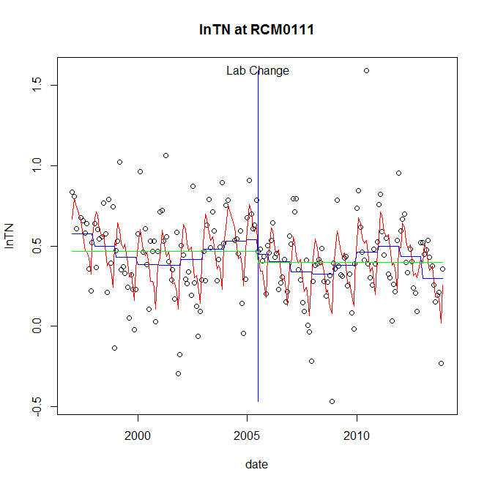

GAM analysis for station RCM0111 dependent variable lnTN

|  |  |  |  |  |
| --- | --- | --- | --- | --- |
| **Type** | **Source** | **edf** | **F-stat** | **p-value** |
| parametric terms | step | 1 | 0.6796 | 0.4108 |
|  | year | 1 | 68.3235 | <0.0001 |
| smoothed terms | s(year) | 6 | 3.1126 | 0.0047 |
|  | s(doy) | 6.87 | 10.1752 | <0.0001 |

GAM analysis for station RCM0111 dependent variable lnTN

|  |  |  |  |  |
| --- | --- | --- | --- | --- |
| **parameter** | **estimate** | **Std. Err.** | **t value** | **p-value** |
| (Intercept) | 0.001379 | 0.000464 | 2.9732 | 0.0033 |
| step | -0.088361 | 0.107183 | -0.8244 | 0.4108 |
| year | 0.000235 | 2.8e-05 | 8.2658 | <0.0001 |

root mean-square error = 0.2144

adjusted r-square = 0.3487

station = RCM0111 dependent = lnNH4

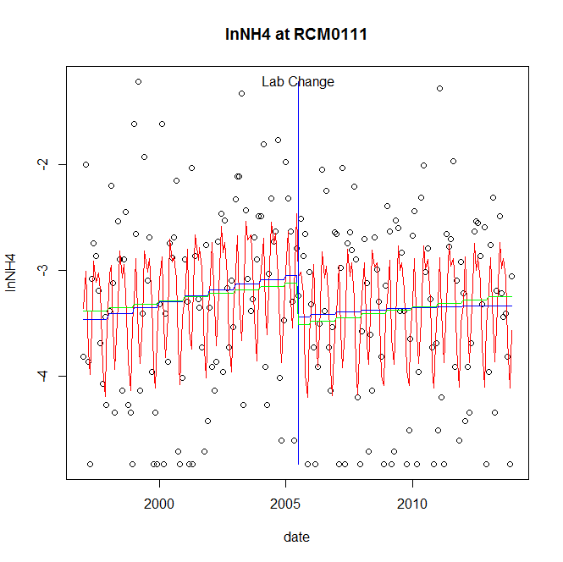

GAM analysis for station RCM0111 dependent variable lnNH4

|  |  |  |  |  |
| --- | --- | --- | --- | --- |
| **Type** | **Source** | **edf** | **F-stat** | **p-value** |
| parametric terms | step | 1 | 2.9768 | 0.0861 |
|  | year | 1 | 616.4621 | <0.0001 |
| smoothed terms | s(year) | 1.7 | 1.9589 | 0.1412 |
|  | s(doy) | 6.76 | 8.0203 | <0.0001 |

GAM analysis for station RCM0111 dependent variable lnNH4

|  |  |  |  |  |
| --- | --- | --- | --- | --- |
| **parameter** | **estimate** | **Std. Err.** | **t value** | **p-value** |
| (Intercept) | -4e-04 | 0.000358 | -1.1161 | 0.2658 |
| step | -0.392163 | 0.227296 | -1.7253 | 0.0861 |
| year | -0.001563 | 6.3e-05 | -24.8287 | <0.0001 |

root mean-square error = 0.7778

adjusted r-square = 0.2434

station = RCM0111 dependent = lnNO23

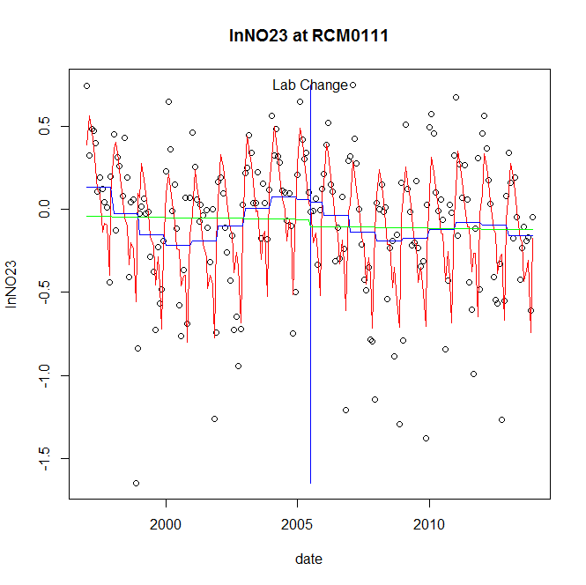

GAM analysis for station RCM0111 dependent variable lnNO23

|  |  |  |  |  |
| --- | --- | --- | --- | --- |
| **Type** | **Source** | **edf** | **F-stat** | **p-value** |
| parametric terms | step | 1 | 0.008 | 0.9290 |
|  | year | 1 | 0.873 | 0.3513 |
| smoothed terms | s(year) | 5.56 | 3.4962 | 0.0022 |
|  | s(doy) | 7.65 | 20.3766 | <0.0001 |

GAM analysis for station RCM0111 dependent variable lnNO23

|  |  |  |  |  |
| --- | --- | --- | --- | --- |
| **parameter** | **estimate** | **Std. Err.** | **t value** | **p-value** |
| (Intercept) | 0.001391 | 0.000606 | 2.2967 | 0.0227 |
| step | -0.013248 | 0.148399 | -0.0893 | 0.9290 |
| year | -3.6e-05 | 3.9e-05 | -0.9344 | 0.3513 |

root mean-square error = 0.3117

adjusted r-square = 0.477

station = RCM0111 dependent = lnNO2

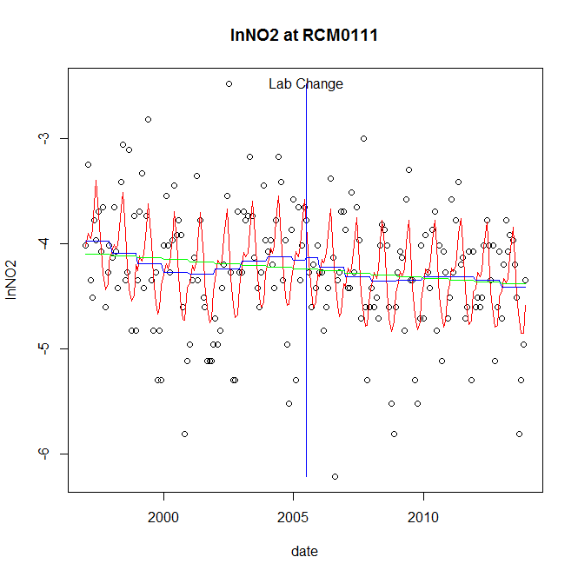

GAM analysis for station RCM0111 dependent variable lnNO2

|  |  |  |  |  |
| --- | --- | --- | --- | --- |
| **Type** | **Source** | **edf** | **F-stat** | **p-value** |
| parametric terms | step | 1 | 0.0092 | 0.9238 |
|  | year | 1 | 1331.3721 | <0.0001 |
| smoothed terms | s(year) | 4.81 | 1.0337 | 0.4011 |
|  | s(doy) | 5.57 | 9.4063 | <0.0001 |

GAM analysis for station RCM0111 dependent variable lnNO2

|  |  |  |  |  |
| --- | --- | --- | --- | --- |
| **parameter** | **estimate** | **Std. Err.** | **t value** | **p-value** |
| (Intercept) | 0.001041 | 0.000828 | 1.2582 | 0.2099 |
| step | 0.021375 | 0.223125 | 0.0958 | 0.9238 |
| year | -0.002129 | 5.8e-05 | -36.488 | <0.0001 |

root mean-square error = 0.504

adjusted r-square = 0.2904

station = RCM0111 dependent = lnTP

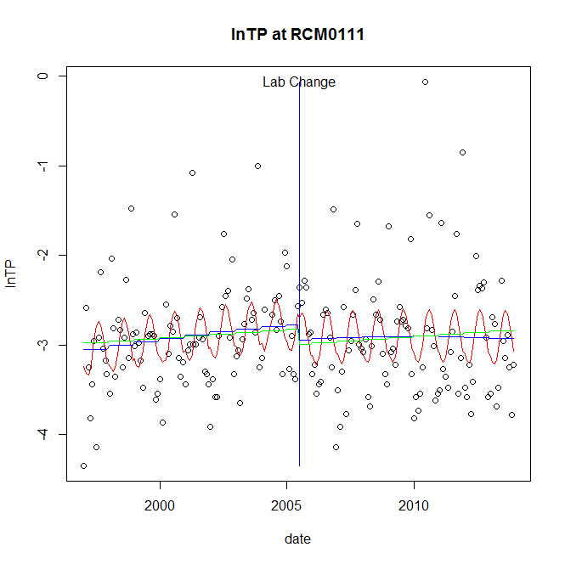

GAM analysis for station RCM0111 dependent variable lnTP

|  |  |  |  |  |
| --- | --- | --- | --- | --- |
| **Type** | **Source** | **edf** | **F-stat** | **p-value** |
| parametric terms | step | 1 | 1.0156 | 0.3148 |
|  | year | 1 | 854.3801 | <0.0001 |
| smoothed terms | s(year) | 1.73 | 1.5353 | 0.2149 |
|  | s(doy) | 2.64 | 3.8224 | <0.0001 |

GAM analysis for station RCM0111 dependent variable lnTP

|  |  |  |  |  |
| --- | --- | --- | --- | --- |
| **parameter** | **estimate** | **Std. Err.** | **t value** | **p-value** |
| (Intercept) | -0.000214 | 0.000276 | -0.7765 | 0.4384 |
| step | -0.1734 | 0.172066 | -1.0077 | 0.3148 |
| year | -0.001413 | 4.8e-05 | -29.2298 | <0.0001 |

root mean-square error = 0.5771

adjusted r-square = 0.1414

station = RCM0111 dependent = lnPO4

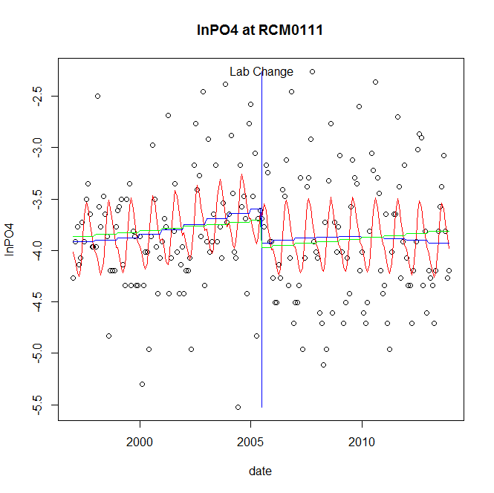

GAM analysis for station RCM0111 dependent variable lnPO4

|  |  |  |  |  |
| --- | --- | --- | --- | --- |
| **Type** | **Source** | **edf** | **F-stat** | **p-value** |
| parametric terms | step | 1 | 3.336 | 0.0693 |
|  | year | 1 | 1406.4478 | <0.0001 |
| smoothed terms | s(year) | 2.48 | 1.4669 | 0.2236 |
|  | s(doy) | 3.68 | 5.049 | <0.0001 |

GAM analysis for station RCM0111 dependent variable lnPO4

|  |  |  |  |  |
| --- | --- | --- | --- | --- |
| **parameter** | **estimate** | **Std. Err.** | **t value** | **p-value** |
| (Intercept) | 1.9e-05 | 0.000406 | 0.0466 | 0.9629 |
| step | -0.329428 | 0.180362 | -1.8265 | 0.0693 |
| year | -0.001836 | 4.9e-05 | -37.5026 | <0.0001 |

root mean-square error = 0.5521

adjusted r-square = 0.171

No title given

|  |  |  |  |
| --- | --- | --- | --- |
| **station** | **dep** | **step.est** | **step.pv** |
| RCM0111 | lnTSS | -0.126318 | 0.7010 |
| RCM0111 | lnTN | -0.088361 | 0.4108 |
| RCM0111 | lnNH4 | -0.392163 | 0.0861 |
| RCM0111 | lnNO23 | -0.013248 | 0.9290 |
| RCM0111 | lnNO2 | 0.021375 | 0.9238 |
| RCM0111 | lnTP | -0.1734 | 0.3148 |
| RCM0111 | lnPO4 | -0.329428 | 0.0693 |

station = SAV0000 dependent = lnTSS

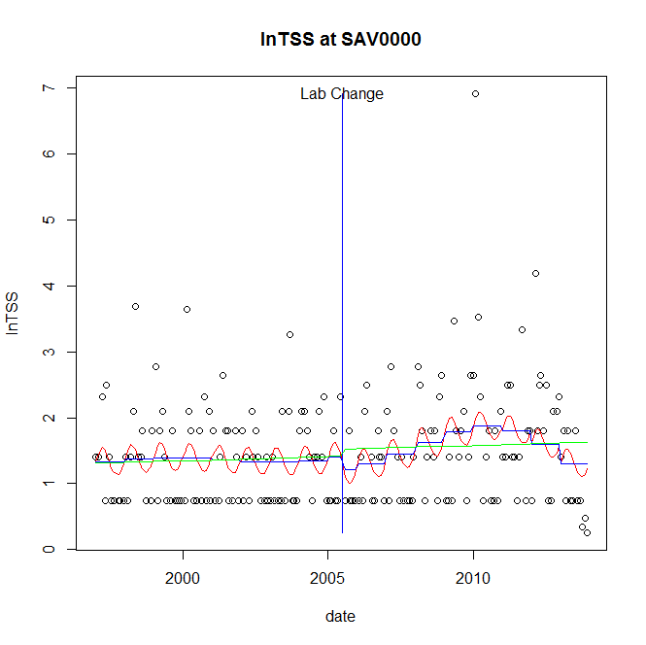

GAM analysis for station SAV0000 dependent variable lnTSS

|  |  |  |  |  |
| --- | --- | --- | --- | --- |
| **Type** | **Source** | **edf** | **F-stat** | **p-value** |
| parametric terms | step | 1 | 0.298 | 0.5858 |
|  | year | 1 | 72.9267 | <0.0001 |
| smoothed terms | s(year) | 4.36 | 1.7635 | 0.1178 |
|  | s(doy) | 1.97 | 1.1391 | 0.0042 |

GAM analysis for station SAV0000 dependent variable lnTSS

|  |  |  |  |  |
| --- | --- | --- | --- | --- |
| **parameter** | **estimate** | **Std. Err.** | **t value** | **p-value** |
| (Intercept) | 0.001584 | 0.001188 | 1.3336 | 0.1839 |
| step | -0.189596 | 0.347327 | -0.5459 | 0.5858 |
| year | 0.000778 | 9.1e-05 | 8.5397 | <0.0001 |

root mean-square error = 0.8038

adjusted r-square = 0.098

station = SAV0000 dependent = lnTN

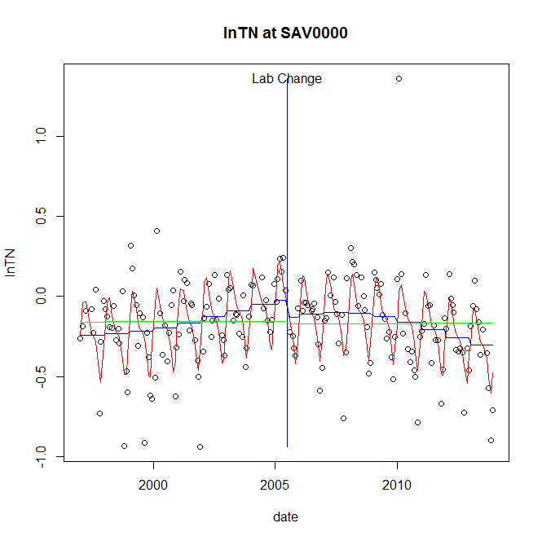

GAM analysis for station SAV0000 dependent variable lnTN

|  |  |  |  |  |
| --- | --- | --- | --- | --- |
| **Type** | **Source** | **edf** | **F-stat** | **p-value** |
| parametric terms | step | 1 | 1.8982 | 0.1700 |
|  | year | 1 | 7.5187 | 0.0067 |
| smoothed terms | s(year) | 3.23 | 6.2899 | <0.0001 |
|  | s(doy) | 5.62 | 16.3258 | <0.0001 |

GAM analysis for station SAV0000 dependent variable lnTN

|  |  |  |  |  |
| --- | --- | --- | --- | --- |
| **parameter** | **estimate** | **Std. Err.** | **t value** | **p-value** |
| (Intercept) | 0.000242 | 0.000217 | 1.1148 | 0.2664 |
| step | -0.107218 | 0.077821 | -1.3778 | 0.1700 |
| year | -5.8e-05 | 2.1e-05 | -2.742 | 0.0067 |

root mean-square error = 0.2019

adjusted r-square = 0.4526

station = SAV0000 dependent = lnNH4

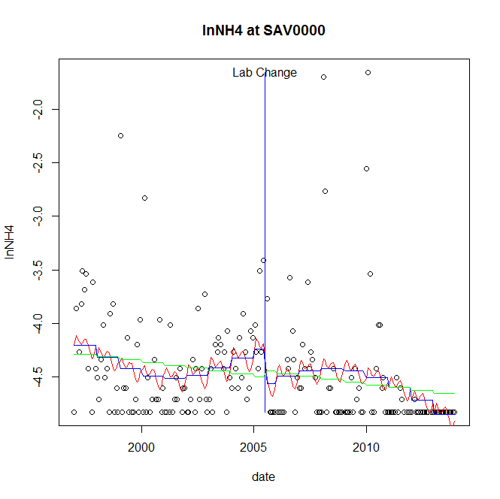

GAM analysis for station SAV0000 dependent variable lnNH4

|  |  |  |  |  |
| --- | --- | --- | --- | --- |
| **Type** | **Source** | **edf** | **F-stat** | **p-value** |
| parametric terms | step | 1 | 2.5294 | 0.1134 |
|  | year | 1 | 1642.2493 | <0.0001 |
| smoothed terms | s(year) | 3.74 | 3.1341 | 0.0120 |
|  | s(doy) | 3.46 | 0.7107 | 0.1467 |

GAM analysis for station SAV0000 dependent variable lnNH4

|  |  |  |  |  |
| --- | --- | --- | --- | --- |
| **parameter** | **estimate** | **Std. Err.** | **t value** | **p-value** |
| (Intercept) | 0.001471 | 0.000624 | 2.3578 | 0.0194 |
| step | -0.32143 | 0.202106 | -1.5904 | 0.1134 |
| year | -0.002154 | 5.3e-05 | -40.5247 | <0.0001 |

root mean-square error = 0.5016

adjusted r-square = 0.1073

station = SAV0000 dependent = lnNO23

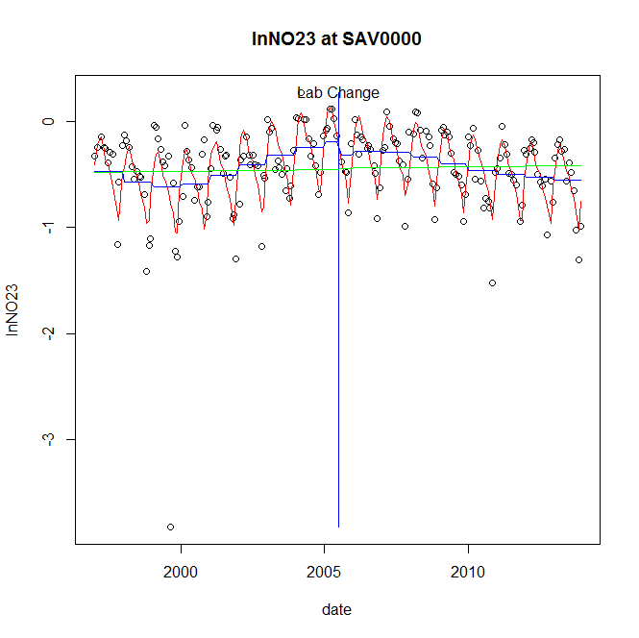

GAM analysis for station SAV0000 dependent variable lnNO23

|  |  |  |  |  |
| --- | --- | --- | --- | --- |
| **Type** | **Source** | **edf** | **F-stat** | **p-value** |
| parametric terms | step | 1 | 0.8454 | 0.3590 |
|  | year | 1 | 27.8828 | <0.0001 |
| smoothed terms | s(year) | 4.86 | 6.3181 | <0.0001 |
|  | s(doy) | 6.74 | 16.5839 | <0.0001 |

GAM analysis for station SAV0000 dependent variable lnNO23

|  |  |  |  |  |
| --- | --- | --- | --- | --- |
| **parameter** | **estimate** | **Std. Err.** | **t value** | **p-value** |
| (Intercept) | 0.000758 | 0.000502 | 1.5095 | 0.1329 |
| step | -0.125569 | 0.136569 | -0.9195 | 0.3590 |
| year | -0.000187 | 3.5e-05 | -5.2804 | <0.0001 |

root mean-square error = 0.2977

adjusted r-square = 0.4591

station = SAV0000 dependent = lnNO2

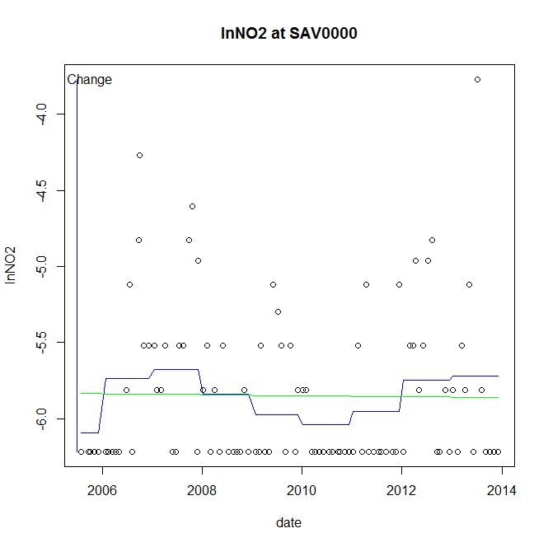

GAM analysis for station SAV0000 dependent variable lnNO2

|  |  |  |  |  |
| --- | --- | --- | --- | --- |
| **Type** | **Source** | **edf** | **F-stat** | **p-value** |
| parametric terms | step | 1 | 1.7715 | 0.1864 |
|  | year | 1 | 14281.5682 | <0.0001 |
| smoothed terms | s(year) | 4.49 | 1.7725 | 0.1198 |
|  | s(doy) | 0 | 0 | 0.5216 |

GAM analysis for station SAV0000 dependent variable lnNO2

|  |  |  |  |  |
| --- | --- | --- | --- | --- |
| **parameter** | **estimate** | **Std. Err.** | **t value** | **p-value** |
| (Intercept) | -0.000594 | 0.000446 | -1.331 | 0.1864 |
| step | -0.000594 | 0.000446 | -1.331 | 0.1864 |
| year | -0.00291 | 2.4e-05 | -119.5055 | <0.0001 |

root mean-square error = 0.4916

adjusted r-square = 0.0727

station = SAV0000 dependent = lnTP

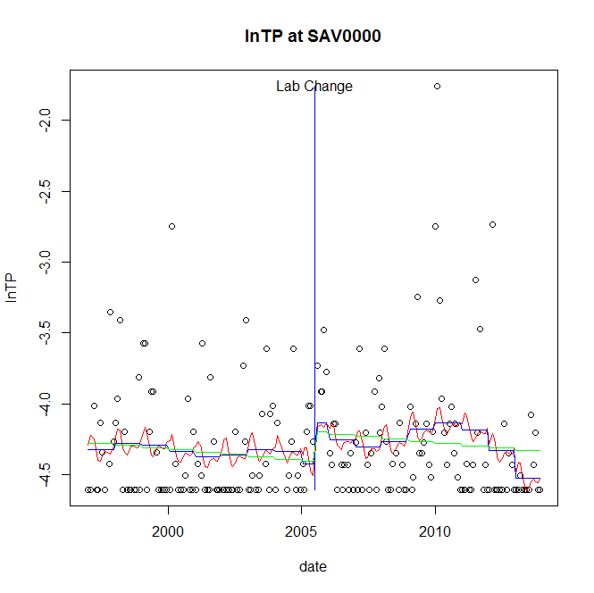

GAM analysis for station SAV0000 dependent variable lnTP

|  |  |  |  |  |
| --- | --- | --- | --- | --- |
| **Type** | **Source** | **edf** | **F-stat** | **p-value** |
| parametric terms | step | 1 | 1.8505 | 0.1754 |
|  | year | 1 | 1584.9705 | <0.0001 |
| smoothed terms | s(year) | 5.65 | 1.6121 | 0.1400 |
|  | s(doy) | 3.29 | 0.7067 | 0.1325 |

GAM analysis for station SAV0000 dependent variable lnTP

|  |  |  |  |  |
| --- | --- | --- | --- | --- |
| **parameter** | **estimate** | **Std. Err.** | **t value** | **p-value** |
| (Intercept) | 0.000907 | 0.00086 | 1.0552 | 0.2927 |
| step | 0.286987 | 0.210971 | 1.3603 | 0.1754 |
| year | -0.002217 | 5.6e-05 | -39.8117 | <0.0001 |

root mean-square error = 0.4224

adjusted r-square = 0.0545

station = SAV0000 dependent = lnPO4

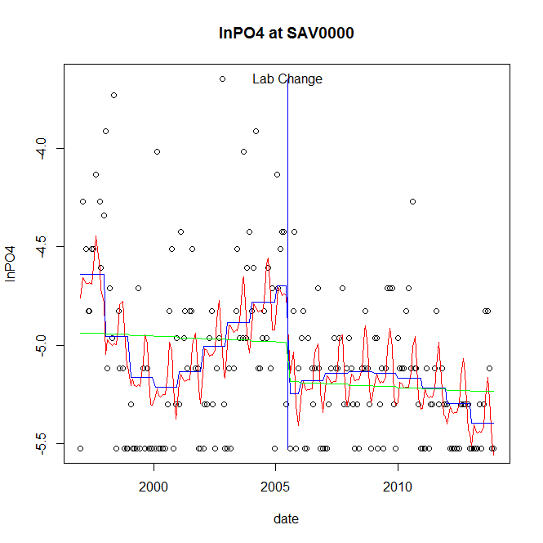

GAM analysis for station SAV0000 dependent variable lnPO4

|  |  |  |  |  |
| --- | --- | --- | --- | --- |
| **Type** | **Source** | **edf** | **F-stat** | **p-value** |
| parametric terms | step | 1 | 10.4666 | 0.0014 |
|  | year | 1 | 2962.3994 | <0.0001 |
| smoothed terms | s(year) | 5.47 | 6.1727 | <0.0001 |
|  | s(doy) | 5.14 | 2.6994 | 0.0004 |

GAM analysis for station SAV0000 dependent variable lnPO4

|  |  |  |  |  |
| --- | --- | --- | --- | --- |
| **parameter** | **estimate** | **Std. Err.** | **t value** | **p-value** |
| (Intercept) | 0.002564 | 0.000673 | 3.8082 | 0.0002 |
| step | -0.550554 | 0.170175 | -3.2352 | 0.0014 |
| year | -0.002403 | 4.4e-05 | -54.4279 | <0.0001 |

root mean-square error = 0.3495

adjusted r-square = 0.2833

step significant

No title given

|  |  |  |  |
| --- | --- | --- | --- |
| **station** | **dep** | **step.est** | **step.pv** |
| SAV0000 | lnTSS | -0.189596 | 0.5858 |
| SAV0000 | lnTN | -0.107218 | 0.1700 |
| SAV0000 | lnNH4 | -0.32143 | 0.1134 |
| SAV0000 | lnNO23 | -0.125569 | 0.3590 |
| SAV0000 | lnNO2 | -0.000594 | 0.1864 |
| SAV0000 | lnTP | 0.286987 | 0.1754 |
| SAV0000 | lnPO4 | -0.550554 | 0.0014 |

station = SEN0008 dependent = lnTSS

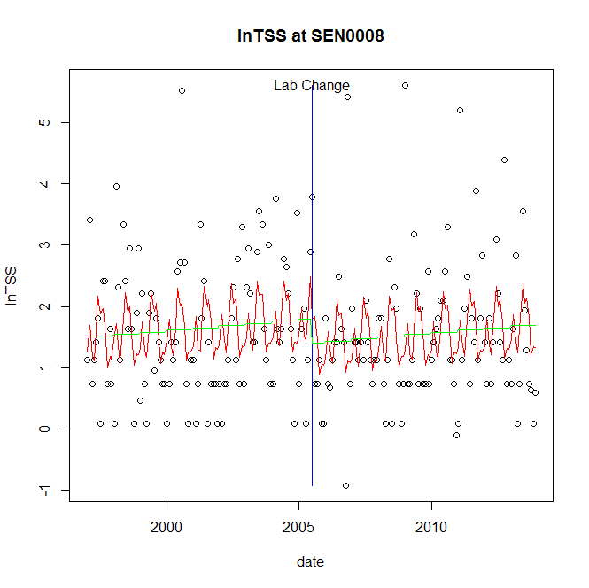

GAM analysis for station SEN0008 dependent variable lnTSS

|  |  |  |  |  |
| --- | --- | --- | --- | --- |
| **Type** | **Source** | **edf** | **F-stat** | **p-value** |
| parametric terms | step | 1 | 1.8132 | 0.1797 |
|  | year | 1 | 112.9027 | <0.0001 |
| smoothed terms | s(year) | 1 | 1.3456 | 0.2475 |
|  | s(doy) | 6.83 | 3.4088 | 0.0002 |

GAM analysis for station SEN0008 dependent variable lnTSS

|  |  |  |  |  |
| --- | --- | --- | --- | --- |
| **parameter** | **estimate** | **Std. Err.** | **t value** | **p-value** |
| (Intercept) | -0.000418 | 0.000361 | -1.1589 | 0.2479 |
| step | -0.399487 | 0.296677 | -1.3465 | 0.1797 |
| year | 0.00088 | 8.3e-05 | 10.6256 | <0.0001 |

root mean-square error = 1.0583

adjusted r-square = 0.101

station = SEN0008 dependent = lnTN

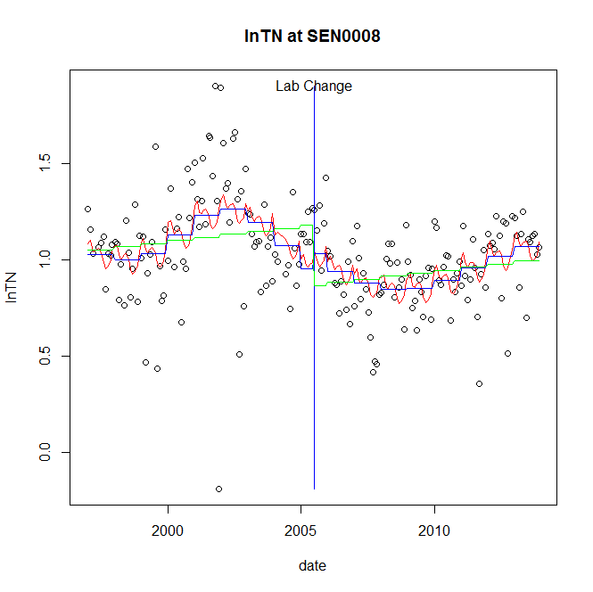

GAM analysis for station SEN0008 dependent variable lnTN

|  |  |  |  |  |
| --- | --- | --- | --- | --- |
| **Type** | **Source** | **edf** | **F-stat** | **p-value** |
| parametric terms | step | 1 | 0.4491 | 0.5036 |
|  | year | 1 | 245.3461 | <0.0001 |
| smoothed terms | s(year) | 5.79 | 4.6404 | 0.0001 |
|  | s(doy) | 4.41 | 1.1226 | 0.0638 |

GAM analysis for station SEN0008 dependent variable lnTN

|  |  |  |  |  |
| --- | --- | --- | --- | --- |
| **parameter** | **estimate** | **Std. Err.** | **t value** | **p-value** |
| (Intercept) | -4.7e-05 | 0.000503 | -0.0932 | 0.9258 |
| step | 0.079526 | 0.118672 | 0.6701 | 0.5036 |
| year | 0.000492 | 3.1e-05 | 15.6635 | <0.0001 |

root mean-square error = 0.2408

adjusted r-square = 0.2313

station = SEN0008 dependent = lnNH4

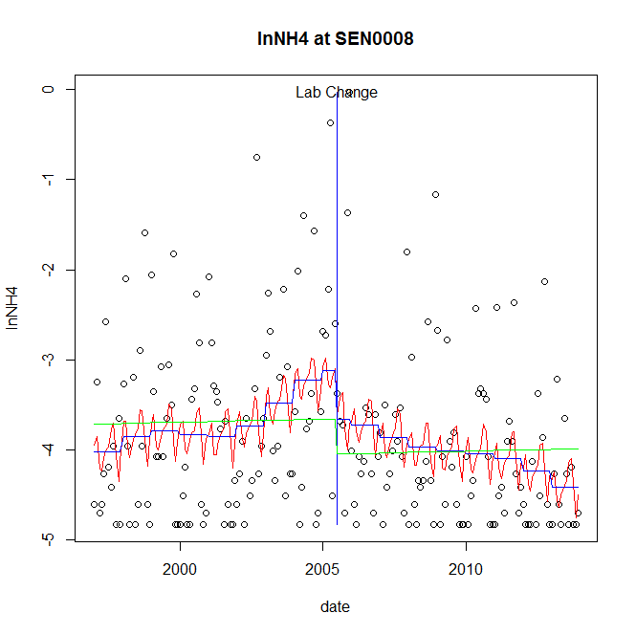

GAM analysis for station SEN0008 dependent variable lnNH4

|  |  |  |  |  |
| --- | --- | --- | --- | --- |
| **Type** | **Source** | **edf** | **F-stat** | **p-value** |
| parametric terms | step | 1 | 1.6342 | 0.2027 |
|  | year | 1 | 265.0663 | <0.0001 |
| smoothed terms | s(year) | 5.2 | 2.5186 | 0.0222 |
|  | s(doy) | 5.45 | 1.3651 | 0.0571 |

GAM analysis for station SEN0008 dependent variable lnNH4

|  |  |  |  |  |
| --- | --- | --- | --- | --- |
| **parameter** | **estimate** | **Std. Err.** | **t value** | **p-value** |
| (Intercept) | -6.5e-05 | 0.001651 | -0.0396 | 0.9685 |
| step | -0.53945 | 0.421989 | -1.2783 | 0.2027 |
| year | -0.001791 | 0.00011 | -16.2809 | <0.0001 |

root mean-square error = 0.9181

adjusted r-square = 0.1157

station = SEN0008 dependent = lnNO23

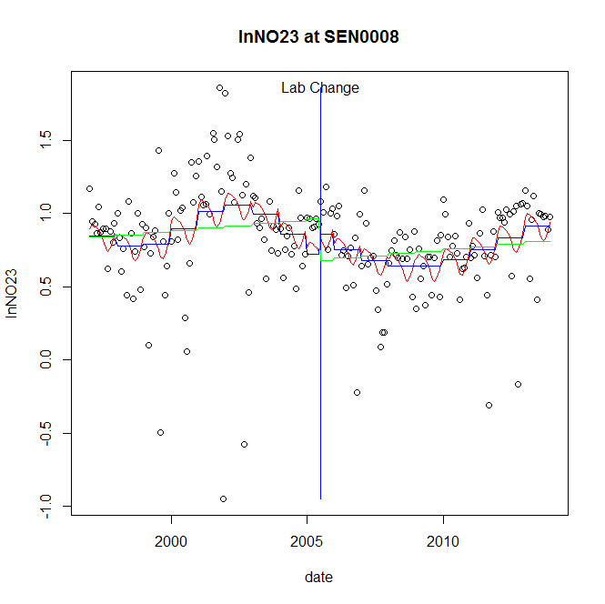

GAM analysis for station SEN0008 dependent variable lnNO23

|  |  |  |  |  |
| --- | --- | --- | --- | --- |
| **Type** | **Source** | **edf** | **F-stat** | **p-value** |
| parametric terms | step | 1 | 0.6964 | 0.4050 |
|  | year | 1 | 79.5239 | <0.0001 |
| smoothed terms | s(year) | 5.63 | 2.6728 | 0.0143 |
|  | s(doy) | 2.6 | 1.0708 | 0.0149 |

GAM analysis for station SEN0008 dependent variable lnNO23

|  |  |  |  |  |
| --- | --- | --- | --- | --- |
| **parameter** | **estimate** | **Std. Err.** | **t value** | **p-value** |
| (Intercept) | 3e-06 | 0.00067 | 0.0047 | 0.9962 |
| step | 0.135405 | 0.162259 | 0.8345 | 0.4050 |
| year | 0.000376 | 4.2e-05 | 8.9176 | <0.0001 |

root mean-square error = 0.3404

adjusted r-square = 0.1404

station = SEN0008 dependent = lnNO2

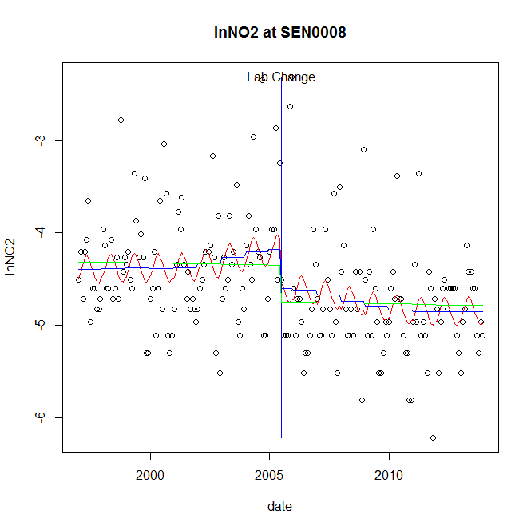

GAM analysis for station SEN0008 dependent variable lnNO2

|  |  |  |  |  |
| --- | --- | --- | --- | --- |
| **Type** | **Source** | **edf** | **F-stat** | **p-value** |
| parametric terms | step | 1 | 3.4554 | 0.0645 |
|  | year | 1 | 1291.406 | <0.0001 |
| smoothed terms | s(year) | 3.58 | 1.0521 | 0.3815 |
|  | s(doy) | 1.98 | 1.0738 | 0.0058 |

GAM analysis for station SEN0008 dependent variable lnNO2

|  |  |  |  |  |
| --- | --- | --- | --- | --- |
| **parameter** | **estimate** | **Std. Err.** | **t value** | **p-value** |
| (Intercept) | -0.000158 | 0.000688 | -0.2297 | 0.8186 |
| step | -0.422525 | 0.227302 | -1.8589 | 0.0645 |
| year | -0.002168 | 6e-05 | -35.9361 | <0.0001 |

root mean-square error = 0.592

adjusted r-square = 0.1648

station = SEN0008 dependent = lnTP

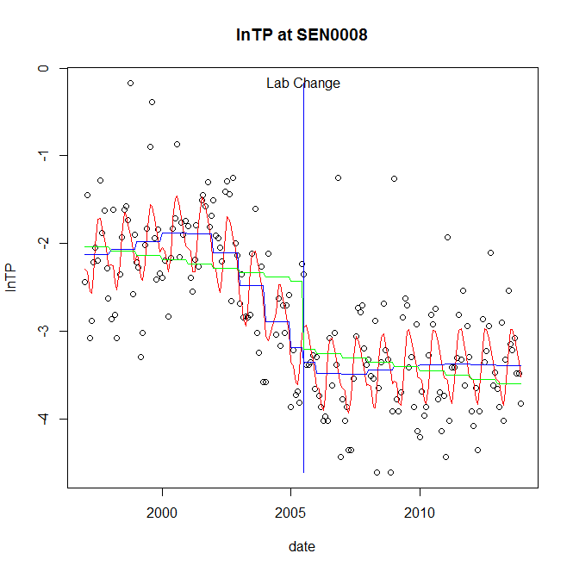

GAM analysis for station SEN0008 dependent variable lnTP

|  |  |  |  |  |
| --- | --- | --- | --- | --- |
| **Type** | **Source** | **edf** | **F-stat** | **p-value** |
| parametric terms | step | 1 | 0.4157 | 0.5199 |
|  | year | 1 | 418.5921 | <0.0001 |
| smoothed terms | s(year) | 5.51 | 8.6256 | <0.0001 |
|  | s(doy) | 4.97 | 7.3227 | <0.0001 |

GAM analysis for station SEN0008 dependent variable lnTP

|  |  |  |  |  |
| --- | --- | --- | --- | --- |
| **parameter** | **estimate** | **Std. Err.** | **t value** | **p-value** |
| (Intercept) | -0.000277 | 0.001036 | -0.2674 | 0.7894 |
| step | -0.163184 | 0.253103 | -0.6447 | 0.5199 |
| year | -0.001371 | 6.7e-05 | -20.4595 | <0.0001 |

root mean-square error = 0.5296

adjusted r-square = 0.6461

station = SEN0008 dependent = lnPO4

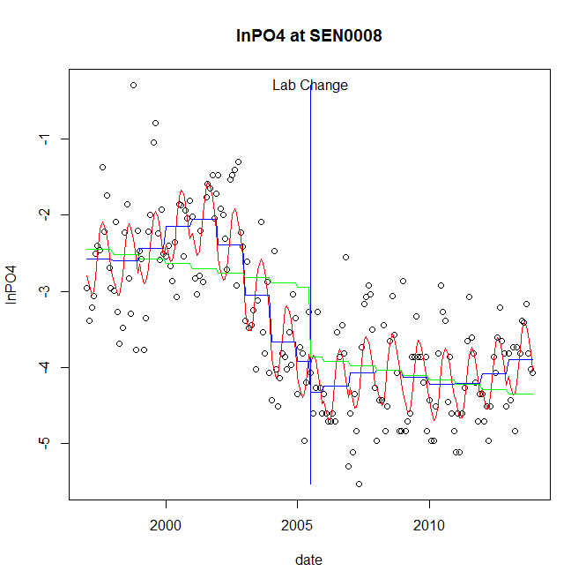

GAM analysis for station SEN0008 dependent variable lnPO4

|  |  |  |  |  |
| --- | --- | --- | --- | --- |
| **Type** | **Source** | **edf** | **F-stat** | **p-value** |
| parametric terms | step | 1 | 1.9401 | 0.1653 |
|  | year | 1 | 466.75 | <0.0001 |
| smoothed terms | s(year) | 6.59 | 15.4441 | <0.0001 |
|  | s(doy) | 3.56 | 9.5788 | <0.0001 |

GAM analysis for station SEN0008 dependent variable lnPO4

|  |  |  |  |  |
| --- | --- | --- | --- | --- |
| **parameter** | **estimate** | **Std. Err.** | **t value** | **p-value** |
| (Intercept) | -0.000877 | 0.001312 | -0.6684 | 0.5047 |
| step | -0.400841 | 0.28778 | -1.3929 | 0.1653 |
| year | -0.001604 | 7.4e-05 | -21.6044 | <0.0001 |

root mean-square error = 0.5543

adjusted r-square = 0.7206

No title given

|  |  |  |  |
| --- | --- | --- | --- |
| **station** | **dep** | **step.est** | **step.pv** |
| SEN0008 | lnTSS | -0.399487 | 0.1797 |
| SEN0008 | lnTN | 0.079526 | 0.5036 |
| SEN0008 | lnNH4 | -0.53945 | 0.2027 |
| SEN0008 | lnNO23 | 0.135405 | 0.4050 |
| SEN0008 | lnNO2 | -0.422525 | 0.0645 |
| SEN0008 | lnTP | -0.163184 | 0.5199 |
| SEN0008 | lnPO4 | -0.400841 | 0.1653 |

station = SUS0109 dependent = lnTSS

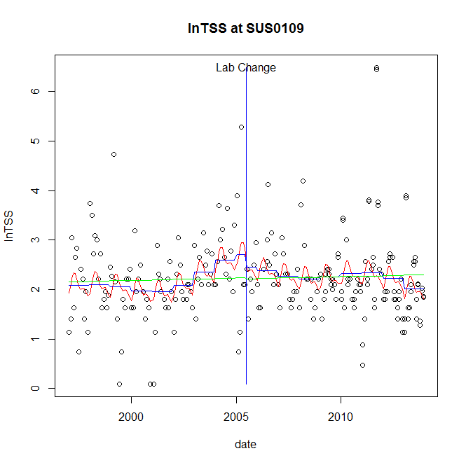

GAM analysis for station SUS0109 dependent variable lnTSS

|  |  |  |  |  |
| --- | --- | --- | --- | --- |
| **Type** | **Source** | **edf** | **F-stat** | **p-value** |
| parametric terms | step | 1 | 0.4777 | 0.4901 |
|  | year | 1 | 110.546 | <0.0001 |
| smoothed terms | s(year) | 5.55 | 2.0949 | 0.0508 |
|  | s(doy) | 3.45 | 1.4633 | 0.0070 |

GAM analysis for station SUS0109 dependent variable lnTSS

|  |  |  |  |  |
| --- | --- | --- | --- | --- |
| **parameter** | **estimate** | **Std. Err.** | **t value** | **p-value** |
| (Intercept) | 0.001189 | 0.001409 | 0.8443 | 0.3993 |
| step | -0.249924 | 0.361595 | -0.6912 | 0.4901 |
| year | 0.00118 | 0.000112 | 10.5141 | <0.0001 |

root mean-square error = 0.7775

adjusted r-square = 0.0802

station = SUS0109 dependent = lnTN

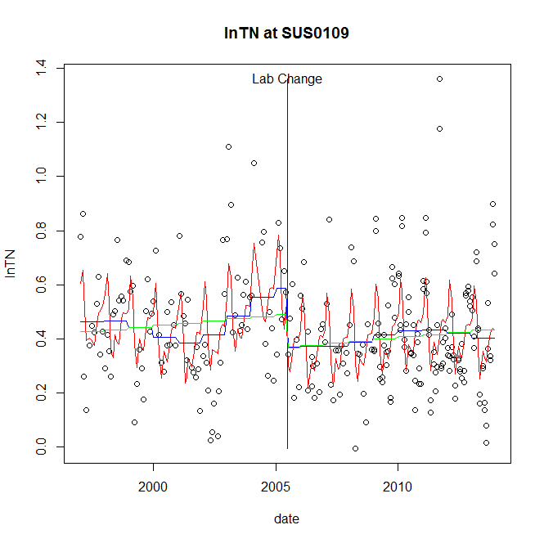

GAM analysis for station SUS0109 dependent variable lnTN

|  |  |  |  |  |
| --- | --- | --- | --- | --- |
| **Type** | **Source** | **edf** | **F-stat** | **p-value** |
| parametric terms | step | 1 | 6.3321 | 0.0125 |
|  | year | 1 | 105.4868 | <0.0001 |
| smoothed terms | s(year) | 5.69 | 1.9244 | 0.0721 |
|  | s(doy) | 6.51 | 9.2018 | <0.0001 |

GAM analysis for station SUS0109 dependent variable lnTN

|  |  |  |  |  |
| --- | --- | --- | --- | --- |
| **parameter** | **estimate** | **Std. Err.** | **t value** | **p-value** |
| (Intercept) | 8.1e-05 | 0.000337 | 0.2398 | 0.8107 |
| step | -0.217461 | 0.086418 | -2.5164 | 0.0125 |
| year | 0.000282 | 2.7e-05 | 10.2707 | <0.0001 |

root mean-square error = 0.1806

adjusted r-square = 0.2613

step significant

station = SUS0109 dependent = lnNH4

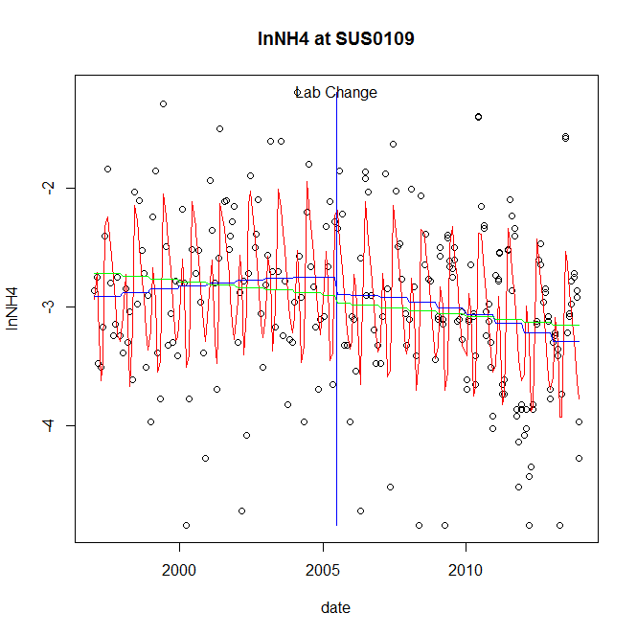

GAM analysis for station SUS0109 dependent variable lnNH4

|  |  |  |  |  |
| --- | --- | --- | --- | --- |
| **Type** | **Source** | **edf** | **F-stat** | **p-value** |
| parametric terms | step | 1 | 0.7346 | 0.3922 |
|  | year | 1 | 747.1553 | <0.0001 |
| smoothed terms | s(year) | 2.25 | 3.6307 | 0.0167 |
|  | s(doy) | 7.32 | 23.0491 | <0.0001 |

GAM analysis for station SUS0109 dependent variable lnNH4

|  |  |  |  |  |
| --- | --- | --- | --- | --- |
| **parameter** | **estimate** | **Std. Err.** | **t value** | **p-value** |
| (Intercept) | 0.000293 | 0.000329 | 0.8916 | 0.3735 |
| step | -0.141524 | 0.165125 | -0.8571 | 0.3922 |
| year | -0.001448 | 5.3e-05 | -27.3341 | <0.0001 |

root mean-square error = 0.5417

adjusted r-square = 0.445

station = SUS0109 dependent = lnNO23

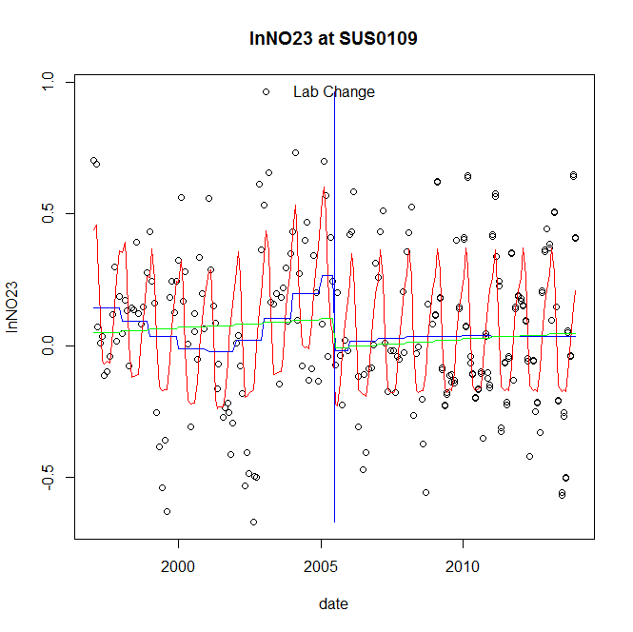

GAM analysis for station SUS0109 dependent variable lnNO23

|  |  |  |  |  |
| --- | --- | --- | --- | --- |
| **Type** | **Source** | **edf** | **F-stat** | **p-value** |
| parametric terms | step | 1 | 8.645 | 0.0036 |
|  | year | 1 | 14.7176 | 0.0002 |
| smoothed terms | s(year) | 4.91 | 2.6914 | 0.0163 |
|  | s(doy) | 5.8 | 24.9956 | <0.0001 |

GAM analysis for station SUS0109 dependent variable lnNO23

|  |  |  |  |  |
| --- | --- | --- | --- | --- |
| **parameter** | **estimate** | **Std. Err.** | **t value** | **p-value** |
| (Intercept) | 0.000323 | 0.000348 | 0.9282 | 0.3542 |
| step | -0.287387 | 0.097742 | -2.9402 | 0.0036 |
| year | 0.000118 | 3.1e-05 | 3.8364 | 0.0002 |

root mean-square error = 0.2239

adjusted r-square = 0.4635

step significant

station = SUS0109 dependent = lnNO2

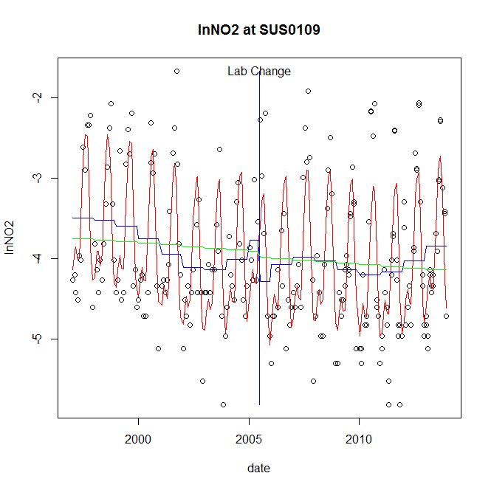

GAM analysis for station SUS0109 dependent variable lnNO2

|  |  |  |  |  |
| --- | --- | --- | --- | --- |
| **Type** | **Source** | **edf** | **F-stat** | **p-value** |
| parametric terms | step | 1 | 3.5333 | 0.0613 |
|  | year | 1 | 465.2759 | <0.0001 |
| smoothed terms | s(year) | 5.77 | 4.1694 | 0.0004 |
|  | s(doy) | 6.23 | 44.4196 | <0.0001 |

GAM analysis for station SUS0109 dependent variable lnNO2

|  |  |  |  |  |
| --- | --- | --- | --- | --- |
| **parameter** | **estimate** | **Std. Err.** | **t value** | **p-value** |
| (Intercept) | -0.001095 | 0.001077 | -1.0166 | 0.3103 |
| step | -0.512844 | 0.272833 | -1.8797 | 0.0613 |
| year | -0.001831 | 8.5e-05 | -21.5703 | <0.0001 |

root mean-square error = 0.5731

adjusted r-square = 0.5979

station = SUS0109 dependent = lnTP

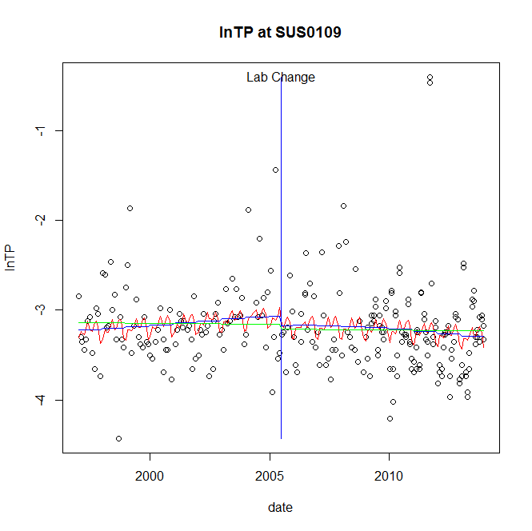

GAM analysis for station SUS0109 dependent variable lnTP

|  |  |  |  |  |
| --- | --- | --- | --- | --- |
| **Type** | **Source** | **edf** | **F-stat** | **p-value** |
| parametric terms | step | 1 | 0.5877 | 0.4440 |
|  | year | 1 | 1191.9963 | <0.0001 |
| smoothed terms | s(year) | 2.04 | 1.1447 | 0.3194 |
|  | s(doy) | 5.49 | 1.0867 | 0.1393 |

GAM analysis for station SUS0109 dependent variable lnTP

|  |  |  |  |  |
| --- | --- | --- | --- | --- |
| **parameter** | **estimate** | **Std. Err.** | **t value** | **p-value** |
| (Intercept) | 2.4e-05 | 0.000254 | 0.0931 | 0.9259 |
| step | -0.106701 | 0.139183 | -0.7666 | 0.4440 |
| year | -0.001561 | 4.5e-05 | -34.5253 | <0.0001 |

root mean-square error = 0.4624

adjusted r-square = 0.0333

station = SUS0109 dependent = lnPO4

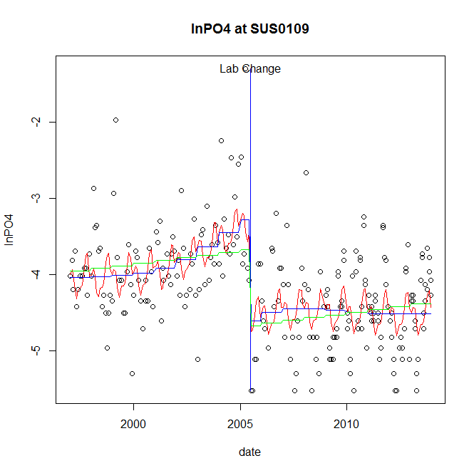

GAM analysis for station SUS0109 dependent variable lnPO4

|  |  |  |  |  |
| --- | --- | --- | --- | --- |
| **Type** | **Source** | **edf** | **F-stat** | **p-value** |
| parametric terms | step | 1 | 35.9757 | <0.0001 |
|  | year | 1 | 602.5951 | <0.0001 |
| smoothed terms | s(year) | 4.16 | 4.3755 | 0.0007 |
|  | s(doy) | 5.64 | 3.5362 | <0.0001 |

GAM analysis for station SUS0109 dependent variable lnPO4

|  |  |  |  |  |
| --- | --- | --- | --- | --- |
| **parameter** | **estimate** | **Std. Err.** | **t value** | **p-value** |
| (Intercept) | -0.000113 | 0.000712 | -0.1595 | 0.8734 |
| step | -1.327758 | 0.221368 | -5.998 | <0.0001 |
| year | -0.001705 | 6.9e-05 | -24.5478 | <0.0001 |

root mean-square error = 0.551

adjusted r-square = 0.3425

step significant

No title given

|  |  |  |  |
| --- | --- | --- | --- |
| **station** | **dep** | **step.est** | **step.pv** |
| SUS0109 | lnTSS | -0.249924 | 0.4901 |
| SUS0109 | lnTN | -0.217461 | 0.0125 |
| SUS0109 | lnNH4 | -0.141524 | 0.3922 |
| SUS0109 | lnNO23 | -0.287387 | 0.0036 |
| SUS0109 | lnNO2 | -0.512844 | 0.0613 |
| SUS0109 | lnTP | -0.106701 | 0.4440 |
| SUS0109 | lnPO4 | -1.327758 | <0.0001 |

station = TOW0030 dependent = lnTSS

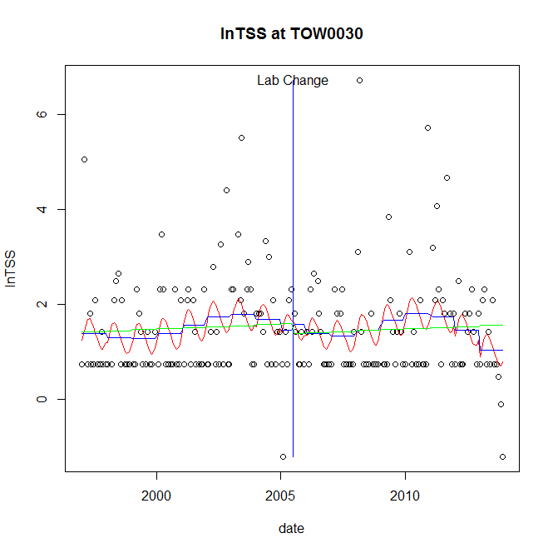

GAM analysis for station TOW0030 dependent variable lnTSS

|  |  |  |  |  |
| --- | --- | --- | --- | --- |
| **Type** | **Source** | **edf** | **F-stat** | **p-value** |
| parametric terms | step | 1 | 0.0544 | 0.8158 |
|  | year | 1 | 32.2949 | <0.0001 |
| smoothed terms | s(year) | 5.27 | 1.6433 | 0.1354 |
|  | s(doy) | 2.24 | 1.5103 | 0.0012 |

GAM analysis for station TOW0030 dependent variable lnTSS

|  |  |  |  |  |
| --- | --- | --- | --- | --- |
| **parameter** | **estimate** | **Std. Err.** | **t value** | **p-value** |
| (Intercept) | 0.003266 | 0.001923 | 1.6982 | 0.0911 |
| step | 0.112202 | 0.481069 | 0.2332 | 0.8158 |
| year | 0.000713 | 0.000126 | 5.6829 | <0.0001 |

root mean-square error = 1.0366

adjusted r-square = 0.0867

station = TOW0030 dependent = lnTN

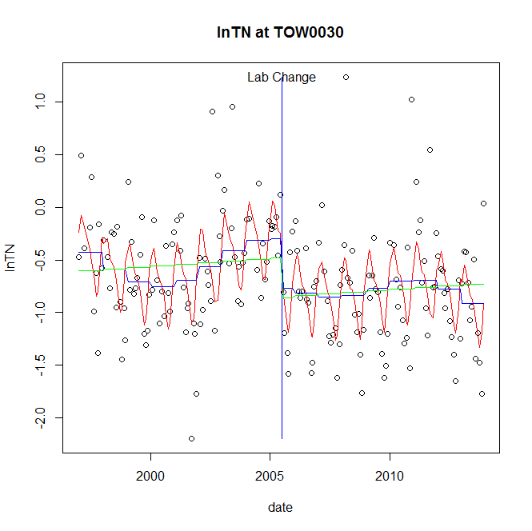

GAM analysis for station TOW0030 dependent variable lnTN

|  |  |  |  |  |
| --- | --- | --- | --- | --- |
| **Type** | **Source** | **edf** | **F-stat** | **p-value** |
| parametric terms | step | 1 | 4.6903 | 0.0317 |
|  | year | 1 | 15.5949 | 0.0001 |
| smoothed terms | s(year) | 5.3 | 2.5689 | 0.0196 |
|  | s(doy) | 4.39 | 6.9248 | <0.0001 |

GAM analysis for station TOW0030 dependent variable lnTN

|  |  |  |  |  |
| --- | --- | --- | --- | --- |
| **parameter** | **estimate** | **Std. Err.** | **t value** | **p-value** |
| (Intercept) | 0.001838 | 0.000865 | 2.126 | 0.0349 |
| step | -0.463932 | 0.214217 | -2.1657 | 0.0317 |
| year | -0.000226 | 5.7e-05 | -3.949 | 0.0001 |

root mean-square error = 0.4528

adjusted r-square = 0.3131

step significant

station = TOW0030 dependent = lnNH4

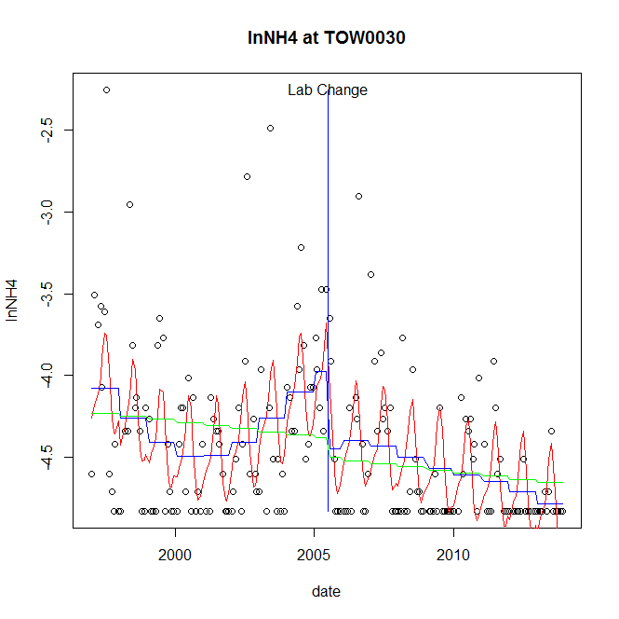

GAM analysis for station TOW0030 dependent variable lnNH4

|  |  |  |  |  |
| --- | --- | --- | --- | --- |
| **Type** | **Source** | **edf** | **F-stat** | **p-value** |
| parametric terms | step | 1 | 7.6814 | 0.0061 |
|  | year | 1 | 2256.432 | <0.0001 |
| smoothed terms | s(year) | 4.87 | 6.0179 | <0.0001 |
|  | s(doy) | 4.3 | 8.0464 | <0.0001 |

GAM analysis for station TOW0030 dependent variable lnNH4

|  |  |  |  |  |
| --- | --- | --- | --- | --- |
| **parameter** | **estimate** | **Std. Err.** | **t value** | **p-value** |
| (Intercept) | 0.001592 | 0.000641 | 2.4836 | 0.0139 |
| step | -0.470446 | 0.169742 | -2.7715 | 0.0061 |
| year | -0.0021 | 4.4e-05 | -47.5019 | <0.0001 |

root mean-square error = 0.3789

adjusted r-square = 0.39

step significant

station = TOW0030 dependent = lnNO23

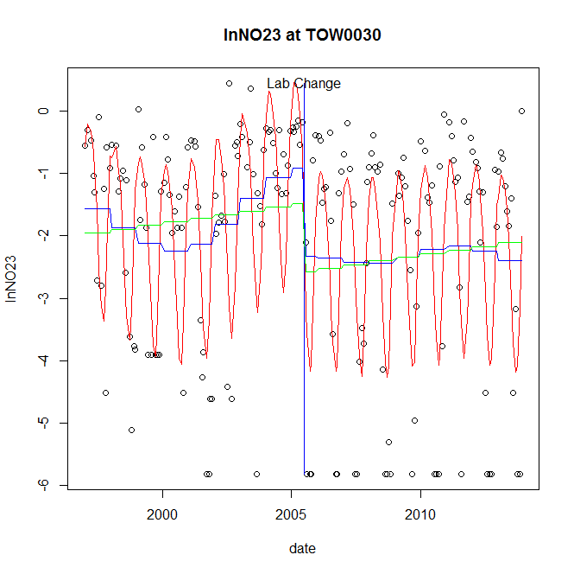

GAM analysis for station TOW0030 dependent variable lnNO23

|  |  |  |  |  |
| --- | --- | --- | --- | --- |
| **Type** | **Source** | **edf** | **F-stat** | **p-value** |
| parametric terms | step | 1 | 5.5494 | 0.0195 |
|  | year | 1 | 18.5048 | <0.0001 |
| smoothed terms | s(year) | 4.75 | 2.4067 | 0.0321 |
|  | s(doy) | 4.3 | 17.5029 | <0.0001 |

GAM analysis for station TOW0030 dependent variable lnNO23

|  |  |  |  |  |
| --- | --- | --- | --- | --- |
| **parameter** | **estimate** | **Std. Err.** | **t value** | **p-value** |
| (Intercept) | 0.002933 | 0.002214 | 1.3247 | 0.1869 |
| step | -1.405298 | 0.596547 | -2.3557 | 0.0195 |
| year | -0.000669 | 0.000156 | -4.3017 | <0.0001 |

root mean-square error = 1.348

adjusted r-square = 0.4724

step significant

station = TOW0030 dependent = lnNO2

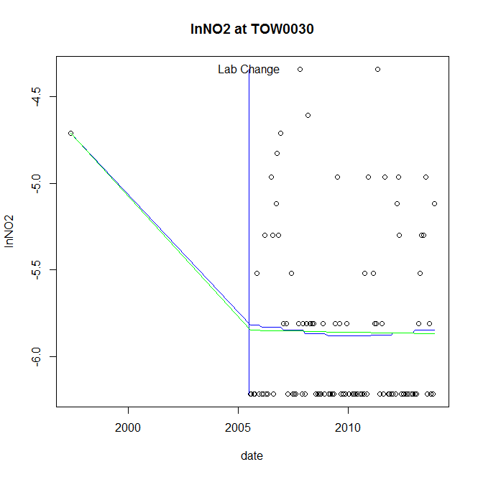

GAM analysis for station TOW0030 dependent variable lnNO2

|  |  |  |  |  |
| --- | --- | --- | --- | --- |
| **Type** | **Source** | **edf** | **F-stat** | **p-value** |
| parametric terms | step | 1 | 1.5714 | 0.2131 |
|  | year | 1 | 37.8195 | <0.0001 |
| smoothed terms | s(year) | 1.35 | 0.0528 | 0.9190 |
|  | s(doy) | 0 | 0 | 0.4997 |

GAM analysis for station TOW0030 dependent variable lnNO2

|  |  |  |  |  |
| --- | --- | --- | --- | --- |
| **parameter** | **estimate** | **Std. Err.** | **t value** | **p-value** |
| (Intercept) | -1.6e-05 | 0.00018 | -0.0888 | 0.9294 |
| step | -0.998248 | 0.79634 | -1.2535 | 0.2131 |
| year | -0.002418 | 0.000393 | -6.1498 | <0.0001 |

root mean-square error = 0.5051

adjusted r-square = 0.0355

station = TOW0030 dependent = lnTP

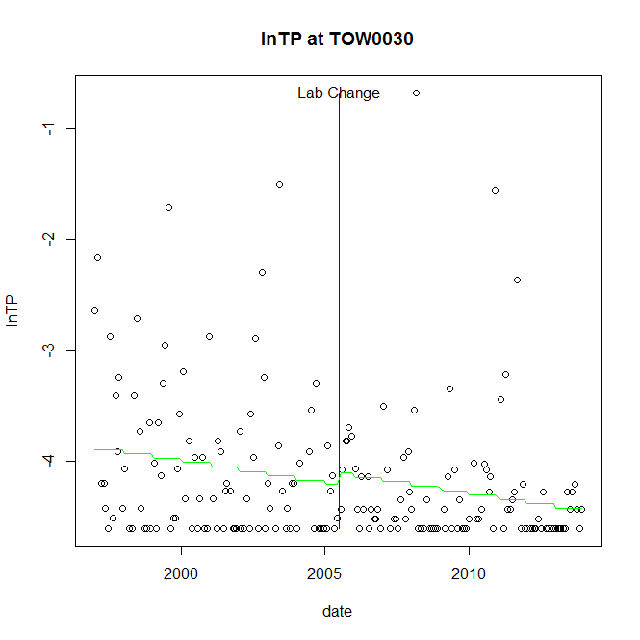

GAM analysis for station TOW0030 dependent variable lnTP

|  |  |  |  |  |
| --- | --- | --- | --- | --- |
| **Type** | **Source** | **edf** | **F-stat** | **p-value** |
| parametric terms | step | 1 | 0.3461 | 0.5570 |
|  | year | 1 | 1636.8246 | <0.0001 |
| smoothed terms | s(year) | 1 | 4.2036 | 0.0417 |
|  | s(doy) | 0 | 0 | 0.8045 |

GAM analysis for station TOW0030 dependent variable lnTP

|  |  |  |  |  |
| --- | --- | --- | --- | --- |
| **parameter** | **estimate** | **Std. Err.** | **t value** | **p-value** |
| (Intercept) | 0.000462 | 0.000226 | 2.0458 | 0.0422 |
| step | 0.108087 | 0.183736 | 0.5883 | 0.5570 |
| year | -0.002102 | 5.2e-05 | -40.4577 | <0.0001 |

root mean-square error = 0.6389

adjusted r-square = 0.0457

station = TOW0030 dependent = lnPO4

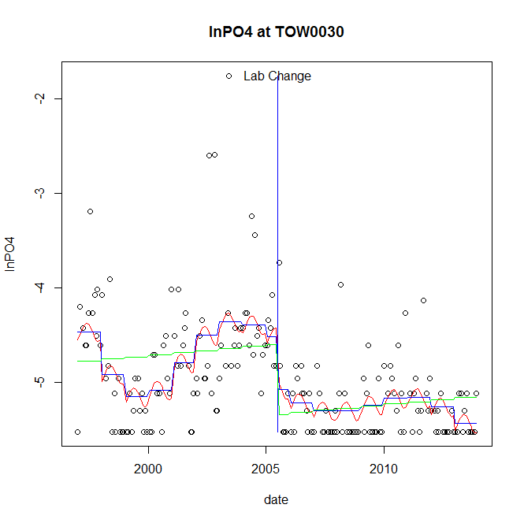

GAM analysis for station TOW0030 dependent variable lnPO4

|  |  |  |  |  |
| --- | --- | --- | --- | --- |
| **Type** | **Source** | **edf** | **F-stat** | **p-value** |
| parametric terms | step | 1 | 5.321 | 0.0222 |
|  | year | 1 | 1424.7305 | <0.0001 |
| smoothed terms | s(year) | 6.15 | 6.5312 | <0.0001 |
|  | s(doy) | 1.65 | 0.7959 | 0.0127 |

GAM analysis for station TOW0030 dependent variable lnPO4

|  |  |  |  |  |
| --- | --- | --- | --- | --- |
| **parameter** | **estimate** | **Std. Err.** | **t value** | **p-value** |
| (Intercept) | 0.004022 | 0.001068 | 3.7672 | 0.0002 |
| step | -0.555934 | 0.241004 | -2.3067 | 0.0222 |
| year | -0.002346 | 6.2e-05 | -37.7456 | <0.0001 |

root mean-square error = 0.4821

adjusted r-square = 0.365

step significant

No title given

|  |  |  |  |
| --- | --- | --- | --- |
| **station** | **dep** | **step.est** | **step.pv** |
| TOW0030 | lnTSS | 0.112202 | 0.8158 |
| TOW0030 | lnTN | -0.463932 | 0.0317 |
| TOW0030 | lnNH4 | -0.470446 | 0.0061 |
| TOW0030 | lnNO23 | -1.405298 | 0.0195 |
| TOW0030 | lnNO2 | -0.998248 | 0.2131 |
| TOW0030 | lnTP | 0.108087 | 0.5570 |
| TOW0030 | lnPO4 | -0.555934 | 0.0222 |

station = WIL0013 dependent = lnTSS

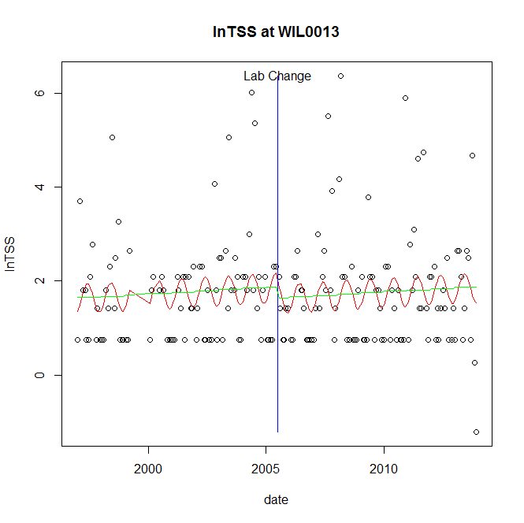

GAM analysis for station WIL0013 dependent variable lnTSS

|  |  |  |  |  |
| --- | --- | --- | --- | --- |
| **Type** | **Source** | **edf** | **F-stat** | **p-value** |
| parametric terms | step | 1 | 0.5408 | 0.4630 |
|  | year | 1 | 95.1566 | <0.0001 |
| smoothed terms | s(year) | 1 | 0.6721 | 0.4134 |
|  | s(doy) | 1.87 | 1.1708 | 0.0029 |

GAM analysis for station WIL0013 dependent variable lnTSS

|  |  |  |  |  |
| --- | --- | --- | --- | --- |
| **parameter** | **estimate** | **Std. Err.** | **t value** | **p-value** |
| (Intercept) | -0.000316 | 0.000386 | -0.8187 | 0.4140 |
| step | -0.238171 | 0.323869 | -0.7354 | 0.4630 |
| year | 0.000932 | 9.6e-05 | 9.7548 | <0.0001 |

root mean-square error = 1.151

adjusted r-square = 0.0453

station = WIL0013 dependent = lnTN

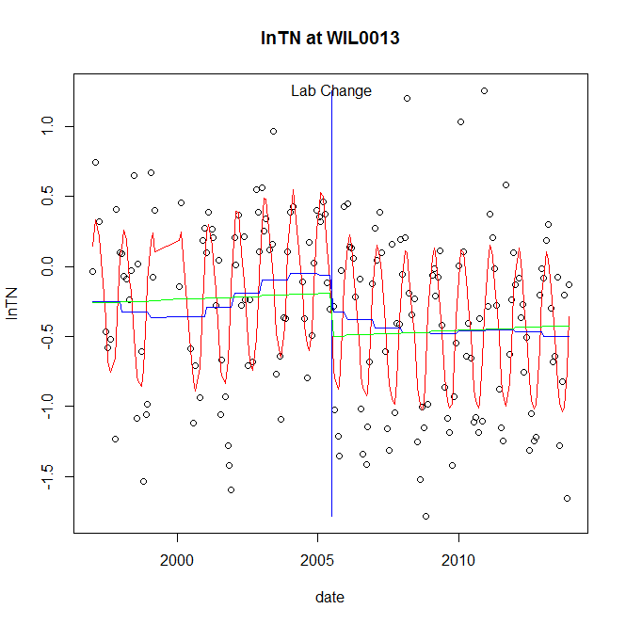

GAM analysis for station WIL0013 dependent variable lnTN

|  |  |  |  |  |
| --- | --- | --- | --- | --- |
| **Type** | **Source** | **edf** | **F-stat** | **p-value** |
| parametric terms | step | 1 | 1.6808 | 0.1965 |
|  | year | 1 | 2.6544 | 0.1051 |
| smoothed terms | s(year) | 4.52 | 1.4426 | 0.2054 |
|  | s(doy) | 4.72 | 19.1723 | <0.0001 |

GAM analysis for station WIL0013 dependent variable lnTN

|  |  |  |  |  |
| --- | --- | --- | --- | --- |
| **parameter** | **estimate** | **Std. Err.** | **t value** | **p-value** |
| (Intercept) | 0.000624 | 0.000714 | 0.8748 | 0.3829 |
| step | -0.258496 | 0.199386 | -1.2965 | 0.1965 |
| year | -9.3e-05 | 5.7e-05 | -1.6292 | 0.1051 |

root mean-square error = 0.45

adjusted r-square = 0.4898

station = WIL0013 dependent = lnNH4

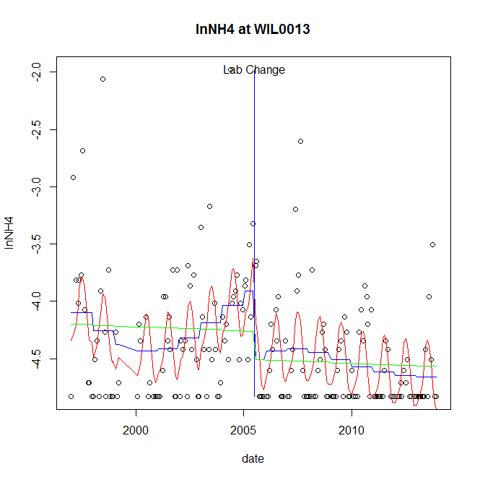

GAM analysis for station WIL0013 dependent variable lnNH4

|  |  |  |  |  |
| --- | --- | --- | --- | --- |
| **Type** | **Source** | **edf** | **F-stat** | **p-value** |
| parametric terms | step | 1 | 10.2298 | 0.0016 |
|  | year | 1 | 1531.397 | <0.0001 |
| smoothed terms | s(year) | 4.38 | 3.7469 | 0.0025 |
|  | s(doy) | 3.85 | 6.0814 | <0.0001 |

GAM analysis for station WIL0013 dependent variable lnNH4

|  |  |  |  |  |
| --- | --- | --- | --- | --- |
| **parameter** | **estimate** | **Std. Err.** | **t value** | **p-value** |
| (Intercept) | 0.000987 | 0.000653 | 1.5116 | 0.1324 |
| step | -0.59744 | 0.186793 | -3.1984 | 0.0016 |
| year | -0.002041 | 5.2e-05 | -39.1331 | <0.0001 |

root mean-square error = 0.4355

adjusted r-square = 0.3204

step significant

station = WIL0013 dependent = lnNO23

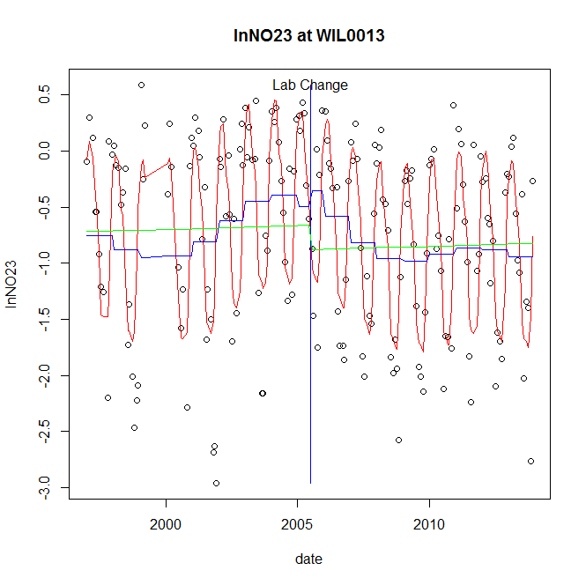

GAM analysis for station WIL0013 dependent variable lnNO23

|  |  |  |  |  |
| --- | --- | --- | --- | --- |
| **Type** | **Source** | **edf** | **F-stat** | **p-value** |
| parametric terms | step | 1 | 0.316 | 0.5748 |
|  | year | 1 | 32.8761 | <0.0001 |
| smoothed terms | s(year) | 5.45 | 3.933 | 0.0009 |
|  | s(doy) | 6.73 | 32.4221 | <0.0001 |

GAM analysis for station WIL0013 dependent variable lnNO23

|  |  |  |  |  |
| --- | --- | --- | --- | --- |
| **parameter** | **estimate** | **Std. Err.** | **t value** | **p-value** |
| (Intercept) | 0.001173 | 0.001054 | 1.1131 | 0.2672 |
| step | 0.143393 | 0.255103 | 0.5621 | 0.5748 |
| year | -0.000405 | 7.1e-05 | -5.7338 | <0.0001 |

root mean-square error = 0.5333

adjusted r-square = 0.601

station = WIL0013 dependent = lnNO2

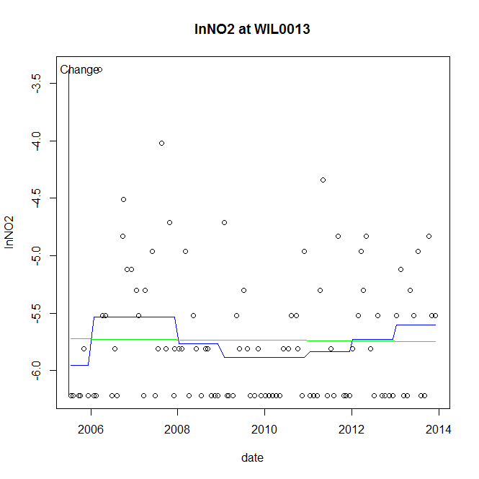

GAM analysis for station WIL0013 dependent variable lnNO2

|  |  |  |  |  |
| --- | --- | --- | --- | --- |
| **Type** | **Source** | **edf** | **F-stat** | **p-value** |
| parametric terms | step | 1 | 3.9362 | 0.0501 |
|  | year | 1 | 10682.679 | <0.0001 |
| smoothed terms | s(year) | 4.46 | 1.5774 | 0.1683 |
|  | s(doy) | 0 | 0 | 0.6287 |

GAM analysis for station WIL0013 dependent variable lnNO2

|  |  |  |  |  |
| --- | --- | --- | --- | --- |
| **parameter** | **estimate** | **Std. Err.** | **t value** | **p-value** |
| (Intercept) | -0.000994 | 0.000501 | -1.984 | 0.0501 |
| step | -0.000994 | 0.000501 | -1.984 | 0.0501 |
| year | -0.002853 | 2.8e-05 | -103.357 | <0.0001 |

root mean-square error = 0.5601

adjusted r-square = 0.0647

station = WIL0013 dependent = lnTP

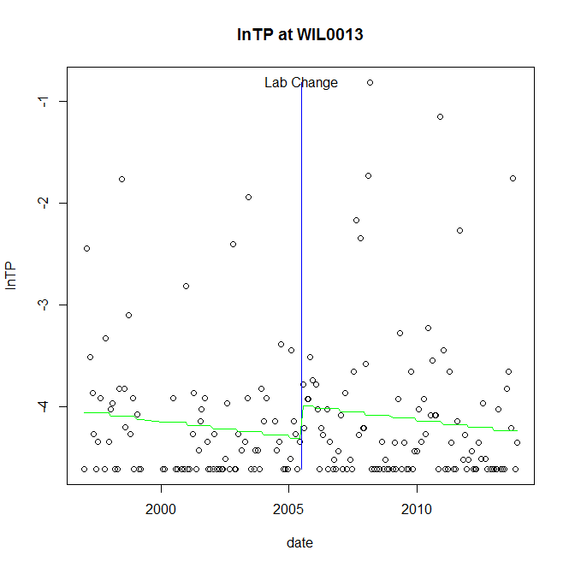

GAM analysis for station WIL0013 dependent variable lnTP

|  |  |  |  |  |
| --- | --- | --- | --- | --- |
| **Type** | **Source** | **edf** | **F-stat** | **p-value** |
| parametric terms | step | 1 | 2.6449 | 0.1056 |
|  | year | 1 | 1308.6363 | <0.0001 |
| smoothed terms | s(year) | 1 | 2.0324 | 0.1557 |
|  | s(doy) | 0 | 0 | 0.8326 |

GAM analysis for station WIL0013 dependent variable lnTP

|  |  |  |  |  |
| --- | --- | --- | --- | --- |
| **parameter** | **estimate** | **Std. Err.** | **t value** | **p-value** |
| (Intercept) | 0.000336 | 0.000236 | 1.4212 | 0.1570 |
| step | 0.320362 | 0.196985 | 1.6263 | 0.1056 |
| year | -0.002154 | 6e-05 | -36.1751 | <0.0001 |

root mean-square error = 0.6879

adjusted r-square = 0.0038

station = WIL0013 dependent = lnPO4

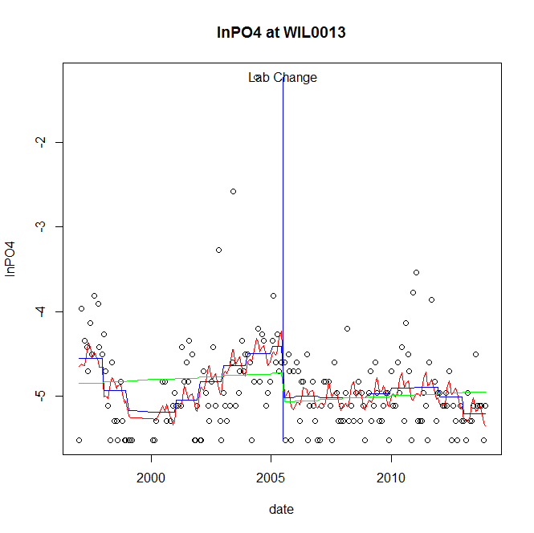

GAM analysis for station WIL0013 dependent variable lnPO4

|  |  |  |  |  |
| --- | --- | --- | --- | --- |
| **Type** | **Source** | **edf** | **F-stat** | **p-value** |
| parametric terms | step | 1 | 6.5777 | 0.0112 |
|  | year | 1 | 1203.4662 | <0.0001 |
| smoothed terms | s(year) | 5.68 | 4.7157 | 0.0001 |
|  | s(doy) | 5.08 | 1.236 | 0.0689 |

GAM analysis for station WIL0013 dependent variable lnPO4

|  |  |  |  |  |
| --- | --- | --- | --- | --- |
| **parameter** | **estimate** | **Std. Err.** | **t value** | **p-value** |
| (Intercept) | 0.003538 | 0.001019 | 3.4709 | 0.0007 |
| step | -0.612756 | 0.23892 | -2.5647 | 0.0112 |
| year | -0.00229 | 6.6e-05 | -34.691 | <0.0001 |

root mean-square error = 0.4909

adjusted r-square = 0.1949

step significant

No title given

|  |  |  |  |
| --- | --- | --- | --- |
| **station** | **dep** | **step.est** | **step.pv** |
| WIL0013 | lnTSS | -0.238171 | 0.4630 |
| WIL0013 | lnTN | -0.258496 | 0.1965 |
| WIL0013 | lnNH4 | -0.59744 | 0.0016 |
| WIL0013 | lnNO23 | 0.143393 | 0.5748 |
| WIL0013 | lnNO2 | -0.000994 | 0.0501 |
| WIL0013 | lnTP | 0.320362 | 0.1056 |
| WIL0013 | lnPO4 | -0.612756 | 0.0112 |

station = YOU0925 dependent = lnTSS

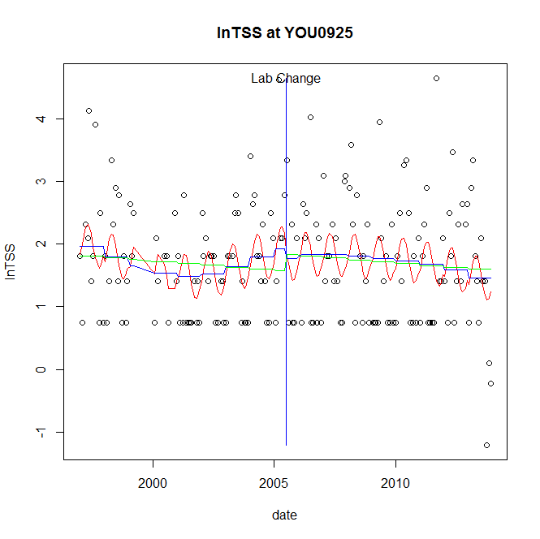

GAM analysis for station YOU0925 dependent variable lnTSS

|  |  |  |  |  |
| --- | --- | --- | --- | --- |
| **Type** | **Source** | **edf** | **F-stat** | **p-value** |
| parametric terms | step | 1 | 0.1811 | 0.6709 |
|  | year | 1 | 77.6156 | <0.0001 |
| smoothed terms | s(year) | 3.75 | 1.5011 | 0.1946 |
|  | s(doy) | 2.13 | 2.1821 | <0.0001 |

GAM analysis for station YOU0925 dependent variable lnTSS

|  |  |  |  |  |
| --- | --- | --- | --- | --- |
| **parameter** | **estimate** | **Std. Err.** | **t value** | **p-value** |
| (Intercept) | 0.001704 | 0.001125 | 1.5141 | 0.1318 |
| step | -0.153388 | 0.360419 | -0.4256 | 0.6709 |
| year | 0.00089 | 0.000101 | 8.81 | <0.0001 |

root mean-square error = 0.8983

adjusted r-square = 0.113

station = YOU0925 dependent = lnTN

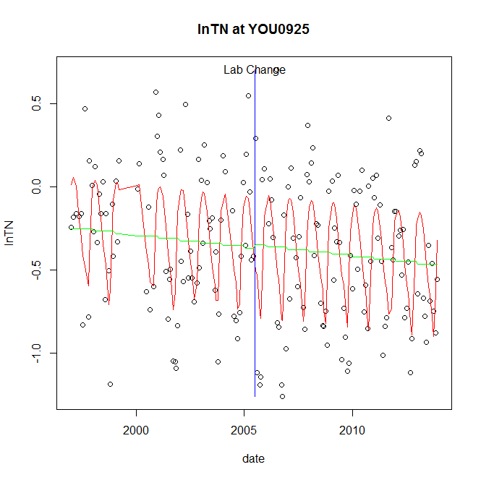

GAM analysis for station YOU0925 dependent variable lnTN

|  |  |  |  |  |
| --- | --- | --- | --- | --- |
| **Type** | **Source** | **edf** | **F-stat** | **p-value** |
| parametric terms | step | 1 | 0.0347 | 0.8525 |
|  | year | 1 | 35.342 | <0.0001 |
| smoothed terms | s(year) | 1 | 1.8359 | 0.1771 |
|  | s(doy) | 5.6 | 11.5292 | <0.0001 |

GAM analysis for station YOU0925 dependent variable lnTN

|  |  |  |  |  |
| --- | --- | --- | --- | --- |
| **parameter** | **estimate** | **Std. Err.** | **t value** | **p-value** |
| (Intercept) | 0.000164 | 0.000121 | 1.3543 | 0.1774 |
| step | 0.018897 | 0.101452 | 0.1863 | 0.8525 |
| year | -0.000181 | 3e-05 | -5.9449 | <0.0001 |

root mean-square error = 0.3497

adjusted r-square = 0.3426

station = YOU0925 dependent = lnNH4

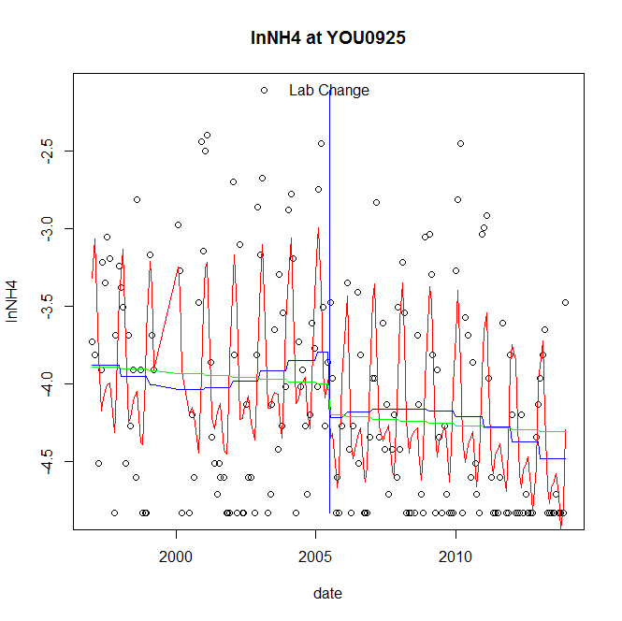

GAM analysis for station YOU0925 dependent variable lnNH4

|  |  |  |  |  |
| --- | --- | --- | --- | --- |
| **Type** | **Source** | **edf** | **F-stat** | **p-value** |
| parametric terms | step | 1 | 3.964 | 0.0480 |
|  | year | 1 | 1036.9258 | <0.0001 |
| smoothed terms | s(year) | 3.38 | 1.5825 | 0.1774 |
|  | s(doy) | 5.7 | 12.0431 | <0.0001 |

GAM analysis for station YOU0925 dependent variable lnNH4

|  |  |  |  |  |
| --- | --- | --- | --- | --- |
| **parameter** | **estimate** | **Std. Err.** | **t value** | **p-value** |
| (Intercept) | 0.001022 | 0.000604 | 1.6908 | 0.0926 |
| step | -0.422983 | 0.212449 | -1.991 | 0.0480 |
| year | -0.001924 | 6e-05 | -32.2013 | <0.0001 |

root mean-square error = 0.5523

adjusted r-square = 0.3996

step significant

station = YOU0925 dependent = lnNO23

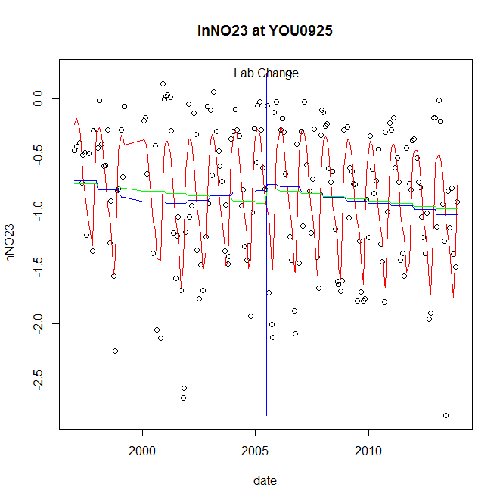

GAM analysis for station YOU0925 dependent variable lnNO23

|  |  |  |  |  |
| --- | --- | --- | --- | --- |
| **Type** | **Source** | **edf** | **F-stat** | **p-value** |
| parametric terms | step | 1 | 0.0742 | 0.7856 |
|  | year | 1 | 71.1303 | <0.0001 |
| smoothed terms | s(year) | 3.69 | 1.4014 | 0.2281 |
|  | s(doy) | 5.79 | 19.7551 | <0.0001 |

GAM analysis for station YOU0925 dependent variable lnNO23

|  |  |  |  |  |
| --- | --- | --- | --- | --- |
| **parameter** | **estimate** | **Std. Err.** | **t value** | **p-value** |
| (Intercept) | 0.000769 | 0.000566 | 1.3601 | 0.1755 |
| step | 0.050608 | 0.185764 | 0.2724 | 0.7856 |
| year | -0.000439 | 5.2e-05 | -8.4339 | <0.0001 |

root mean-square error = 0.4637

adjusted r-square = 0.465

station = YOU0925 dependent = lnNO2

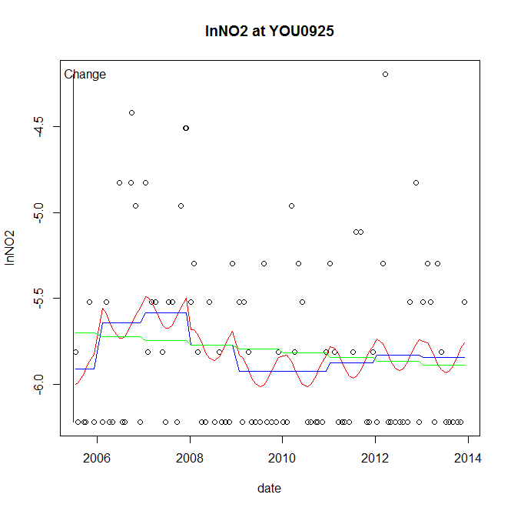

GAM analysis for station YOU0925 dependent variable lnNO2

|  |  |  |  |  |
| --- | --- | --- | --- | --- |
| **Type** | **Source** | **edf** | **F-stat** | **p-value** |
| parametric terms | step | 1 | 1.1483 | 0.2866 |
|  | year | 1 | 13906.0191 | <0.0001 |
| smoothed terms | s(year) | 4.08 | 1.5436 | 0.1838 |
|  | s(doy) | 1.27 | 0.4065 | 0.0655 |

GAM analysis for station YOU0925 dependent variable lnNO2

|  |  |  |  |  |
| --- | --- | --- | --- | --- |
| **parameter** | **estimate** | **Std. Err.** | **t value** | **p-value** |
| (Intercept) | -0.00043 | 0.000401 | -1.0716 | 0.2866 |
| step | -0.00043 | 0.000401 | -1.0716 | 0.2866 |
| year | -0.002887 | 2.4e-05 | -117.9238 | <0.0001 |

root mean-square error = 0.4943

adjusted r-square = 0.0857

station = YOU0925 dependent = lnTP

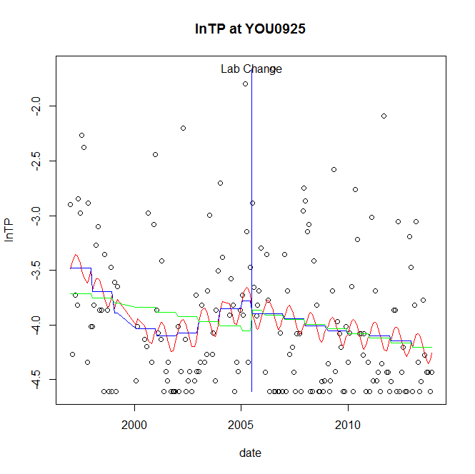

GAM analysis for station YOU0925 dependent variable lnTP

|  |  |  |  |  |
| --- | --- | --- | --- | --- |
| **Type** | **Source** | **edf** | **F-stat** | **p-value** |
| parametric terms | step | 1 | 0.1783 | 0.6734 |
|  | year | 1 | 654.9944 | <0.0001 |
| smoothed terms | s(year) | 4.23 | 2.561 | 0.0277 |
|  | s(doy) | 1.82 | 0.7053 | 0.0293 |

GAM analysis for station YOU0925 dependent variable lnTP

|  |  |  |  |  |
| --- | --- | --- | --- | --- |
| **parameter** | **estimate** | **Std. Err.** | **t value** | **p-value** |
| (Intercept) | 0.00161 | 0.000919 | 1.7515 | 0.0816 |
| step | -0.113401 | 0.268584 | -0.4222 | 0.6734 |
| year | -0.00195 | 7.6e-05 | -25.5929 | <0.0001 |

root mean-square error = 0.625

adjusted r-square = 0.101

station = YOU0925 dependent = lnPO4

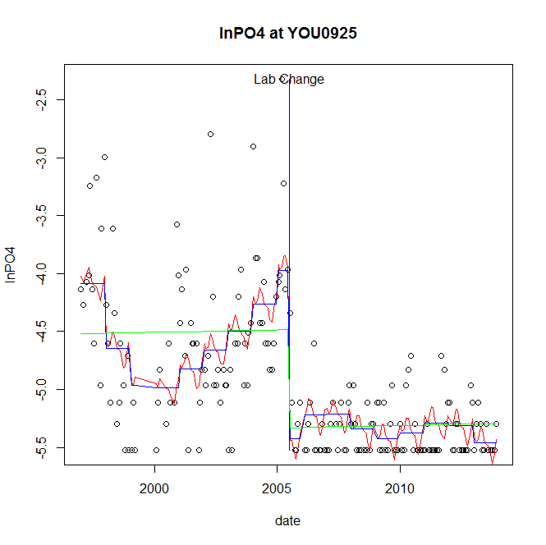

GAM analysis for station YOU0925 dependent variable lnPO4

|  |  |  |  |  |
| --- | --- | --- | --- | --- |
| **Type** | **Source** | **edf** | **F-stat** | **p-value** |
| parametric terms | step | 1 | 40.7056 | <0.0001 |
|  | year | 1 | 1120.0503 | <0.0001 |
| smoothed terms | s(year) | 6.52 | 7.5172 | <0.0001 |
|  | s(doy) | 4.81 | 1.1264 | 0.0830 |

GAM analysis for station YOU0925 dependent variable lnPO4

|  |  |  |  |  |
| --- | --- | --- | --- | --- |
| **parameter** | **estimate** | **Std. Err.** | **t value** | **p-value** |
| (Intercept) | 0.004492 | 0.00108 | 4.1581 | <0.0001 |
| step | -1.454819 | 0.228025 | -6.3801 | <0.0001 |
| year | -0.002089 | 6.2e-05 | -33.4672 | <0.0001 |

root mean-square error = 0.4353

adjusted r-square = 0.5425

step significant

No title given

|  |  |  |  |
| --- | --- | --- | --- |
| **station** | **dep** | **step.est** | **step.pv** |
| YOU0925 | lnTSS | -0.153388 | 0.6709 |
| YOU0925 | lnTN | 0.018897 | 0.8525 |
| YOU0925 | lnNH4 | -0.422983 | 0.0480 |
| YOU0925 | lnNO23 | 0.050608 | 0.7856 |
| YOU0925 | lnNO2 | -0.00043 | 0.2866 |
| YOU0925 | lnTP | -0.113401 | 0.6734 |
| YOU0925 | lnPO4 | -1.454819 | <0.0001 |

station = YOU1139 dependent = lnTSS

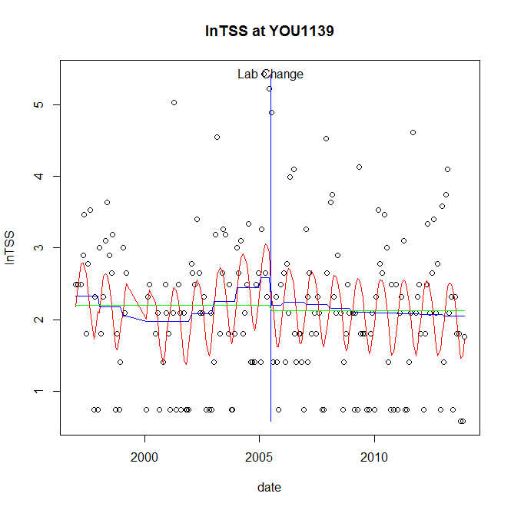

GAM analysis for station YOU1139 dependent variable lnTSS

|  |  |  |  |  |
| --- | --- | --- | --- | --- |
| **Type** | **Source** | **edf** | **F-stat** | **p-value** |
| parametric terms | step | 1 | 1.0561 | 0.3055 |
|  | year | 1 | 123.321 | <0.0001 |
| smoothed terms | s(year) | 3.91 | 1.0836 | 0.3677 |
|  | s(doy) | 2.9 | 4.1908 | <0.0001 |

GAM analysis for station YOU1139 dependent variable lnTSS

|  |  |  |  |  |
| --- | --- | --- | --- | --- |
| **parameter** | **estimate** | **Std. Err.** | **t value** | **p-value** |
| (Intercept) | 0.001012 | 0.001215 | 0.8335 | 0.4056 |
| step | -0.389597 | 0.379101 | -1.0277 | 0.3055 |
| year | 0.001181 | 0.000106 | 11.105 | <0.0001 |

root mean-square error = 0.9339

adjusted r-square = 0.1754

station = YOU1139 dependent = lnTN

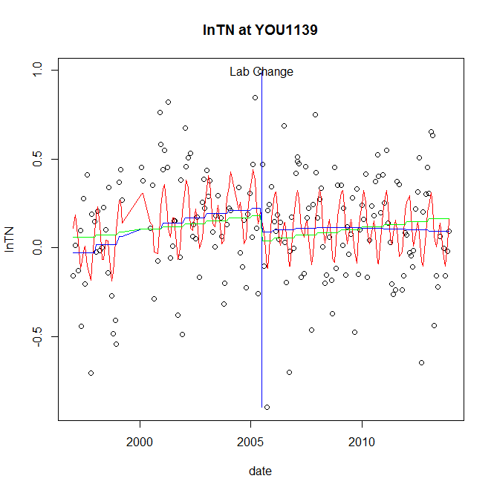

GAM analysis for station YOU1139 dependent variable lnTN

|  |  |  |  |  |
| --- | --- | --- | --- | --- |
| **Type** | **Source** | **edf** | **F-stat** | **p-value** |
| parametric terms | step | 1 | 2.3179 | 0.1297 |
|  | year | 1 | 14.14 | 0.0002 |
| smoothed terms | s(year) | 2.16 | 3.8683 | 0.0144 |
|  | s(doy) | 5.06 | 5.1309 | <0.0001 |

GAM analysis for station YOU1139 dependent variable lnTN

|  |  |  |  |  |
| --- | --- | --- | --- | --- |
| **parameter** | **estimate** | **Std. Err.** | **t value** | **p-value** |
| (Intercept) | -0.000224 | 0.000171 | -1.3129 | 0.1909 |
| step | -0.135483 | 0.08899 | -1.5225 | 0.1297 |
| year | 9.9e-05 | 2.6e-05 | 3.7603 | 0.0002 |

root mean-square error = 0.2792

adjusted r-square = 0.2098

station = YOU1139 dependent = lnNH4

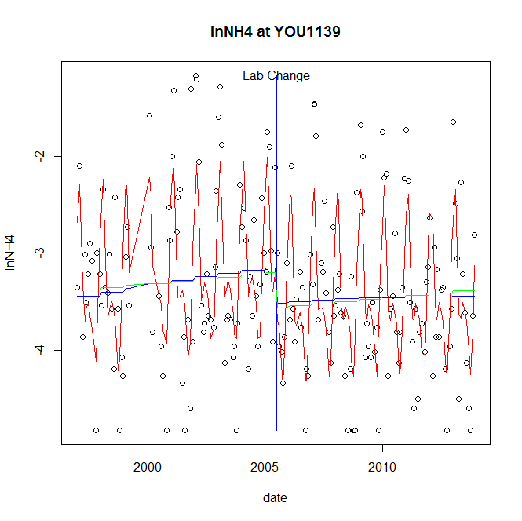

GAM analysis for station YOU1139 dependent variable lnNH4

|  |  |  |  |  |
| --- | --- | --- | --- | --- |
| **Type** | **Source** | **edf** | **F-stat** | **p-value** |
| parametric terms | step | 1 | 3.8021 | 0.0527 |
|  | year | 1 | 803.8121 | <0.0001 |
| smoothed terms | s(year) | 1.59 | 1.6346 | 0.1966 |
|  | s(doy) | 6.19 | 19.3385 | <0.0001 |

GAM analysis for station YOU1139 dependent variable lnNH4

|  |  |  |  |  |
| --- | --- | --- | --- | --- |
| **parameter** | **estimate** | **Std. Err.** | **t value** | **p-value** |
| (Intercept) | -0.000269 | 0.000272 | -0.9917 | 0.3226 |
| step | -0.364242 | 0.186801 | -1.9499 | 0.0527 |
| year | -0.001564 | 5.5e-05 | -28.3516 | <0.0001 |

root mean-square error = 0.644

adjusted r-square = 0.4646

station = YOU1139 dependent = lnNO23

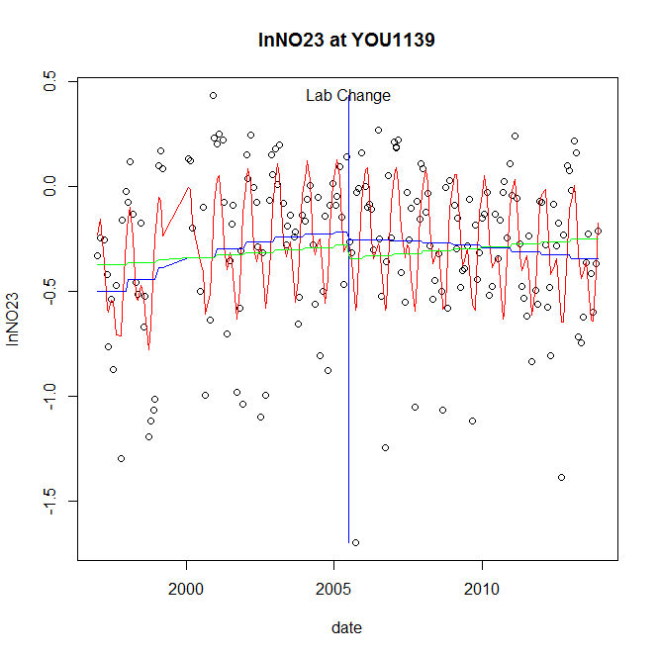

GAM analysis for station YOU1139 dependent variable lnNO23

|  |  |  |  |  |
| --- | --- | --- | --- | --- |
| **Type** | **Source** | **edf** | **F-stat** | **p-value** |
| parametric terms | step | 1 | 0.1311 | 0.7177 |
|  | year | 1 | 22.0221 | <0.0001 |
| smoothed terms | s(year) | 2.36 | 4.8661 | 0.0033 |
|  | s(doy) | 5.36 | 12.1398 | <0.0001 |

GAM analysis for station YOU1139 dependent variable lnNO23

|  |  |  |  |  |
| --- | --- | --- | --- | --- |
| **parameter** | **estimate** | **Std. Err.** | **t value** | **p-value** |
| (Intercept) | -0.000236 | 0.000202 | -1.1668 | 0.2448 |
| step | -0.035068 | 0.096842 | -0.3621 | 0.7177 |
| year | -0.000132 | 2.8e-05 | -4.6928 | <0.0001 |

root mean-square error = 0.2999

adjusted r-square = 0.3637

station = YOU1139 dependent = lnNO2

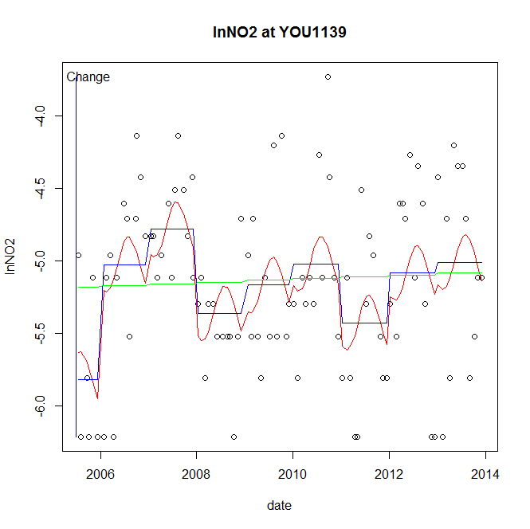

GAM analysis for station YOU1139 dependent variable lnNO2

|  |  |  |  |  |
| --- | --- | --- | --- | --- |
| **Type** | **Source** | **edf** | **F-stat** | **p-value** |
| parametric terms | step | 1 | 3.1661 | 0.0784 |
|  | year | 1 | 9854.0651 | <0.0001 |
| smoothed terms | s(year) | 6.51 | 3.8129 | 0.0011 |
|  | s(doy) | 1.84 | 1.173 | 0.0029 |

GAM analysis for station YOU1139 dependent variable lnNO2

|  |  |  |  |  |
| --- | --- | --- | --- | --- |
| **parameter** | **estimate** | **Std. Err.** | **t value** | **p-value** |
| (Intercept) | -0.001229 | 0.000691 | -1.7794 | 0.0784 |
| step | -0.001229 | 0.000691 | -1.7794 | 0.0784 |
| year | -0.002566 | 2.6e-05 | -99.2676 | <0.0001 |

root mean-square error = 0.5268

adjusted r-square = 0.2246

station = YOU1139 dependent = lnTP

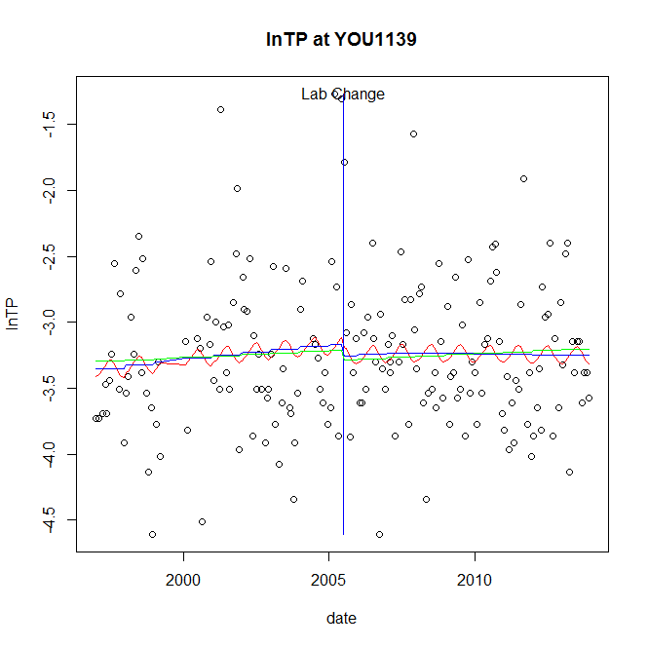

GAM analysis for station YOU1139 dependent variable lnTP

|  |  |  |  |  |
| --- | --- | --- | --- | --- |
| **Type** | **Source** | **edf** | **F-stat** | **p-value** |
| parametric terms | step | 1 | 0.2529 | 0.6157 |
|  | year | 1 | 1018.7657 | <0.0001 |
| smoothed terms | s(year) | 1.57 | 0.9969 | 0.3630 |
|  | s(doy) | 1.25 | 0.3078 | 0.1234 |

GAM analysis for station YOU1139 dependent variable lnTP

|  |  |  |  |  |
| --- | --- | --- | --- | --- |
| **parameter** | **estimate** | **Std. Err.** | **t value** | **p-value** |
| (Intercept) | -0.000154 | 0.000242 | -0.6369 | 0.5250 |
| step | -0.083845 | 0.166735 | -0.5029 | 0.6157 |
| year | -0.001598 | 5e-05 | -31.9181 | <0.0001 |

root mean-square error = 0.5681

adjusted r-square = 0.0111

station = YOU1139 dependent = lnPO4

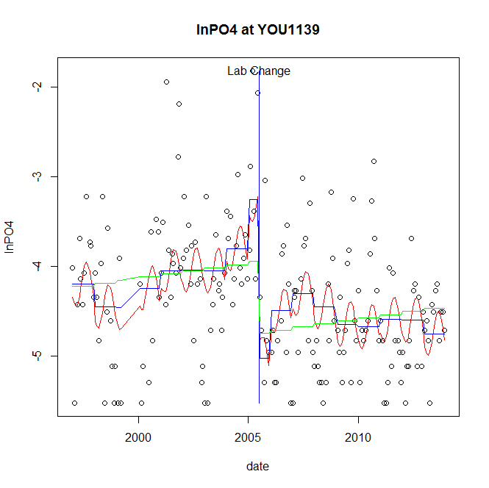

GAM analysis for station YOU1139 dependent variable lnPO4

|  |  |  |  |  |
| --- | --- | --- | --- | --- |
| **Type** | **Source** | **edf** | **F-stat** | **p-value** |
| parametric terms | step | 1 | 26.2313 | <0.0001 |
|  | year | 1 | 318.2605 | <0.0001 |
| smoothed terms | s(year) | 6.63 | 3.7227 | 0.0009 |
|  | s(doy) | 2.22 | 2.0631 | <0.0001 |

GAM analysis for station YOU1139 dependent variable lnPO4

|  |  |  |  |  |
| --- | --- | --- | --- | --- |
| **parameter** | **estimate** | **Std. Err.** | **t value** | **p-value** |
| (Intercept) | 0.002717 | 0.001653 | 1.6444 | 0.1018 |
| step | -1.76947 | 0.345488 | -5.1216 | <0.0001 |
| year | -0.001701 | 9.5e-05 | -17.8399 | <0.0001 |

root mean-square error = 0.6599

adjusted r-square = 0.2412

step significant

No title given

|  |  |  |  |
| --- | --- | --- | --- |
| **station** | **dep** | **step.est** | **step.pv** |
| YOU1139 | lnTSS | -0.389597 | 0.3055 |
| YOU1139 | lnTN | -0.135483 | 0.1297 |
| YOU1139 | lnNH4 | -0.364242 | 0.0527 |
| YOU1139 | lnNO23 | -0.035068 | 0.7177 |
| YOU1139 | lnNO2 | -0.001229 | 0.0784 |
| YOU1139 | lnTP | -0.083845 | 0.6157 |
| YOU1139 | lnPO4 | -1.76947 | <0.0001 |

Crosstabulation of dep and step.sig

|  |  |  |  |
| --- | --- | --- | --- |
| **dep / step.sig** | **step.sig FALSE.** | **step.sig TRUE.** | **step.sig Sum** |
| dep lnNH4 | 36 | 17 | 53 |
| dep lnNO2 | 46 | 7 | 53 |
| dep lnNO23 | 49 | 4 | 53 |
| dep lnPO4 | 25 | 28 | 53 |
| dep lnTN | 48 | 5 | 53 |
| dep lnTP | 49 | 4 | 53 |
| dep lnTSS | 48 | 5 | 53 |
| dep Sum | 301 | 70 | 371 |

Significant counts exceed 5.8

end of file